DE_AWS_CarePlusDataStores
Data Engineering Pipeline for Analytics Consumption

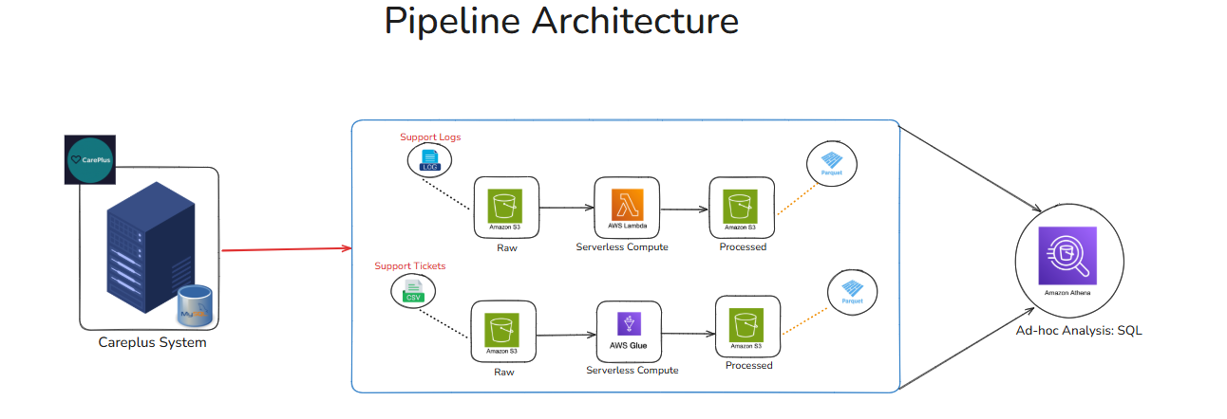

1. Introduction
This pipeline architecture represents a serverless data engineering workflow designed to demonstrate how raw operational data generated by a business system is ingested, processed, and prepared for analytical consumption. The architecture focuses on data engineering fundamentals, emphasizing ingestion, transformation, storage optimization, and analyst-ready delivery rather than business analytics or dashboards.
The design reflects real-world cloud constraints and highlights the separation between data generation, data engineering, and data analysis layers.

2. Source System: CarePlus
The CarePlus system acts as the primary source of data. It generates operational data as part of day-to-day business activities. Two distinct data streams originate from this system:
- Support Logs
These include system-generated logs capturing application behavior, events, and operational information.
- Support Tickets
These are structured, CSV-based records representing customer or operational support tickets.
Separating these two data types allows different processing strategies to be applied based on data characteristics.

3. Data Ingestion Layer (Amazon S3 – Raw Zone)
All incoming data from the CarePlus system is batch-ingested into Amazon S3, which serves as the Raw Data Layer of the data lake.
Key characteristics of this layer:
- Data is stored in its original format
- No transformations are applied at ingestion time
- Acts as a durable, scalable landing zone
- Decouples source systems from processing logic
Using S3 as the ingestion layer aligns with common industry practices for building cost-effective and scalable data lakes.

4. Processing Layer – Serverless Compute
The processing layer is implemented using serverless AWS services, ensuring scalability without infrastructure management.
4.1 Support Logs Processing (AWS Lambda)
- Raw support logs stored in S3 are processed using AWS Lambda
- Lambda performs lightweight transformations such as:
  - Parsing log structures
  - Cleaning malformed records
  - Converting semi-structured logs into structured formats
- After processing, the transformed data is written back to S3
Lambda is well-suited here due to:
- Event-driven execution
- Low operational overhead
- Suitability for small to medium-sized batch transformations

4.2 Support Tickets Processing (AWS Glue)
- Raw CSV-based support ticket data is processed using AWS Glue
- Glue handles:
  - Schema interpretation
  - Structured ETL-style transformations
  - Consistent data formatting
- Processed outputs are written back to S3
Glue is appropriate for this path because ticket data is structured and benefits from schema-aware transformations.

5. Processed Data Layer (Amazon S3 – Optimized Zone)
After processing, all transformed datasets are stored back in Amazon S3 in the Processed Data Layer.
Storage Format: Parquet
- Data is stored in Parquet, a columnar storage format
- Parquet is chosen because it:
  - Reduces storage footprint
  - Improves query performance
  - Is optimized for analytical workloads
This layer represents analytics-ready storage, optimized for downstream consumption.

6. Query & Analysis Layer (Conceptual)
The architecture includes Amazon Athena as a conceptual ad-hoc SQL query layer.
- Athena allows SQL queries directly on Parquet data stored in S3
- Enables fast, serverless analysis without data movement
- Demonstrates how processed data can be queried by analysts
In the context of this project:
- Athena is included at the design level
- Full implementation was limited due to access and free-tier constraints
- The architecture still reflects realistic enterprise data lake designs

***Note : Due to subscription constraints/free tier limitations we were unable to perform AWS Athena, but now our data is ready for analysis

7. Security and Access Control
Access between services is governed using AWS IAM roles and policies.
Key security principles applied:
- Role-based access instead of hardcoded credentials
- Least-privilege permissions between S3, Lambda, and Glue
- Controlled service-to-service communication
This ensures secure data handling while maintaining flexibility in a serverless environment.

8. Architectural Characteristics
The pipeline demonstrates several important architectural principles:
- Serverless-first design
No servers or clusters to manage
- Layered data architecture
Raw → Processed → Query-ready separation
- Scalability and fault isolation
Each component operates independently
- Analyst-focused delivery
Final outputs are structured and consumable by analytics tools

9. Key Learnings from the Architecture
- Data engineering does not end at storage; delivery matters
- Storage-optimized formats (Parquet) are not always analyst-friendly
- Serverless services simplify infrastructure management
- Cloud constraints (permissions, pricing tiers) influence design decisions
- Clear separation of responsibilities improves pipeline maintainability

10. Conclusion
This pipeline architecture effectively demonstrates the end-to-end journey of data from source systems to analytics-ready storage. By focusing on ingestion, processing, optimization, and delivery, the project provides a realistic view of how data engineering supports data analysts in real-world environments.
The design intentionally prioritizes clarity, honesty, and practicality, making it a strong foundation for understanding modern data engineering workflows.

