📊 Sales Analytics Project — Jira-Based Delivery Summary
Project Overview
This project represents a structured sales analytics delivery executed using Jira as a work management platform. The goal was to simulate how a real analytics team plans, tracks, and delivers analytical outcomes using an industry-aligned workflow.
The project was managed using a team-managed Kanban setup, reflecting continuous analytics delivery rather than sprint-based development.
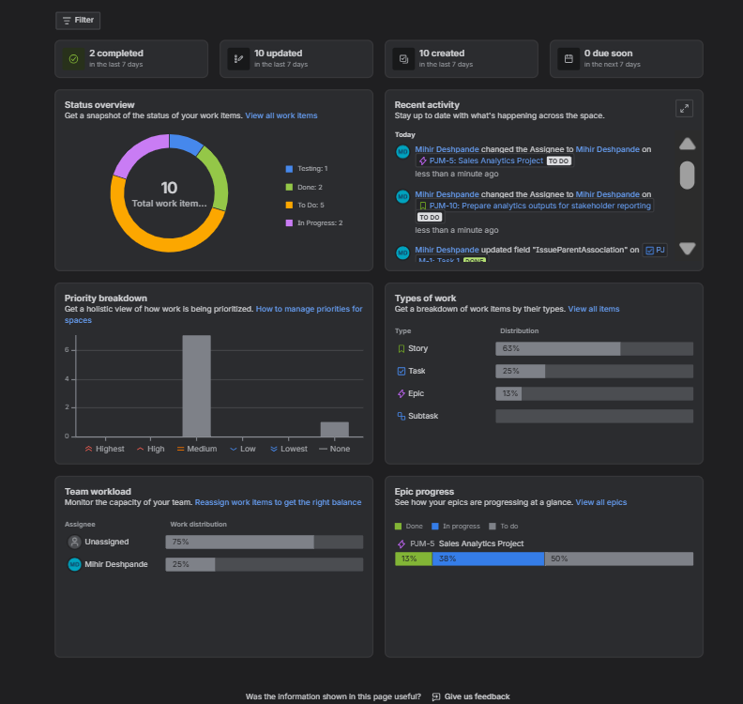
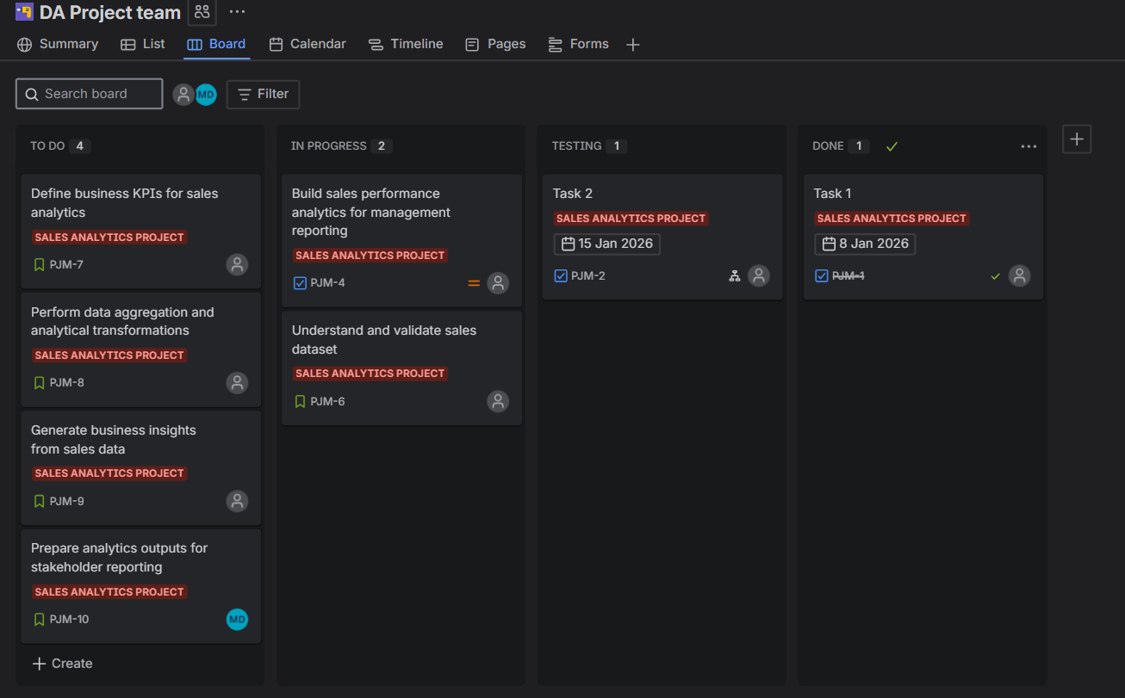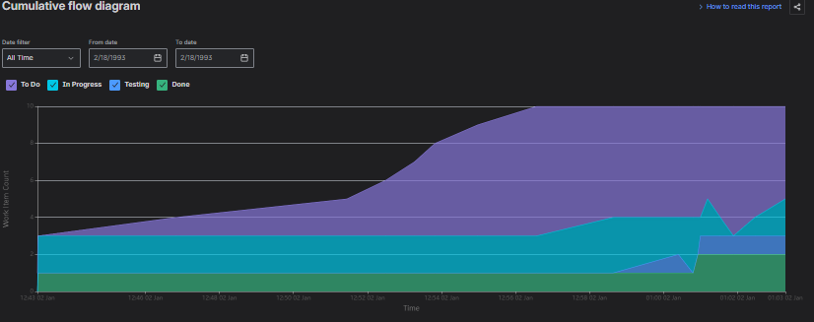

Project Structure & Organization
Space & Project Setup
- Space Name: DA Project Team
- Project Type: Jira Software (Team-managed)
- Delivery Model: Kanban
- Board: Automatically generated Kanban board with lifecycle stages
The team-managed configuration enables flexibility, fast setup, and autonomous workflow control—commonly used by analytics and BI teams.

Work Hierarchy
Epic
Sales Analytics Project
- Represents the overall business initiative
- Groups all analytical efforts under a single objective

Tasks (Major Deliverables)
- Build sales performance analytics for management reporting
- Validate and understand the sales dataset
Tasks represent high-level analytical deliverables contributing directly to the Epic.

Stories (Granular Analytical Work)
- Define business KPIs for sales analytics
- Perform data aggregation and analytical transformations
- Generate business insights from sales data
- Prepare analytics outputs for stakeholder reporting
Stories represent discrete, value-driven analytical activities executed as part of the overall delivery.

Workflow & Board Design
The Kanban board reflects the natural progression of analytical work:
- To Do: Planned analytical activities
- In Progress: Active analysis and development
- Testing: Validation and review of outputs
- Done: Completed and approved deliverables
This workflow supports continuous delivery and transparency across the project lifecycle.

Tracking & Visibility
Jira dashboards provide real-time visibility into:
- Work distribution across statuses
- Epic-level progress tracking
- Work type breakdown (Epics, Tasks, Stories)
- Team workload and completion metrics
These views help monitor progress, identify bottlenecks, and ensure balanced execution.

Key Outcomes
- Established a realistic analytics project structure using Jira
- Demonstrated hierarchical organization of analytical work
- Implemented continuous delivery using a Kanban workflow
- Achieved clear traceability from business initiative to execution
- Maintained end-to-end visibility across planning, execution, and completion

Conclusion
This project demonstrates how analytics initiatives can be effectively planned and executed using Jira’s team-managed Kanban model. By structuring work into Epics, Tasks, and Stories, and tracking progress on a unified board, the project reflects a practical, real-world approach to analytics delivery and operational management.

