AI-Powered SQL Analytics Agent using n8n and PostgreSQL
Complete Project Guide

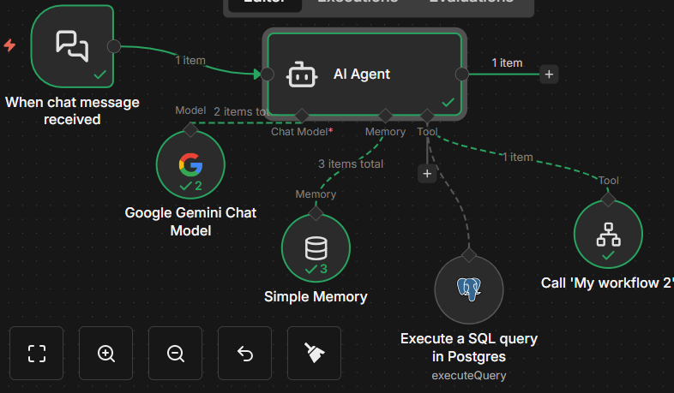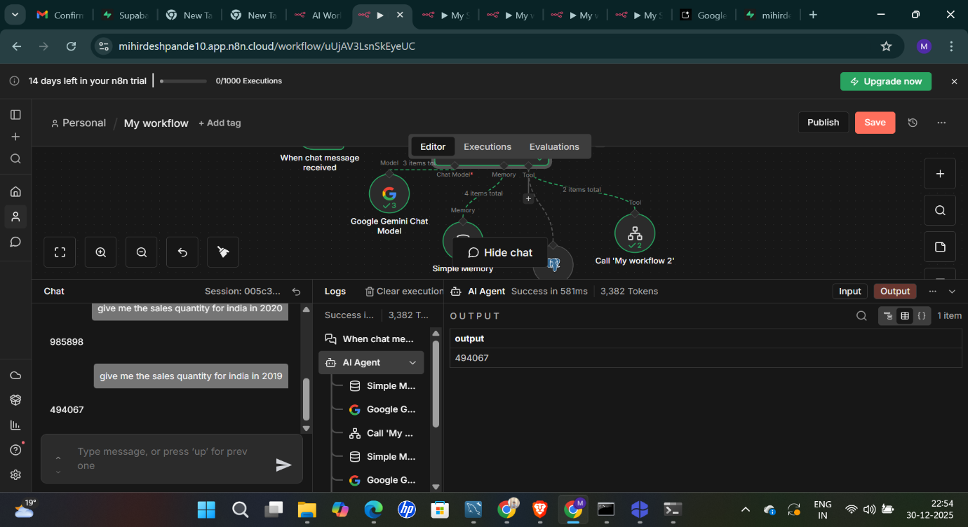

1. Project Overview
This project implements an AI-powered SQL Analytics Agent that enables users to ask business questions in plain English and receive accurate, real-time answers from a PostgreSQL database.
The system converts natural language queries into validated SQL, executes them on a star-schema analytics database, and returns trustworthy results. The solution emphasizes correctness, schema awareness, and non-hallucinating AI behavior, making it suitable for real-world analytics use cases.

2. Conceptual Analogy (High-Level Understanding)
The architecture can be understood using a simple analogy:
A father wants vegetables from the market.
Instead of going himself, he sends his son with clear rules:
- What to buy
- Where to buy
- How to verify correctness
- And to return only with real items, not guesses
In this system:
- The father represents the user’s business question
- The son represents the AI Agent
- The market represents the PostgreSQL database
- The rules ensure the agent does not guess, hallucinate, or return incorrect data
- The vegetables represent validated query results
The core idea is delegation with strict constraints.

3. Database Design and Data Modeling
3.1 Choice of Database
- PostgreSQL (Supabase) was selected for reliability, SQL strictness, and analytics suitability.
3.2 Schema Design
A star schema was implemented to model real-world sales analytics.
Dimension Tables
- dim_customer – customer attributes (market, platform, channel)
- dim_product – product hierarchy and classification
Fact Tables
- fact_sales_monthly – sales quantities over time
- fact_forecast_monthly – forecasted demand
- Pricing and cost fact tables for profitability analysis
This separation ensures:
- Clear business meaning
- Efficient aggregations
- Predictable joins

4. Data Ingestion Process
- Raw CSV files were loaded into PostgreSQL.
- Tables were created explicitly using SQL to ensure correct data types.
- Data was imported using schema-matched CSV loading.
- Row counts and sanity checks were performed to confirm data integrity.
Special attention was given to:
- Text vs Date types
- Preventing implicit casting errors
- Ensuring analytics-safe structures

5. Workflow Automation using n8n
5.1 Workflow Purpose
The n8n workflow acts as the orchestration layer, coordinating:
- User input
- AI reasoning
- Database execution
- Final output delivery
5.2 Trigger Mechanism
- A chat-based trigger accepts natural language questions.
- Each message initiates a fresh, deterministic execution.

6. AI Agent Design (Core Intelligence)
6.1 Role of the AI Agent
The AI Agent is responsible for:
- Understanding the intent of the question
- Mapping intent to schema
- Generating correct SQL
- Executing queries using tools
- Returning only verified answers
6.2 Tool-First Design Principle
The agent is not allowed to behave like a chatbot.
Strict rules were enforced:
- The agent must use tools
- The agent cannot ask for table or column names
- The agent cannot fabricate schema
- The agent cannot answer without database execution
This eliminates hallucinations entirely.

7. Schema Awareness and Business Mapping
The agent was explicitly trained to understand:
- Which tables contain measures (facts)
- Which tables contain filters (dimensions)
- How business terms map to schema fields
Examples:
- “Sales quantity” → fact_sales_monthly.sold_quantity
- “Country” → dim_customer.market
- “Year” → extracted from date fields
This mirrors how a trained analyst reasons, not how a chatbot guesses.

8. SQL Generation and Execution
When a question is received:
- Intent is parsed (metric, dimension, filter, time)
- Correct fact table is selected
- Required dimension joins are inferred
- SQL is generated following PostgreSQL standards
- Query is executed using a Postgres tool
- Raw database results are returned
Only read-only SQL is permitted.

9. Result Validation (Critical Step)
Every AI-generated query was manually verified by executing the equivalent SQL directly in PostgreSQL.
This confirmed:
- Correct joins
- Correct filters
- Correct aggregations
- Correct handling of data types
This step ensures the system is trustworthy, not just functional.

10. Error Handling and Reliability
10.1 Schema Errors
- The agent refuses to answer if required data does not exist.
- A standardized response is returned instead of guessing.
10.2 Data Type Issues
- Explicit casting was used where CSV-loaded data contained text fields.
- PostgreSQL strictness prevented silent logical errors.
10.3 Rate Limits
- API rate-limit errors were identified as infrastructure-level constraints, not logic issues.

11. Why This Architecture Works
This approach succeeds because:
- Reasoning is separated from execution
- AI is constrained by tools
- Data modeling follows analytics best practices
- Every answer is verifiable
The system behaves like a junior analyst who is supervised by strict rules, rather than an uncontrolled language model.

12. Key Technical Skills Demonstrated
- SQL analytics and joins
- Star schema modeling
- PostgreSQL type handling
- Workflow orchestration (n8n)
- Tool-based AI agents
- Prompt engineering for determinism
- Validation of AI outputs

13. Final Outcome
The completed system allows:
- Business users to ask questions naturally
- Accurate SQL generation without schema exposure
- Real-time analytics on production-style data
- High confidence in results through validation
This project demonstrates the ability to design, implement, and validate an AI-assisted analytics system, not merely write SQL queries.

14. Summary Statement (Project Closure)
This project showcases a structured approach to integrating AI with analytics workflows, emphasizing correctness, schema awareness, and execution reliability. The result is a scalable foundation for AI-assisted decision support systems in data-driven environments.

