Lactation curve model with explicit representation of perturbations as a phenotyping tool for dairy livestock precision farming
A. Ben Abdelkrim ^{1, 2}, L. Puillet ¹, P. Gomes^{1, 3}, O. Martin¹
¹Université Paris-Saclay, INRAE, AgroParisTech, UMR Modélisation Systémique Appliquée aux Ruminants, 75005, Paris, France.
² Université Paris-Saclay, INRAE, AgroParisTech, UMR GABI, 78350, Jouy-en-Josas, France
³ NEOVIA, 56250, Saint-Nolff, France
Corresponding author: Ahmed Ben Abdelkrim. Email: ahmed.ben-abdelkrim@inrae.fr

Supplementary material
Supplementary tables
TableS1 Model parameters
Supplementary figures
Figure S1 Results with 3 other different lactation models applied on lactation curves of dairy goats. a: $y_{\left(t\right)}=a-b∙t-a∙e^{-ct}$(Cobby and Le Du, 1978); b: $y_{\left(t\right)}=a{∙b}^{ct}∙e^{-ct}$ (Dhanoa, 1981); c:$y_{\left(t\right)}=a+b∙e^{-kt}+ ct$(Wilmink, 1987).
Figure S2. Two-step algorithm for PLM fitting data of one lactation
Figure S3 Dairy goat data set: daily milk time-series data during lactation (n=319 goats, 80773 records) by breed (a: Alpine and b: Sannen) and parity (primiparous in red and multiparous in blue).
Figure S4 Example of the perturbed lactation model fitting procedure result on a dairy goat lactation dataset. a) The fitting results on goat lactations exhibiting the minimum values for the Root Mean Square Error (RMSE) (0.11kg). b) The fitting results on goat lactations exhibiting the maximum values for the RMSE (0.41kg).
Figure S5 Changes of the Wood's parameters (a, b and c) during the detection of the 15 perturbations of the PLM first step for the 319 goats studied. Each red line represent the result mean of the repeat of the 100 times fitting sequence with the ‘shotgun search’ and n_{max} = 15.
Supplementary materials
Material S1 Fitting Procedure

Table S1 Model parameters
Symbol | Definition
Wood Model
A | Parameter scaling the general level of the lactation curve
B | Parameter controlling the type and magnitude of the curvature of the lactation curve
C | Parameter regulating the rate of decrease in milk yield after the lactation peak
Perturbed Lactation Model with N perturbations (PLM_{N})
N | Number of perturbations
I | Perturbation number ($i∈\left[0;N\right]$)
t_{P,i} | Time of start of the i^{th} perturbation
k_{0,i} | Parameter of intensity of the i^{th} perturbation
k_{1,i} | Parameter of collapse speed of the i^{th} perturbation
k_{2,i} | Parameter of recovery speed of the i^{th} perturbation

Supporting Figures:
a)
c)
b)
Figure S1. Results with 3 other different lactation models applied on lactation curves of dairy goats. a: $y_{\left(t\right)}=a-b∙t-a∙e^{-ct}$ (Cobby and Le Du, 1978). b: $y_{\left(t\right)}=a{∙b}^{ct}∙e^{-ct}$ (Dhanoa, 1981). c:${ y}_{\left(t\right)}=a+b∙e^{-kt}+ ct$ (Wilmink, 1987).

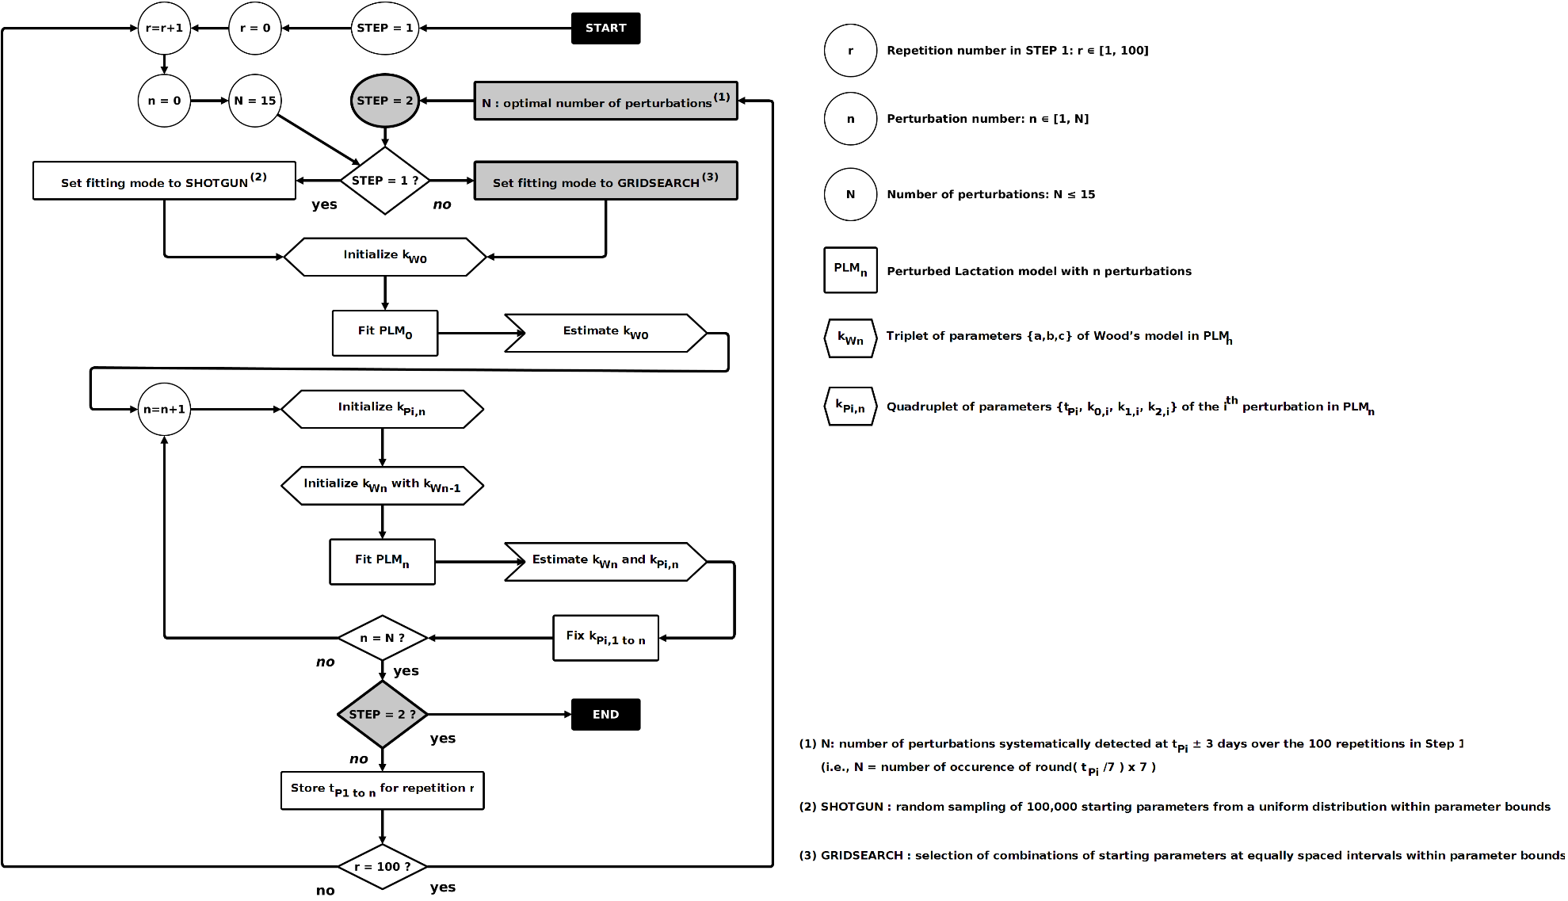
Figure S2. Two-step algorithm for PLM fitting data of one lactation

Figure S3 Dairy goat data set: daily milk time series data over lactation (n=319 goats, 80773 records) by breed (a: Alpine and b: Sannen) and parity (primiparous in red and multiparous in blue).

b)
a)
Figure S4 Example of the perturbed lactation model fitting procedure result on a dairy goat lactation dataset. a) The fitting results on goat lactations exhibiting the minimum values for the Root Mean Square Error (RMSE) (0.11kg). b) The fitting results on goat lactations exhibiting the maximum values for the RMSE (0.41kg).

Figure S5 Changes of the Wood's parameters (a, b and c) during the detection of the 15 perturbations of the PLM first step for the 319 goats studied. Each red line represent the result mean of the repeat of the 100 times fitting sequence with the ‘shotgun search’ and n_{max} = 15.

Material S1 Fitting Procedure
PLM is aimed at detecting perturbations in milk yield time-series data and thus, provide estimates of (1) a theoretical unperturbed lactation curve and (2) the number, timing and shape of the perturbations leading to the observed perturbed lactation curve. A dedicated algorithm was developed in R (R Core Development Team, 2018) with the aim of fitting PLM on lactation data and deriving parameter estimates$a,b, and c$to characterize the unperturbed lactation curve, $n$ to define the number of perturbations and parameter estimates $\left({t_{P}}_{i}{, k}_{0,i},k_{1,i}, and k_{2,i}\right)$ for each i^{th} detected perturbation. Preliminary tests have shown that repeated fittings using different starting values can lead to the detection of perturbations differing in total number and detection order. This raised the question of the theoretical identifiability of the model parameters (for further details on identifiability see Muñoz-Tamayo et al., (2018)) and of the use of a stop criterion to estimate$n$. The structure of the model does not allow a classical identifiability analysis to be performed if n is unknown. However, by using the software DAISY (Differential Algebra for Identifiability of Systems (Bellu et al., 2007), we could assess that for one perturbation the PLM parameters are locally identifiable. To facilitate the identification of the model parameters, we adopted a fitting strategy in two steps: first, performing numerous repeated fittings to estimate the most frequent number of perturbations. In the second step, we fixed as known the number of perturbations detected in step 1 and proceeded to estimate the remaining parameters of the model. This strategy ultimately makes it possible to estimate an optimal number of perturbations and facilitates the estimation of the model parameters.
In the following section, ${PLM}_{n}$ stands for PLM with $n$ perturbations, ${k_{W}}_{n}$ stands for the triplet of parameters $\left(a, b, c\right)$ of Wood’s model estimated with$n$perturbations ($n$ ranging from 0 to $n_{max}$) and ${k_{P}}_{i,n}$ stands for the quadruplet $\left({t_{P}}_{i}{,k}_{0,i},k_{1,i},k_{2,i}\right)$ of the i^{th} perturbation ($n$ ranging from 1 to $n_{max}$). Since ${PLM}_{n}$ combines an estimated unperturbed lactation curve and n perturbations, ${PLM}_{n}^{*}$ stands for the unperturbed lactation model (i.e., the lactation curve when the n perturbations are removed). ${PLM}_{0}$ (i.e., PLM with zero perturbation) corresponds to the original Wood’s model without any perturbation.
The nls.multstart package (version 1.0.0; Padfield and Matheson, 2018) performing non-linear least squares regression with the Levenberg-Marquardt algorithm and with multiple starting values was used for each single fit. Two different sampling schemes of starting parameters were used: random sampling of starting parameters from a uniform distribution within the starting parameter bounds or selection of combinations of starting parameters at equally spaced intervals across each of the starting parameter bounds. These two fitting methods are hereafter referred to as ‘shotgun search’ and ‘gridstart search’ respectively. Starting parameter bounds are defined as follows: $a$: $\left]0;100\right]$; $b$: $\left]0;1\right]$; $c$: $\left]0;1\right]$; ${t_{P}}_{i}$: $\left[t_{0};t_{3}\right]$(where $t_{0}$ and $t_{3}$ are the times of first and last records of the dataset); $k_{0,i}$: $\left]0;1\right]$; $k_{1,i}$: $\left[0;10\right]$;$k_{2,i}$: $\left[0;10\right]$. For the ‘shotgun search’, the number of random combinations of starting parameters was set to 100 000. For the ‘gridstart search’, the number of combinations of starting parameters (i.e., the size of the grid), was set to five for parameters$a$,$b$,$c$,$k_{0,i}$,$k_{1,i}$,$k_{2,i}$and to 10 for the parameter${t_{P}}_{i}$. Consequently, for the fit of one perturbation (i.e., estimating 3 + 4 = 7 parameters) the number of tested combinations of starting parameters was 7⁶ x 10 = 1 176 490. For both search methods, the best model was selected on the basis of the lowest Akaike Information Criterion (AIC) score (Akaike, 1974).
The whole fitting procedure includes repetitions of a fitting sequence that proceeds by successive addition of perturbations. This fitting sequence is defined in such a way that the estimate of the parameters of each new perturbation is obtained while the parameters of the previously added perturbations are kept fixed. Therefore, the fitting of ${PLM}_{i}$provides parameters estimates for the new added i^{th} perturbation and for a new version of Wood model’s parameters ${k_{W}}_{i}$ (i.e., each time a new perturbation is added, a new version of the unperturbed lactation is refined). For a given lactation dataset composed of daily milk yield records, the preliminary fitting of ${PLM}_{0 }$(i.e., the original Wood’s model without any perturbation) was first performed to estimate${k_{W}}_{0}$. Then, the fitting sequence starts by the fitting of ${PLM}_{1}$(i.e., PLM with 1 perturbation) thus providing estimates ${k_{W}}_{1}$and${{ k}_{P}}_{1,1}$. Then, the fitting of ${PLM}_{2}$consists in estimating ${k_{W}}_{2}$and ${k_{P}}_{2,2}$with ${k_{P}}_{1,2}$ fixed equal to${{ k}_{P}}_{1,1}$. Then, the fitting of ${PLM}_{3}$ consists in estimating ${k_{W}}_{3}$ and ${k_{P}}_{3,3}$ with ${k_{P}}_{1,3}$ and ${k_{P}}_{2,3}$ fixed equal to ${k_{P}}_{1,2}$ and${{ k}_{P}}_{2,2}$, respectively. The procedure is applied stepwise until the maximum number of perturbation $n_{max}$ is reached. This maximum number is an a priori user defined value to fix a stop criterion. Preliminary tests have shown that setting$n_{max}=15$ was sufficient. The end of the fitting sequence consists in reordering the $n_{max}$ detected perturbations in decreasing order according to the time of perturbation ${t_{P}}_{i}$ (the original obtained order of perturbations is based on the opportunities found by the fitting procedure to improve the goodness-of-fit for each added perturbation).
Finally, the whole fitting procedure is carried out following the 3 following steps:
Step1: Repeat 100 times the fitting sequence with the ‘shotgun search’ and${ n}_{max}=15$.
Step2: Compare the fitting results of the 100 repetitions obtained in Step1 and identify perturbations systematically detected at ${t_{P}}_{i}$± 3 days. This was performed by counting, for the 15 perturbations over the 100 fitting results, the number of occurrences of the rounded value${{ t}_{P}}_{i}^{*}=round\left({{t_{P}}_{i}}/7\right)∙7$. Step1 provides the optimal number of perturbations denoted $N$(i.e., the value of n giving the best fit) with an estimate of ${t_{P}}_{i}$ for each perturbation (calculated as the median of the${{ t}_{P}}_{i}$with the same rounded value${t_{P}}_{i}^{*}$).
Step3: Perform the fitting sequence with the ‘gridstart search’, with $n_{max}=N$ and with starting parameters bounds for each ${t_{P}}_{i}$ reset to$\left[{t_{P}}_{i}-10 ;{t_{P}}_{i}+10\right]$. This last fit provides the final estimates ${k_{W}}_{N}$ and $\left({k_{P}}_{1,N},…,and {k_{P}}_{N,N}\right)$ characterizing respectively the best fit for the unperturbed model and the $N$ detected perturbations.

References
Akaike, H., 1974. A new look at the statistical model identification. IEEE Transactions on Automatic Control 19, 716–723.
Bellu, G., Saccomani, M.P., Audoly, S., D’Angiò, L., 2007. DAISY: A new software tool to test global identifiability of biological and physiological systems. Computer Methods and Programs in Biomedicine 88, 52-61.
Cobby, J.M., Le Du, Y.L.P., 1978. On fitting curves to lactation data. Animal Science 26, 127-133
Dhanoa, M.S., 1981. A note on an alternative form of the lactation model of Wood. Animal Science 32, 349-351.
Muñoz-Tamayo, R., Puillet, L., Daniel, J.B., Sauvant, D., Martin, O., Taghipoor, M., Blavy, P., 2018. Review: To be or not to be an identifiable model. Is this a relevant question in animal science modelling? Animal 12, 701–712.
Padfield. D., Matheson, G., 2018. nls. multstart: robust non-linear regression using AIC scores. R package version 1. https://cran.r-project.org/package=nls.multstart
Wilmink, J.B.M., 1987. Adjustment of test-day milk, fat and protein yield for age, season and stage of lactation. Livestock Production Science 16, 335-348.

This is the dataset and R functions of the data analysis and modelling procedure to quantify and phenotyping milk production with an explicit and systemic representation of perturbations. Perturbed Lactation Model (PLM) incorporates an explicit representation of perturbations and convert individual raw time series data into biological meaningful parameters. It is easier for animal scientists to work on these parameters than it could be with purely mathematical parameters. The model therefore facilitates findings on individual variability. For detail description of the procedure please search for the article with the same title.

