Task 1: Local Repository Setup

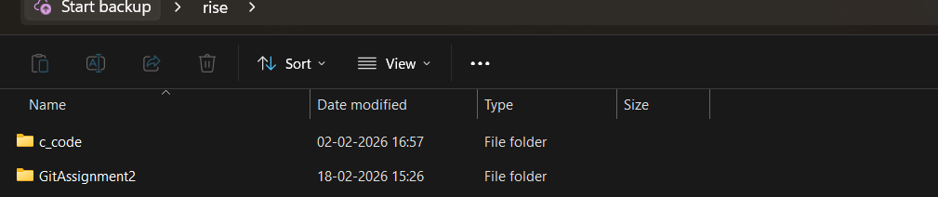
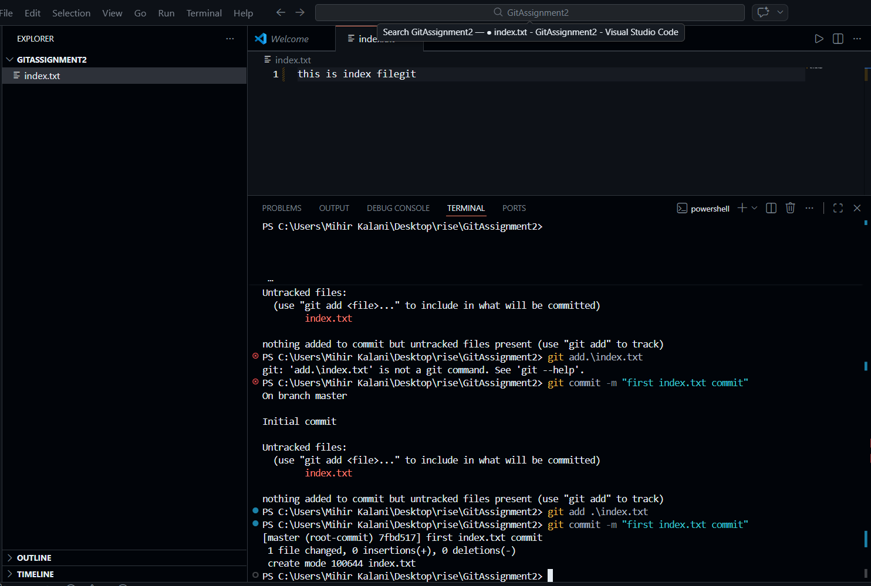

Task 2: Remote Repository Creation

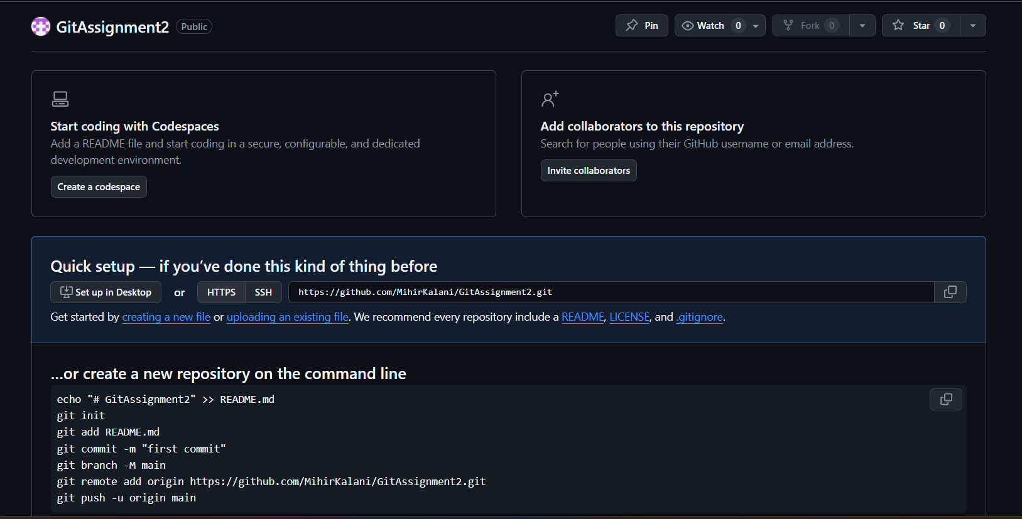

Task 3: Connect Local Repository to Remote

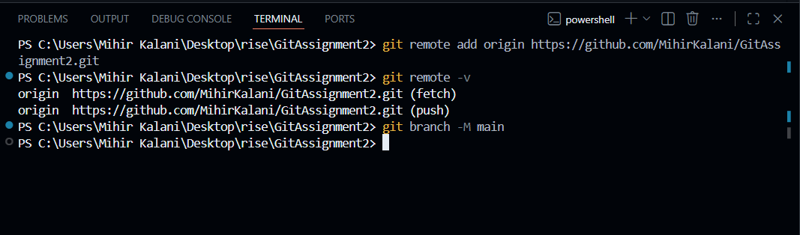

Task 4: Push Local Changes to Remote

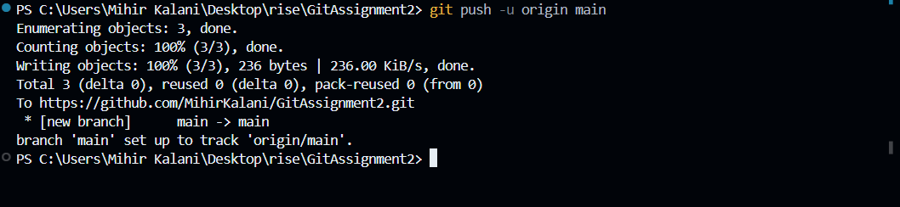

Task 5 Branch Creation and Work
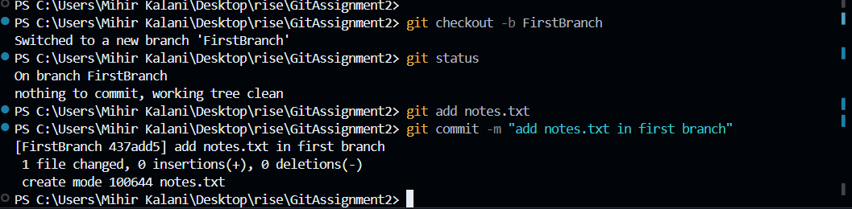


TASK 6: Merge Branch into Main

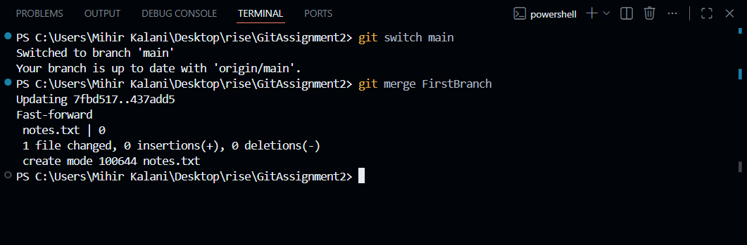

TASK 7 – Final Sync with Remote

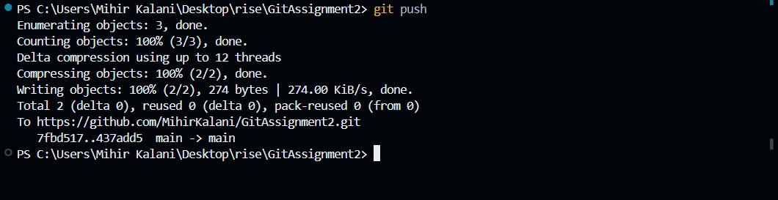

TASK 8 – Simple Pull

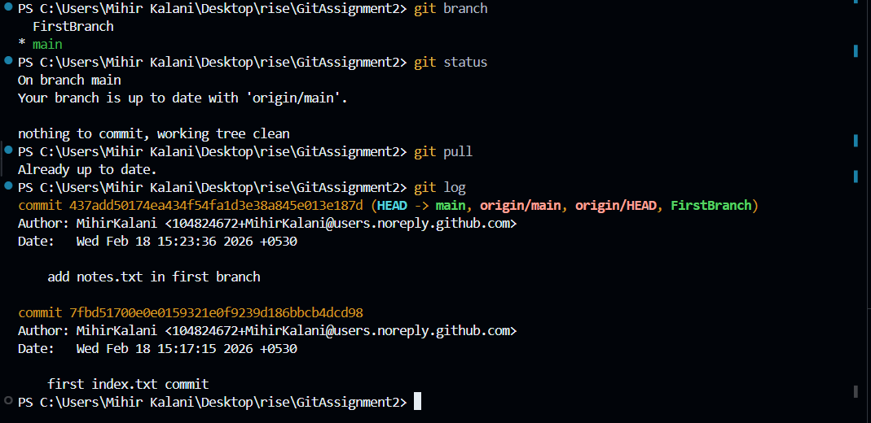

TASK 9 – Push and Pull with Conflict Resolution

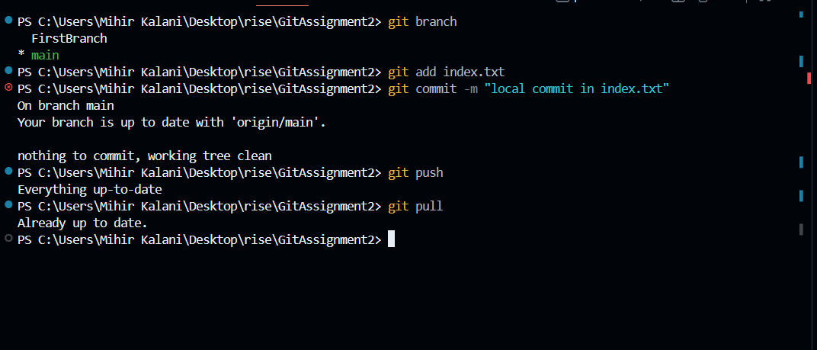

TASK 10 - Clone an Existing Repository
