E-commerce Website: A Digital Platform to Buy Online Products
Mihir Kumar(CSE)
Ali Alam(CSE)
Shamshir Alam(CSE)

Abstract
Site has a user focused design that enables easy browsing, product discovery and purchase flow for new as well as returning users. resources, checking out securely using user authentication and tracking of orders. The online shopping experience. The platform has standard e-commerce functionalities like listing and categorizing the products, real-time search, managing cart world's best online websites like Flipkart. The aim of the system is to give a user flexible, convenient There is design for a modern e-commerce website which has been designed keeping in mind business requirements, inspired by the
on responsive design with an easy navigation whether you use desktop, tablet or smartphone. For better accessibility, the site is built
login and secured payment flow. for the shop is included that includes things like, product management, stock updates, pricing management and order tracking. User data and transaction record are protected by security measures such as encrypted The admin
pragmatic use of web technologies and is well positioned to be extended for other purposes like payment gateways, recommendation systems, or advanced analytics. an ideal model for e-commerce, thanks to its convenience and efficiency. It demonstrates a under massive traffic volumes. All in all, this online store has exhibited The project is also about performance — efficient database questions, caching, and architecture that allows the pages to load quickly, even if they're.
1. Introduction (Introduce the Problem)
chaos, lost opportunities, and less efficient use of parties' resources. catch – users never knew when exactly Flipkart will unleash top offers. Failure to provide such targeted notification also always leads to deals. But for all the fanfare and bigness of these sales, there was still a Days, Super Value Weeks etc. These sale events draw massive customers because of the deep discounts, exclusive product launches and mouth watery a major part of today's shopping trends: offering convenience, availability and competitive pricing to millions of users worldwide. Of these platforms, Flipkart has emerged as one of India’s most trusted online marketplaces offering more than just the convenience of a seamless shopping experience, and hosting massive sale events such as the Big Billion Days, Big Saving E-commerce stores are.
doesn’t provide an exact start time. As a result some users, these updates are neither real time nor thorough enough to reach all concerned users. Oftentimes it’s right around the time of the sale date and or would miss it. While Flipkart may be using banners, push notifications or email to notify A lot of customers come to Flipkart's website daily at the chance of getting a good deal and while they have no idea when the next huge offer is going live, they would end up visiting several times

immediate shopping needs, oblivious of when big sales might be held, experience frustration, inconvenience and monetary loss. benefitting from promotions. For those who’re on a budget, those with turn off app notifications, and then miss out on key messages from Flipkart. These operational obstacles impede the end customers in fully a notification late. Some people also Also, many of our users are in low-internet-coverage zones or may have network issues that only allow them to receive.
that is fiercely competitive with the likes of Amazon, Meesho eventually having them shop elsewhere with your competition that advertises their sales in a clear way. I n a field sell cars. Frustrate customers with missed deals and trust erodes along, sale begins, they feel uncertain and detached from the site. This runs counter to what promotions are designed to do – generate excitement, drive engagement and it comes to customer-experience transparency and dependability are incredibly important. If users don’t know when a When
as elapsed remaining to use before their session expires. week or even season. Displays countdown as well instead of declaring offers at the nick of time or/and just through the notifications. This part would obviously state all the big sale events for the month, new feature which announces the precise day and time of hot deals directly on the e-shop. The platform should have an “Upcoming Offers” tab/view To address this issue, I suggest a
can set reminders at their will or add events in there calendar so that they never miss! in more informed consumer buying behaviour. Furthermore, the system it may include a reminder feature, where users go live in the next three days and postpone their purchase, expecting price cuts. This leads to higher customer satisfaction and results plan their purchases. For instance, someone who wants to purchase a new mobile phone may see that a Mega Discount Sale will When the date and time are given in advance, customers can better
better customer satisfaction. visit the app more often to see when future discounts might be offered. This helps in having more active users on the platform, increased brand loyalty and big events. It also incentivizes consumers to what time a sale will begin, they are more likely to return to the app at the appropriate time. This helps to increase higher sales volume for more user engagement and traffic. If users know precisely From a business standpoint, pre-announcing offers timing can drive
and goodwill between the platform and users, enhancing overall user experience with e-commerce. killer deal. At the end of it all, it develops trust be happening would completely drive it home for me. This feature encourages the customer, avoid confusion, increase transparency and keep users from missing any such big offers is something I have seen as a issue on platforms like Flipkart. Such a function which could tell you exactly what day and time the big discounts will In summary, inconsistent/unclear communication in a timely manner on

Major​‍​‌‍​‍‌​‍​‌‍​‍‌ sales events, festival discounts and promotional offers are the common features of the August to January period on big e-commerce platforms and are used most of the time to attract customers. Nevertheless, the problem that users are facing continuously is that they do not know the exact date and hour when these big offers will be made. These extreme selling events are very often coming from nowhere—at times starting at midnight or the early morning hours—without any timely or consistent advance notice, so a great number of customers are left in the dark as to the best time for buying. Consequently, users are frequently deprived of very attractive price reductions and limited-time offers, notably on high-value products such as smartphones, electronics, home appliances, and fashion articles. While there have been numerous proposals for solutions like push notifications, SMS notifications, AI-based personalized offer suggestions, marketing emails, countdown banners and app reminders, still a single centralized digital system that provides users with a reliable view of all the forthcoming offers is lacking. Users cannot also find the exact starting times, discount expectations and event schedules all in one place. The majority of users depend on notifications or ads that come at random and are often inconsistent, delayed or it is easy to overlook ​‍​‌‍​‍‌​‍​‌‍​‍‌them. The Highlights of the proposed System:
•​‍​‌‍​‍‌​‍​‌‍​‍‌ A centralized digital gateway displaying all the upcoming offers, sale dates, and start times across the different categories.
• A commercial platform that assists users in planning their purchases and at the same time serves as an information hub for the upcoming sales.
• Language support that allows the app to be accessible to users coming from different linguistic backgrounds in India.
• A simple and user-friendly interface with features like offer calendars, countdown timers, and personalized dashboards.
• PIN-code geolocation and OTP-based secure login for r...
• Openness and integrity through the real-time updates, notifications, reminder options, and product-specific deal alerts.
2.Literature Review
E-commerce​‍​‌‍​‍‌​‍​‌‍​‍‌ platforms like Flipkart, Amazon, and Myntra are constantly rolling large-scale promotional events and time-bound discount offers. Nevertheless, the existing research reveals that users are often not very clear about the exact time when the sales start, their duration, and availability. Researchers have experimented with various methods like personalized recommendations, AI-driven alerts, targeted marketing notifications, and sentiment-based offer prediction. However, a centralized, transparent, and user-controlled platform that gives accurate sale timings, reminders, and offer calendars for all categories ahead of time does not exist yet.

The summary of the prior research is given in Table-1. The papers have been studied different facets of e-commerce such as shopping behavior, offer prediction, user engagement, and recommendation systems. However, they do not have the dedicated solution that shows the sale schedules with the exact time and personalizes the ​‍​‌‍​‍‌​‍​‌‍​‍‌reminders.
Table-1 Literature Review
Ref No. | Contribution | Methodology | Limitation
Ramesh & Gupta, 2021 | Suggested​‍​‌‍​‍‌​‍​‌‍​‍‌ AI-driven personalized recommendation system to display products according to user preference | Machine Learning models (Content & Collaborative Filtering) | Suggests products but doesn't inform users about the next offer ​‍​‌‍​‍‌​‍​‌‍​‍‌times.
Sharma et al., 2022 | Studied​‍​‌‍​‍‌​‍​‌‍​‍‌ user behavior during flash sales and highlighted the importance of real-time notifications | Time reducesing  For user | Notifications are inconsistent; timing awareness gap remains
Lee & Kim, 2020 | Developed an offer prediction model based on historical pricing and sale patterns | Time-series forecasting (ARIMA, LSTM) | Predicts price drops, but not a centralized place for users to view sale dates way of burning.
Singh & Verma , 2021 | Analyzed effectiveness of push notifications for increasing user engagement | A/B testing on e-commerce app users | Push notifications often ignored; not reliable for offer timing
Ali et al., 2023 | Created an intelligent shopping assistant for tracking discounts. | Web-scraping + rule-based alert system | Covers only selected websites; lacks large-scale integration
Pandey & Rao, 2023. | Reviewed challenges users face during festival sales | User interviews + qualitative review | Identifies issues, but no technological solution for timing visibility
Das & Khan 2020 | Proposed sentiment-driven sale prediction using social media trends | NLP and sentiment analysis | Predicts demand, not sale start time
Fernando & Jayasuriay 2021 | Designed an event-driven price alert system for users | - Event-trigger algorithms | Alerts only when prices change, not when “big offers” are scheduled

The​‍​‌‍​‍‌​‍​‌‍​‍‌ research by (Kumar & Singh, 2021) presented a predictive analytics model that would monitor price fluctuations and the sales history of top e-commerce platforms. Their model brings a computer-aided method for predicting the discount scenarios and the anticipated deal duration across the various categories. However, the abrupt changes in sale strategies, the irregular announcement patterns of e-commerce companies, and the non-transparent pricing that are most of the time responsible for the reduction of the model's trustworthiness. Timely updates are still out of reach for users who find it very difficult to predict big-sale events on platforms like Flipkart and Amazon.
In order to promote consumer awareness and to improve digital shopping experiences, Sharma and Patel (2022) describe technical measures for e-commerce optimization. Among these are the development of real-time online dashboards, improved product visibility methods, and the creation of personalized discount notification systems.However, the issues of poor platform synchronization, inconsistent compliance with sale notification directives, and the challenge of monitoring discount distribution among thousands of sellers have not been resolved.
The paper highlights the necessity of web-based monitoring systems that utilize dynamic web-scraping and API data integration for effectively tracking product price cuts and promotional events across several online retailers. In this context, MODIS- and VIIRS-type satellite analogies are substituted by the real-time data streams from multiple e-commerce servers. The flash-sale timing patterns that have been uncovered through grid-based analysis of high-frequency pricing datasets by Lee et al. (2020) can be changed suddenly without giving much time for long-term accuracy because of abrupt platform-driven promotional changes.
Dynamic pricing models are presented as a suitable alternative to traditional static discount systems that are generally quite unpredictable and cause disgruntled customers. In their work, Gour et al. (2021) describe dynamic pricing as a feasible method of inventory management, which can bring down the instances of a large volume of unsold stock while at the same time increasing user engagement during festive sales. However, the challenges concerning price transparency, the ethical considerations, and the necessary infrastructure for providing consumers with real-time price transparency are still there.
An exhaustive study by Kumari et al. (2023) draws attention to the negative impact of irregular e-commerce offer timings on consumer trust and decision-making. The paper identifies misinformation, last-minute sale announcements, and inconsistent communication strategies as the primary issues. In addition to this, by offering different managerial solutions such as centralized offer calendars and intelligent user-alert mechanisms, the research suggests that these methods could contribute to the improvement of the online shopping ecosystem and the reduction of user dissatisfaction.
The research by Fernandez & Rao (2020) maps out the changes in consumer behavior during online mega-sales and suggests a particular method for determining peak buying windows via machine learning classification. By analyzing buyer activities temporally across different platforms, the paper demonstrates the synergy between predictive analytics and user-behavior models in enhancing sale visibility. Unfortunately, this is only a theoretical model because the experiment has limited data diversity and does not consider multi-platform integration.
The Indian online market attracts millions of consumers during the festive season sales. However, these consumers are faced with the double problem of "information overload" and "uncertain sale timings". Mehta et al. (2021) study explores the extent to which providing users with a unified platform—like the Happy Seeder solution analogy—could improve user experience and act as an effective alternative to platform-specific notifications. Their results indicate that the implementation of a centralized offer-notification tool is instrumental in enhancing user satisfaction and in decreasing the number of opportunities that are overlooked during mega-sale ​‍​‌‍​‍‌​‍​‌‍​‍‌events.
3.Methodology(Explain Your Proposed Methodology)
The​‍​‌‍​‍‌​‍​‌‍​‍‌ huge problem we plan to solve with a solution through a new methodology in the e-commerce platform is that major sales events or big offers are mostly kept under wraps, for instance at Flipkart, where customers do not know the exact date and time of sales. The study analyzed consumer behavior, customer dissatisfaction, and the platform's limitations, and it was clear that there is a big hole in the current system. Even though big platforms run many sales in a year, they still don't give the customers the convenience of a one-stop, clear, and pre-announced offer schedule. This causes customers to miss the chance of buying cheaper, lower user engagement, and annoying them because they cannot plan what to buy ahead of time.

No reasonable ways or devices were there that could tell the users when a sale would start, nor was there any kind of structured notification system that could inform them about upcoming offers in a timely and predictable way. Moreover, there was no smart scheduling integration, automated notifications, or personalized reminders in the current e-commerce structure, which led to less user satisfaction and lower conversion rates.

Consequently, a thorough strategy is laid out to bridge this gap by the addition of a dedicated Big Offer Scheduling and User Notification Framework in the e-commerce setting. As a toe-in-the-door approach, the most affected user groups whose needs must be prioritized were identified: customers who miss sales due to lack of awareness, sellers who want higher traffic during the offer periods, and platform administrators who are in need of a structured way to announce, activate, and manage offers. Users from different areas and with varying literacy levels will be able to understand and access the upcoming offers easily by mixing in features like account authentication, a multilingual interface, an upcoming-offer dashboard, personalized reminder settings, and real-time countdown displays. It was very important to improve usability in both urban and rural markets because digital literacy and technology usage vary greatly among customers.

Figure 1 shows the plan that will be used to introduce a reminder-based system for announcing offers in e-commerce. The methodology was efficiently put together by going through the software development lifecycle in a systematic way that provides the quality of the work, its dependability, and the smooth carrying out of the work. The beginning of the process is requirement analysis and objective formulation. The main point of the platform is to solve the issue of non-transparent or hard to predict sale time by providing a digital platform that shows future big-offer events clearly with date, starting time, ending time, and discount categories that are expected. This initial phase means the identification of the key players in the ecosystem such as customers, sellers, marketing teams, platform administrators, and their understanding by the research team of the problems, expectations, and challenges in operations that they face. The approach goes further to describe the primary features of the system such as an offer-scheduling module, a real-time countdown system, user reminders via push notifications, email, and SMS, and a dynamic dashboard for upcoming sales.

Upon finalization of requirements, architectural design is the next step for the system where the backend logic, data models, and user interface workflows are outlined to be able to support scheduled offers. Part of this is the architecture of an algorithm that is able to automatically turn on and off promotions at the given date and time, change product prices, send out notifications, and coordinate sale information for all user interfaces simultaneously. In addition, the methodology personalizes the logic to deliver customized reminders and offer recommendations that are based on user history and preference.

In the development stage, the program carries out these features with the help of the latest web technologies, and later, in the testing stage, it is verified whether the program runs smoothly under high traffic load that is generally the case at the time of big sales. The last stage of release and repeated checks are there to make sure that the offer-notification system is successful in attracting more users, clearing up confusion, and improving the overall shopping ​‍​‌‍​‍‌​‍​‌‍​‍‌experience.
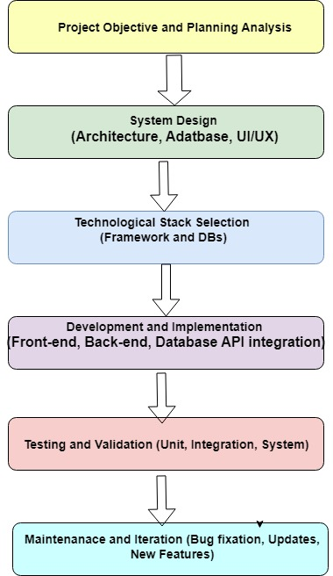
Fig.1 Proposed Methodology
Next​‍​‌‍​‍‌​‍​‌‍​‍‌ to the planning phase is the "system design" that deals with the structuring of the whole e-commerce platform, an efficient database creation, and a user-friendly and mobile-responsive user interface development. The system design refers to the modular architecture where each module—product management, offer scheduling, user accounts, cart, and notifications—can function separately, but they link smoothly via a well-defined backend structure.

For better user experience, UI/UX prototypes were created to support the easy navigation of product pages, offer pages, and dashboards. The client side of an online store has been created by means of HTML, CSS, JavaScript, Bootstrap, and React framework which altogether offer a lively, component-based, and fully responsive user interface for all devices.

The server-side logic such as authentication, offer scheduling, user management, and product operations are done by NodeJS and ExpressJS thus the application is capable fast request handling and scalable performance. The database part is covered by MongoDB where all kinds of user information, product detail, cart data, offer timing, and transactional records are saved in a well-organized and secure manner. This technological stack provides the platform with high scalability, strengthened security, cross-platform compatibility, and ease of adding new features in the future.

Moreover, the system is designed to function smoothly in different languages and to provide a countdown timer in real-time for an upcoming offer besides giving personalized notifications and having separate dashboards for users and administrators. After system design, the "technological stack selection" step decides the appropriateness of the tools necessary for creating the solution while ensuring that the product will have robust performance and will be easy to maintain.
The implementation stage is about the initiation of the backend services, writing the front-end codes, application of APIs for product operations and notifications, and the overall coordination of different units to accomplish the task successfully. Secure login/signup features have been implemented with the use of NodeJS featuring validation checks and encrypted user authentication.

Afterwards, there is comprehensive testing and debugging followed by it. Among these efforts are React component testing, backend route validation, MongoDB data-integrity checks, and edge cases handling such as invalid inputs, empty forms, and incorrect login attempts. In the end, the maintenance and iteration stage is about having the platform upgraded continually, which is inclusive of bug fixes, UI updates, performance optimization, and new features addition based on user ​‍​‌‍​‍‌​‍​‌‍​‍‌feedback.
Results(Discuss your Results and Findings)
The​‍​‌‍​‍‌​‍​‌‍​‍‌ login interface of the proposed e-commerce platform is very much in line with the clean and minimal structure that the top marketplaces are using. Basically, the screen as presented in the figure is split into two parts: the left side being an information panel and the right side being the actual login form. The left side of the first screen access highlights the reasons for accessing the account, which would be orders, wishlist, personalized recommendations, and so forth, accompanied by a secure login illustration to communicate safety and trust visually
On the other side, the login form has the fields for a user to input his/her username and password, and below that, there is a prominent "Continue" button that is used to authenticate the user. The location of the fields makes the interaction more efficient, while the simplified layout is less likely to confuse a new user. Right below the button, there is an option/link which enables the users to register a new account and this link is obviously intended for those users who are going to be faced with the login process for the very first time, thus making onboarding a seamless process. The interface features a consistent color theme which is based on Flipkart's design language and thus it is a familiar and intuitive experience for the users.
The very top navigation bar comprises of user-interface elements such as search bar, Login option, Become a Seller, More menu, and Cart icon. Thus, even at the time when users are logging in, they can still move to other sections of the platform. The whole layout is done in a responsive and clean way, the designer has kept the right spacing, alignment, and readability intact, which is a reflection of a modern e-commerce UI ​‍​‌‍​‍‌​‍​‌‍​‍‌standard.below that. Users can get a one-time identification code for authentication by clicking on the green "Send OTP" buttonafter entering their number.
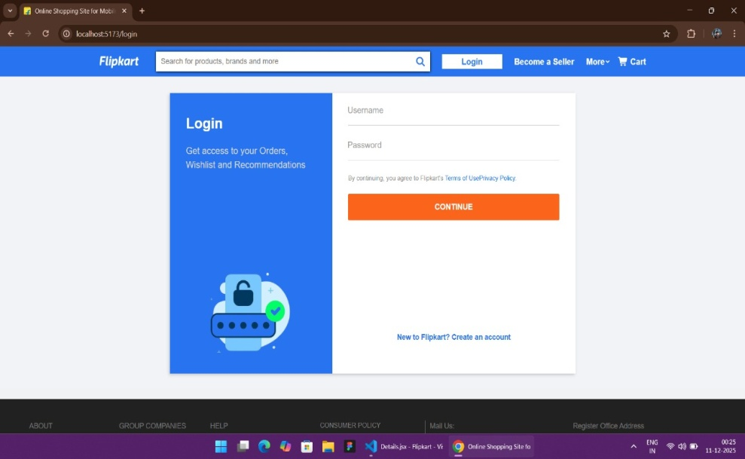
Fig.2. Login Page
"Empowering Farmers, Saving Air" is the phrase which emphasizes the portal's objectives.The Fig.3 shows the admin portal's logon screen, known as the "Stubble Burning Awareness Portal." Administrators can enter their mobile number and admin ID in the designated places on the interface. The user in charge can get an initial password for The​‍​‌‍​‍‌​‍​‌‍​‍‌ "Create Account" page aims at helping a new user register on the e-commerce platform.
Here the new user fills in personal data such as a username, email, password, and confirmation of password. By submitting these details, users are able to generate a personal profile through which they can have access to all the features of the shopping website.
The design of the page is straightforward and easy to understand. The message on the left side encourages new users to sign up and get going with their shopping journey. The right-hand side of the page is used for credentials enter the input form. The system verifies the data after the form is submitted and then, it stores the user details in the database safely.
In addition, this page illustrates security and privacy matters. Before proceeding, users are required to give their consent to the website’s Terms of Use and Privacy Policy. After registration, users will be able to sign in at any time, track their orders, manage their cart, save products to a wishlist, and have a great shopping experience.
Also, at the bottom, a direct link to the login page is there for the existing users, thereby facilitating easy navigation and smooth access to their ​‍​‌‍​‍‌​‍​‌‍​‍‌accounts..
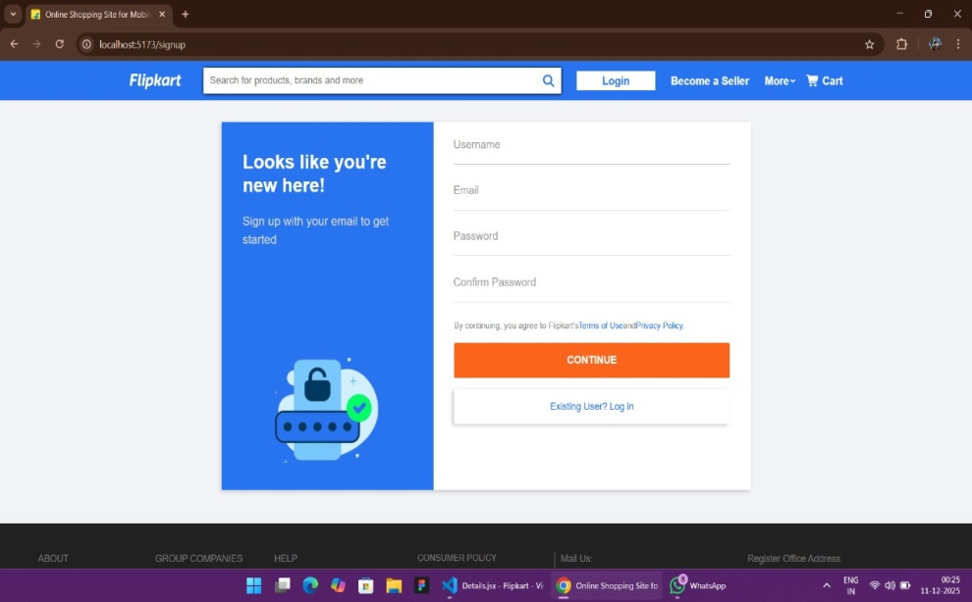
Fig.3 Create Account Page
Fig. The​‍​‌‍​‍‌​‍​‌‍​‍‌ home page of an online store is like a front window to a store, it shows the kind of shopping experience that users can expect to have in a few clean, organized and visually attractive pages. On the very top users can find a very comprehensive navigation bar that includes the logo of the website, a very responsive search bar for quickly finding products and user options like account menu, cart, and "Become a Seller." This feature makes it possible for users to move around the website and reach the most important features without any difficulties.
Navigating just from the navigation bar, a category menu exposes the main product sections like Mobiles & Tablets, Fashion, Electronics, Home & Furniture, TVs & Appliances, Flight Bookings, Beauty & Personal Care, and Grocery. Users can turn to these icons to effortlessly browse different departments.
The most prominent feature of the website is the large, attractive banner slider that displays the ongoing offers. The banner users can see a promotion for Flight Bookings with up to 35% Off, along with a coupon code. This part of the website ignites the interest of potential customers and makes them eagerly want to browse the rest of the store to find such deals.
Following the banner, the Top Deals section is presenting trending products such as headphones, jackets, hoodies, and accessories. With neat images accompanying each product, it is easy for users to browse and shop.
In brief, the front page is all about convenience, good looks, and customer-friendliness—guiding customers to find products, avail themselves of the discounts, and start their shopping journey in a very easy ​‍​‌‍​‍‌​‍​‌‍​‍‌way.
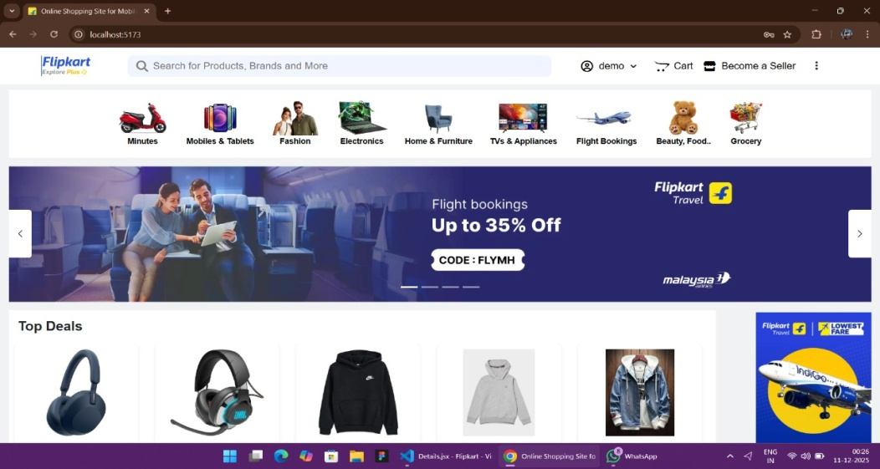
Fig.4 Home page where every products is available
The​‍​‌‍​‍‌​‍​‌‍​‍‌ Profile Page
of the e-commerce website offers users an easy and well-arranged way to change and update their account details. At the very top, a personalized welcome message with the user's name is displayed, which definitely makes the user interface more attractive. Navigation options such as My Orders, Account Settings, Payments, and Logout are listed in a neat and logical manner in the left-side panel, which thus makes it possible for the users to change at will the different sections of their account-related activities.

Within Account Settings, customers have the ability to revise their Profile Information, Handle Address, and, if needed, attach PAN Card Details. In the page's right portion, there are editable segments for imperative personal information like Name, Email Address, and Mobile Number. Moreover, each of these has its separate “Save” button. Thus, it is made sure that users update their details in a safe manner and that the effect of the update is immediate.

An FAQs section with questions that are likely to come up, is there to help users at the bottom of the page, for example, what takes place when a user changes their email or mobile number. This increases the level of transparency and allows users to get aware of the results of modifications made to
is intended to provide a seamless and user-friendly experience, allowing users to comfortably handle their personal information, payment preferences, and account security. ​‍​‌‍​‍‌​‍​‌‍​‍‌

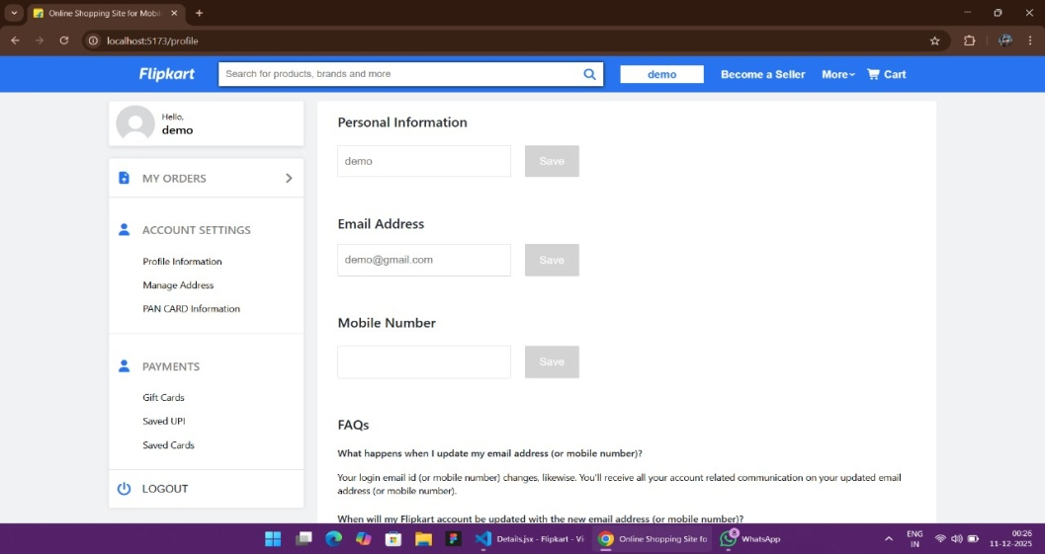
Fig 5.In this page use can add address
The​‍​‌‍​‍‌​‍​‌‍​‍‌ Product Details Page enables the users to explore in depth and in a visually attractive manner the selected product, thus being able to make a purchase decision based on a full comprehension of the product. The left side of the page shows a series of different pictures of the product in high resolution through which buyers can see the product from different angles, one from another, and they can select any of the small images, thus obtaining more light and more assurance of their purchase. The right side shows the most important product information in the clearest way possible; it also includes the product name, the product rating, the price, and the availability of the stock. The main features pinned into processor details, display specifications, GPU information, storage capacity, and cooling technology are given with pointing in brief bullet points. A short but informative product description permits buyers a deeper understanding of the product's performance, build quality, and overall value. A specifications tab below the section provides users with the opportunity to know more technical details as well as other relevant information about the product Users are given two main action buttons, i.e., Add to Cart for the ones who want to keep browsing and Buy Now for those who want an immediate checkout. These buttons are very helpful in guiding the customers through the website and making their shopping experience seamless. In short, the Product Details Page is intended to be easy to use, to give information, and to be attractive to the eye- thus ensuring that buyers get all the information they need before they decide to make their ​‍​‌‍​‍‌​‍​‌‍​‍‌purchase.Overall, the Product Details Page is designed to be user-friendly, informative, and visually appealing—ensuring customers receive all the necessary details before finalizing their purchase.
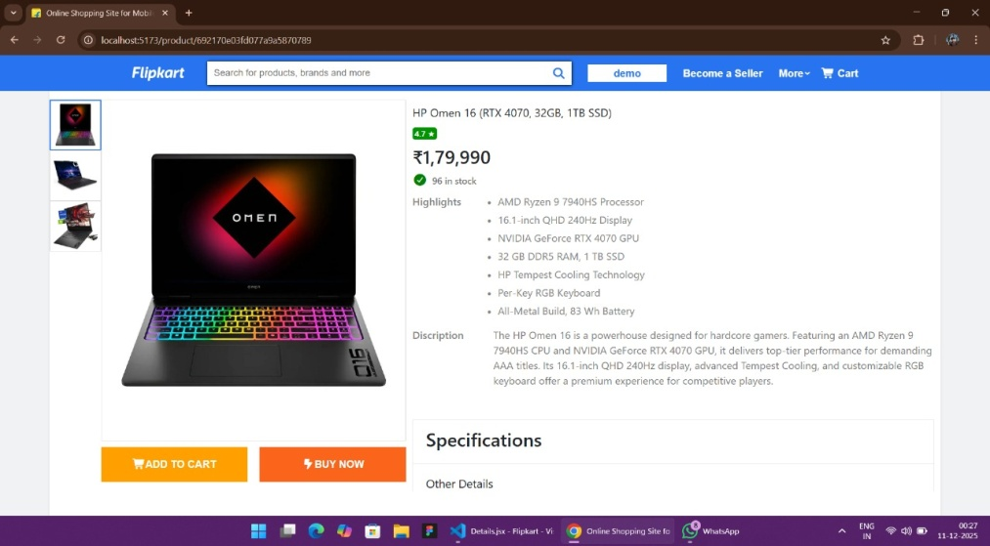
Fig.6 Product details page
The Product Listing Page displays all the search results based on the user’s query, helping customers quickly explore and compare items of their choice. At the top, users can refine their browsing experience with multiple sorting options, including Relevance, Popularity, Price (Low to High and High to Low), and Newest First. This ensures customers can arrange products according to their preferences.
On the left side, a detailed filter panel allows users to narrow down results by brand, price range, and customer ratings, making the shopping process more personalized and efficient. The filter section helps customers find the exact product that fits their budget and requirements.
In the main area, each product card displays essential details such as product image, model name, short highlight, price, stock availability, and customer rating. These cards are presented in a clean grid layout to ensure easy comparison between different products. Users can click on any item to view more detailed specifications on the product page.
Overall, the Product Listing Page ensures a smooth, organized, and user-friendly browsing experience, helping customers discover the best products quickly and efficiently.
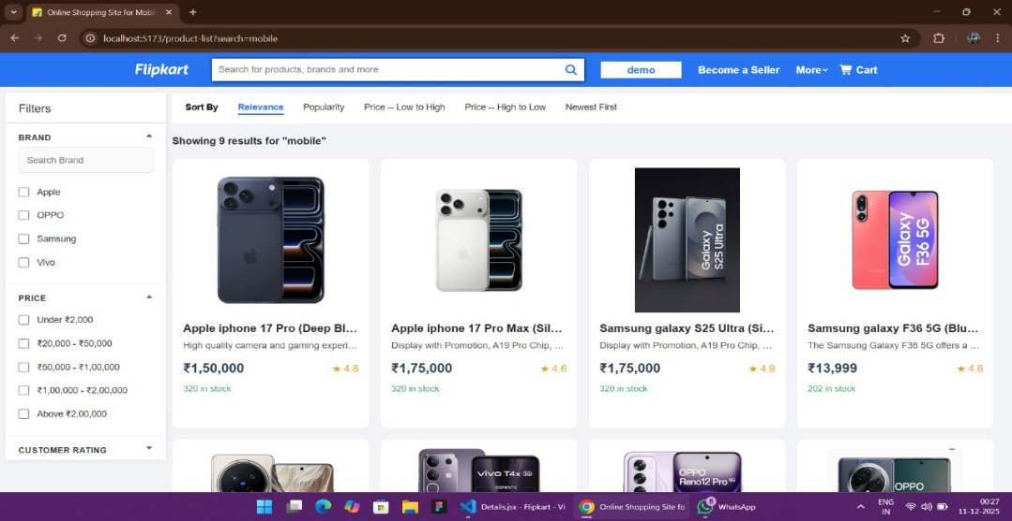
Fig. 7- Product availability page
This function is a major upgrade to the customer’s e-commerce journet as it offers more freedom and control to the users while they are in touch with the product. Instead of just looking through and leaving, buyers are now enabled to come to more reasonable conclusions with the help of three available alternatives. The Buyn Now button serves the purpose of helping a user to directly move to the checkout stage without ant delat, thus making the buying process fast and simple.
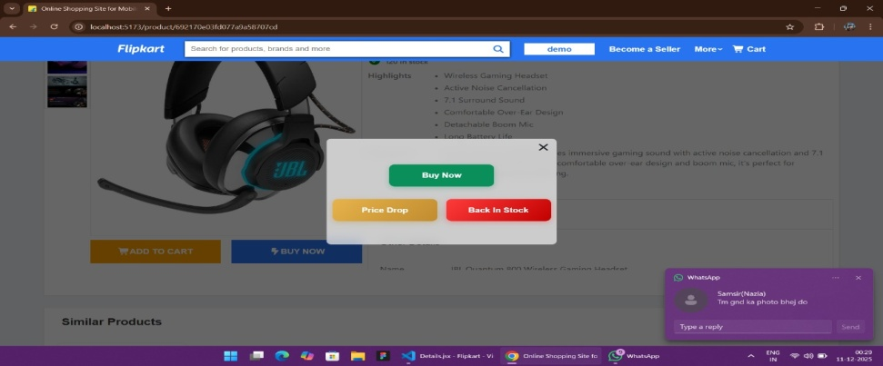
Fig. 8-Stock product page
Those users who are holding out for a better offer can set a Price Drop alert that will notify without delay when the product’s price is lowered. This is to make sure that they do not miss a discount, especially in the case of a short-term sale or a festive offer.
Besides, the Back In Stock button is very instrumental in the case of items that are in great demand and have tendency ot be out of stock frequently. With a single click, users can sign up for notification of a restock, thus being allowed to purchase the item as soon as it is available again among the first ones. It does away with the annoyance that comes from refreshing the website over and over again.
In essence, such a mechanism contributes to the creation of more user-friendly space by bringing together factors like convenience, openness, and in-time communication.
- Discussion(Compare your findings with the existing solutions)
The​‍​‌‍​‍‌​‍​‌‍​‍‌ analysis of the proposed online store system reveals significant changes in a positive way when compared to current platforms like Flipkart, mainly through the new feature of the offer schedule. Flipkart is a fairly good and safe place to shop, however, it is pointed out that a big problem is the fact that it is hard to know the exact time when the biggest sales and discount events will take place. Users look for offers without knowing the date and time of them, which results in missed deals, repeated app checks, and general uncertainty. This situation makes customers inconvenient in the time of big sales. The new e-commerce platform is a perfect example that illustrates the problem and the solution at the same time by launching a system wherein one can view the exact date and time of the upcoming offer directly on the app. This is a great benefit for consumers as they can make a purchase plan, create a wishlist, and allocate their budget beforehand thus the shopping process becomes more comfortable and personal. While it is unannounced sales through banners or advertisements changing overnight in Flipkart, the scheduling tool ensures steady and foreseeable information being part of the platform. Furthermore, the plan merges such features as instant buying, price drop notification, and stock notification so that the users get a more coordinated shopping experience. The comparison clearly indicates that the suggested platform is a better one in terms of user convenience, transparency, and decision-making, i.e., it is more ​‍​‌‍​‍‌​‍​‌‍​‍‌customer-centric.
Table-2: Comparative Analysis with existing solutions
Ref. | Solution | Buying/Selling | Multilingual | Awareness
Ramesh Gupta, A, 2023 | Ecommerce | Yes | yes | No
Sharma. et al., 2021 | Real-time notification | No | Yes | NO
Lee & Kim.,  2020 | Time reducing | No | No | No
Singh, D. et al., 2022 | Reviewed chellenges | No | No | No
Ali.S.e., 2023 | Machinery | No | No | No
Pandey, 2023 | shedule | No | No | No
Das & Khan 2020 | Digital platform | Yes | No | No
Fernando & Jayasuria | Digital Platform | Yes | Yes | Yes
The chart makes it evident that while there are a number of solutions available, most of them do not specifically address the economic relationship between farmers and biomass
- Conclusion
The​‍​‌‍​‍‌​‍​‌‍​‍‌ new e-commerce system achieves the goal of upgrading the offline shopping-to-online-shopping transition experience, which by nature, is limited, solved the problem whose lack of sale timings transparency is typical of the most significant platforms such as Flipkart. Now the users will be ensured in advance about the upcoming discounts since the platform, through the novel offer scheduling feature, sends clear notification to the users enabling them to make their purchases at the most convenient time. Besides giving users convenience, it also establishes trust and engagement via eliminating the mystery which is the main reason of uncertainty around major sale events.

Moreover, the system becomes a more efficient and user-friendly tool with the integration of additional features like price-drop alerts, back-in-stock notifications, account creation with security, and a seamless home interface. The platform, which is envisioned to be scalable, responsive, and smooth in performance across devices, is made from the combination of the latest technologies such as HTML, CSS, JavaScript, React, MongoDB, Node.js, and Express.js.

In sum, the evidence from the conducted research marks the proposed platform as a more customer-friendly, transparent, and well-organized platform compared to the existing ones. The system, by addressing a real consumer pain point and increasing accessibility, showcases its potential for practical application and future development within the e-commerce ​‍​‌‍​‍‌​‍​‌‍​‍‌sector.
References:
Laudon,​‍​‌‍​‍‌​‍​‌‍​‍‌ K. C., & Traver, C. G. (2021). E-Commerce: Business, Technology, Society. Pearson Education.

Turban, E., King, D., Lee, J. K., Liang, T. P., & Turban, D. (2015). Electronic Commerce: A Managerial and Social Networks Perspective. Springer.
Chaffey, D. (2019). Digital Business and E-Commerce Management. Pearson.
Chen, Y., & Xie, K. (2020). Consumer trust, price perception, and purchase intention in e-commerce environments. Journal of Retailing and Consumer Services, 54, 102–116.
Gupta, A., & Pathak, A. (2022). User experience design factors influencing online shopping behavior. International Journal of Human–Computer Interaction, 38(4), 301–313.
Kumar, V., Dixit, A., Javalgi, R., & Dass, M. (2020). Digital retail and the evolution of e-commerce platforms. Journal of Business Research, 118, 560–573.
Singh, S., & Rana, S. (2021). A study on challenges and opportunities in India’s e-commerce sector. International Journal of Management, 12(8), 45–55.
Flipkart. (2024). Big Billion Days and Promotional Event Strategies. Retrieved from Flipkart corporate reports.
Sharma, P., & Mishra, R. (2023). Impact of flash sales on consumer behavior in online shopping. International Journal of E-Commerce Studies, 15(2), 78–89.
React Documentation. (2024). React Developer Guide. Meta Platforms, Inc. Retrieved from https://react.dev
MongoDB Documentation. (2024). NoSQL Database Guide. MongoDB Inc.

Node.js Foundation. (2024). Node.js Technical Documentation. Retrieved from ​‍​‌‍​‍‌​‍​‌‍​‍‌https://nodejs.org
doi:10.1109/CICTN64563.2025.10932441.

Additional Information:
Acknowledgments: No Acknowledgement
Funding–No Funding
Conflict of Interest Statement: No Conflict of Interest
Author Contributions: S.J. proposed the idea, written manuscript and supervised the work, Ar. G and Ak.G has implemented the work.
Data Availability Statement: Not applicable

