RD and relational schema with normalization proofs.

* **Table functional dependencies and BCNF decomposition :**

**1.** **Owners:**

Attributes: OwnerID,Fname,Lname,Minit,Email

FDs:

OwnerID->Fname

OwnerID->Lname

OwnerID->Minit

OwnerID->Email

PK : OwnerID

NF : BCNF

**2. League**

Attributes: LeagueName,CommissionerID

No FDs

PK: {LeagueName,CommissionerID}

NF : BCNF

**3. Team**

Attributes: TeamName, Location, OwnerID

FDs : {TeamName,OwnerID}->Location

PK : {TeamName,OwnerID}

NF : BCNF

**4. TeamPlayers**

Attributes : PlayerID,TeamName,TeamOwnerID

FDS: No FDs

PK: {PlayerID,TeamName,TeamOwnerID}

NF: BCNF

**5. Match**

Attributes: MatchID

FDs : No FDs

PK : MatchID

NF : BCNF

**6. Players**

Attributes : ID,Name,Position

FDs : ID->Name

ID->Position

Pk : ID

NF : BCNF

**7. PlayerMatchPerfomance**

Attributes:PlayerID,MatchID,OverTimeLosses,Saves,OvertimeWins,GoalsAllowed,GoalsSaves,BlockedShots,CornerKicks,BlockedShots,PenaltyKickGoals,Goals,Assists,Shots,ShotsOnGoal,PenaltyKickAttempts,Steals,GameWinningGoals,Ejections,PenaltyKickAttemptsDefended,PenaltyKickGoalsDefended

FDs : {PlayerID,MatchID}->{OverTimeLosses,Saves,OvertimeWins,GoalsAllowed,GoalsSaves,BlockedShots,CornerKicks,BlockedShots,PenaltyKickGoals,Goals,Assists,Shots,ShotsOnGoal,PenaltyKickAttempts,Steals,GameWinningGoals,Ejections,PenaltyKickAttemptsDefended,PenaltyKickGoalsDefended}

PK : {PlayerID,MatchID}

NF : BCNF

**8 Participations**

Attributes: TeamName,OwnerID,LeagueName,CommissionerID

FDs: No FDs

PK: {TeamName,OwnerID,LeagueName,CommissionerID}

NF : BCNF

**9. LeagueMatches**

Attributes: MatchID,LeagueName,CommissionerID

FDs: No FDs

PK: {MatchID,LeagueName,CommissionerID}

NF: BCNF

**10 TeamLeagueMatchPerfomance**

Attributes:TeamName,MatchID,OwnerID,LeagueName,LeagueCommissionerID,Score

FDs: {TeamName,MatchID,OwnerID,LeagueName,LeagueCommissionerID}->Score

PK:{TeamName,MatchID,OwnerID,LeagueName,LeagueCommissionerID}

NF: BCNF

11 Matchuefateams

Attributes:matchid,teamname

FDs: No FDS

PK: {matchid,teamname}

NF: BCNF

12 uefateams

Attributes:teamname

FDs: No FDS

PK: {teamname}

NF: BCNF

13 playermatchscore

Attributes:playerid,matchid,score

FDs: {playerid,matchid}->score

PK: {playerid,matchid}

NF: BCNF

* Relational Schema

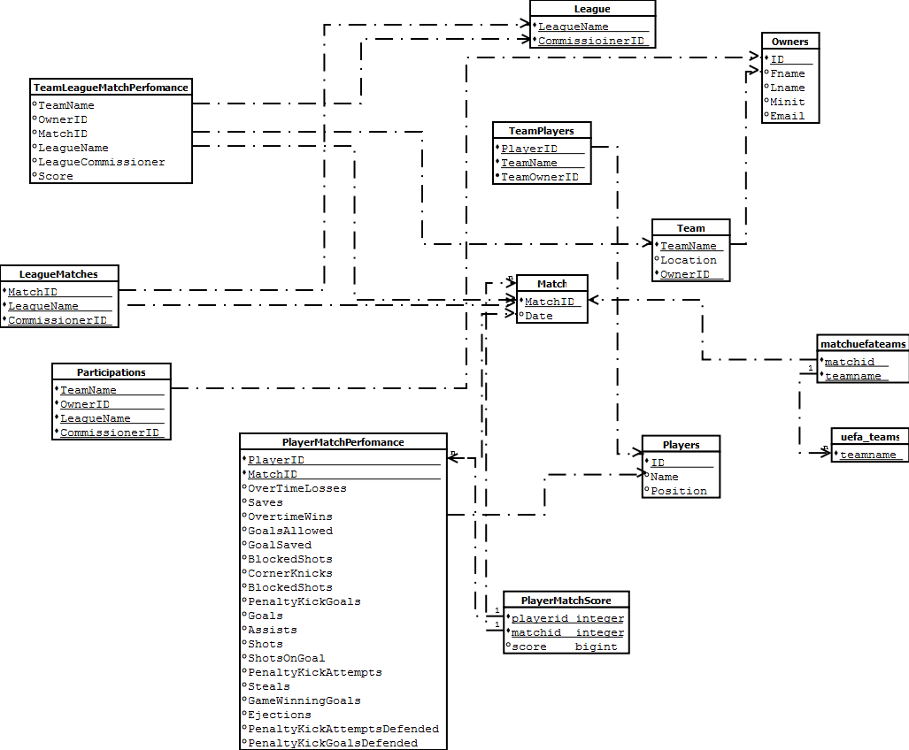

* ER Diagram

