MediKiosk — Detailed Project Draft

MediKiosk — Detailed Project Draft

Smart AI-Powered Patient Intake & Triage Kiosk

Smart India Hackathon 2026 · Team Submission

One-line pitch: MediKiosk replaces the paper token + waiting-room confusion at government hospitals with a conversational AI kiosk that takes the patient's full clinical history, scans their documents, generates a SOAP note, and routes them to the right department — before they ever sit in front of the doctor.

1. Problem Statement
Indian government hospitals face a massive patient load, leading to four interconnected bottlenecks at the Outpatient Department (OPD):
- Wasted Doctor Time (History Taking):
* The Issue: Doctors spend 3 to 5 minutes per patient simply asking basic questions (e.g., "Kab se dard hai? Kahan dard hai? Puraani dawai kya le rahe ho?").
* The Impact: If a doctor sees 100 patients a day, they waste up to 6 hours just taking basic history. That is time that should be spent on diagnosis and treatment.
- Incorrect Department Routing:
* The Issue: At the registration counter, non-medical staff (or confused patients) often select the wrong department (e.g., sending a patient with chest pain caused by acid reflux to Cardiology instead of General Medicine).
* The Impact: The patient waits 2 hours to see a doctor, only to be told, "Yeh mera department nahi hai, wahan jao." This doubles their waiting time and frustrates everyone.
- Hidden Context (Paper Reports):
* The Issue: Patients bring old, crumpled paper reports and lab results. The doctor has to spend time reading them on the spot.
* The Impact: Doctors are forced to make rapid decisions without a clean, organized view of the patient's past medical history and current lab values.
- No Intelligent Triage (First-Come, First-Served):
* The Issue: A patient with a minor headache and a patient having a mild heart attack are put in the same queue.
* The Impact: Critical emergency cases are not fast-tracked, leading to severe risks.
The MediKiosk Solution: A single, multilingual, voice-enabled kiosk placed before the consultation room that solves all four problems automatically.

2. What MediKiosk Does — End-to-End Flow
--- Code Block ---
Patient arrives at hospital
│
▼
┌─────────────────────────────┐
│ STEP 1: ABHA Authentication│ → Patient enters 14-digit ABHA ID
│ (index.html) │ → Past medical history auto-loaded from ABDM (simulated)
└────────────┬────────────────┘
│
▼
┌─────────────────────────────┐
│ STEP 2: AI Intake Chat │ → ARIA (AI nurse) asks one question at a time
│ (chat.html) │ → SOCRATES framework for symptom collection
│ │ → Voice input (Web Speech API) in Hi/En/Ta/Bn
│ │ → TTS reads AI replies aloud
│ │ → Patient can upload reports/prescriptions (OCR)
│ │ → Emergency red-flag detection → instant alert
└────────────┬────────────────┘
│
▼
┌─────────────────────────────┐
│ STEP 3: AI Summary │ → Groq LLM (primary) generates SOAP note JSON
│ Generation │ → Gemini (fallback) if Groq fails
│ (/api/generate_summary) │ → Department routing + triage priority assigned
│ │ → Token created, saved to session + disk
└────────────┬────────────────┘
│
▼
┌────────────────────────────────────────────────────────┐
│ STEP 4: Dual-panel waiting │
│ Patient → status.html │ Doctor → doctor_panel.html │
│ Sees: token #, dept, │ Sees: live queue, priority │
│ priority, live update │ sorted, SOAP + OCR reports │
│ via Server-Sent Events │ forced to "View Analysis" │
│ │ before approving │
└─────────────────────────┬──────────────────────────────┘
│ Doctor clicks Approve
▼
┌─────────────────────────────┐
│ STEP 5: Patient Notified │ → SSE pushes "Approved" in real-time
│ (status.html) │ → Green screen flash, large queue number
│ │ → Instructions: go to [Department] counter
└─────────────────────────────┘
│
▼
┌─────────────────────────────┐
│ STEP 6: Dashboard Review │ → Doctor/staff reviews full SOAP note
│ (dashboard.html) │ → Can edit fields (contenteditable)
│ │ → Confidence flags highlight missing data
│ │ → "Push to ABDM" writes to patient's ABHA locker (mock FHIR)
└─────────────────────────────┘
------------------

3. Technology Stack

Backend
Component | Technology | Why
Web Framework | FastAPI (Python) | Async-first, auto OpenAPI docs, SSE support built-in
AI Provider (Primary) | Groq Cloud — `llama-3.1-8b-instant` | Ultra-low latency (~200ms), free tier, multilingual
AI Provider (Vision/Fallback) | Google Gemini — `gemini-3.5-flash-lite` | Only model with multimodal (OCR) capability on free tier
Data Persistence | JSON file (`session_data.json`) | Lightweight, no DB setup needed for hackathon; easily swappable to PostgreSQL
Real-time Push | Server-Sent Events (SSE) | Native browser support, no WebSocket library needed
Environment Config | python-dotenv | API keys in `.env`, never committed
OCR Pipeline | Gemini Vision API | Extracts clinical data from uploaded images/PDFs
ABHA/ABDM Mock | In-memory simulation | Real ABDM requires production credentials; mock replicates the data model

Frontend
Component | Technology | Why
Styling | Tailwind CSS (CDN) | Utility-first, zero build step — perfect for hackathon speed
Typography | Google Fonts — Inter + JetBrains Mono | Professional medical-grade look
Markdown Rendering | marked.js | Renders AI-generated SOAP notes with proper formatting
TTS | Web Speech API (SpeechSynthesis) | Browser-native, zero cost, multilingual (Hi/En/Ta/Bn)
STT (Voice Input) | Web Speech API (SpeechRecognition) | Browser-native voice → text → auto-send
Real-time Updates | EventSource (SSE client) | Patient status page updates without polling
No framework | Vanilla JS + HTML | Runs on any device including government kiosk hardware

4. Data Flow Diagram
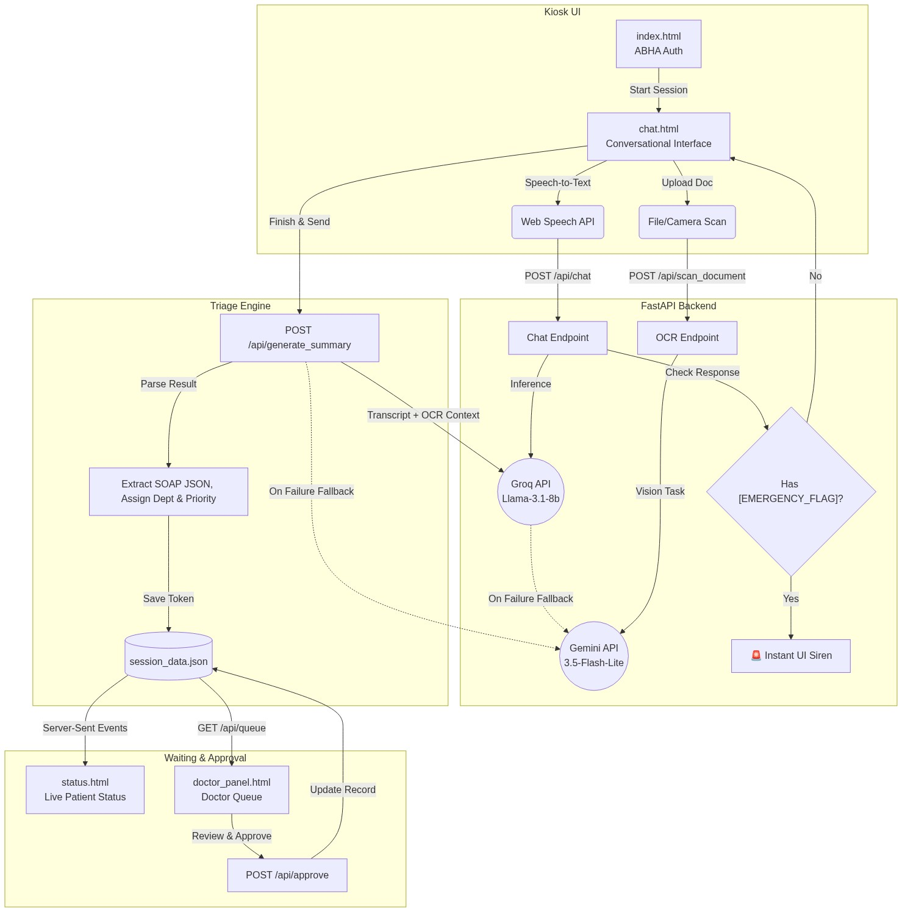
Figure: Architecture Data Flow

5. AI Pipeline — Detailed

5.1 Chat Pipeline (`/api/chat`)
--- Code Block ---
Patient message
│
▼
Build message array:
[SYSTEM PROMPT from agent.md]
+ [Past medical history injection]
+ [Full chatHistory from frontend]
+ [Current user message]
│
▼
Try Groq (llama-3.1-8b-instant)
→ response.choices[0].message.content
│
Fails? ──► Try Gemini
→ Build synthetic history format
→ [{"role":"user","parts":[system+history]}, {"role":"model","parts":["Understood"]}, {"role":"user","parts":[current_msg]}]
→ model.generate_content(messages)
│
▼
Check for [EMERGENCY_FLAG] in response
→ If found: is_emergency=True returned to frontend
→ Frontend: red pulsing button + full-screen siren overlay
│
▼
Return {doctor_response, is_emergency} to frontend
------------------

5.2 OCR Pipeline (`/api/scan_document`)
--- Code Block ---
Patient uploads image/PDF
│
▼
Backend validation:
- File type whitelist: jpg, jpeg, png, webp, pdf
- Size limit: 10MB
- model not None check
│
▼
Read file bytes → base64 encode
│
▼
Gemini multimodal call:
prompt = "You are a clinical document reader..."
model.generate_content([prompt, {"mime_type": ..., "data": base64}])
│
▼
Return extracted_data (OCR text) to frontend
│
▼
Frontend:
- Displays OCR result as system message
- Injects into chatHistory as:
"[SYSTEM NOTE: The patient uploaded a medical document. Extracted details: {text}]"
- This context flows into ALL future AI responses + the final summary
------------------

5.3 Summary + Triage Pipeline (`/api/generate_summary`)
--- Code Block ---
Patient clicks "Finish & Send to Doctor"
│
▼
Backend receives full chatHistory
│
▼
Transcript builder:
- Regular messages → "USER: ...\nASSISTANT: ..."
- OCR messages → "SYSTEM (DOCUMENT OCR): ..."
- Other SYSTEM NOTEs → filtered out
- report_analysis[] → extracted OCR texts for storage
│
▼
Validate: transcript not empty → else 400
│
▼
Inject transcript into SUMMARY_AGENT_PROMPT template
(from agent.md, {transcript} placeholder replaced)
│
▼
Try Groq (structured JSON request, temperature=0.2)
→ Expects raw JSON back
│
Fails? ──► Try Gemini
→ Same prompt, same JSON expectation
│
▼
JSON parsing:
- Strip markdown code fences (``` or ```json)
- json.loads()
- Except JSONDecodeError → fallback {summary_markdown: raw_text}
│
▼
Department validation:
- Against VALID_DEPTS whitelist
- Unknown dept → "General Medicine"
│
▼
Build token_data dict:
{token_id, abha_id, department, priority, queue_number,
summary_markdown, soap{S,O,A,P}, confidence_flags[], reports[],
status:"Pending", approved_by:null, timestamp}
│
▼
PATIENT_QUEUE[token_id] = token_data
DEPT_COUNTERS[dept] += 1
_save_session() → write to session_data.json
│
▼
Return token_data to patient (shown in modal)
------------------

5.4 Doctor Approval Pipeline (`/api/approve`)
--- Code Block ---
Doctor opens modal (forced to read SOAP + reports)
│
▼
Clicks "Approve Patient"
│
▼
POST /api/approve {token_id, doctor_name}
│
▼
token_data.status = "Approved"
token_data.approved_by = doctor_name
_save_session()
│
▼
SSE stream for patient's token_id returns:
data: {"status":"Approved", "approved_by":"Dr. Sharma", ...}
│
▼
Patient's status.html receives SSE event:
- Green full-screen flash
- "You're Approved!" card with queue number
- Instructions to go to department counter
------------------

5.5 Real-time SSE Stream (`/api/stream/{token_id}`)
--- Code Block ---
async def event_stream():
while True:
token = PATIENT_QUEUE.get(token_id)
if not token:
yield 'data: {"error": "Token not found"}\n\n'; return
yield f'data: {json.dumps(token)}\n\n'
if token["status"] == "Approved":
return # close stream
await asyncio.sleep(1) # poll every 1 second
------------------

6. Prompt Architecture (`agent.md`)
The entire AI behavior is controlled by a single `agent.md` file — editable without touching Python code.

Structure
--- Code Block ---
# CHAT_AGENT_PROMPT
[Chat agent instructions]
---
# SUMMARY_AGENT_PROMPT
[Summary/triage agent instructions with {transcript} placeholder]
------------------

Chat Agent Design Philosophy (ARIA)
- Identity: "Think like a detective, not a receptionist"
- Core framework: SOCRATES (Site, Onset, Character, Radiation, Associations, Timing, Exacerbating/Relieving, Severity)
- Branching logic: Chest pain → mandatory cardiac questions; Headache → neuro screen; Abdominal → bowel/fever
- Red-flag interruption: Instantly halts interview, outputs `[EMERGENCY_FLAG]`, refuses further engagement
- AYUSH mode: Switches to Dashavidha Pariksha (10-fold Ayurvedic examination) on trigger words
- Language lock: Detects from first message, stays locked — plus 4-language panel support

Summary Agent Design Philosophy
- Reader: Senior consultant physician reviewing in under 30 seconds
- S: Verbatim chief complaint + SOCRATES data, explicitly notes uncollected fields
- O: Only what was actually observed/mentioned — never fabricated
- A: Ranked differentials with reasoning ("1. ACS — rationale. 2. GERD — rationale")
- P: Specific investigations ("ECG, Troponin I, CXR PA view") — NOT vague ("cardiac workup")
- confidence_flags: Every SOCRATES dimension flagged with high/medium/low + reason for low confidence
- priority: Defined logic — Emergency > High (severity ≥8/10 or rapid worsening) > Medium > Low

7. Frontend Pages & Their Roles
Page | File | Role
Login | `index.html` | ABHA ID entry with 14-digit validation, consent checkbox
Chat | `chat.html` | ARIA AI interview, voice I/O, OCR upload, TTS, language picker
Dashboard | `dashboard.html` | Patient-facing SOAP summary review before doctor sees them
Status | `status.html` | Patient waiting screen — live SSE token status
Doctor Panel | `doctor_panel.html` | Doctor queue view — priority-sorted cards, full analysis modal, approve

8. Data Model

`token_data` (in-memory + JSON)
--- Code Block ---
{
"token_id": "A1B2C3D4",
"abha_id": "12345678901234",
"department": "Cardiology",
"priority": "High",
"queue_number": 3,
"summary_markdown": "**55-year-old male** presenting with...",
"soap": {
"S": "Crushing chest pain radiating to left arm, onset 2 hours ago...",
"O": "No objective data from kiosk. Requires clinical examination.",
"A": "1. ACS — substernal pain + radiation + diaphoresis. 2. GERD — less likely.",
"P": "ECG, Troponin I, CXR PA view — urgent."
},
"confidence_flags": [
{"field": "Radiation", "confidence": "high", "value": "Left arm", "note": ""},
{"field": "Severity", "confidence": "medium", "value": "8/10", "note": "Patient seemed to underreport"}
],
"reports": ["Report OCR text from uploaded prescription..."],
"status": "Pending",
"approved_by": null,
"timestamp": "2026-09-19T20:00:00"
}
------------------

Session File (`session_data.json`)
--- Code Block ---
{
"queue": { "A1B2C3D4": { ...token_data... } },
"counters": { "Cardiology": 3, "General Medicine": 12 }
}
------------------

9. Security & Reliability Choices
Concern | Approach
API Key exposure | `.env` file, never committed (`.gitignore`)
File upload abuse | Whitelist: jpg/png/webp/pdf only, 10MB max
AI hallucination of dept | VALID_DEPTS whitelist, unknown → General Medicine
Both AI providers failing | Raises HTTP 500 with friendly patient-facing message
Empty transcript | Validated before LLM call → HTTP 400
JSON parse failure | Graceful fallback — stores raw text as summary_markdown
Session loss on restart | `_save_session()` called on every queue mutation
Doctor skipping review | "View Analysis" button is `pointer-events-none`, card click = only entry to modal

10. AYUSH Integration
MediKiosk has first-class support for Ayurvedic/AYUSH consultations:
- Trigger words: "ayurveda", "vaidya", "prakriti", "nadi", "पंचकर्म", etc.
- Mode switch: Full Dashavidha Pariksha (10-parameter Ayurvedic intake)
- Parameters collected: Prakriti, Vikriti, Sara, Samhanana, Pramana, Satmya, Sattva, Ahara Shakti, Vyayama Shakti, Vaya + Nidana
- SOAP relabeling: S → Prakriti + Vikriti, O → Dashavidha Pariksha, A → Dosha Assessment (Vata/Pitta/Kapha), P → Vaidya Plan
- Routing: Always routes to `Ayurveda (AYUSH)` department
- UI: Green AYUSH badge shows on doctor panel and dashboard

11. Multi-language Support
Language | Voice Input | TTS Output | AI Response | Trigger
Hindi | ✅ `hi-IN` | ✅ | ✅ (Devanagari) | Default
English | ✅ `en-IN` | ✅ | ✅ | Panel select / `en-IN`
Tamil | ✅ `ta-IN` | ✅ (if browser supports) | ✅ (Tamil script) | Panel select
Bengali | ✅ `bn-IN` | ✅ (if browser supports) | ✅ (Bengali script) | Panel select
Language switching injects a `[SYSTEM NOTE]` into `chatHistory` — the AI is instructed to lock to the new language from that point.

12. Limitations & Future Roadmap

Current Limitations (Hackathon Scope)
Limitation | Reason
ABDM push is mocked | Real ABDM requires NHA production credentials
Session storage is JSON file | No multi-server, no concurrent write safety
TTS works best on Chrome/Edge | Web Speech API support varies by browser
OCR only via Gemini Vision | Groq doesn't support multimodal yet
No authentication for doctor panel | Assumed intranet deployment

Roadmap
- [ ] Replace JSON session with PostgreSQL + Redis
- [ ] Real ABDM FHIR integration (PHR app linking)
- [ ] Add NLP intent detection to skip redundant questions
- [ ] Kiosk hardware integration (camera-based document scan, fingerprint for ABHA)
- [ ] Vitals capture via IoT (BP cuff, SpO2 — inject into SOAP-O automatically)
- [ ] LLM fine-tuning on Indian medical corpus (ICD-10 aware)
- [ ] RTL support for Urdu

13. Repository Structure
--- Code Block ---
medikiosk-sih26047/
├── backend/
│ ├── main.py ← FastAPI app (444 lines)
│ ├── agent.md ← All AI prompts (ARIA + Summary agent)
│ ├── session_data.json ← Runtime queue persistence
│ ├── .env ← GEMINI_API_KEY, GROQ_API_KEY (gitignored)
│ ├── requirements.txt ← Python dependencies
│ └── static/
│ ├── index.html ← ABHA login
│ ├── chat.html ← AI intake interview + TTS
│ ├── dashboard.html ← Patient SOAP summary review
│ ├── status.html ← Patient live token status
│ └── doctor_panel.html ← Doctor queue + approval panel
├── README.md
├── ARCHITECTURE.md
├── medikiosk_architecture_modules.md
└── MediKiosk_Project_Draft.md ← This file
------------------

14. How to Run
--- Code Block ---
# 1. Clone
git clone https://github.com/MihirMaurya-dev/medikiosk-sih26047.git
cd medikiosk-sih26047/backend

# 2. Install dependencies
pip install -r requirements.txt

# 3. Set API keys
echo "GEMINI_API_KEY=your_key_here" > .env
echo "GROQ_API_KEY=your_groq_key_here" >> .env

# 4. Run
uvicorn main:app --host 127.0.0.1 --port 8000 --reload

# 5. Open browser
# Patient: http://127.0.0.1:8000
# Doctor: http://127.0.0.1:8000/doctor-panel
------------------

15. Key Differentiators vs Existing Solutions
Feature | MediKiosk | Traditional OPD System
History taking | AI does it before doctor | Doctor does it during consultation
Language support | 4 Indian languages + voice | Usually English forms
Document scanning | Instant OCR via AI vision | Manual reading by doctor
Triage priority | Auto-assigned by AI (Low/Medium/High/Emergency) | Manual — first come first served
AYUSH support | Built-in Dashavidha Pariksha | Not supported
Real-time status | Live SSE — no refresh needed | Token display boards
ABDM integration | FHIR-ready mock | Usually none
Emergency detection | Instant red-flag → siren overlay | Patient waits in queue

Generated: 2026-09-19 | Version: 2.0 | Team: MediKiosk SIH-26047

