MediKiosk — Detailed Project Draft

MediKiosk — Detailed Project Draft

Smart AI-Powered Patient Intake & Triage Kiosk

Smart India Hackathon 2026 · Team Submission

One-line pitch: MediKiosk replaces the paper token + waiting-room confusion at government hospitals with a conversational AI kiosk that takes the patient's full clinical history, scans their documents, generates a SOAP note, and routes them to the right department — before they ever sit in front of the doctor.

1. Problem Statement
Indian government hospitals face a massive patient load, leading to four interconnected bottlenecks at the Outpatient Department (OPD):
- Wasted Doctor Time (History Taking):
* The Issue: Doctors spend 3 to 5 minutes per patient simply asking basic questions (e.g., "Kab se dard hai? Kahan dard hai? Puraani dawai kya le rahe ho?").
* The Impact: If a doctor sees 100 patients a day, they waste up to 6 hours just taking basic history. That is time that should be spent on diagnosis and treatment.
- Incorrect Department Routing:
* The Issue: At the registration counter, non-medical staff (or confused patients) often select the wrong department (e.g., sending a patient with chest pain caused by acid reflux to Cardiology instead of General Medicine).
* The Impact: The patient waits 2 hours to see a doctor, only to be told, "Yeh mera department nahi hai, wahan jao." This doubles their waiting time and frustrates everyone.
- Hidden Context (Paper Reports):
* The Issue: Patients bring old, crumpled paper reports and lab results. The doctor has to spend time reading them on the spot.
* The Impact: Doctors are forced to make rapid decisions without a clean, organized view of the patient's past medical history and current lab values.
- No Intelligent Triage (First-Come, First-Served):
* The Issue: A patient with a minor headache and a patient having a mild heart attack are put in the same queue.
* The Impact: Critical emergency cases are not fast-tracked, leading to severe risks.
The MediKiosk Solution: A single, multilingual, voice-enabled kiosk placed before the consultation room that solves all four problems automatically.

2. What MediKiosk Does — End-to-End Flow
MediKiosk streamlines the entire OPD intake process through a structured 6-step journey:
- Patient Authentication & Discovery (`index.html`)
* The patient inputs their 14-digit ABHA (Ayushman Bharat Health Account) ID on the kiosk screen.
* The system authenticates the user and fetches their past medical history, existing conditions, and known allergies securely from the ABDM network.
- AI-Driven Clinical Interview (`chat.html`)
* The patient interacts with ARIA, the multilingual AI triage nurse, using natural voice or text (supported in Hindi, English, Tamil, and Bengali).
* ARIA systematically collects symptoms using the SOCRATES medical framework.
* Patients can hold up physical documents to the camera; the kiosk performs OCR to extract vital medical data.
* Emergency Safety Net: If red-flag symptoms are detected, ARIA instantly halts the interview and triggers an immediate triage alert.
- Intelligent Triage & Summary Generation (Backend)
* Once the patient finishes, the entire transcript and OCR data are processed by the Groq `llama-3.1-8b` model (with Gemini fallback).
* The AI generates a structured SOAP note, assigns a triage priority (Low/Medium/High/Emergency), and routes the patient to the correct specialist department.
- Synchronized Waiting Experience (`status.html` & `doctor_panel.html`)
* Patient View: The kiosk switches to a live status board showing their queue number and department.
* Doctor View: The physician's dashboard updates in real-time. Patients are sorted strictly by clinical priority, not chronologically.
- Physician Review & Approval
* Before the patient even enters the room, the doctor reviews the AI-generated SOAP note and differential diagnoses.
* The doctor clicks "Approve Patient" to call them in.
- Patient Notification & EMR Push
* Server-Sent Events (SSE) instantly flash a green "Approved" signal on the patient's screen, instructing them to proceed to the cabin.
* The final clinical note can be updated by the doctor and pushed back to the patient's ABHA locker.

3. Technology Stack

Backend
Component | Technology | Why
Web Framework | FastAPI (Python) | Async-first, auto OpenAPI docs, SSE support built-in
AI Provider (Primary) | Groq Cloud — `llama-3.1-8b-instant` | Ultra-low latency (~200ms), free tier, multilingual
AI Provider (Vision/Fallback) | Google Gemini — `gemini-3.5-flash-lite` | Only model with multimodal (OCR) capability on free tier
Data Persistence | JSON file (`session_data.json`) | Lightweight, no DB setup needed for hackathon; easily swappable to PostgreSQL
Real-time Push | Server-Sent Events (SSE) | Native browser support, no WebSocket library needed
Environment Config | python-dotenv | API keys in `.env`, never committed
OCR Pipeline | Gemini Vision API | Extracts clinical data from uploaded images/PDFs
ABHA/ABDM Mock | In-memory simulation | Real ABDM requires production credentials; mock replicates the data model

Frontend
Component | Technology | Why
Styling | Tailwind CSS (CDN) | Utility-first, zero build step — perfect for hackathon speed
Typography | Google Fonts — Inter + JetBrains Mono | Professional medical-grade look
Markdown Rendering | marked.js | Renders AI-generated SOAP notes with proper formatting
TTS | Web Speech API (SpeechSynthesis) | Browser-native, zero cost, multilingual (Hi/En/Ta/Bn)
STT (Voice Input) | Web Speech API (SpeechRecognition) | Browser-native voice → text → auto-send
Real-time Updates | EventSource (SSE client) | Patient status page updates without polling
No framework | Vanilla JS + HTML | Runs on any device including government kiosk hardware

4. Data Flow Diagram
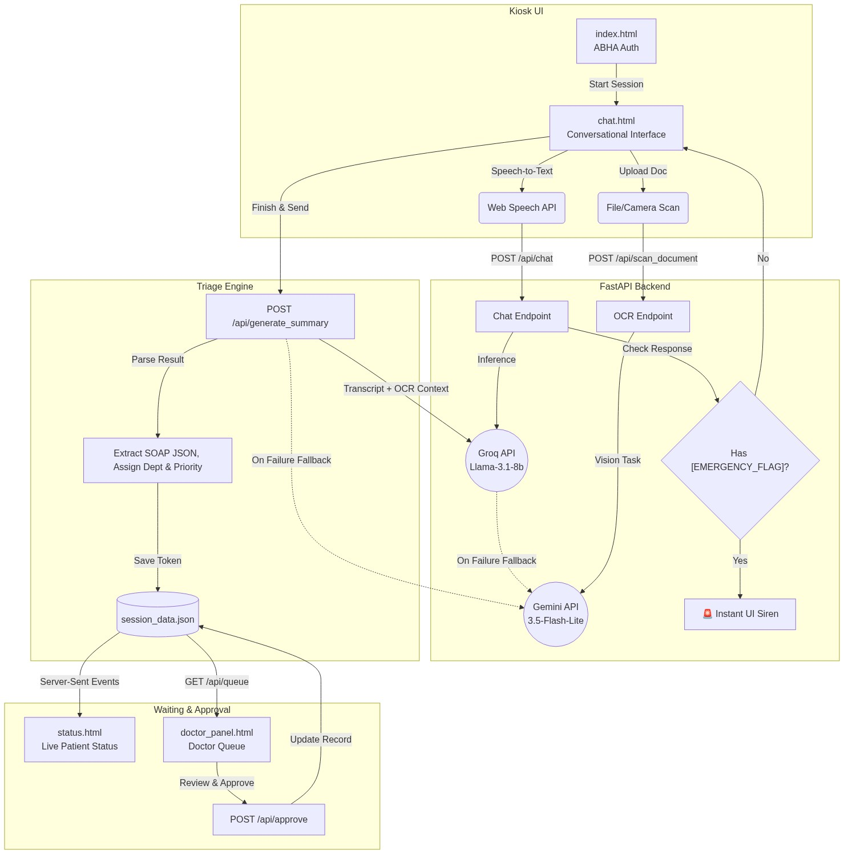
Figure: Architecture Data Flow

5. AI Pipeline — Detailed
Our backend utilizes a multi-model fallback architecture to ensure 100% uptime and speed.

5.1 Chat Pipeline (`/api/chat`)
- Input: Patient's ABHA ID, previous chat history, and the current message.
- Process: The system builds a prompt containing the ARIA persona, past medical history, and user input. It calls Groq's `llama-3.1-8b` for ultra-fast inference. If rate-limited, it automatically falls back to `gemini-3.5-flash-lite`.
- Output: Returns the AI's response text and an `is_emergency` boolean (triggered if the AI outputs `[EMERGENCY_FLAG]`).

5.2 Document Vision Pipeline (`/api/scan_document`)
- Input: Uploaded images or PDFs (max 10MB).
- Process: The file is converted to base64 and sent to Gemini Vision. The model acts as a clinical document reader, extracting key lab values, current medications, and past diagnoses.
- Output: The extracted text is returned to the frontend and injected invisibly into the chat history as a `[SYSTEM NOTE]`, ensuring the LLM considers this data for all subsequent questions.

5.3 Clinical Summary Pipeline (`/api/generate_summary`)
- Input: The complete patient interview transcript.
- Process: The transcript is validated and injected into a strict JSON-enforced prompt. The LLM extracts the subjective history, proposes objective next steps, generates differential diagnoses (Assessment), and formulates an investigation plan.
- Output: A structured JSON object containing the SOAP note, assigned department, priority level, and confidence flags.

5.4 Doctor Approval Pipeline (`/api/approve`)
- Input: The unique `token_id` and the doctor's name.
- Process: The token's status in the central queue is updated from "Pending" to "Approved".
- Output: Triggers an event on the SSE stream to notify the waiting patient instantly.

5.5 Real-time Notification Stream (`/api/stream/{token_id}`)
- Architecture: Uses Server-Sent Events (SSE) via FastAPI's `StreamingResponse`.
- Process: Maintains an open HTTP connection with the kiosk. It polls the in-memory queue every second. Once the token status changes to "Approved", it pushes the update and cleanly closes the connection.

6. Prompt Architecture (`agent.md`)
The entire AI behavior is controlled by a single `agent.md` file — editable without touching Python code.

Structure
--- Code Block ---
# CHAT_AGENT_PROMPT
[Chat agent instructions]
---
# SUMMARY_AGENT_PROMPT
[Summary/triage agent instructions with {transcript} placeholder]
------------------

Chat Agent Design Philosophy (ARIA)
- Identity: "Think like a detective, not a receptionist"
- Core framework: SOCRATES (Site, Onset, Character, Radiation, Associations, Timing, Exacerbating/Relieving, Severity)
- Branching logic: Chest pain → mandatory cardiac questions; Headache → neuro screen; Abdominal → bowel/fever
- Red-flag interruption: Instantly halts interview, outputs `[EMERGENCY_FLAG]`, refuses further engagement
- AYUSH mode: Switches to Dashavidha Pariksha (10-fold Ayurvedic examination) on trigger words
- Language lock: Detects from first message, stays locked — plus 4-language panel support

Summary Agent Design Philosophy
- Reader: Senior consultant physician reviewing in under 30 seconds
- S: Verbatim chief complaint + SOCRATES data, explicitly notes uncollected fields
- O: Only what was actually observed/mentioned — never fabricated
- A: Ranked differentials with reasoning ("1. ACS — rationale. 2. GERD — rationale")
- P: Specific investigations ("ECG, Troponin I, CXR PA view") — NOT vague ("cardiac workup")
- confidence_flags: Every SOCRATES dimension flagged with high/medium/low + reason for low confidence
- priority: Defined logic — Emergency > High (severity ≥8/10 or rapid worsening) > Medium > Low

7. Frontend Pages & Their Roles
Page | File | Role
Login | `index.html` | ABHA ID entry with 14-digit validation, consent checkbox
Chat | `chat.html` | ARIA AI interview, voice I/O, OCR upload, TTS, language picker
Dashboard | `dashboard.html` | Patient-facing SOAP summary review before doctor sees them
Status | `status.html` | Patient waiting screen — live SSE token status
Doctor Panel | `doctor_panel.html` | Doctor queue view — priority-sorted cards, full analysis modal, approve

8. Data Model
MediKiosk uses a highly structured schema to maintain state between the patient kiosk and the doctor's terminal.

8.1 Patient Token Schema (`token_data`)
Every intake session generates a Token Object with the following fields:
- Identity & Routing:
* `token_id`: Unique alphanumeric identifier (e.g., "A1B2C3D4").
* `abha_id`: The patient's 14-digit national health ID.
* `department`: The AI-assigned specialist department (e.g., "Cardiology").
* `queue_number`: The sequential token number for that specific department.
- Clinical Data:
* `priority`: Triage urgency (`Low`, `Medium`, `High`, `Emergency`).
* `soap`: A nested object containing `S` (Subjective), `O` (Objective), `A` (Assessment), and `P` (Plan).
* `reports`: An array of text extracted from physical documents via OCR.
- Metadata & State:
* `confidence_flags`: An array of AI self-evaluations highlighting missing or low-confidence data points (e.g., if the patient was vague about pain severity).
* `status`: Current state in the queue (`Pending` or `Approved`).
* `timestamp`: ISO-8601 creation time for chronological sorting.

8.2 Database Architecture (`session_data.json`)
For the hackathon scope, state is persisted in a lightweight JSON file (easily swappable to PostgreSQL/Redis). It contains two primary keys:
- `queue`: A dictionary mapping `token_id` to the full `token_data` object.
- `counters`: A dictionary tracking the next available queue number for each specific department.

9. Security & Reliability Choices
Concern | Approach
API Key exposure | `.env` file, never committed (`.gitignore`)
File upload abuse | Whitelist: jpg/png/webp/pdf only, 10MB max
AI hallucination of dept | VALID_DEPTS whitelist, unknown → General Medicine
Both AI providers failing | Raises HTTP 500 with friendly patient-facing message
Empty transcript | Validated before LLM call → HTTP 400
JSON parse failure | Graceful fallback — stores raw text as summary_markdown
Session loss on restart | `_save_session()` called on every queue mutation
Doctor skipping review | "View Analysis" button is `pointer-events-none`, card click = only entry to modal

10. AYUSH Integration
MediKiosk has first-class support for Ayurvedic/AYUSH consultations:
- Trigger words: "ayurveda", "vaidya", "prakriti", "nadi", "पंचकर्म", etc.
- Mode switch: Full Dashavidha Pariksha (10-parameter Ayurvedic intake)
- Parameters collected: Prakriti, Vikriti, Sara, Samhanana, Pramana, Satmya, Sattva, Ahara Shakti, Vyayama Shakti, Vaya + Nidana
- SOAP relabeling: S → Prakriti + Vikriti, O → Dashavidha Pariksha, A → Dosha Assessment (Vata/Pitta/Kapha), P → Vaidya Plan
- Routing: Always routes to `Ayurveda (AYUSH)` department
- UI: Green AYUSH badge shows on doctor panel and dashboard

11. Multi-language Support
Language | Voice Input | TTS Output | AI Response | Trigger
Hindi | ✅ `hi-IN` | ✅ | ✅ (Devanagari) | Default
English | ✅ `en-IN` | ✅ | ✅ | Panel select / `en-IN`
Tamil | ✅ `ta-IN` | ✅ (if browser supports) | ✅ (Tamil script) | Panel select
Bengali | ✅ `bn-IN` | ✅ (if browser supports) | ✅ (Bengali script) | Panel select
Language switching injects a `[SYSTEM NOTE]` into `chatHistory` — the AI is instructed to lock to the new language from that point.

12. Limitations & Future Roadmap

Current Limitations (Hackathon Scope)
Limitation | Reason
ABDM push is mocked | Real ABDM requires NHA production credentials
Session storage is JSON file | No multi-server, no concurrent write safety
TTS works best on Chrome/Edge | Web Speech API support varies by browser
OCR only via Gemini Vision | Groq doesn't support multimodal yet
No authentication for doctor panel | Assumed intranet deployment

Roadmap
- [ ] Replace JSON session with PostgreSQL + Redis
- [ ] Real ABDM FHIR integration (PHR app linking)
- [ ] Add NLP intent detection to skip redundant questions
- [ ] Kiosk hardware integration (camera-based document scan, fingerprint for ABHA)
- [ ] Vitals capture via IoT (BP cuff, SpO2 — inject into SOAP-O automatically)
- [ ] LLM fine-tuning on Indian medical corpus (ICD-10 aware)
- [ ] RTL support for Urdu

13. Repository Structure
--- Code Block ---
medikiosk-sih26047/
├── backend/
│ ├── main.py ← FastAPI app (444 lines)
│ ├── agent.md ← All AI prompts (ARIA + Summary agent)
│ ├── session_data.json ← Runtime queue persistence
│ ├── .env ← GEMINI_API_KEY, GROQ_API_KEY (gitignored)
│ ├── requirements.txt ← Python dependencies
│ └── static/
│ ├── index.html ← ABHA login
│ ├── chat.html ← AI intake interview + TTS
│ ├── dashboard.html ← Patient SOAP summary review
│ ├── status.html ← Patient live token status
│ └── doctor_panel.html ← Doctor queue + approval panel
├── README.md
├── ARCHITECTURE.md
├── medikiosk_architecture_modules.md
└── MediKiosk_Project_Draft.md ← This file
------------------

14. How to Run & Deploy
Follow these steps to spin up the MediKiosk platform locally.

Prerequisites
- Python 3.9 or higher
- Valid API keys for Groq and Google Gemini

Step-by-Step Installation
- Clone the Repository
Download the source code to your local machine:
```bash
git clone https://github.com/MihirMaurya-dev/medikiosk-sih26047.git
cd medikiosk-sih26047/backend
```
- Install Dependencies
It is recommended to use a virtual environment. Install the required Python packages:
```bash
pip install -r requirements.txt
```
- Configure Environment Variables
Create a `.env` file in the `backend` directory and add your API keys. Do not commit this file to version control.
```env
GEMINI_API_KEY=your_gemini_key_here
GROQ_API_KEY=your_groq_key_here
```
- Start the FastAPI Server
Launch the backend server with Uvicorn (hot-reloading enabled):
```bash
uvicorn main:app --host 127.0.0.1 --port 8000 --reload
```
- Access the Interfaces
Open your web browser and navigate to:
* Patient Kiosk (Start Here): `http://127.0.0.1:8000/`
* Doctor's Dashboard: `http://127.0.0.1:8000/doctor-panel`

15. Key Differentiators vs Existing Solutions
Feature | MediKiosk | Traditional OPD System
History taking | AI does it before doctor | Doctor does it during consultation
Language support | 4 Indian languages + voice | Usually English forms
Document scanning | Instant OCR via AI vision | Manual reading by doctor
Triage priority | Auto-assigned by AI (Low/Medium/High/Emergency) | Manual — first come first served
AYUSH support | Built-in Dashavidha Pariksha | Not supported
Real-time status | Live SSE — no refresh needed | Token display boards
ABDM integration | FHIR-ready mock | Usually none
Emergency detection | Instant red-flag → siren overlay | Patient waits in queue

