Mini Project Assignment Book

Name: Mihir Sopan Patil
Domain: AIML
College & Branch Name: Zeal Polytechnic, Diploma In AIML

- Student Management System

Output:

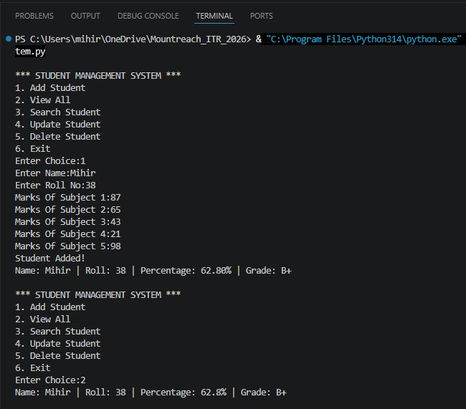
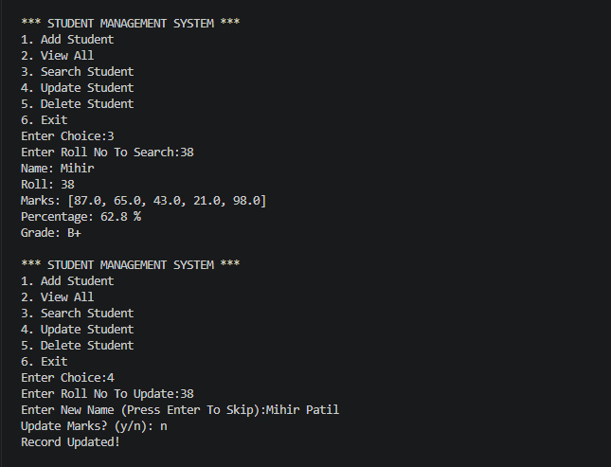

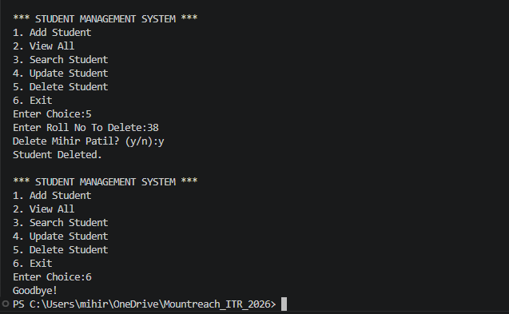

Program Code:

# Project 1 - Student Management System

students = {} # Stores All Student Data

def calculate_grade(percentage):
if percentage >= 90:
return "O"
elif percentage >= 80:
return "A+"
elif percentage >= 70:
return "A"
elif percentage >= 60:
return "B+"
elif percentage >= 50:
return "B"
else:
return "F"

def add_student():
name = input("Enter Name:")
roll = int(input("Enter Roll No:"))

if roll in students:
print("Roll Number Already Exists!")
return

marks = []
for i in range(1, 6):
m = float(input(f"Marks Of Subject {i}:"))
marks.append(m)

percentage = sum(marks) / 5
grade = calculate_grade(percentage)

students[roll] = {
"name": name,
"roll": roll,
"marks": marks,
"percentage": round(percentage, 2),
"grade": grade
}

print("Student Added!")
print(f"Name: {name} | Roll: {roll} | Percentage: {percentage:.2f}% | Grade: {grade}")

def view_all():
if len(students) == 0:
print("No Students Found.")
return

for roll in students:
s = students[roll]
print(f"Name: {s['name']} | Roll: {s['roll']} | Percentage: {s['percentage']}% | Grade: {s['grade']}")

def search_student():
roll = int(input("Enter Roll No To Search:"))

if roll not in students:
print("Student Not Found.")
return

s = students[roll]
print("Name:", s['name'])
print("Roll:", s['roll'])
print("Marks:", s['marks'])
print("Percentage:", s['percentage'], "%")
print("Grade:", s['grade'])

def update_student():
roll = int(input("Enter Roll No To Update:"))

if roll not in students:
print("Student Not Found.")
return

name = input("Enter New Name (Press Enter To Skip):")
if name != "":
students[roll]["name"] = name

choice = input("Update Marks? (y/n): ")
if choice == "y":
marks = []
for i in range(1, 6):
m = float(input(f"Marks of Subject {i}:"))
marks.append(m)
percentage = sum(marks) / 5
students[roll]["marks"] = marks
students[roll]["percentage"] = round(percentage, 2)
students[roll]["grade"] = calculate_grade(percentage)

print("Record Updated!")

def delete_student():
roll = int(input("Enter Roll No To Delete:"))

if roll not in students:
print("Student Not Found.")
return

confirm = input(f"Delete {students[roll]['name']}? (y/n):")
if confirm == "y":
del students[roll]
print("Student Deleted.")
else:
print("Cancelled.")

# Main Menu Loop
while True:
print("\n*** STUDENT MANAGEMENT SYSTEM ***")
print("1. Add Student")
print("2. View All")
print("3. Search Student")
print("4. Update Student")
print("5. Delete Student")
print("6. Exit")

choice = input("Enter Choice:")

if choice == "1":
add_student()
elif choice == "2":
view_all()
elif choice == "3":
search_student()
elif choice == "4":
update_student()
elif choice == "5":
delete_student()
elif choice == "6":
print("Goodbye!")
break
else:
print("Invalid Choice.")

- Library Management System

Output:

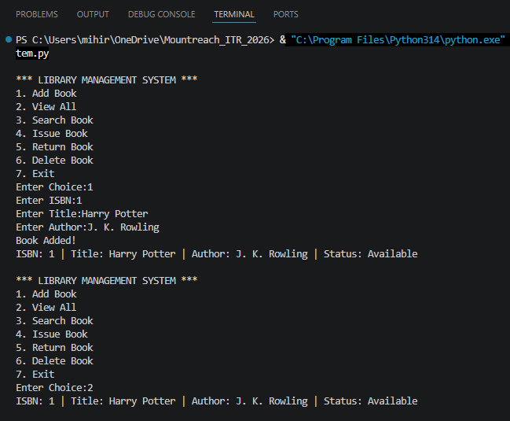

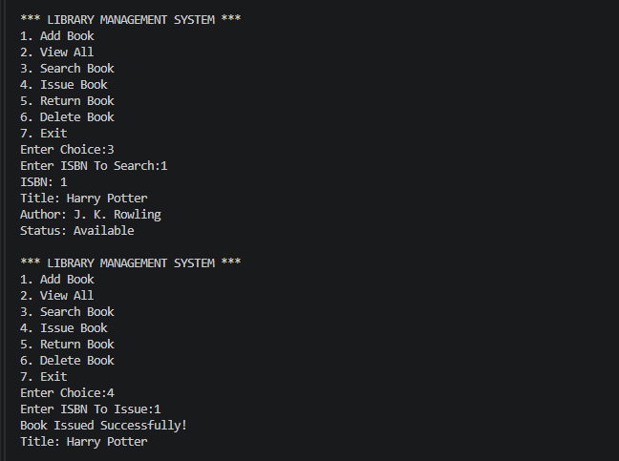
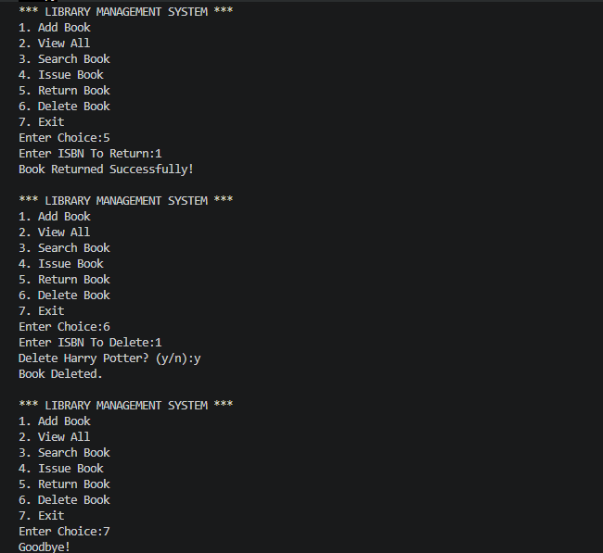

Program Code:

# Project 2 - Library Management System

book = {} # Stores All Book Data

def add_book():
isbn = input("Enter ISBN:")

if isbn in book:
print("ISBN Already Exists!")
return

title = input("Enter Title:")
author = input("Enter Author:")

book[isbn] = {
"isbn": isbn,
"title": title,
"author": author,
"status": "Available"
}

print("Book Added!")
print(f"ISBN: {isbn} | Title: {title} | Author: {author} | Status: Available")

def view_all():
if len(book) == 0:
print("No Books Found.")
return

for isbn in book:
b = book[isbn]
print(f"ISBN: {b['isbn']} | Title: {b['title']} | Author: {b['author']} | Status: {b['status']}")

def search_book():
isbn = input("Enter ISBN To Search:")

if isbn not in book:
print("Book Not Found.")
return

b = book[isbn]

print("ISBN:", b['isbn'])
print("Title:", b['title'])
print("Author:", b['author'])
print("Status:", b['status'])

def issue_book():
isbn = input("Enter ISBN To Issue:")

if isbn not in book:
print("Book Not Found.")
return

if book[isbn]["status"] == "Issued":
print("Book Already Issued.")
return

book[isbn]["status"] = "Issued"

print("Book Issued Successfully!")
print("Title:", book[isbn]['title'])

def return_book():
isbn = input("Enter ISBN To Return:")

if isbn not in book:
print("Book Not Found.")
return

if book[isbn]["status"] == "Available":
print("Book Is Already Available.")
return

book[isbn]["status"] = "Available"

print("Book Returned Successfully!")

def delete_book():
isbn = input("Enter ISBN To Delete:")

if isbn not in book:
print("Book Not Found.")
return

confirm = input(f"Delete {book[isbn]['title']}? (y/n):")

if confirm == "y":
del book[isbn]
print("Book Deleted.")
else:
print("Cancelled.")

# Main Menu Loop
while True:
print("\n*** LIBRARY MANAGEMENT SYSTEM ***")
print("1. Add Book")
print("2. View All")
print("3. Search Book")
print("4. Issue Book")
print("5. Return Book")
print("6. Delete Book")
print("7. Exit")

choice = input("Enter Choice:")

if choice == "1":
add_book()
elif choice == "2":
view_all()
elif choice == "3":
search_book()
elif choice == "4":
issue_book()
elif choice == "5":
return_book()
elif choice == "6":
delete_book()
elif choice == "7":
print("Goodbye!")
break
else:
print("Invalid Choice.")

- Personal Expense Tracker

Output:

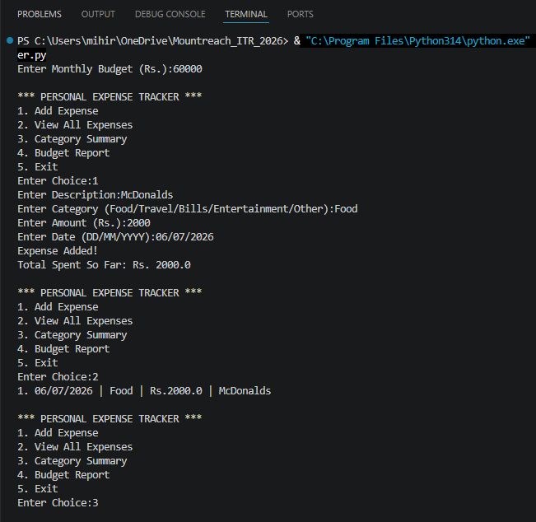
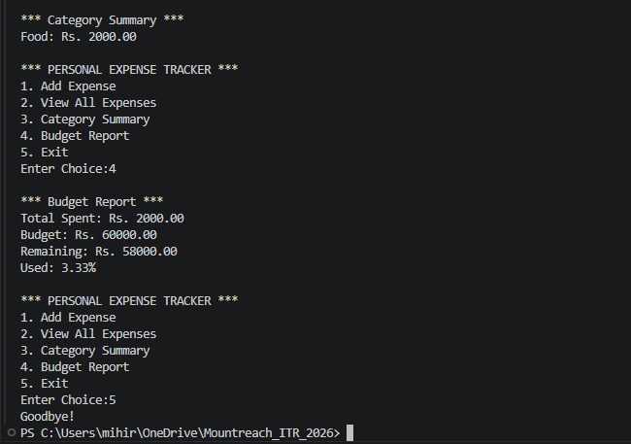

Program Code:

# Project 3 - Personal Expense Tracker

expenses = [] # List Of All Expenses
monthly_budget = float(input("Enter Monthly Budget (Rs.):"))

def add_expense():
description = input("Enter Description:")
category = input("Enter Category (Food/Travel/Bills/Entertainment/Other):")
amount = float(input("Enter Amount (Rs.):"))
date = input("Enter Date (DD/MM/YYYY):")

expense = {
"description": description,
"category": category,
"amount": amount,
"date": date
}

expenses.append(expense)

total = 0
for e in expenses:
total += e["amount"]

print("Expense Added!")
print("Total Spent So Far: Rs.", total)

def view_expenses():
if len(expenses) == 0:
print("No Expenses Recorded.")
return

for i in range(len(expenses)):
e = expenses[i]
print(f"{i+1}. {e['date']} | {e['category']} | Rs.{e['amount']} | {e['description']}")

def category_summary():
if len(expenses) == 0:
print("No Expenses To Show.")
return

summary = {}

for e in expenses:
cat = e["category"]

if cat in summary:
summary[cat] += e["amount"]
else:
summary[cat] = e["amount"]

print("\n*** Category Summary ***")

for cat in summary:
print(f"{cat}: Rs. {summary[cat]:.2f}")

def budget_report():
total = 0

for e in expenses:
total += e["amount"]

remaining = monthly_budget - total
percent_used = (total / monthly_budget) * 100

print("\n*** Budget Report ***")
print(f"Total Spent: Rs. {total:.2f}")
print(f"Budget: Rs. {monthly_budget:.2f}")
print(f"Remaining: Rs. {remaining:.2f}")
print(f"Used: {percent_used:.2f}%")

if percent_used >= 100:
print("WARNING: Budget Exceeded!")
elif percent_used >= 80:
print("WARNING: You Have Used 80% Of Your Budget!")

# Main Menu Loop
while True:
print("\n*** PERSONAL EXPENSE TRACKER ***")
print("1. Add Expense")
print("2. View All Expenses")
print("3. Category Summary")
print("4. Budget Report")
print("5. Exit")

choice = input("Enter Choice:")

if choice == "1":
add_expense()
elif choice == "2":
view_expenses()
elif choice == "3":
category_summary()
elif choice == "4":
budget_report()
elif choice == "5":
print("Goodbye!")
break
else:
print("Invalid Choice.")

- Quiz & Examination System

Output:

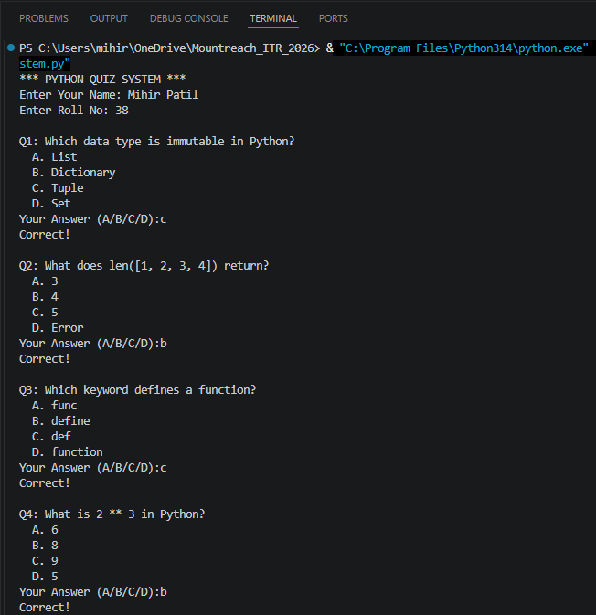
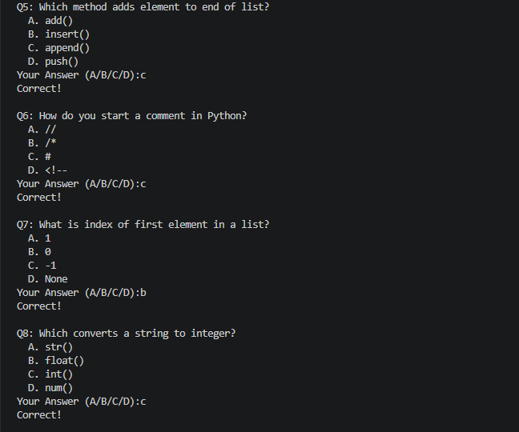
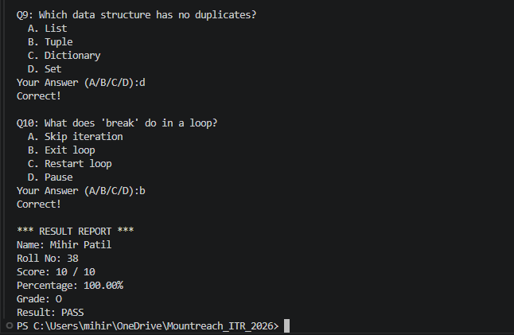

Program Code:

# Project 4 - Quiz and Examination System

questions = [
("Which data type is immutable in Python?", "List", "Dictionary", "Tuple", "Set", "C"),
("What does len([1, 2, 3, 4]) return?", "3", "4", "5", "Error", "B"),
("Which keyword defines a function?", "func", "define", "def", "function", "C"),
("What is 2 ** 3 in Python?", "6", "8", "9", "5", "B"),
("Which method adds element to end of list?", "add()", "insert()", "append()", "push()", "C"),
("How do you start a comment in Python?", "//", "/*", "#", "<!--", "C"),
("What is index of first element in a list?", "1", "0", "-1", "None", "B"),
("Which converts a string to integer?", "str()", "float()", "int()", "num()", "C"),
("Which data structure has no duplicates?", "List", "Tuple", "Dictionary", "Set", "D"),
("What does 'break' do in a loop?", "Skip iteration", "Exit loop", "Restart loop", "Pause", "B"),
]

def calculate_grade(percentage):
if percentage >= 90:
return "O"
elif percentage >= 80:
return "A+"
elif percentage >= 70:
return "A"
elif percentage >= 60:
return "B+"
elif percentage >= 50:
return "B"
else:
return "F"

# Get student details
print("*** PYTHON QUIZ SYSTEM ***")
name = input("Enter Your Name: ")
roll = input("Enter Roll No: ")

score = 0
wrong_answers = []

# Loop Through All Questions
for i in range(len(questions)):
q = questions[i]

print(f"\nQ{i+1}: {q[0]}")
print(f" A. {q[1]}")
print(f" B. {q[2]}")
print(f" C. {q[3]}")
print(f" D. {q[4]}")

answer = input("Your Answer (A/B/C/D):").upper()

if answer == q[5]:
print("Correct!")
score += 1
else:
print("Wrong! Correct Answer Is:", q[5])
wrong_answers.append(q)

# Calculate Result
total = len(questions)
percentage = (score / total) * 100
grade = calculate_grade(percentage)
result = "PASS" if percentage >= 50 else "FAIL"

# Show Result Report
print("\n*** RESULT REPORT ***")
print(f"Name: {name}")
print(f"Roll No: {roll}")
print(f"Score: {score} / {total}")
print(f"Percentage: {percentage:.2f}%")
print(f"Grade: {grade}")
print(f"Result: {result}")

# Show Wrong Answers Review
if len(wrong_answers) > 0:
print("\n*** Wrong Answers Review ***")
for q in wrong_answers:
print("Q:", q[0])
print("Correct Answer:", q[5])

- Inventory Management System

Output:

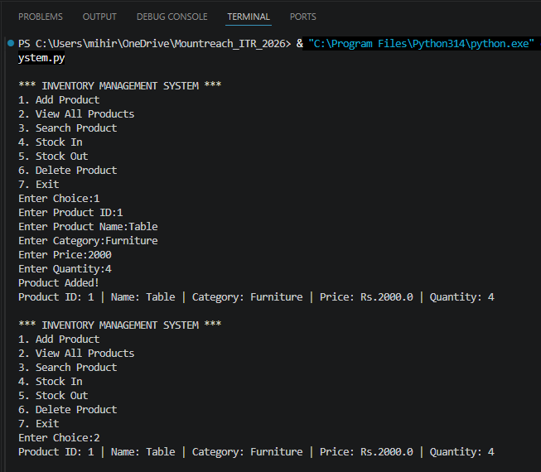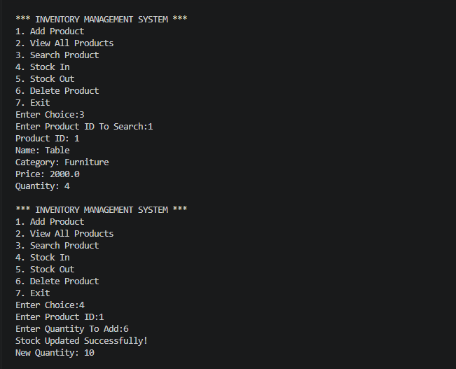
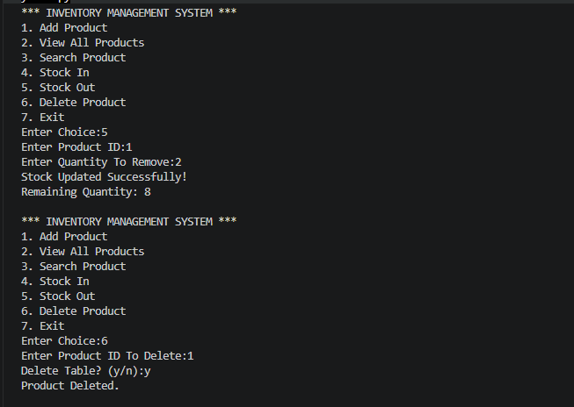

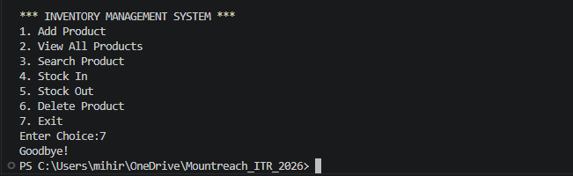

Program Code:

# Project 5 - Inventory Management System

inventory = {} # Stores All Product Data

def add_product():
product_id = input("Enter Product ID:")

if product_id in inventory:
print("Product ID Already Exists!")
return

name = input("Enter Product Name:")
category = input("Enter Category:")
price = float(input("Enter Price:"))
quantity = int(input("Enter Quantity:"))

inventory[product_id] = {
"product_id": product_id,
"name": name,
"category": category,
"price": price,
"quantity": quantity
}

print("Product Added!")
print(f"Product ID: {product_id} | Name: {name} | Category: {category} | Price: Rs.{price} | Quantity: {quantity}")

def view_all():
if len(inventory) == 0:
print("No Products Found.")
return

for product_id in inventory:
p = inventory[product_id]
print(f"Product ID: {p['product_id']} | Name: {p['name']} | Category: {p['category']} | Price: Rs.{p['price']} | Quantity: {p['quantity']}")

def search_product():
product_id = input("Enter Product ID To Search:")

if product_id not in inventory:
print("Product Not Found.")
return

p = inventory[product_id]

print("Product ID:", p['product_id'])
print("Name:", p['name'])
print("Category:", p['category'])
print("Price:", p['price'])
print("Quantity:", p['quantity'])

def stock_in():
product_id = input("Enter Product ID:")

if product_id not in inventory:
print("Product Not Found.")
return

qty = int(input("Enter Quantity To Add:"))

inventory[product_id]["quantity"] += qty

print("Stock Updated Successfully!")
print("New Quantity:", inventory[product_id]["quantity"])

def stock_out():
product_id = input("Enter Product ID:")

if product_id not in inventory:
print("Product Not Found.")
return

qty = int(input("Enter Quantity To Remove:"))

if qty > inventory[product_id]["quantity"]:
print("Not Enough Stock.")
return

inventory[product_id]["quantity"] -= qty

print("Stock Updated Successfully!")
print("Remaining Quantity:", inventory[product_id]["quantity"])

def delete_product():
product_id = input("Enter Product ID To Delete:")

if product_id not in inventory:
print("Product Not Found.")
return

confirm = input(f"Delete {inventory[product_id]['name']}? (y/n):")

if confirm == "y":
del inventory[product_id]
print("Product Deleted.")
else:
print("Cancelled.")

# Main Menu Loop
while True:
print("\n*** INVENTORY MANAGEMENT SYSTEM ***")
print("1. Add Product")
print("2. View All Products")
print("3. Search Product")
print("4. Stock In")
print("5. Stock Out")
print("6. Delete Product")
print("7. Exit")

choice = input("Enter Choice:")

if choice == "1":
add_product()
elif choice == "2":
view_all()
elif choice == "3":
search_product()
elif choice == "4":
stock_in()
elif choice == "5":
stock_out()
elif choice == "6":
delete_product()
elif choice == "7":
print("Goodbye!")
break
else:
print("Invalid Choice.")

