Task 1: Session 1 (AIML) - Assignment Questions

Name: Mihir Sopan Patil
Domain: AIML
College & Branch Name: Zeal Polytechnic, Diploma In AIML

- Variables & Naming Rules
Create variables to store the following information about yourself:
- Your full name (string)
- Your age (integer)
- Your height in meters (float)
- Whether you are a student (boolean)
Print all four variables. Then explain in comments why you chose those variable names and check their data types using type().

Output:

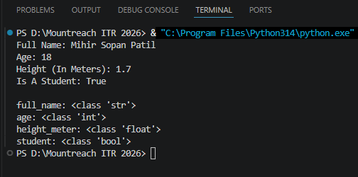

Program Code:

# Storing Information In Variables
full_name = "Mihir Sopan Patil" # stores a person's full name(String)
age = 18 # stores age in whole numbers(Integer)
height_meter = 1.7 # stores height in meters(Float)
student = True # stores student True/False information(Boolean)

# Printing The Data Stored In Variables
print("Full Name:", full_name)
print("Age:", age)
print("Height (In Meters):", height_meter)
print("Is A Student:", student)

# Checking Data Types Of Variables
print("\nfull_name:", type(full_name))
print("age:", type(age))
print("height_meter:", type(height_meter))
print("student:", type(student))

- Data Types
Write a Python program that:
- Creates one variable of each core data type: str, int, float, and bool.
- Prints each variable along with its data type using type().
Try converting the integer to float and float to integer. Print the results and explain the output.

Output:

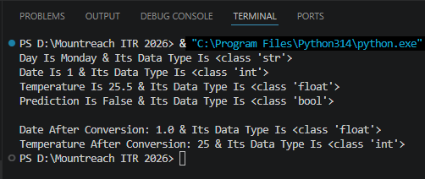

Program Code:

# Creates One Variable Of Each Core Data Type
day = "Monday" # String
date = 1 # Integer
temperature = 25.5 # Float
prediction = False # Boolean

# Prints Each Variable Along With Its Data Type Using type()
print("Day Is", day, "& Its Data Type Is", type(day))
print("Date Is", date, "& Its Data Type Is", type(date))
print("Temperature Is", temperature, "& Its Data Type Is", type(temperature))
print("Prediction Is", prediction, "& Its Data Type Is", type(prediction))

# Converting The Integer To Float & Float To Integer
date= float(date) # Converts Integer To Float
temperature= int(temperature) # Converts Float To Integer

# Print The Results
print("\nDate After Conversion:", date, "& Its Data Type Is", type(date))
print("Temperature After Conversion:", temperature, "& Its Data Type Is", type(temperature))

# After Converting The Integer To Float, The Value Of Date Becomes 1.0
# After Converting The Float To Integer, The Value Of Temperature Becomes 25 (The Decimal Part Is Removed)

- Operators - Arithmetic
Write a program that takes two numbers a = 15 and b = 4 and prints the results of:
- Addition, Subtraction, Multiplication, Division, Floor Division, Modulo, and Exponentiation.
Add comments explaining the difference between / and // operators with an example.

Output:

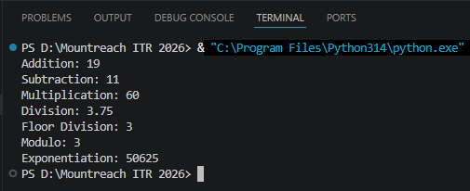

Program Code:

# Arithmetic Operators In Python
a = 15
b = 4

# Performing Arithmetic Operations
print("Addition:", a + b) # +
print("Subtraction:", a - b) # -
print("Multiplication:", a * b) # *
print("Division:", a / b) # /
print("Floor Division:", a // b) # //
print("Modulo:", a % b) # %
print("Exponentiation:", a ** b) # **

# / (Division) Returns The Exact Quotient As A Floating-Point Number.
# // (Floor Division) Returns The Quotient Rounded Down To The Nearest Whole Number.
- Operators - Comparison & Logical
Given:
x = 25
y = 30
z = 25
Write expressions using comparison and logical operators to check:
- Is x greater than y?
- Is x equal to z?
- Is x less than or equal to y AND y is not equal to z?
- Is x greater than y OR x equal to z?
Print all results with descriptive messages.
Output:

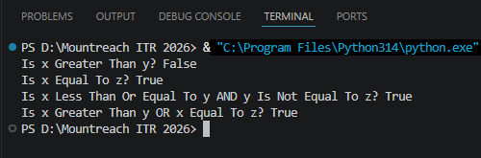

Program Code:

# Given Values
x = 25
y = 30
z = 25

# Is x Greater Than y?
print("Is x Greater Than y?", x > y) # False
# Is x Equal To z?
print("Is x Equal To z?", x == z) # True
# Is x Less Than Or Equal To y AND y Is Not Equal To z?
print("Is x Less Than Or Equal To y AND y Is Not Equal To z?", x <= y and y != z) # True
# Is x Greater Than y OR x Equal To z?
print("Is x Greater Than y OR x Equal To z?", x > y or x == z) # True

- Input/Output
Write a program that asks the user to input:
- Their name
- Their birth year
Then calculate and print their current age (assume current year is 2026). Use proper formatting and add comments explaining why you need to convert the input.
Output:
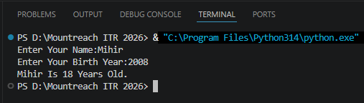

Program Code:

# Input From User
name = input("Enter Your Name:")
birth_year = int(input("Enter Your Birth Year:"))

#input() Always Returns String, Even If The User Types A Number
#To Do Arithmetic Operations, We Convert The String To An Integer Using int()

# Assume The Current Year Is 2026
current_year = 2026

# Calculate Age
age = current_year - birth_year

# Print The Result With Proper Formatting
print(name,"Is",age,"Years Old.")

- Combined - Variables, Operators & Input
Create a simple BMI Calculator:
- Take height (in meters) and weight (in kg) as input from the user.
- Calculate BMI using the formula: BMI = weight / (height ** 2)
- Print the BMI rounded to 2 decimal places.
Include appropriate comments.
Output:

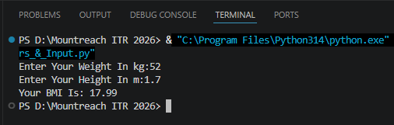

Program Code:

# BMI Calculator

# Take Weight & Height As Input From The User
weight = float(input("Enter Your Weight In kg:"))
height = float(input("Enter Your Height In m:"))

# Calculate BMI
BMI = weight / (height ** 2)

# Print The Result
print("Your BMI Is:", round(BMI, 2))

- Comments
Write a small program that calculates the area and perimeter of a rectangle.
- Take length and width as input.
- Use at least 5 meaningful comments (single-line and one multi-line comment).
- Follow good commenting practices (explain why, not what for obvious lines).

Output:

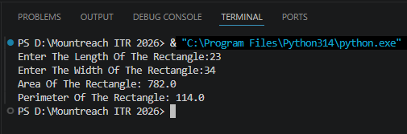

Program Code:

"""
This Program Calculates The Area & Perimeter Of A Rectangle.
The Results Help Us Understand The Size Of The Rectangle And The
Distance Around Its Boundary.
"""

# Taking Input As Float Allows Users To Enter Decimal Values If Needed
length = float(input("Enter The Length Of The Rectangle:"))
width = float(input("Enter The Width Of The Rectangle:"))

# Area Is Useful For Measuring The Space Inside The Rectangle
area = length * width

# Perimeter Is Useful For Finding The Total Distance Around The Rectangle
perimeter = 2 * (length + width)

# Displaying The Results In A Clear And User-Friendly Format
print("Area Of The Rectangle:", area)

# Showing The Perimeter Separately Makes The Output Easier To Read
print("Perimeter Of The Rectangle:", perimeter)

- Operators - Assignment & Membership
Given:
fruits = ["mango", "apple", "banana", "cherry"]
score = 50
Perform the following operations:
- Add 25 to score using assignment operator (+=).
- Check if "apple" is in the fruits list.
- Check if "grape" is not in the list.
Print all results with clear messages.
Output:

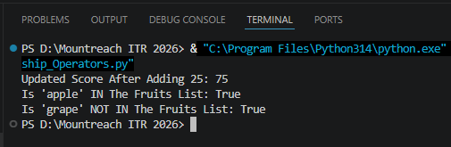

Program Code:

# Given List & Variable
fruits = ["mango", "apple", "banana", "cherry"]
score = 50

# Add 25 To Score Using The += Assignment Operator
score += 25 # score = score + 25
print("Updated Score After Adding 25:", score)

# Check If "apple" Is IN The Fruits List
has_apple = "apple" in fruits
print("Is 'apple' IN The Fruits List:", has_apple)

# Check If "grape" Is NOT IN The Fruits List
no_grape = "grape" not in fruits
print("Is 'grape' NOT IN The Fruits List:", no_grape)
- Mini Project - All Concepts
Write a Student Profile Generator program that:
- Takes input: name, age, city, and marks in 3 subjects.
- Calculates total marks and percentage.
- Prints a formatted profile with all information.
- Use meaningful variable names, proper comments, and different data types

Output:
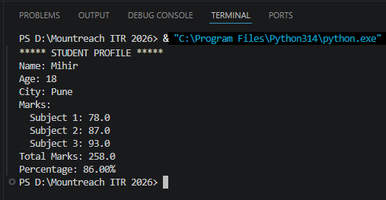

Program Code:

# Taking Input From The User For Student Profile
name = input("Enter Your Name:")
age = int(input("Enter Your Age:"))
city = input("Enter Your City:")

# Taking Marks For 3 Subjects
marks_subject1 = float(input("Enter Marks For Subject 1:"))
marks_subject2 = float(input("Enter Marks For Subject 2:"))
marks_subject3 = float(input("Enter Marks For Subject 3:"))

# Calculating Total Marks
total_marks = marks_subject1 + marks_subject2 + marks_subject3

# Calculating Percentage
percentage = (total_marks / 300) * 100 # Assuming Each Subject Is Of 100 Marks

# Printing The Student Profile
print("\n***** STUDENT PROFILE *****")
print("Name:", name)
print("Age:", age)
print("City:", city)
print("Marks:")
print(" Subject 1:", marks_subject1)
print(" Subject 2:", marks_subject2)
print(" Subject 3:", marks_subject3)
print("Total Marks:", total_marks)
print("Percentage:", f"{percentage:.2f}%")

- Debugging & Understanding
The following code has some issues. Correct it and add proper comments explaining the fixes:

Name = "Alice"
age 20
city = Amsterdam

print("My name is" + Name)
print("I am" age "years old")
print("I live in " city)

# Check if age is greater than 18 and print message

print("Adult:" age > 18)

Output:

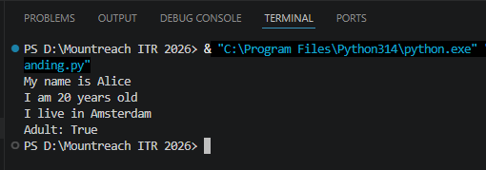

Program Code:

Name = "Alice"
age = 20 # Added Assignment Operator (=)
city = "Amsterdam" # Added Quotes Around Text

print("My name is " + Name) # Using + To Join Strings
print("I am", age, "years old") # Using Commas To Separate Values & Variables
print("I live in", city) # Using Commas To Separate Values & Variables

print("Adult:", age > 18) # Using A Comma In Print To Show Result Of Comparison

