Task 10: Session 10 (AIML) - Assignment Questions

Name: Mihir Sopan Patil
Domain: AIML
College & Branch Name: Zeal Polytechnic, Diploma In AIML

- Basic Class & Object
Create a class named Car with:
- Attributes: brand and model (set using init ).
- A method display_info() that prints the brand and model.
Create two objects of the Car class with different values and call the method for both.

Output:

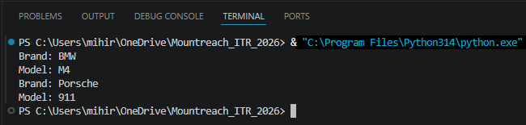

Program Code:

class Car:
def __init__(self, brand, model):
self.brand = brand
self.model = model

def display_info(self):
print("Brand:",self.brand)
print("Model:",self.model)

car1 = Car("BMW", "M4")
car2 = Car("Porsche", "911")
car1.display_info()
car2.display_info()

- Using init Constructor
Write a class Book that takes title, author, and price as parameters in init .
Create a method show_details() to print all the book information.
Create at least two book objects and display their details.

Output:

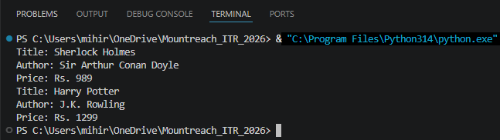

Program Code:

class Book:
def __init__(self, title, author, price):
self.title = title
self.author = author
self.price = price

def show_details(self):
print("Title:", self.title)
print("Author:", self.author)
print("Price: Rs.", self.price)

book1 = Book("Sherlock Holmes", "Sir Arthur Conan Doyle", 989)
book2 = Book("Harry Potter", "J.K. Rowling", 1299)
book1.show_details()
book2.show_details()

- Instance Methods & self
Create a class BankAccount with:
- Attributes: account_holder and balance (initialized in init ).
- Methods:
- deposit(amount) — add amount to balance.
- withdraw(amount) — subtract amount from balance (only if sufficient balance).
- show_balance() — print current balance.
Create an object and demonstrate all methods.

Output:

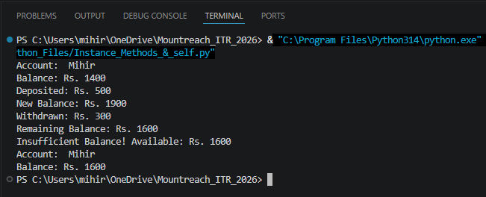
Program Code:

class BankAccount:
def __init__(self, account_holder, balance=0):
self.account_holder = account_holder
self.balance = balance

def deposit(self, amount):
self.balance += amount
print("Deposited: Rs.", amount)
print("New Balance: Rs.", self.balance)

def withdraw(self, amount):
if amount <= self.balance:
self.balance -= amount
print("Withdrawn: Rs.", amount)
print("Remaining Balance: Rs.", self.balance)
else:
print("Insufficient Balance! Available: Rs.", self.balance)

def show_balance(self):
print("Account: ", self.account_holder)
print("Balance: Rs.", self.balance)

acc = BankAccount("Mihir", 1400)
acc.show_balance()
acc.deposit(500)
acc.withdraw(300)
acc.withdraw(2000) # Should Fail -> Insufficient Balance
acc.show_balance()

- Method With Parameters
Create a class Student with attributes name and marks.
Add a method calculate_grade() that returns "Pass" if marks ≥ 40, otherwise "Fail".
Create 3 student objects, display their details, and print their grades.

Output:

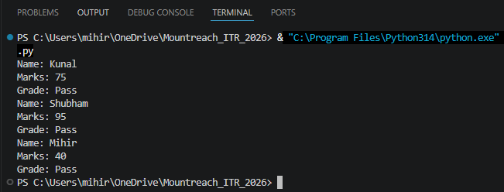

Program Code:

class Student:
def __init__(self, name, marks):
self.name = name
self.marks = marks

def calculate_grade(self):
if self.marks >= 40:
return "Pass"
else:
return "Fail"

def display(self):
print("Name:", self.name)
print("Marks:", self.marks)
print("Grade:",self.calculate_grade())

s1 = Student("Kunal",75)
s1.display()
s2 = Student("Shubham",95)
s2.display()
s3 = Student("Mihir",40)
s3.display()

- Multiple Methods
Create a class Employee with:
- Attributes: name, salary (use init ).
- Methods:
- display_details()
- give_raise(amount) — increase salary and print new salary.
- yearly_bonus() — return 10% of current salary.
Create an employee object and demonstrate all methods.

Output:

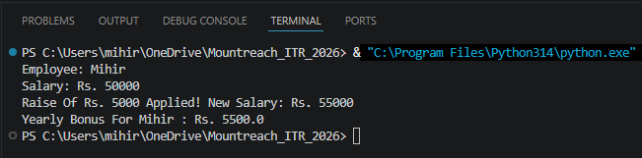

Program Code:

class Employee:
def __init__(self, name, salary):
self.name = name
self.salary = salary

def display_details(self):
print("Employee:", self.name)
print("Salary: Rs.",self.salary)

def give_raise(self, amount):
self.salary += amount
print("Raise Of Rs.", amount, "Applied! New Salary: Rs.", self.salary)

def yearly_bonus(self):
bonus = self.salary * 0.10
print("Yearly Bonus For", self.name, ": Rs.", bonus)

emp = Employee("Mihir", 50000)
emp.display_details()
emp.give_raise(5000)
emp.yearly_bonus()

- Real - World Object Modeling
Create a class MobilePhone with attributes: brand, model, battery_percentage.
Add these methods:
- charge(percent) — increase battery.
- use_phone(minutes) — reduce battery by 1% per 10 minutes.
- show_status() — print current status.
Create an object and simulate some usage.

Output:

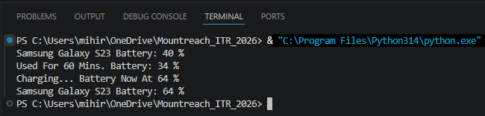

Program Code:
class MobilePhone:
def __init__(self, brand, model, battery_percentage):
self.brand = brand
self.model = model
self.battery_percentage = battery_percentage

def charge(self, percent):
self.battery_percentage = min(100, self.battery_percentage + percent)
print("Charging... Battery Now At", self.battery_percentage, "%")

def use_phone(self, minutes):
drain = minutes // 10 # 1% Battery Drained Per 10 Minutes
self.battery_percentage = max(0, self.battery_percentage - drain)
print("Used For", minutes, "Mins. Battery:", self.battery_percentage, "%")

def show_status(self):
print(self.brand, self.model, "Battery:", self.battery_percentage, "%")

phone = MobilePhone("Samsung", "Galaxy S23", 40)
phone.show_status()
phone.use_phone(60) # Drains 6%
phone.charge(30) # Charges To 64%
phone.show_status()
- Combining Concepts
Create a class Rectangle with attributes length and width.
Add methods:
- area() — return the area.
- perimeter() — return the perimeter.
- display() — print length, width, area, and perimeter.
Take input from user for length and width, create object, and display results.

Output:

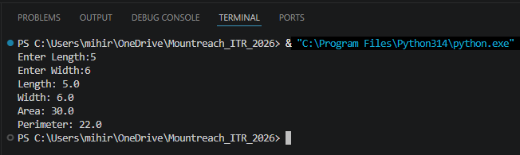

Program Code:
class Rectangle:
def __init__(self, length, width):
self.length = length
self.width = width

def area(self):
return self.length * self.width

def perimeter(self):
return 2 * (self.length + self.width)

def display(self):
print("Length:", self.length)
print("Width:", self.width)
print("Area:", self.area())
print("Perimeter:", self.perimeter())

l = float(input("Enter Length:"))
w = float(input("Enter Width:"))
rect = Rectangle(l, w)
rect.display()
- Updating Attributes
Create a class Player with attributes name, score, and level.
Add methods:
- increase_score(points)
- level up () - increase level by 1.
- show_progress()
Create an object, update score and level multiple times, and show progress.

Output:

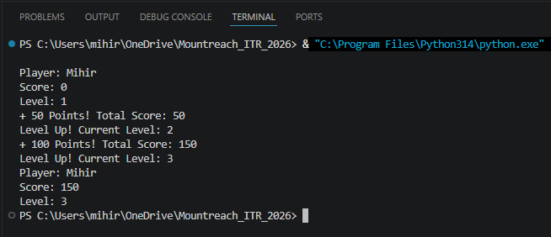

Program Code:

class Player:
def __init__(self, name, score=0, level=1):
self.name = name
self.score = score
self.level = level

def increase_score(self, points):
self.score += points
print("+", points, "Points! Total Score:", self.score)

def level_up(self):
self.level += 1
print("Level Up! Current Level:", self.level)

def show_progress(self):
print("Player:", self.name)
print("Score:", self.score)
print("Level:", self.level)

player = Player("Mihir")
player.show_progress()
player.increase_score(50)
player.level_up()
player.increase_score(100)
player.level_up()
player.show_progress()

- Debugging OOP Code
The following code has errors. Correct it and add proper comments explaining the fixes:
class Person:
def __init__(name, age):
name = name
age = age

def introduce():
print("My name is" name "and I am" age "years old.")

p1 = Person("Rahul", 25)
p1.introduce()

Output:

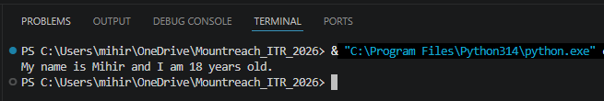

Program Code:

class Person:
def __init__(self, name, age): # Fix 1: Added 'self'
self.name = name # Fix 2: self.name Stores The Attribute
self.age = age # Fix 2: elf.age Stores The Attribute

def introduce(self): # Fix 3: Added 'self'
# Fix 4: f-string For Proper String Formatting
print(f"My name is {self.name} and I am {self.age} years old.")

p1 = Person("Mihir", 18)
p1.introduce()

- Mini Project - Combined Concepts
Create a Simple Library Management System using OOP:
Design a class Book with:
- Attributes: title, author, status ("Available" or "Issued").
- Methods: issue_book(), return_book(), show_info().
Create multiple book objects and demonstrate issuing/returning books with proper messages.
Use a menu (while loop) to allow the user to:
- Add a new book
- Issue a book
- Return a book
- Show all books
- Exit

Output:

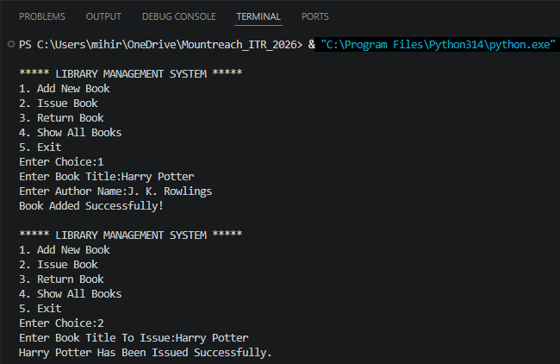

Program Code:

class Book:
def __init__(self):
self.title = input("Enter Book Title:")
self.author = input("Enter Author Name:")
self.status = "Available"

def issue_book(self):
if self.status == "Available":
self.status = "Issued"
print(self.title, "Has Been Issued Successfully.")
else:
print(self.title, "Is Already Issued.")

def return_book(self):
if self.status == "Issued":
self.status = "Available"
print(self.title, "Has Been Returned Successfully.")
else:
print(self.title, "Was Not Issued.")

def show_info(self):
print("\nTitle :", self.title)
print("Author :", self.author)
print("Status :", self.status)

library = []

def add_book():
book = Book()
library.append(book)
print("Book Added Successfully!")

def issue_book():
title = input("Enter Book Title To Issue:")

for book in library:
if book.title == title:
book.issue_book()
return

print("Book Not Found!")

def return_book():
title = input("Enter Book Title To Return:")

for book in library:
if book.title == title:
book.return_book()
return

print("Book Not Found!")

def show_all_books():
if len(library) == 0:
print("No Books Available.")
else:
for book in library:
book.show_info()

while True:
print("\n***** LIBRARY MANAGEMENT SYSTEM *****")
print("1. Add New Book")
print("2. Issue Book")
print("3. Return Book")
print("4. Show All Books")
print("5. Exit")

choice = input("Enter Choice:")

if choice == "1":
add_book()

elif choice == "2":
issue_book()

elif choice == "3":
return_book()

elif choice == "4":
show_all_books()

elif choice == "5":
print("Exiting Program...")
break

else:
print("Invalid Choice!")

