Task 10: Session 10 (AIML) - Assignment Questions

Name: Mihir Sopan Patil
Domain: AIML
College & Branch Name: Zeal Polytechnic, Diploma In AIML

- Basic Class & Object
Create a class named Car with:
- Attributes: brand and model (set using init ).
- A method display_info() that prints the brand and model.
Create two objects of the Car class with different values and call the method for both.

Output:

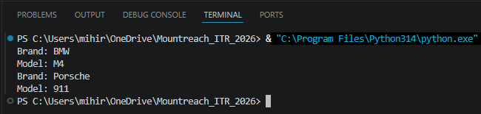

- Using init Constructor
Write a class Book that takes title, author, and price as parameters in init .
Create a method show_details() to print all the book information.
Create at least two book objects and display their details.

Output:

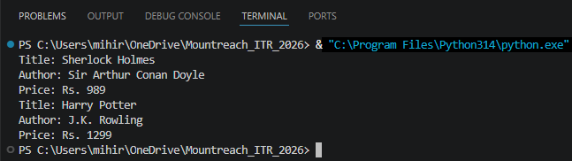

- Instance Methods & self
Create a class BankAccount with:
- Attributes: account_holder and balance (initialized in init ).
- Methods:
- deposit(amount) — add amount to balance.
- withdraw(amount) — subtract amount from balance (only if sufficient balance).
- show_balance() — print current balance.
Create an object and demonstrate all methods.

Output:

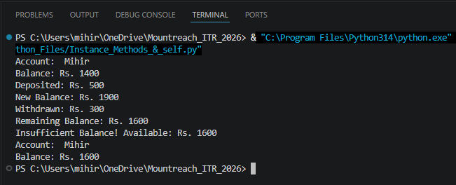

- Method With Parameters
Create a class Student with attributes name and marks.
Add a method calculate_grade() that returns "Pass" if marks ≥ 40, otherwise "Fail".
Create 3 student objects, display their details, and print their grades.

Output:

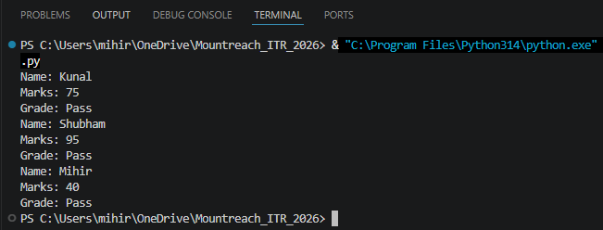

- Multiple Methods
Create a class Employee with:
- Attributes: name, salary (use init ).
- Methods:
- display_details()
- give_raise(amount) — increase salary and print new salary.
- yearly_bonus() — return 10% of current salary.
Create an employee object and demonstrate all methods.

Output:

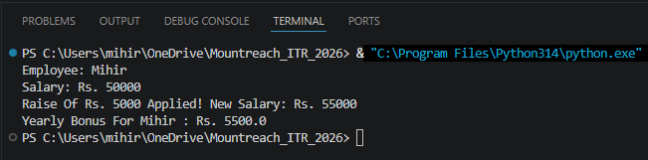

- Real - World Object Modeling
Create a class MobilePhone with attributes: brand, model, battery_percentage.
Add these methods:
- charge(percent) — increase battery.
- use_phone(minutes) — reduce battery by 1% per 10 minutes.
- show_status() — print current status.
Create an object and simulate some usage.

Output:

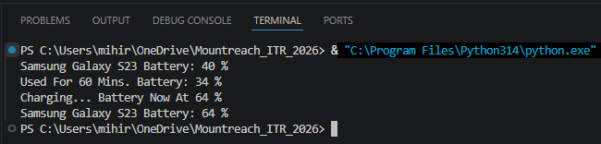

- Combining Concepts
Create a class Rectangle with attributes length and width.
Add methods:
- area() — return the area.
- perimeter() — return the perimeter.
- display() — print length, width, area, and perimeter.
Take input from user for length and width, create object, and display results.

Output:

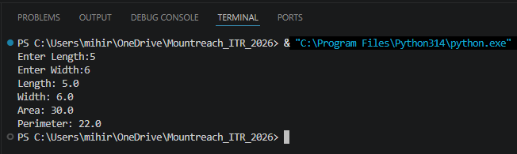

- Updating Attributes
Create a class Player with attributes name, score, and level.
Add methods:
- increase_score(points)
- level up () - increase level by 1.
- show_progress()
Create an object, update score and level multiple times, and show progress.

Output:

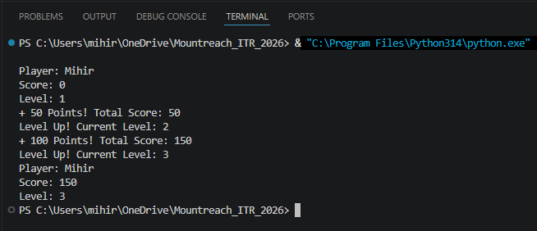

- Debugging OOP Code
The following code has errors. Correct it and add proper comments explaining the fixes:
class Person:
def __init__(name, age):
name = name
age = age

def introduce():
print("My name is" name "and I am" age "years old.")

p1 = Person("Rahul", 25)
p1.introduce()

Output:

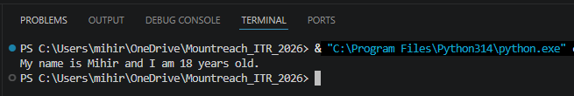

- Mini Project - Combined Concepts
Create a Simple Library Management System using OOP:
Design a class Book with:
- Attributes: title, author, status ("Available" or "Issued").
- Methods: issue_book(), return_book(), show_info().
Create multiple book objects and demonstrate issuing/returning books with proper messages.
Use a menu (while loop) to allow the user to:
- Add a new book
- Issue a book
- Return a book
- Show all books
- Exit

Output:

