Task 11: Session 11 (AIML) - Assignment Questions

Name: Mihir Sopan Patil
Domain: AIML
College & Branch Name: Zeal Polytechnic, Diploma In AIML

- Basic try-except
Write a program that takes two numbers as input from the user and prints their division.
Use try-except to handle the case when the user enters non-numeric input (ValueError).
Print a friendly message if an error occurs.

Output:

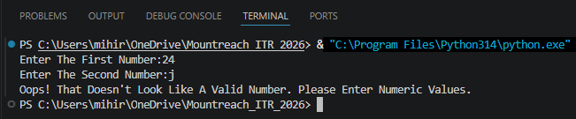

Program Code:

try:
num1 = float(input("Enter The First Number:"))
num2 = float(input("Enter The Second Number:"))
result = num1 / num2
print("Result Of Division:", result)
except ValueError:
print("Oops! That Doesn't Look Like A Valid Number. Please Enter Numeric Values.")

- Handling ZeroDivisionError
Write a program that divides two numbers entered by the user.
Use try-except to specifically catch ZeroDivisionError and print: "Error: Division by zero is not allowed."
Also handle ValueError for invalid input.

Output:

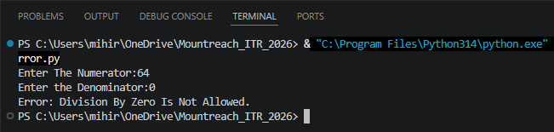

Program Code:

try:
num1 = float(input("Enter The Numerator:"))
num2 = float(input("Enter the Denominator:"))
result = num1 / num2
print("Result:", result)
except ZeroDivisionError:
print("Error: Division By Zero Is Not Allowed.")
except ValueError:
print("Error: Invalid Input. Please Enter Numeric Values Only.")

- Multiple except Blocks
Create a program that performs division and also tries to convert a string to integer.
Handle both ValueError and ZeroDivisionError with separate except blocks and appropriate messages.

Output:

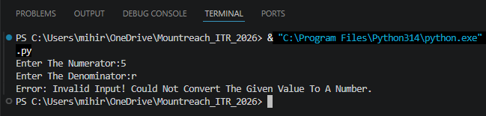
Program Code:

try:
num1 = float(input("Enter The Numerator:"))
num2 = float(input("Enter The Denominator:"))
result = num1 / num2 # May Raise ZeroDivisionError

text = input("Enter A String To Convert To Integer:")
converted = int(text) # May Raise ValueError
print("Division Result:", result, "Converted Integer:", converted)

except ValueError:
# Triggered When Input Cannot Be Converted To The Expected Numeric Type
print("Error: Invalid Input! Could Not Convert The Given Value To A Number.")
except ZeroDivisionError:
# Triggered When The Denominator Is Zero
print("Error: You Cannot Divide A Number By Zero!")

- Using else
Write a program that takes two numbers and divides them.
Use try, except, and else.
The else block should print "Division performed successfully!" only when no exception occurs.

Output:

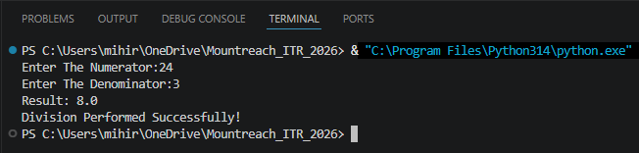

Program Code:

try:
num1 = float(input("Enter The Numerator:"))
num2 = float(input("Enter The Denominator:"))
result = num1 / num2
except ValueError:
print("Error: Please Enter Valid Numeric Values.")
except ZeroDivisionError:
print("Error: Division By Zero Is Not Allowed.")
else:
# The else Block Runs Only When No Exception Was Raised In The try Block
print("Result:", result)
print("Division Performed Successfully!")

- Using finally
Modify the division program to include a finally block that always prints: "Program execution completed."
Demonstrate that finally runs whether an exception occurs or not.
Add comments explaining the purpose of finally.
Output:

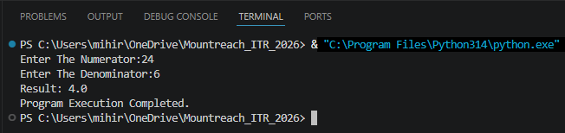

Program Code:

try:
num1 = float(input("Enter The Numerator:"))
num2 = float(input("Enter The Denominator:"))
result = num1 / num2
print("Result:", result)
except ValueError:
print("Error: Invalid input. Please Enter Numbers Only.")
except ZeroDivisionError:
print("Error: Division By Zero Is Not Allowed.")
finally:
# The finally Block Always Executes Regardless Of Whether An Exception Occurred Or Not.
print("Program Execution Completed.")

- Combined try-except-else-finally
Write a complete division program using all four blocks (try, except, else, finally):
- Handle ValueError and ZeroDivisionError.
- Print success message in else.
- Always thank the user in finally.

Output:

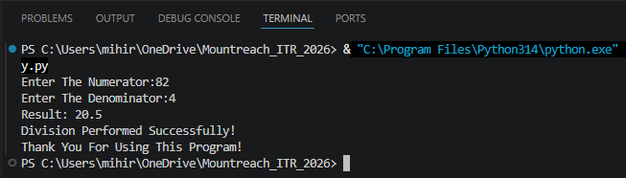

Program Code:

try:
num1 = float(input("Enter The Numerator:"))
num2 = float(input("Enter The Denominator:"))
result = num1 / num2
except ValueError:
# Handles Non-Numeric Input
print("Error: Please Enter Valid Numeric Values.")
except ZeroDivisionError:
# Handles Division By Zero
print("Error: Division By Zero Is Not Allowed.")
else:
# Runs Only When The try Block Succeeds Without Any Exception
print("Result:", result)
print("Division Performed Successfully!")
finally:
# Always Runs - Good Place To Thank The User Or Clean Up Resources
print("Thank You For Using This Program!")

- Practical - Age Input
Write a program that asks the user for their age.
- Convert the input to integer.
- If the age is negative, raise a ValueError with message "Age cannot be negative."
- Handle the exception gracefully and print a suitable message.

Output:

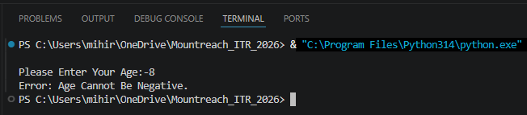

Program Code:
try:
age = int(input("Please Enter Your Age:"))
if age < 0:
# Manually Raising A ValueError With A Descriptive Message
raise ValueError("Age Cannot Be Negative.")
print("Your Age Is:", age)
except ValueError as e:
# As e Captures The Exception Object So We Can Print Its Message
print("Error:", e)

- Multiple Exceptions In One Block
Create a program that:
- Takes a number as input.
- Divides 100 by that number.
- Handle both ValueError and ZeroDivisionError in a single except block using a tuple.
Print a combined error message.

Output:

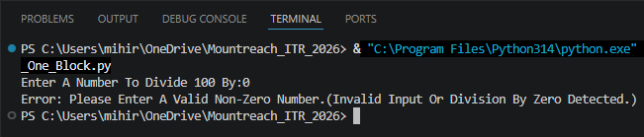

Program Code:

try:
num = float(input("Enter A Number To Divide 100 By:"))
result = 100 / num
print("Result:", result)
except (ValueError, ZeroDivisionError):
# A Single except Block Handling Two Exception Types Via A Tuple
print("Error: Please Enter A Valid Non-Zero Number."
"(Invalid Input Or Division By Zero Detected.)")

- Debugging Exception Code
The following code has issues. Correct it and add comments explaining the fixes:
try
num = int(input("Enter a number: "))
result = 100 / num
print("Result:", result)
except ValueError
print("Please enter a valid number")
except:
print("Some error occurred")

Output:

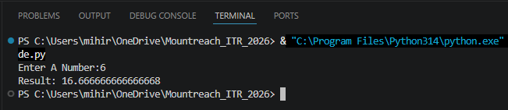

Program Code:

try: # Fix 1: Added ':'
num = int(input("Enter A Number:"))
result = 100 / num
print("Result:", result)
except ValueError: # Fix 2: Added ':'
print("Please Enter A Valid Number")
except ZeroDivisionError: # Fix 3: Added specific handler
print("Error: Cannot Divide By Zero!")
except Exception as e: # Generic Catch-Allj
print("Some Error Occurred:", e)

- Mini Project - Exception Handling
Create a Simple Calculator with exception handling:
The program should run in a loop and show this menu:
- Addition
- Subtraction
- Multiplication
- Division
- Exit
- Take user choice and two numbers.
- Perform the operation inside try block.
- Handle ValueError (invalid input) and ZeroDivisionError (for division).
- Use finally to print "Operation attempted." after every calculation.
- Continue until user chooses to exit.

Output:

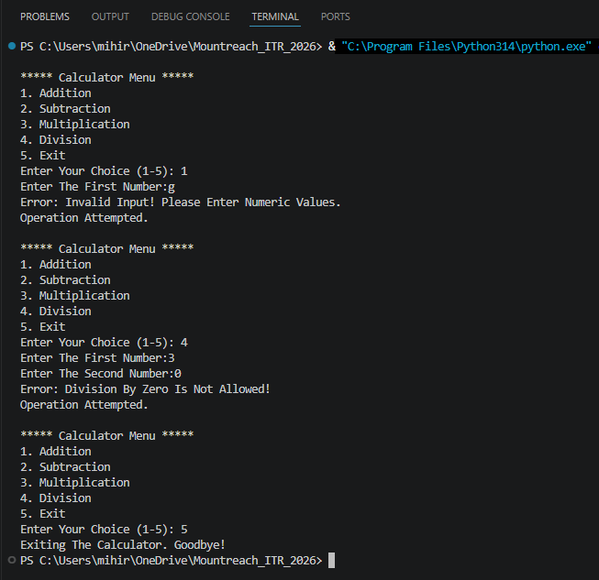

Program Code:

while True:
# Display menu
print("\n***** Calculator Menu *****")
print("1. Addition")
print("2. Subtraction")
print("3. Multiplication")
print("4. Division")
print("5. Exit")

choice = input("Enter Your Choice (1-5): ")

# Exit Condition Checked Before Entering Try Block
if choice == "5":
print("Exiting The Calculator. Goodbye!")
break

try:
num1 = float(input("Enter The First Number:"))
num2 = float(input("Enter The Second Number:"))

if choice == "1":
result = num1 + num2
print(f"Result: {num1} + {num2} = {result}")
elif choice == "2":
result = num1 - num2
print(f"Result: {num1} - {num2} = {result}")
elif choice == "3":
result = num1 * num2
print(f"Result: {num1} × {num2} = {result}")
elif choice == "4":
result = num1 / num2 # May Raise ZeroDivisionError
print(f"Result: {num1} / {num2} = {result}")
else:
print("Invalid Choice! Please Select A Number Between 1 & 5.")

except ValueError:
# Triggered When The User Enters Non-Numeric Input For A Number
print("Error: Invalid Input! Please Enter Numeric Values.")
except ZeroDivisionError:
# Triggered Only For Division When The Denominator Is Zero
print("Error: Division By Zero Is Not Allowed!")
finally:
# Runs After Every Iteration Regardless Of Success Or Error
print("Operation Attempted.")

