Task 11: Session 11 (AIML) - Assignment Questions

Name: Mihir Sopan Patil
Domain: AIML
College & Branch Name: Zeal Polytechnic, Diploma In AIML

- Basic try-except
Write a program that takes two numbers as input from the user and prints their division.
Use try-except to handle the case when the user enters non-numeric input (ValueError).
Print a friendly message if an error occurs.

Output:

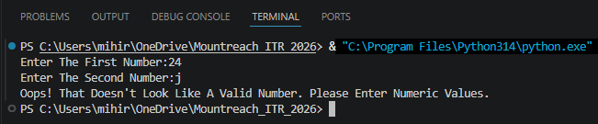

- Handling ZeroDivisionError
Write a program that divides two numbers entered by the user.
Use try-except to specifically catch ZeroDivisionError and print: "Error: Division by zero is not allowed."
Also handle ValueError for invalid input.

Output:

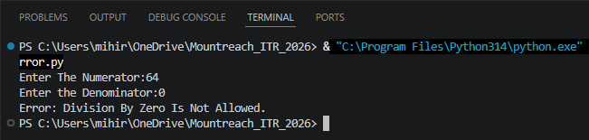

- Multiple except Blocks
Create a program that performs division and also tries to convert a string to integer.
Handle both ValueError and ZeroDivisionError with separate except blocks and appropriate messages.

Output:

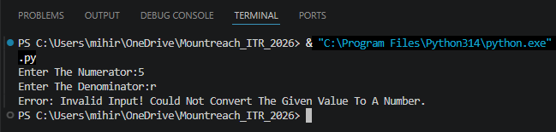

- Using else
Write a program that takes two numbers and divides them.
Use try, except, and else.
The else block should print "Division performed successfully!" only when no exception occurs.

Output:

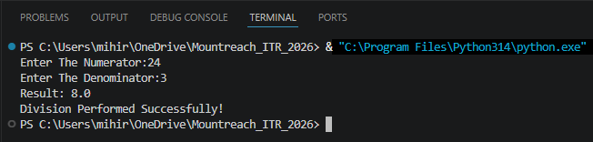

- Using finally
Modify the division program to include a finally block that always prints: "Program execution completed."
Demonstrate that finally runs whether an exception occurs or not.
Add comments explaining the purpose of finally.
Output:

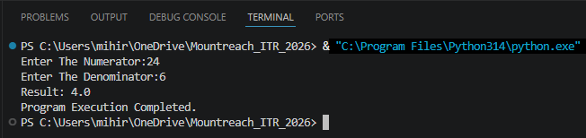

- Combined try-except-else-finally
Write a complete division program using all four blocks (try, except, else, finally):
- Handle ValueError and ZeroDivisionError.
- Print success message in else.
- Always thank the user in finally.

Output:

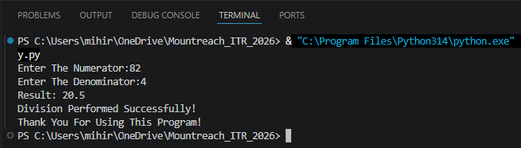

- Practical - Age Input
Write a program that asks the user for their age.
- Convert the input to integer.
- If the age is negative, raise a ValueError with message "Age cannot be negative."
- Handle the exception gracefully and print a suitable message.

Output:

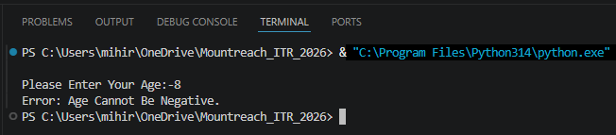

- Multiple Exceptions In One Block
Create a program that:
- Takes a number as input.
- Divides 100 by that number.
- Handle both ValueError and ZeroDivisionError in a single except block using a tuple.
Print a combined error message.

Output:

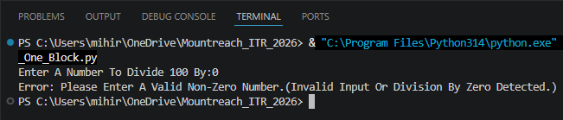

- Debugging Exception Code
The following code has issues. Correct it and add comments explaining the fixes:
try
num = int(input("Enter a number: "))
result = 100 / num
print("Result:", result)
except ValueError
print("Please enter a valid number")
except:
print("Some error occurred")

Output:

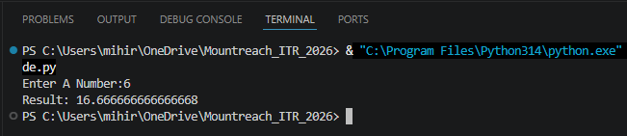

- Mini Project - Exception Handling
Create a Simple Calculator with exception handling:
The program should run in a loop and show this menu:
- Addition
- Subtraction
- Multiplication
- Division
- Exit
- Take user choice and two numbers.
- Perform the operation inside try block.
- Handle ValueError (invalid input) and ZeroDivisionError (for division).
- Use finally to print "Operation attempted." after every calculation.
- Continue until user chooses to exit.

Output:

