Task 2: Session 2 (AIML) - Assignment Questions

Name: Mihir Sopan Patil
Domain: AIML
College & Branch Name: Zeal Polytechnic, Diploma In AIML

- if Statement
Write a program that asks the user to enter their age.
If the age is 18 or more, print the message: "You are eligible to vote."
(Do not print anything if the condition is False).
Add comments.

Output:

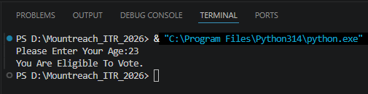

Program Code:

# Take Age As Input From User & Convert It To Integer
age = int(input("Please Enter Your Age:"))

# Check If The Age Is 18 Or More
if age >= 18:
print("You Are Eligible To Vote.") # Print Message Only If The Condition Is True

- if - else Statement
Write a program that takes a number as input from the user and checks whether it is even or odd.
Print "Even Number" or "Odd Number" accordingly.

Output:

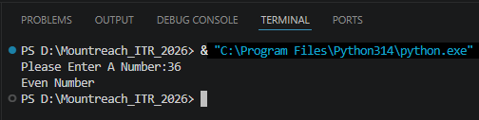

Program Code:

# Take Number As Input From User & Convert It To Integer
number = int(input("Please Enter A Number:"))

# Check If The Number Is Divisible By 2
if number % 2 == 0:
print("Even Number") # If Remainder Is 0, So The Number Is Even
else:
print("Odd Number") # Or ELse The Number Is Odd

- if - elif - else Statement
Write a program to assign grades based on marks entered by the user:
- Marks ≥ 90 → "Grade A - Excellent"
- Marks ≥ 75 → "Grade B - Good"
- Marks ≥ 60 → "Grade C - Average"
- Marks ≥ 40 → "Grade D - Pass"
- Marks < 40 → "Fail"
Use if-elif-else and print the appropriate grade message.

Output:

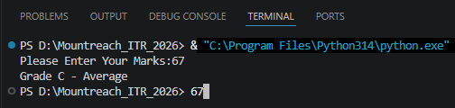

Program Code:

# Take Marks As Input From User & Convert It To Integer
marks = int(input("Please Enter Your Marks:"))

# Assigning Grade Based On Marks
if marks >= 90:
print("Grade A - Excellent") # If Marks Are 90 Or Above -> Grade A
elif marks >= 75:
print("Grade B - Good") # If Marks Are Between 75 & 89 -> Grade B
elif marks >= 60:
print("Grade C - Average") # If Marks Are Between 60 & 74 -> Grade C
elif marks >= 40:
print("Grade D - Pass") # If Marks Are Between 40 & 59 -> Grade D
else:
print("Fail") # Or Else Marks Are Below 40 -> Fail

- for Loop With Range
Write a program using for loop and range() to:
- Print all numbers from 1 to 30.
- Print all odd numbers from 1 to 50.
- Print the sum of numbers from 1 to 15.
Add comments explaining the use of range().

Output:

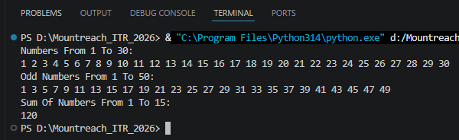

Program Code:

# Print All Numbers From 1 To 30
print("Numbers From 1 To 30:")
for number in range(1, 31): # Starts At 1, Stops Before 31
print(number, end=" ")

# Print All Odd Numbers From 1 To 50
print("\nOdd Numbers From 1 To 50:")
for number in range(1, 51, 2): # Starts At 1, Stops Before 51, Step Size 2 (Only Odd Numbers)
print(number, end=" ")

# Print The Sum Of Numbers From 1 To 15
print("\nSum Of Numbers From 1 To 15:")
sum = 0
for number in range(1, 16): # Starts At 1, Stops Before 16
sum = sum + number # Add Each Number To The Running Total
print(sum) # Print The Final Sum After The Loop Ends

- While Loop
Write a program using while loop to print the following:
- Numbers from 1 to 20.
- Also print the cube of each number (i.e., 1³, 2³, 3³, ...).
Stop when the number exceeds 20.

Output:

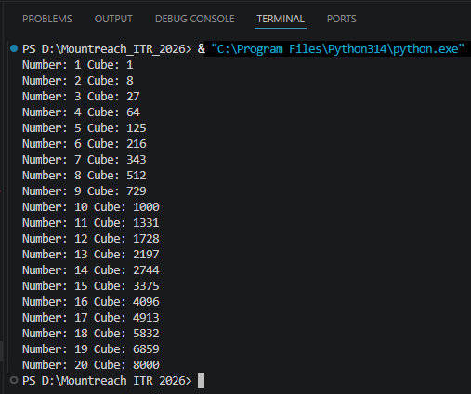

Program Code:

# Initialize The Counter Variable To 1
number = 1

# The While Loop Runs As Long As Number Is 20 Or Less
while number <= 20:

# Cube Of The Current Number
cube = number ** 3

# Print The Number And Its Cube Side By Side
print("Number:", number, "Cube:", cube)

# Increment The Counter By 1 To Move To The Next Number
number = number + 1

- while Loop - User Controlled
Write a program that repeatedly asks the user to enter a positive number.
Keep adding the entered numbers to a running total. Stop when the user enters a negative number or zero. Finally, print the total sum.

Output:

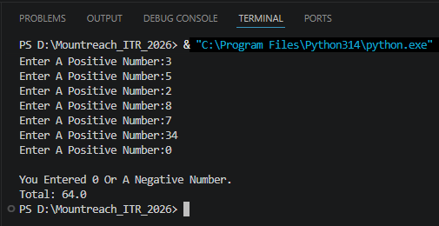

Program Code:

# Initialize The Total To 0
total = 0

# Take Input From The User For The First Number Before Entering The Loop
number = float(input("Enter A Positive Number:"))

# Keep Looping Until The User Enters A Positive Number
while number > 0:

# Add The Entered Number To The Total
total = total + number

# Ask The User For The Next Number
number = float(input("Enter A Positive Number:"))

print("\nYou Entered 0 Or A Negative Number.")
print("Total:", total)
- Nested if Statement
Write a program that takes two inputs:
- temperature (integer)
- is_raining (enter "yes" or "no")
Then give advice using nested if:
- If temperature > 30 and not raining → "Hot day, wear light clothes."
- If temperature > 30 and raining → "Hot and rainy, carry umbrella."
- If temperature < 15 and raining → "Cold and rainy, wear jacket and take umbrella."
- Else give a suitable message.

Output:

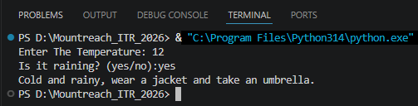

Program Code:

# Take Inputs From The User
temperature = int(input("Enter The Temperature: "))
is_raining = input("Is it raining? (yes/no):")

# Outer if: Check If Temperature Is Above 30 (Hot)
if temperature > 30:

# Inner if: Check Rain Condition When It Is Hot
if is_raining == "no":
# If Hot & No Rain
print("Hot day, wear light clothes.")
else:
# Or Else Hot & Raining
print("Hot and rainy, carry an umbrella.")

# Outer elif: Check If Temperature Is Below 15 (Cold)
elif temperature < 15:

# Inner if: Check Rain Condition When It Is Cold
if is_raining == "yes":
# If Cold & Raining
print("Cold and rainy, wear a jacket and take an umbrella.")
else:
# Or Else Cold But No Rain
print("Cold day, wear a warm jacket.")

# Outer else: Temperature Is Between 15 & 30
else:
# Inner if: Check Rain Condition For Mild Weather
if is_raining == "yes":
# If Mild Temperature But Raining
print("Mild but rainy, a light raincoat will do.")
else:
# Or Else Mild Temperature But No Rain
print("Nice weather, enjoy your day!")

- for Loop + if – elif - else
Write a program using for loop that goes from 1 to 40 and:
- Prints "Fizz" if number is divisible by 3
- Prints "Buzz" if number is divisible by 5
- Prints "FizzBuzz" if divisible by both 3 and 5
Otherwise prints the number

Output:

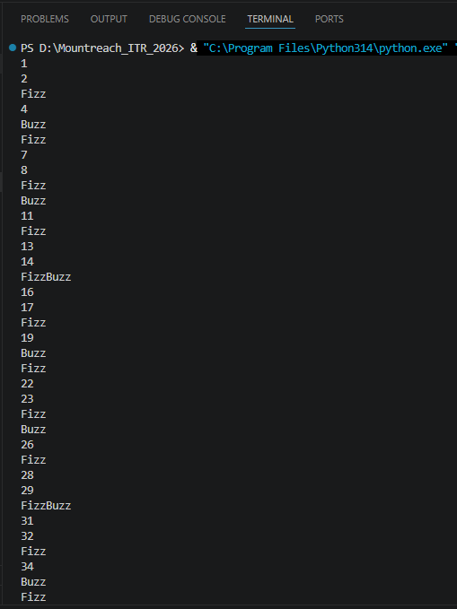

Program Code:

# Starts At 1, Stops Before 41
for number in range(1, 41):

# Check Divisibility By Both 3 & 5
if number % 3 == 0 and number % 5 == 0:
print("FizzBuzz") # If Divisible By Both 3 & 5

# Check Divisibility By 3 Only
elif number % 3 == 0:
print("Fizz") # If Divisible By 3 Only

# Check Divisibility By 5 Only
elif number % 5 == 0:
print("Buzz") # If Divisible By 5 Only

else:
print(number) # Or Else Just Print The Number

- Menu Driven Program
Create a simple calculator using while loop and if-elif-else:
Display this menu repeatedly:

- Add two numbers
- Subtract two numbers
- Multiply two numbers
- Divide two numbers
- Exit
- Ask user for choice.
- Take two numbers as input.
- Perform the operation.
- Continue until user chooses 5 (Exit).
- Handle division by zero case.
Output:

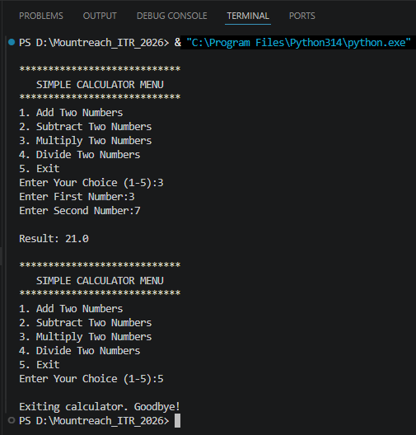
Program Code:

# The while Loop Keeps The Menu Running Until The User Chooses To Exit
while True:

# Display The Menu Repeatedly
print("\n****************************")
print(" SIMPLE CALCULATOR MENU ")
print("****************************")
print("1. Add Two Numbers")
print("2. Subtract Two Numbers")
print("3. Multiply Two Numbers")
print("4. Divide Two Numbers")
print("5. Exit")

# Take Input From User For Menu Choice
choice = int(input("Enter Your Choice (1-5):"))

# Exit The Program If The User Chooses 5
if choice == 5:
print("\nExiting calculator. Goodbye!")
break # break Exits The While Loop Immediately

# For Choices 1 To 4, Take Two Numbers As Input
elif choice in [1, 2, 3, 4]:
num1 = float(input("Enter First Number:"))
num2 = float(input("Enter Second Number:"))

# Perform The Operation Based On The User's Choice
if choice == 1:
result = num1 + num2 # Addition
print("\nResult:", result)

elif choice == 2:
result = num1 - num2 # Subtraction
print("\nResult:", result)

elif choice == 3:
result = num1 * num2 # Multiplication
print("\nResult:", result)

elif choice == 4:
# Handle Division By Zero Before Performing The Operation
if num2 == 0:
print("\nError: Cannot Divide By Zero!")
else:
result = num1 / num2 # Division
print("\nResult:", result)

# Handle Any Invalid Menu Choice (Not 1 To 5)
else:
print("\nInvalid Choice! Please Enter A Number Between 1 And 5.")

- Debugging
The following code contains several errors. Correct the program and add meaningful comments explaining each fix:
num = input("Enter a number: ")
if num
100
print("Large number") elif num > 50
print("Medium number") else
print("Small number")
count = 1
while count < 10 print(count)
count 1
+
>

Output:

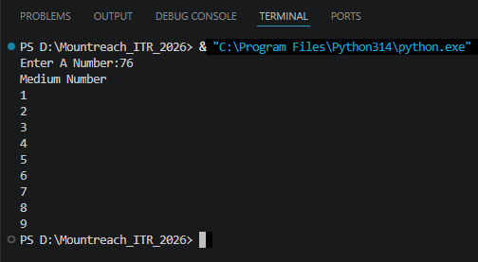

Program Code:

num = int(input("Enter A Number:")) # int() To Convert String Input To integer

if num > 100: # Added missing colon (:)
print("Large Number")

elif num > 50: # Added missing colon (:)
print("Medium Number")

else: # Added missing colon (:)
print("Small Number")

count = 1
while count < 10: # Added missing colon (:)
print(count)
count = count + 1 # Fixed count+1 To count=count+1 To Increment The Variable

