Task 4: Session 4 (AIML) - Assignment Questions

Name: Mihir Sopan Patil
Domain: AIML
College & Branch Name: Zeal Polytechnic, Diploma In AIML

- Lambda Function
Write a lambda function named square that takes a number x and returns its square.
Call the lambda function with input from the user and print the result.
Also write the same logic using a normal def function and compare both in comments.
Output:

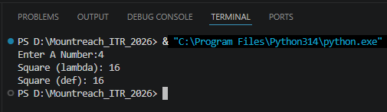

Program Code:
# Lambda Function
# Lambda: square = lambda x: x ** 2 -> Single-Line, No Name Needed Internally
# Use lambda For Short, Throwaway Operations (e.g., Inside Map/Filter/Sorted).
square = lambda x: x ** 2

# Normal def Function For Comparison
# Def: def square_def(x): -> Multi-Line, Readable
# Use def For Anything Reusable, Complex, Or That Needs Documentation.
def square_def(x):
return x ** 2

number = int(input("Enter A Number:"))

print("Square (lambda):", square(number))
print("Square (def):", square_def(number))
- Lambda With Multiple Arguments
Create a lambda function add_three(a, b, c) that returns the sum of three numbers.
Take three numbers as input from the user and print their sum using this lambda function.

Output:

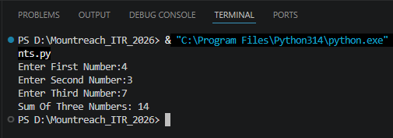

Program Code:

# Lambda Function With Multiple Arguments
add_three = lambda a, b, c: a + b + c

a = int(input("Enter First Number:"))
b = int(input("Enter Second Number:"))
c = int(input("Enter Third Number:"))
print("Sum Of Three Numbers:", add_three(a, b, c))

- For Loop Revision
Write a program using a for loop and range() to:
- Print all numbers from 1 to 25.
- Print the sum of all numbers from 1 to 20.
- Print the table of 5 5 x 1 to 5 x 10.
Add comments explaining when to use for loop.

Output:

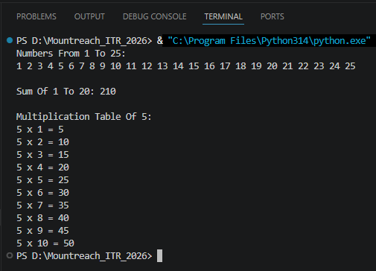

Program Code:

print("Numbers From 1 To 25:")
for i in range(1, 26): # Starts At 1, Stops Before 26
print(i, end=" ")

total = 0
for i in range(1, 21): # Starts At 1, Stops Before 21
total += i
print("\n\nSum Of 1 To 20:", total)

print("\nMultiplication Table Of 5:")
for i in range(1, 11): # Starts At 1, Stops Before 11
print("5 x", i, "=", 5 * i)

# When To Use A For Loop:
# - You Know In Advance How Many Iterations Are Needed.
# - You Want To Iterate Over A Sequence (List, Range, String, etc.).
# - Cleaner & Safer Than While When The Count Is Fixed.

- While Loop Revision
Write a program using a while loop that:
- Repeatedly asks the user to enter a positive number.
- Keeps adding the numbers to a running total.
- Stops when the user enters 0 or a negative number.
- Finally prints the total sum.

Output:

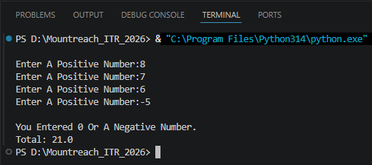

Program Code:
# Initialize The Total To 0
total = 0

# Take Input From The User For The First Number Before Entering The Loop
number = float(input("Enter A Positive Number:"))

# Keep Looping Until The User Enters A Positive Number
while number > 0:

# Add The Entered Number To The Total
total = total + number

# Ask The User For The Next Number
number = float(input("Enter A Positive Number:"))

print("\nYou Entered 0 Or A Negative Number.")
print("Total:", total)
- Math Module
Write a program that imports the math module and does the following:
- Takes a number as input.
- Prints its square root using math.sqrt().
- Prints its factorial using math.factorial() (for positive integers only).
- Prints the ceiling and floor value using math.ceil() and math.floor().
Add comments about the usefulness of the math module.

Output:

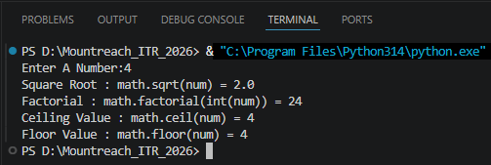

Program Code:

import math # Built-In Module With Mathematical Functions & Constants

num = float(input("Enter A Number:"))

print("Square Root : math.sqrt(num) =", math.sqrt(num))

if num >= 0 and num == int(num): # Factorial Only Works On Non-Negative Integers
print("Factorial : math.factorial(int(num)) =", math.factorial(int(num)))
else:
print("Factorial : Only Defined For Non-Negative Integers")

print("Ceiling Value : math.ceil(num) =", math.ceil(num))
print("Floor Value : math.floor(num) =", math.floor(num))

- Random Module
Write a program using the random module that:
- Generates and prints 5 random integers between 1 and 100.
- Generates and prints one random number between 50 and 150.
- Prints a random floating point number between 0 and 1.
Use different functions from the random module.

Output:

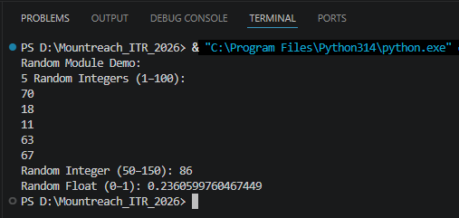

Program Code:

import random # Built-In Module For Generating Pseudo-Random Numbers

print("Random Module Demo:")

# Generate 5 Random Integers Between 1 & 100
print("5 Random Integers (1–100):")
for _ in range(5):
print(random.randint(1, 100))

# One Random Integer Between 50 & 150
print("Random Integer (50–150):", random.randrange(50, 150))

# Random Float Between 0 & 1
print("Random Float (0–1):", random.random())

- Import Methods
Demonstrate different ways of importing modules:
- Import the entire math module using import math and use math.pow(2, 4).
- Import only sqrt from math using from math import sqrt.
- Import math with an alias as m and use m.factorial(5).
Print the results with clear messages.

Output:

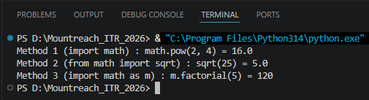

Program Code:

# Importing Module
import math
print("Method 1 (import math) : math.pow(2, 4) =", math.pow(2, 4))

# Import Specific Function - Use Directly Without Prefix
from math import sqrt
print("Method 2 (from math import sqrt) : sqrt(25) =", sqrt(25))

# Import With Alias - Shorter Prefix, Useful For Long Module Names
import math as m
print("Method 3 (import math as m) : m.factorial(5) =", m.factorial(5))

- Custom Module
Create a custom module file named mymodule.py that contains:
- A function greet(name) that prints "Hello [name], Welcome to Python Class!"
- A function calculate_power(base, exp) that returns base raised to exponent.
Then write a main program that imports this module and uses both functions.
Output:

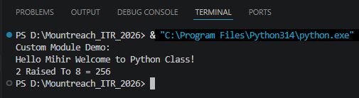

Program Code:

#mymodule.py
def greet(name):
print("Hello", name, "Welcome to Python Class!")

def calculate_power(base, exp):
return base ** exp

#main.py
import mymodule as mm

print("Custom Module Demo:")
mm.greet("Mihir")
print("2 Raised To 8 =", mm.calculate_power(2, 8))

- name == "main"
Write a program that:
- Creates a small function and demonstrates the use of if __name__ == "__main__": so that some code runs only when the file is executed directly.

Output:

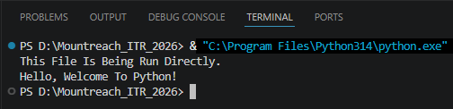

Program Code:

# Define Function
def greet():
print("Hello, Welcome To Python!")

# This Condition Checks Whether The Script Runs Directly
# If True, The Code Inside This Block Will Execute
# If The File Is Imported Into Another File, This Block Will Not Run
if __name__ == "__main__":
print("This File Is Being Run Directly.")

# Call The Greet Function
greet()

- Mini Project - Combined Concepts
Create a Simple Math Utility Program using functions, lambda, loops and modules:
Write the following:
- A lambda function to calculate square of a number.
- A normal function using math module to calculate power.
- Use a while loop to repeatedly ask the user for a number and choice Square / Power / Random Number).
- Use random module to generate a random number when chosen.
Continue until the user chooses to exit. Use proper functions and comments.

Output:

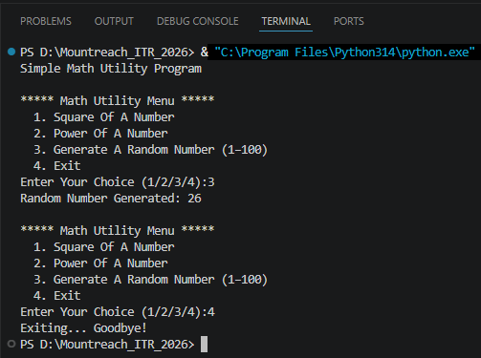

Program Code:

import math
import random

# Lambda Function
square = lambda x: x ** 2

# Normal Functions
def calculate_power(base, exp):
return math.pow(base, exp)

def display_menu():
print("\n***** Math Utility Menu *****")
print(" 1. Square Of A Number")
print(" 2. Power Of A Number")
print(" 3. Generate A Random Number (1–100)")
print(" 4. Exit")

print("Simple Math Utility Program")

while True:
display_menu()
choice = input("Enter Your Choice (1/2/3/4):")

if choice == "1":
num = float(input("Enter A Number:"))
print("Square Of", num,"=", square(num))

elif choice == "2":
base = float(input("Enter Base:"))
exp = float(input("Enter Exponent:"))
print(base, "^", exp, "=", calculate_power(base, exp))

elif choice == "3":
rand_num = random.randint(1, 100)
print("Random Number Generated:", rand_num)

elif choice == "4":
print("Exiting... Goodbye!")
break

else:
print("Invalid Choice. Please Enter 1, 2, 3, Or 4.")

