Task 4: Session 4 (AIML) - Assignment Questions

Name: Mihir Sopan Patil
Domain: AIML
College & Branch Name: Zeal Polytechnic, Diploma In AIML

- Lambda Function
Write a lambda function named square that takes a number x and returns its square.
Call the lambda function with input from the user and print the result.
Also write the same logic using a normal def function and compare both in comments.
Output:

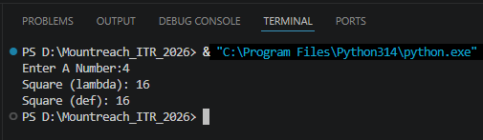

- Lambda With Multiple Arguments
Create a lambda function add_three(a, b, c) that returns the sum of three numbers.
Take three numbers as input from the user and print their sum using this lambda function.

Output:

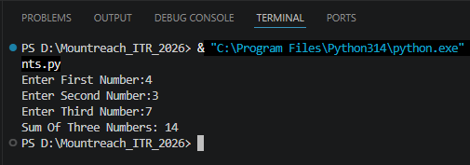

- For Loop Revision
Write a program using a for loop and range() to:
- Print all numbers from 1 to 25.
- Print the sum of all numbers from 1 to 20.
- Print the table of 5 5 x 1 to 5 x 10.
Add comments explaining when to use for loop.

Output:

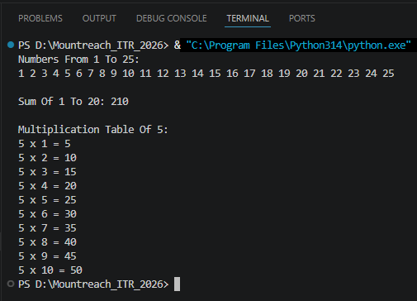

- While Loop Revision
Write a program using a while loop that:
- Repeatedly asks the user to enter a positive number.
- Keeps adding the numbers to a running total.
- Stops when the user enters 0 or a negative number.
- Finally prints the total sum.

Output:

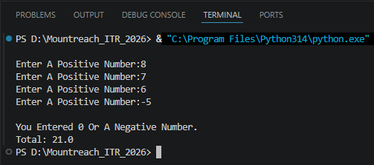

- Math Module
Write a program that imports the math module and does the following:
- Takes a number as input.
- Prints its square root using math.sqrt().
- Prints its factorial using math.factorial() (for positive integers only).
- Prints the ceiling and floor value using math.ceil() and math.floor().
Add comments about the usefulness of the math module.

Output:

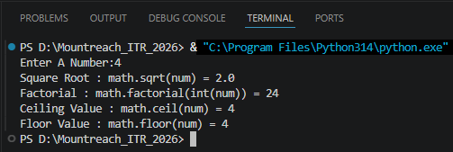

- Random Module
Write a program using the random module that:
- Generates and prints 5 random integers between 1 and 100.
- Generates and prints one random number between 50 and 150.
- Prints a random floating point number between 0 and 1.
Use different functions from the random module.

Output:

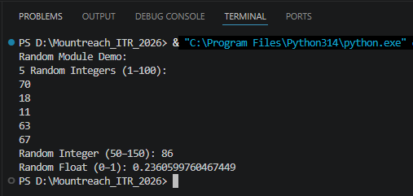

- Import Methods
Demonstrate different ways of importing modules:
- Import the entire math module using import math and use math.pow(2, 4).
- Import only sqrt from math using from math import sqrt.
- Import math with an alias as m and use m.factorial(5).
Print the results with clear messages.

Output:

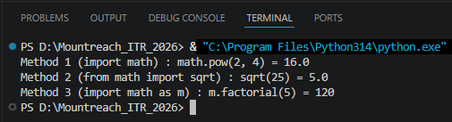

- Custom Module
Create a custom module file named mymodule.py that contains:
- A function greet(name) that prints "Hello [name], Welcome to Python Class!"
- A function calculate_power(base, exp) that returns base raised to exponent.
Then write a main program that imports this module and uses both functions.
Output:

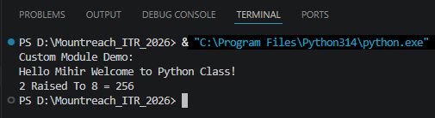

- name == "main"
Write a program that:
- Creates a small function and demonstrates the use of if __name__ == "__main__": so that some code runs only when the file is executed directly.

Output:

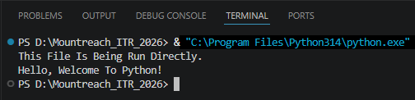

- Mini Project - Combined Concepts
Create a Simple Math Utility Program using functions, lambda, loops and modules:
Write the following:
- A lambda function to calculate square of a number.
- A normal function using math module to calculate power.
- Use a while loop to repeatedly ask the user for a number and choice Square / Power / Random Number).
- Use random module to generate a random number when chosen.
Continue until the user chooses to exit. Use proper functions and comments.

Output:

