Task 5: Session 5 (AIML) - Assignment Questions

Name: Mihir Sopan Patil
Domain: AIML
College & Branch Name: Zeal Polytechnic, Diploma In AIML

- String Indexing
Write a program that takes a string input from the user.
Print:
- The first character
- The last character (using negative index)
- The 3rd character from the start
- The 2nd character from the end
Add comments explaining positive and negative indexing.
Output:

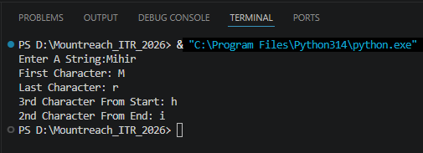

Program Code:

user_string = input("Enter A String:")

# Positive indexing: Starts At 0 From The Left (0, 1, 2, ...)
print("First Character:", user_string[0])

# Negative indexing: Starts At -1 From The Right (-1, -2, -3, ...)
print("Last Character:", user_string[-1])

# Index 2 Gives The 3rd Character From The Start
print("3rd Character From Start:", user_string[2])

# Index -2 Gives The 2nd Character From The End
print("2nd Character From End:", user_string[-2])

- String Slicing
Take a string input from the user.
Using slicing, print:
- The first 5 characters
- The last 4 characters
- The string in reverse order
- Every 2nd character of the string
Include comments explaining the slicing syntax [start:end:step].

Output:

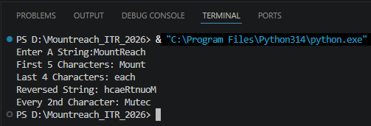

Program Code:

user_string = input("Enter A String:")

# Slicing Syntax: string[start:end:step]
# start -> Index To Begin (Inclusive), Default 0
# end -> Index To Stop (Exclusive), Default len(string)
# step -> How Many Positions To Jump, Default 1

# start=0 (default), end=5
print("First 5 Characters:", user_string[:5])

# start=-4 (4th From end),
print("Last 4 Characters:", user_string[-4:])

# step=-1 Traverses From Right To Left
print("Reversed String:", user_string[::-1])

# step=2 Skips One Character Each Time
print("Every 2nd Character:", user_string[::2])

- String Membership
Write a program that:
- Takes a main string and a substring as input from the user.
- Checks whether the substring is present in the main string using in and not in.
- Prints appropriate messages (e.g., "Substring found!" or "Substring not found!").
Note that it is case-sensitive.

Output:

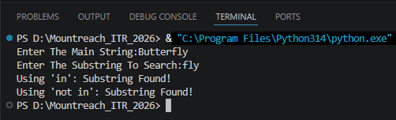

Program Code:

main_string = input("Enter The Main String:")
sub_string = input("Enter The Substring To Search:")

# 'in' Returns True If sub_string Exists Inside main_string (Case-Sensitive)
if sub_string in main_string:
print("Using 'in': Substring Found!")
else:
print("Using 'in': Substring Not Found!")

# 'not in' Returns True If sub_string Does Not Exist Inside main_string
if sub_string not in main_string:
print("Using 'not in': Substring Not Found!")
else:
print("Using 'not in': Substring Found!")

- len() Function
Write a program that:
- Takes a string as input.
- Prints the length of the string using len().
- Prints the last character using len() (without using negative index).
- Prints the middle character if the length is odd.
Add comments on common mistakes with len().

Output:

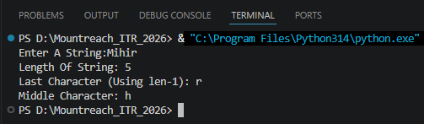

Program Code:

user_string = input("Enter A String:")

# len() Returns The Total Number Of Characters In The String
string_length = len(user_string)
print("Length Of String:", string_length)

print("Last Character (Using len-1):", user_string[string_length - 1])

# Middle Character Is Only Possible When Length Is Odd
if string_length % 2 != 0:
print("Middle Character:", user_string[string_length // 2])
else:
print("String Has Even Length (No Middle Character)")

- range() - Basic Forms
Write a program using for loop and range() to:
- Print numbers from 0 to 10.
- Print numbers from 5 to 15.
- Print odd numbers from 1 to 21.
Explain the three forms of range() in comments.

Output:

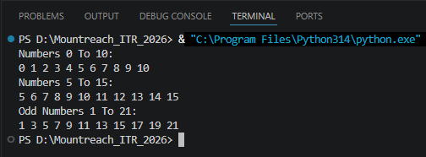

Program Code:

# Three Forms Of range():
# range(stop) -> 0, 1, 2, ..., stop-1
# range(start, stop) -> start, start+1, ..., stop-1
# range(start, stop, step) -> start, start+step, ..., < stop

# range(stop): 0 To 10 Inclusive — Use stop=11
print("Numbers 0 To 10:")
for num in range(11): # range(stop)
print(num, end=" ")

# range(start, stop): 5 To 15 Inclusive — stop=16
print("\nNumbers 5 To 15:")
for num in range(5, 16): # range(start, stop)
print(num, end=" ")

# range(start, stop, step): Odd Numbers 1 To 21, step=2
print("\nOdd Numbers 1 To 21:")
for num in range(1, 22, 2): # range(start, stop, step)
print(num, end=" ")
- range() With Negative Step
Use range() to print:
- Numbers from 20 down to 10 (decreasing).
- Numbers from 15 down to 1 in steps of 2.
Print each sequence on a new line with proper messages.

Output:

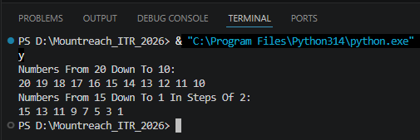

Program Code:

# Negative Step Counts Down (Start Must Be Greater Than Stop)
# range(start, stop, step) Where step < 0 Goes From start Down To stop+1

print("Numbers From 20 Down To 10:")
for num in range(20, 9, -1): # stop=9 so 10 is included
print(num, end=" ")

print("\nNumbers From 15 Down To 1 In Steps Of 2:")
for num in range(15, 0, -2): # stop=0 so 1 is included
print(num, end=" ")

- Combined: Strings + range())
Write a program that takes a string from the user.
Using a for loop and range() with len(), print:
- Each character of the string one by one (with its index).
- The string in reverse order using negative step in range().

Output:

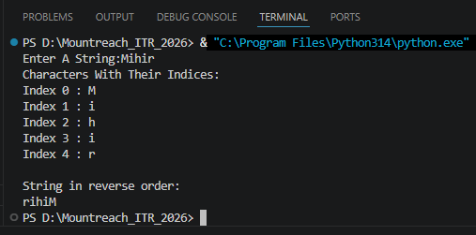

Program Code:

user_string = input("Enter A String:")
str_length = len(user_string)

# Print Each Character With Its Index Using range(len(string))
print("Characters With Their Indices:")
for i in range(str_length):
print("Index", i, ":", user_string[i])

# Reverse Order: Range Starts From Last Index (len-1) Down To 0, step=-1
print("\nString in reverse order:")
for i in range(str_length - 1, -1, -1): # stop=-1 So Index 0 Is Included
print(user_string[i], end="")

- Membership With range()
Write a program that:
  - Takes a number as input from the user.
  - Checks if the number is present in range(1, 51) and in range(10, 100, 5).
  - Prints clear messages for each check.

Output:

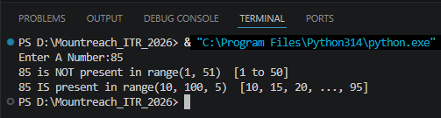

Program Code:

number = int(input("Enter A Number:"))

if number in range(1, 51):
print(number, "IS present in range(1, 51) [1 to 50]")
else:
print(number, "is NOT present in range(1, 51) [1 to 50]")

if number in range(10, 100, 5):
print(number, "IS present in range(10, 100, 5) [10, 15, 20, ..., 95]")
else:
print(number, "is NOT present in range(10, 100, 5) [10, 15, 20, ..., 95]")

- Slicing + range()
Write a program that prints the following using range() and string slicing concepts where applicable:
- First 10 even numbers (2 to 20).
- Numbers from 1 to 30 in steps of 3.
- A string "PythonProgramming" sliced to show "Python", "Programming", and the reverse.

Output:

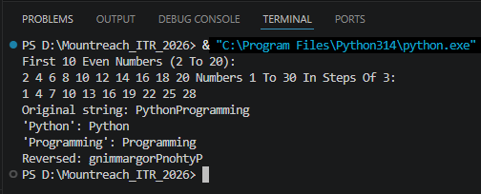

Program Code:

# First 10 Even Numbers: range(start=2, stop=21, step=2)
print("First 10 Even Numbers (2 To 20):")
for num in range(2, 21, 2):
print(num, end=" ")

# Numbers 1 To 30 In Steps Of 3
print("Numbers 1 To 30 In Steps Of 3:")
for num in range(1, 31, 3):
print(num, end=" ")

# String Slicing On "PythonProgramming"
text = "PythonProgramming"
print("\nOriginal string:",text)
print("'Python':", text[:6]) # Index 0–5
print("'Programming':", text[6:]) # Index 6 To End
print("Reversed:", text[::-1]) # step=-1

- Mini Project - Combined
Create a String Analyzer program:
- Take a string input from the user.
- Using functions or directly:
- Print length of the string.
- Print first half and second half using slicing.
- Check if the word "python" (case insensitive — you may convert) is present.
- Use range() to print all characters with their positive and negative indices.
- Print the string in reverse.
Add proper comments and use meaningful variable names.

Output:

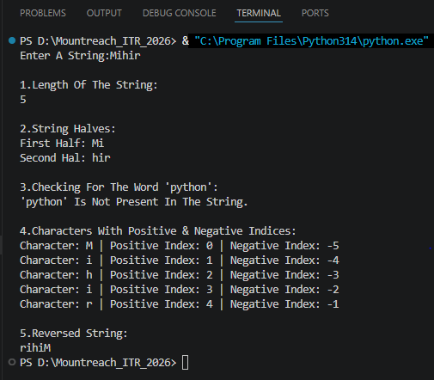

Program Code:

# String Analyzer Program

# Take String Input From The User
user_string = input("Enter A String:")

# Print Length Of The String
print("\n1.Length Of The String:")
print(len(user_string))

# Print First Half & Second Half Using Slicing
middle_index = len(user_string) // 2

first_half = user_string[:middle_index]
second_half = user_string[middle_index:]

print("\n2.String Halves:")
print("First Half:", first_half)
print("Second Hal:", second_half)

# Check If The Word "python" Is Present (Case-Insensitive)
print("\n3.Checking For The Word 'python':")

if "python" in user_string.lower():
print("'python' Is Present In The String.")
else:
print("'python' Is Not Present In The String.")

# Print All Characters With Their Positive And Negative Indices
print("\n4.Characters With Positive & Negative Indices:")

string_length = len(user_string)

for positive_index in range(string_length):
negative_index = positive_index - string_length
print(
"Character:" ,user_string[positive_index],"| "
"Positive Index:", positive_index,"| "
"Negative Index:",negative_index
)

# Print The String In Reverse
print("\n5.Reversed String:")
print(user_string[::-1])

