Task 5: Session 5 (AIML) - Assignment Questions

Name: Mihir Sopan Patil
Domain: AIML
College & Branch Name: Zeal Polytechnic, Diploma In AIML

- String Indexing
Write a program that takes a string input from the user.
Print:
- The first character
- The last character (using negative index)
- The 3rd character from the start
- The 2nd character from the end
Add comments explaining positive and negative indexing.
Output:

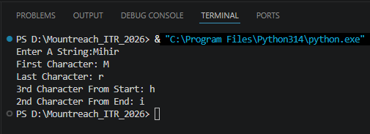

- String Slicing
Take a string input from the user.
Using slicing, print:
- The first 5 characters
- The last 4 characters
- The string in reverse order
- Every 2nd character of the string
Include comments explaining the slicing syntax [start:end:step].

Output:

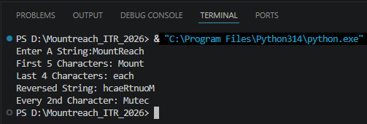

- String Membership
Write a program that:
- Takes a main string and a substring as input from the user.
- Checks whether the substring is present in the main string using in and not in.
- Prints appropriate messages (e.g., "Substring found!" or "Substring not found!").
Note that it is case-sensitive.

Output:

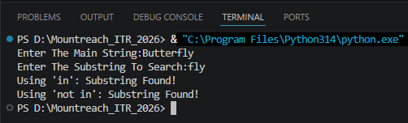

- len() Function
Write a program that:
- Takes a string as input.
- Prints the length of the string using len().
- Prints the last character using len() (without using negative index).
- Prints the middle character if the length is odd.
Add comments on common mistakes with len().

Output:

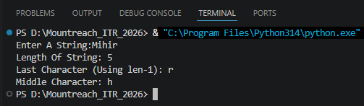

- range() - Basic Forms
Write a program using for loop and range() to:
- Print numbers from 0 to 10.
- Print numbers from 5 to 15.
- Print odd numbers from 1 to 21.
Explain the three forms of range() in comments.

Output:

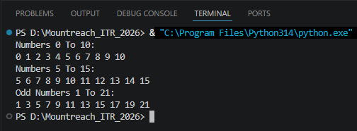

- range() With Negative Step
Use range() to print:
- Numbers from 20 down to 10 (decreasing).
- Numbers from 15 down to 1 in steps of 2.
Print each sequence on a new line with proper messages.

Output:

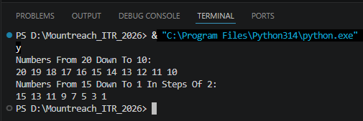

- Combined: Strings + range())
Write a program that takes a string from the user.
Using a for loop and range() with len(), print:
- Each character of the string one by one (with its index).
- The string in reverse order using negative step in range().

Output:

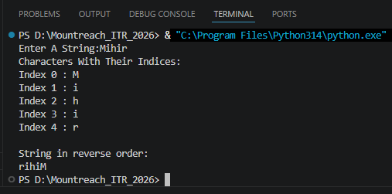

- Membership With range()
Write a program that:
  - Takes a number as input from the user.
  - Checks if the number is present in range(1, 51) and in range(10, 100, 5).
  - Prints clear messages for each check.

Output:

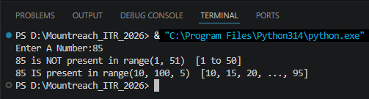

- Slicing + range()
Write a program that prints the following using range() and string slicing concepts where applicable:
- First 10 even numbers (2 to 20).
- Numbers from 1 to 30 in steps of 3.
- A string "PythonProgramming" sliced to show "Python", "Programming", and the reverse.

Output:

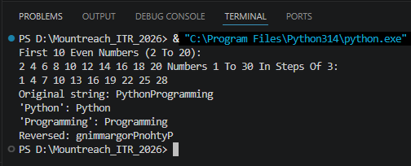

- Mini Project - Combined
Create a String Analyzer program:
- Take a string input from the user.
- Using functions or directly:
- Print length of the string.
- Print first half and second half using slicing.
- Check if the word "python" (case insensitive — you may convert) is present.
- Use range() to print all characters with their positive and negative indices.
- Print the string in reverse.
Add proper comments and use meaningful variable names.

Output:

