Task 6: Session 6 (AIML) - Assignment Questions

Name: Mihir Sopan Patil
Domain: AIML
College & Branch Name: Zeal Polytechnic, Diploma In AIML

- Creating Lists
Write a program to create the following lists using different methods:
- A list of 5 integers directly.
- An empty list using both [] and list().
- A list containing mixed data types (int, string, float, boolean).
- A list of 7 zeros using repetition (*).
Print all lists with clear labels and add comments explaining each creation method.
Output:

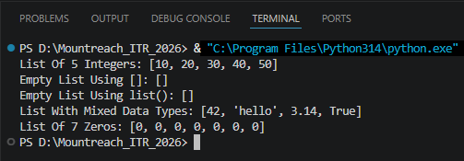

Program Code:

# A List Of 5 Integers Created Directly Using Square Brackets
integers = [10, 20, 30, 40, 50]
print("List Of 5 Integers:", integers)

# Empty List Using [] & list()
empty_list_1 = []
empty_list_2 = list()
print("Empty List Using []:", empty_list_1)
print("Empty List Using list():", empty_list_2)

# A List With Mixed Data Types
mixed = [42, "hello", 3.14, True]
print("List With Mixed Data Types:", mixed)

# A List Of 7 Zeros Using Repetition Operator (*)
zeros = [0] * 7
print("List Of 7 Zeros:", zeros)

- Indexing and Negative Indexing
Create a list: fruits = ["apple", "banana", "mango", "orange", "grape"]
Write code to print:
- First item
- Third item
- Last item (using negative index)
- Second last item (using negative index)
Take a number as input from the user and print the item at that index (handle basic cases only).

Output:

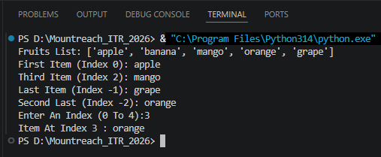

Program Code:

fruits = ["apple", "banana", "mango", "orange", "grape"]
print("Fruits List:", fruits)

print("First Item (Index 0):", fruits[0])
print("Third Item (Index 2):", fruits[2])
print("Last Item (Index -1):", fruits[-1])
print("Second Last (Index -2):", fruits[-2])

i = int(input("Enter An Index (0 To 4):"))
print("Item At Index", i, ":", fruits[i])

- Slicing Lists
Given the list: numbers = [10, 20, 30, 40, 50, 60, 70, 80, 90, 100]
Using slicing, print:
- First 4 elements
- Last 3 elements
- Elements from index 2 to 7
- Every second element
- The entire list in reverse order
Add comments explaining slicing syntax.

Output:

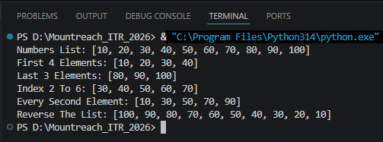

Program Code:

numbers = [10, 20, 30, 40, 50, 60, 70, 80, 90, 100]
print("Numbers List:", numbers)

# Syntax: list[start:stop:step] (stop Is Exclusive)

# First 4 Elements -> start=0 (default), stop=4
print("First 4 Elements:", numbers[:4])

# Last 3 Elements -> start=-3, stop=end (default)
print("Last 3 Elements:", numbers[-3:])

# Elements From Index 2 To 7 -> start=2, stop=7
print("Index 2 To 6:", numbers[2:7])

# Every Second Element -> step=2
print("Every Second Element:", numbers[::2])

# Reverse The List -> step=-1
print("Reverse The List:", numbers[::-1])

- Modifying Lists
Create a list: colors = ["red", "blue", "green", "yellow"]
Perform the following:
- Change "blue" to "purple" using indexing.
- Change the last item to "black".
Print the list after each change.

Output:

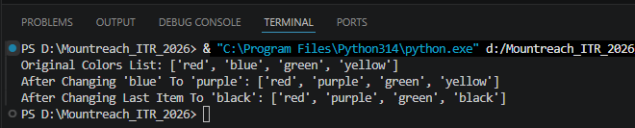

Program Code:

colors = ["red", "blue", "green", "yellow"]
print("Original Colors List:", colors)

# Change "blue" To "purple" Using Its Index
colors[1] = "purple"
print("After Changing 'blue' To 'purple':", colors)

# Change The Last Item To "black"
colors[-1] = "black"
print("After Changing Last Item To 'black':", colors)

- append() & insert()
Write a program that starts with an empty list.
- Use append() to add 5 different city names one by one.
- Use insert() to add one more city at position 2.
- Print the final list.
Take user input for at least 2 cities.

Output:

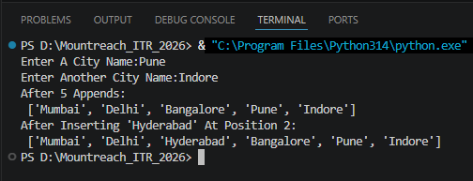

Program Code:

# Empty List
cities = []

# append() Adds The Item To The End Of The List
cities.append("Mumbai")
cities.append("Delhi")
cities.append("Bangalore")

# Take User Input For Two More Cities And Append Them To The List
city1 = input("Enter A City Name:")
city2 = input("Enter Another City Name:")

cities.append(city1)
cities.append(city2)

print("After 5 Appends:\n", cities)

# insert(index, value) Places The Item At The Given Index
cities.insert(2, "Hyderabad")
print("After Inserting 'Hyderabad' At Position 2:\n", cities)
- remove(), pop(), & clear()
Create a list: items = [10, 20, 30, 20, 40, 50]
Perform and print after each operation:
- Remove the first occurrence of 20 using remove().
- Remove the item at index 3 using pop() and print the removed value.
- Remove the last item using pop().
- Clear the entire list using clear().
Add comments explaining the difference between remove() and pop().

Output:

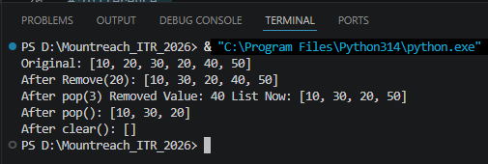

Program Code:

items = [10, 20, 30, 20, 40, 50]
print("Original:", items)

# remove(value) -> Removes The First Occurrence Of The Given Value
items.remove(20)
print("After Remove(20):", items)

# pop(index) -> Removes & Returns The Item At The Given Index
removed = items.pop(3)
print("After pop(3) Removed Value:", removed, "List Now:", items)

# pop() With No Argument Removes & Returns The Last Item
items.pop()
print("After pop():", items)

# clear() -> Removes All Items, Leaving An Empty List
items.clear()
print("After clear():", items)

# Difference:
# remove() -> You Specify The Value To Delete (First Match Only)
# pop() -> You Specify The Index To Delete

- index() & count()
Create a list: scores = [85, 92, 78, 92, 65, 92, 88]
  - Find and print the index of the first occurrence of 92.
  - Count and print how many times 92 appears.
  - Take a number as input from the user and check if it exists in the list. If yes, print its index and count.

Output:

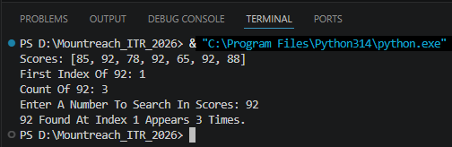

Program Code:

scores = [85, 92, 78, 92, 65, 92, 88]
print("Scores:", scores)

# index() Returns The Position Of The First Occurrence
first_index = scores.index(92)
print("First Index Of 92:", first_index)

# count() Returns How Many Times The Value Appears
count_92 = scores.count(92)
print("Count Of 92:", count_92)

# User Input Check
num = int(input("Enter A Number To Search In Scores: "))
if num in scores:
print(num, "Found At Index", scores.index(num), "Appears", scores.count(num), "Times.")
else:
print(num, "Not Found In The List.")

- sort() & reverse()
Create a list: marks = [45, 78, 65, 90, 34, 82, 71]
- Sort the list in ascending order and print it.
- Sort the list in descending order and print it.
- Reverse the original list (without sorting) and print it.
Add comments on the difference between sort() and reverse().

Output:

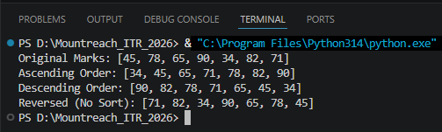

Program Code:

marks = [45, 78, 65, 90, 34, 82, 71]
print("Original Marks:", marks)

# sort() Rearranges Elements In Ascending Order By Default
marks.sort()
print("Ascending Order:", marks)

# sort(reverse=True) Rearranges Elements In Descending Order
marks.sort(reverse=True)
print("Descending Order:", marks)

# Reset To Original, Then Reverse()
marks = [45, 78, 65, 90, 34, 82, 71]
marks.reverse()
print("Reversed (No Sort):", marks)

# Difference:
# sort() -> Reorders Elements By Value (Ascending or Descending)
# reverse() -> Simply Flips The Current Order, Regardless Of Values

- extend() vs append()
Create two lists:
list1 = [1, 2, 3]
list2 = [4, 5, 6]
Demonstrate:
- Using extend() to add list2 to list1.
- Using append() to add list2 to a copy of list1.
Print both results and explain the difference in comments.

Output:

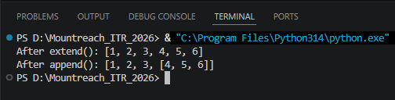

Program Code:

list1 = [1, 2, 3]
list2 = [4, 5, 6]

# extend() Unpacks list2 & Adds Each Element Individually To list1
list1.extend(list2)
print("After extend():", list1)

# append() Adds list2 As A Single Nested Element
list1_copy = [1, 2, 3]
list1_copy.append(list2)
print("After append():", list1_copy)

# Difference:
# extend() -> Merges The Second List Into The First (Flat)
# append() -> Adds The Second List As One Element (Nested)

- Mini Project - Combined Concepts
Create a Student Marks Manager program using lists:
- Take 5 subject marks as input from the user and store them in a list.
- Print the list.
- Add one more subject mark using append().
- Print the highest and lowest marks (using built-in functions).
- Sort the marks in descending order.
- Calculate and print the average marks.
- Use len() to show total number of subjects.
Use proper comments, meaningful variable names, and control structures where needed.

Output:

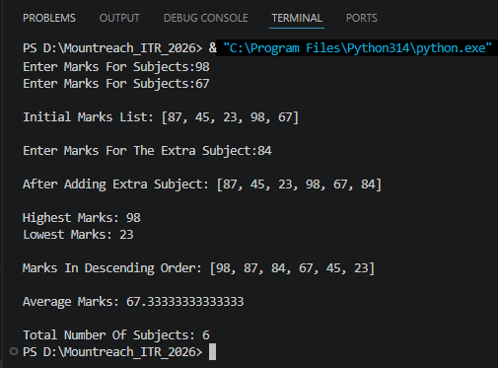

Program Code:

print("*** Student Marks Manager ***")

subject_marks = []

# Collect Marks For 5 Subjects From The User
for i in range(1, 6):
mark = int(input("Enter Marks For Subjects:"))
subject_marks.append(mark)

print("\nInitial Marks List:", subject_marks)

# Add A 6th Subject Mark
extra_mark = int(input("\nEnter Marks For The Extra Subject:"))
subject_marks.append(extra_mark)
print("\nAfter Adding Extra Subject:", subject_marks)

# Built-in max() & min() To Find Highest & Lowest Marks
print("\nHighest Marks:", max(subject_marks))
print("Lowest Marks:", min(subject_marks))

# Sort In Descending Order
subject_marks.sort(reverse=True)
print("\nMarks In Descending Order:", subject_marks)

# Average = Total / Number Of Subjects
average = sum(subject_marks) / len(subject_marks)
print("\nAverage Marks:", average)

# len() Gives The Total Count
print("\nTotal Number Of Subjects:", len(subject_marks))

