Task 6: Session 6 (AIML) - Assignment Questions

Name: Mihir Sopan Patil
Domain: AIML
College & Branch Name: Zeal Polytechnic, Diploma In AIML

- Creating Lists
Write a program to create the following lists using different methods:
- A list of 5 integers directly.
- An empty list using both [] and list().
- A list containing mixed data types (int, string, float, boolean).
- A list of 7 zeros using repetition (*).
Print all lists with clear labels and add comments explaining each creation method.
Output:

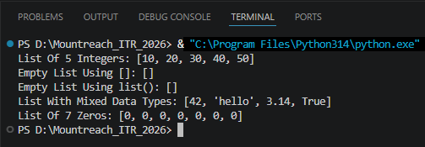

- Indexing & Negative Indexing
Create a list: fruits = ["apple", "banana", "mango", "orange", "grape"]
Write code to print:
- First item
- Third item
- Last item (using negative index)
- Second last item (using negative index)
Take a number as input from the user and print the item at that index (handle basic cases only).

Output:

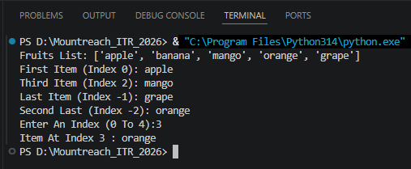

- Slicing Lists
Given the list: numbers = [10, 20, 30, 40, 50, 60, 70, 80, 90, 100]
Using slicing, print:
- First 4 elements
- Last 3 elements
- Elements from index 2 to 7
- Every second element
- The entire list in reverse order
Add comments explaining slicing syntax.

Output:

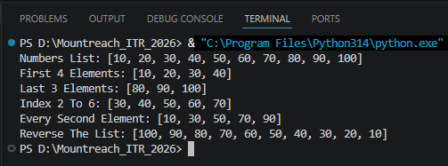

- Modifying Lists
Create a list: colors = ["red", "blue", "green", "yellow"]
Perform the following:
- Change "blue" to "purple" using indexing.
- Change the last item to "black".
Print the list after each change.

Output:

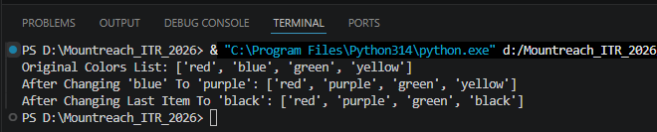

- append() & insert()
Write a program that starts with an empty list.
- Use append() to add 5 different city names one by one.
- Use insert() to add one more city at position 2.
- Print the final list.
Take user input for at least 2 cities.

Output:

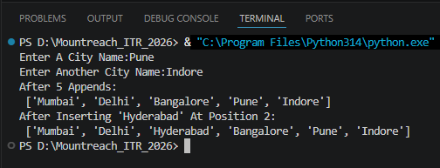

- remove(), pop(), & clear()
Create a list: items = [10, 20, 30, 20, 40, 50]
Perform and print after each operation:
- Remove the first occurrence of 20 using remove().
- Remove the item at index 3 using pop() and print the removed value.
- Remove the last item using pop().
- Clear the entire list using clear().
Add comments explaining the difference between remove() and pop().

Output:

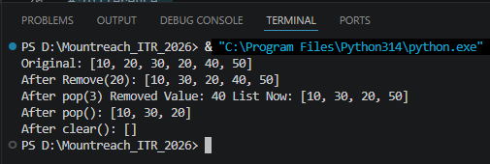

- index() & count()
Create a list: scores = [85, 92, 78, 92, 65, 92, 88]
  - Find and print the index of the first occurrence of 92.
  - Count and print how many times 92 appears.
  - Take a number as input from the user and check if it exists in the list. If yes, print its index and count.

Output:

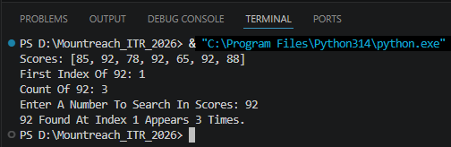

- sort() & reverse()
Create a list: marks = [45, 78, 65, 90, 34, 82, 71]
- Sort the list in ascending order and print it.
- Sort the list in descending order and print it.
- Reverse the original list (without sorting) and print it.
Add comments on the difference between sort() and reverse().

Output:

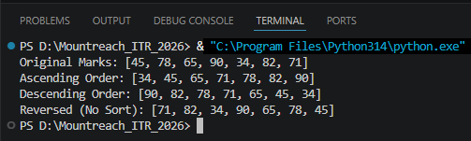

- extend() vs append()
Create two lists:
list1 = [1, 2, 3]
list2 = [4, 5, 6]
Demonstrate:
- Using extend() to add list2 to list1.
- Using append() to add list2 to a copy of list1.
Print both results and explain the difference in comments.

Output:

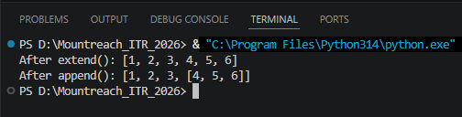

- Mini Project - Combined Concepts
Create a Student Marks Manager program using lists:
- Take 5 subject marks as input from the user and store them in a list.
- Print the list.
- Add one more subject mark using append().
- Print the highest and lowest marks (using built-in functions).
- Sort the marks in descending order.
- Calculate and print the average marks.
- Use len() to show total number of subjects.
Use proper comments, meaningful variable names, and control structures where needed.

Output:

