Task 7: Session 7 (AIML) - Assignment Questions

Name: Mihir Sopan Patil
Domain: AIML
College & Branch Name: Zeal Polytechnic, Diploma In AIML

- Creating Tuples
Write a program to create tuples using different methods:
- A tuple with 5 numbers using parentheses.
- A mixed tuple containing integer, string, float, and boolean.
- An empty tuple using two different ways.
- A single-element tuple with the value 99.
Print all tuples and their types. Add comments explaining the rules for single-element tuples.
Output:

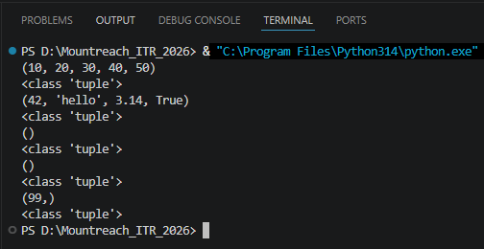

Program Code:

# Tuple With 5 Numbers Using Parentheses
t1 = (10, 20, 30, 40, 50)
print(t1)
print(type(t1))

# Mixed Tuple
t2 = (42, "hello", 3.14, True)
print(t2)
print(type(t2))

# Empty Tuple - Two Ways
t3 = ()
t4 = tuple()
print(t3)
print(type(t3))
print(t4)
print(type(t4))

# Single Element Tuple
# Rule: A Comma Is Required To Make It A Tuple.
# (99) Is Just An Int; (99,) Is A Tuple.
t5 = (99,)
print(t5)
print(type(t5))

- Tuple Packing
Create a tuple without using parentheses (tuple packing) to store: your name, age, and city.
Print the tuple and its type.
Then unpack the tuple into three separate variables and print them individually.

Output:

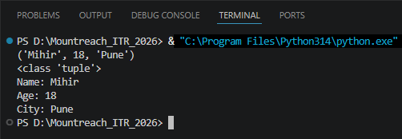

Program Code:

# Tuple Packing - No () Needed
person = "Mihir", 18, "Pune"
print(person)
print(type(person))

# Unpacking Into Separate Variables
name, age, city = person
print("Name:", name)
print("Age:", age)
print("City:", city)

- Indexing & Negative Indexing
Create the tuple: colors = (' red', 'green', ' blue', ' yellow', ' purple', 'orange')
Print:
- First element
- Third element
- Last element (using negative index)
- Second last element (using negative index)
Take an index number as input from the user and print the element at that index.

Output:

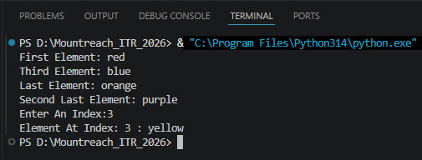

Program Code:

colors = ('red', 'green', 'blue', 'yellow', 'purple', 'orange')

print("First Element:", colors[0])
print("Third Element:", colors[2])
print("Last Element:", colors[-1])
print("Second Last Element:", colors[-2])

i = int(input("Enter An Index:"))
print("Element At Index:", i, ":", colors[i])

- Slicing Tuples
Given the tuple: numbers = (0, 1, 2, 3, 4, 5, 6, 7, 8, 9, 10)
Using slicing, print:
- Elements from index 2 to 7
- First 5 elements
- Last 4 elements
- Every second element
- The entire tuple in reverse order
Add comments explaining the slicing syntax.

Output:

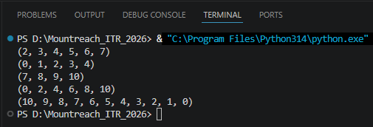

Program Code:

numbers = (0, 1, 2, 3, 4, 5, 6, 7, 8, 9, 10)

# Syntax: tuple[start:stop:step]
# stop Index Is Excluded

# Index 2 To 7 (stop=8 To Include 7)
print(numbers[2:8])

# First 5 Elements (Index 0 To 4)
print(numbers[:5])

# Last 4 Elements
print(numbers[-4:])

# Every Second Element (step=2)
print(numbers[::2])

# Reverse (step=-1)
print(numbers[::-1])

- Nested Tuples
Create a nested tuple to represent a 3•3 matrix:
matrix = ((1, 2, 3), (4, 5, 6), (7, 8, 9))
Print:
- The first row
- The element at second row, third column
- The element at third row, first column

Output:

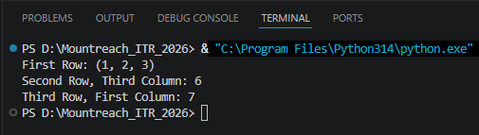

Program Code:

matrix = ((1, 2, 3), (4, 5, 6), (7, 8, 9))

print("First Row:", matrix[0])
print("Second Row, Third Column:", matrix[1][2]) # 6
print("Third Row, First Column:", matrix[2][0]) # 7

- Iterating & Unpacking
Create a tuple: student = (' Rahul', 20, ' Computer Science', 'A')
  - Iterate through the tuple using a for loop and print each item.
  - Unpack the tuple into four variables (name, age, branch, grade) and print them with descriptive messages.

Output:

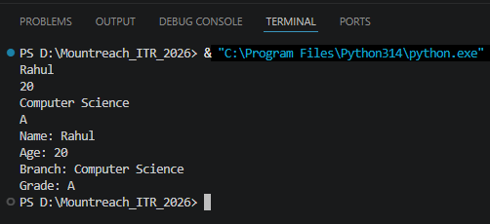

Program Code:

student = ('Rahul', 20, 'Computer Science', 'A')

# Iterate With for Loop
for item in student:
print(item)

# Unpack Into Separate Variables
name, age, branch, grade = student
print("Name:", name)
print("Age:", age)
print("Branch:", branch)
print("Grade:", grade)

- count() Method
Create the tuple: grades = ('A', ' B', 'A', ' C', 'A', ' B', ' D', 'A', ' B')
- Count and print how many times 'A' appears.
- Count and print how many times ' B' appears.
- Take a grade as input from the user and print how many times it appears.

Output:

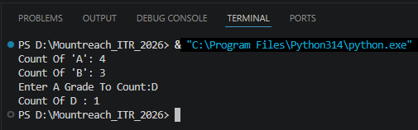

Program Code:

grades = ('A', 'B', 'A', 'C', 'A', 'B', 'D', 'A', 'B')

print("Count Of 'A':", grades.count('A'))
print("Count Of 'B':", grades.count('B'))

user_grade = input("Enter A Grade To Count:")
print("Count Of", user_grade, ":", grades.count(user_grade))

- index() Method
Create the tuple: fruits = (' apple', ' banana', 'cherry', ' banana', ' mango', ' apple')
- Find and print the first index of ' banana'.
- Find and print the first index of ' banana' starting the search from index 2.
- Use try-except to safely find the index of ' kiwi' and print "Not found" if it doesn' t exist.

Output:

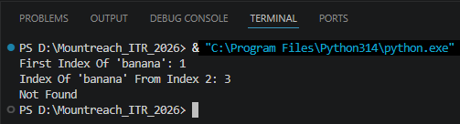

Program Code:

fruits = ('apple', 'banana', 'cherry', 'banana', 'mango', 'apple')

# First Occurrence Of 'banana'
print("First Index Of 'banana':", fruits.index('banana'))

# First 'banana' Starting From Index 2
print("Index Of 'banana' From Index 2:", fruits.index('banana', 2))

# Safe Search For 'kiwi'
try:
print("Index Of 'kiwi':", fruits.index('kiwi'))
except ValueError:
print("Not Found")

- Immutability Of Tuples
Create a tuple: coordinates = (10, 20)
Demonstrate that tuples are immutable by trying to:
- Change the first element
- Add a new element using append()
Explain what errors occur (in comments). Then show the correct way to modify data by converting the tuple to a list, making changes, and converting back to a tuple.

Output:

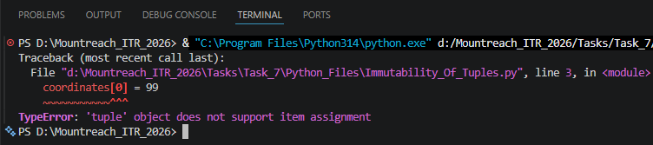

Program Code:

coordinates = (10, 20)

coordinates[0] = 99
# This Will Raise A TypeError Because Tuples Are Immutable
# Trying To Change An Element - Raises TypeError:
# 'tuple' Object Does Not Support Item Assignment
# coordinates[0] = 99 <- This Would Crash

coordinates.append(30)
# This Will Raise An AttributeError Because Tuples Are Immutable
# Trying To Append - Raises AttributeError:
# 'tuple' Object Has No Attribute 'append'
# coordinates.append(30) <- This Would Crash

# Correct Way: Convert To List, Modify, Convert Back
temp = list(coordinates)
temp[0] = 99
temp.append(30)
coordinates = tuple(temp)
print("Modified Coordinates:", coordinates)

- Mini Project - Combined Concepts
Create a Student Record Program using tuples:
- Take input for name, roll number, 3 subject marks.
- Store all information in a tuple (use packing).
- Print the complete record.
- Unpack the tuple and print each value with proper labels.
- Use count() to check how many times a particular mark appears (if any).
- Create a nested tuple to store multiple student records (at least 2 students) and access specific values.
Add meaningful comments and use proper formatting.

Output:

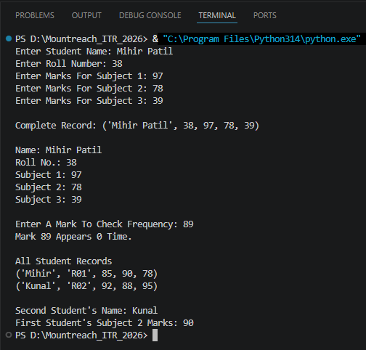
Program Code:

name = input("Enter Student Name: ")
roll = int(input("Enter Roll Number: "))
marks1 = int(input("Enter Marks For Subject 1: "))
marks2 = int(input("Enter Marks For Subject 2: "))
marks3 = int(input("Enter Marks For Subject 3: "))

# Store Using Tuple Packing
record = name, roll, marks1, marks2, marks3

# Print Complete Record
print("\nComplete Record:", record)

# Unpack & Display
s_name, s_roll, s_m1, s_m2, s_m3 = record
print("\nName:", s_name)
print("Roll No.:", s_roll)
print("Subject 1:", s_m1)
print("Subject 2:", s_m2)
print("Subject 3:", s_m3)

# count() Usage
marks_only = (s_m1, s_m2, s_m3)
check_mark = int(input("\nEnter A Mark To Check Frequency: "))
print("Mark", check_mark, "Appears", marks_only.count(check_mark), "Time.")

# Nested Tuple With Multiple Students
all_students = (("Mihir", "R01", 85, 90, 78),("Kunal", "R02", 92, 88, 95))

print("\nAll Student Records")
for s in all_students:
print(s)

# Accessing Specific Values
print("\nSecond Student's Name:", all_students[1][0])
print("First Student's Subject 2 Marks:", all_students[0][3])

