Task 7: Session 7 (AIML) - Assignment Questions

Name: Mihir Sopan Patil
Domain: AIML
College & Branch Name: Zeal Polytechnic, Diploma In AIML

- Creating Tuples
Write a program to create tuples using different methods:
- A tuple with 5 numbers using parentheses.
- A mixed tuple containing integer, string, float, and boolean.
- An empty tuple using two different ways.
- A single-element tuple with the value 99.
Print all tuples and their types. Add comments explaining the rules for single-element tuples.
Output:

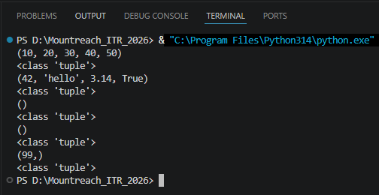

- Tuple Packing
Create a tuple without using parentheses (tuple packing) to store: your name, age, and city.
Print the tuple and its type.
Then unpack the tuple into three separate variables and print them individually.

Output:

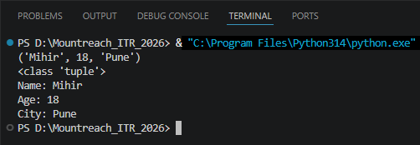

- Indexing & Negative Indexing
Create the tuple: colors = (' red', 'green', ' blue', ' yellow', ' purple', 'orange')
Print:
- First element
- Third element
- Last element (using negative index)
- Second last element (using negative index)
Take an index number as input from the user and print the element at that index.

Output:

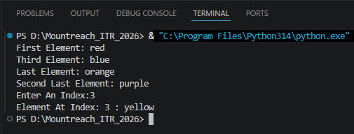

- Slicing Tuples
Given the tuple: numbers = (0, 1, 2, 3, 4, 5, 6, 7, 8, 9, 10)
Using slicing, print:
- Elements from index 2 to 7
- First 5 elements
- Last 4 elements
- Every second element
- The entire tuple in reverse order
Add comments explaining the slicing syntax.

Output:

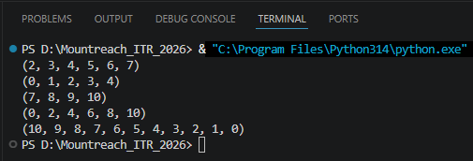

- Nested Tuples
Create a nested tuple to represent a 3•3 matrix:
matrix = ((1, 2, 3), (4, 5, 6), (7, 8, 9))
Print:
- The first row
- The element at second row, third column
- The element at third row, first column

Output:

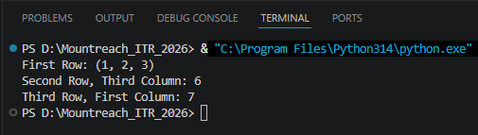

- Iterating & Unpacking
Create a tuple: student = (' Rahul', 20, ' Computer Science', 'A')
  - Iterate through the tuple using a for loop and print each item.
  - Unpack the tuple into four variables (name, age, branch, grade) and print them with descriptive messages.

Output:

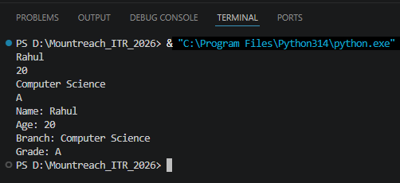

- count() Method
Create the tuple: grades = ('A', ' B', 'A', ' C', 'A', ' B', ' D', 'A', ' B')
- Count and print how many times 'A' appears.
- Count and print how many times ' B' appears.
- Take a grade as input from the user and print how many times it appears.

Output:

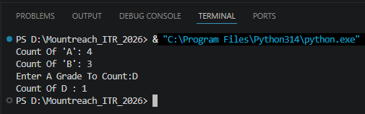

- index() Method
Create the tuple: fruits = (' apple', ' banana', 'cherry', ' banana', ' mango', ' apple')
- Find and print the first index of ' banana'.
- Find and print the first index of ' banana' starting the search from index 2.
- Use try-except to safely find the index of ' kiwi' and print "Not found" if it doesn' t exist.

Output:

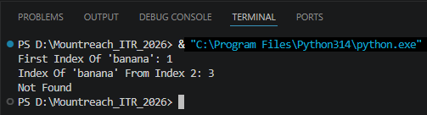

- Immutability Of Tuples
Create a tuple: coordinates = (10, 20)
Demonstrate that tuples are immutable by trying to:
- Change the first element
- Add a new element using append()
Explain what errors occur (in comments). Then show the correct way to modify data by converting the tuple to a list, making changes, and converting back to a tuple.

Output:

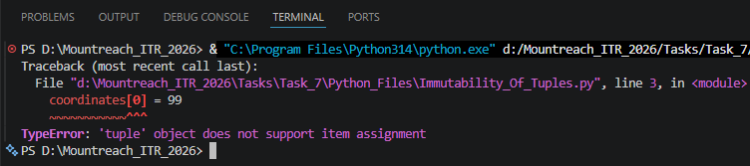

- Mini Project - Combined Concepts
Create a Student Record Program using tuples:
- Take input for name, roll number, 3 subject marks.
- Store all information in a tuple (use packing).
- Print the complete record.
- Unpack the tuple and print each value with proper labels.
- Use count() to check how many times a particular mark appears (if any).
- Create a nested tuple to store multiple student records (at least 2 students) and access specific values.
Add meaningful comments and use proper formatting.

Output:

