Task 8: Session 8 (AIML) - Assignment Questions

Name: Mihir Sopan Patil
Domain: AIML
College & Branch Name: Zeal Polytechnic, Diploma In AIML

- Creating Sets
Write a program to create the following sets:
- A set with 5 integers.
- A set with mixed data types (integer, string, float).
- An empty set using the correct method.
- A set from the string "hello" using the set() constructor.
Print each set and its type. Add comments explaining why sets automatically remove duplicates.

Output:

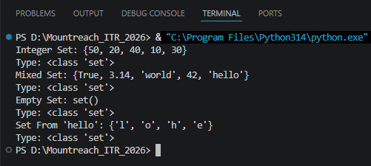

Program Code:

# A Set With 5 Integers
int_set = {10, 20, 30, 40, 50}
print("Integer Set:", int_set)
print("Type:", type(int_set))

# A Set With Mixed Data Types
mixed_set = {42, "hello", 3.14, True, "world"}
print("Mixed Set:", mixed_set)
print("Type:", type(mixed_set))

# An Empty Set Must Use set(), Not {} (That Creates An Empty Dict)
empty_set = set()
print("Empty Set:", empty_set)
print("Type:", type(empty_set))

# A Set From The String "hello" Using set() Constructor
# Sets Store Only Unique Elements, So Duplicate Letters Are Removed
string_set = set("hello")
print("Set From 'hello':", string_set)
print("Type:", type(string_set))

# Why Sets Remove Duplicates:
# Sets Are Implemented Using Hash Tables.
# Each Element Is Hashed & Stored At A Unique Position.
# If Two Elements Have The Same Hash (i.e., They Are Equal), Only One Is Kept.

- Characteristics Of Sets
Create a set: numbers = {10, 20, 30, 20, 40, 10, 50)
- Print the set and observe the output.
- Demonstrate that sets are unordered by printing the set multiple times.
- Try to access the first element using indexing (numbers[0]) and explain the error in comments.

Output:

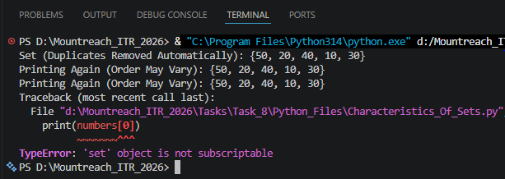

Program Code:

numbers = {10, 20, 30, 20, 40, 10, 50}

print("Set (Duplicates Removed Automatically):", numbers)
print("Printing Again (Order May Vary):", numbers)
print("Printing Again (Order May Vary):", numbers)

# Python Does Not Guarantee Any Apecific Order When Iterating Or Printing A Set.
print(numbers[0])
# Trying Indexing - This Will Raise A TypeError:
# Error: 'set' Object Is Not Subscriptable
# Sets Do Not Support Indexing Or Slicing Because They Are Unordered.
# There Is No Concept Of A "first" Element In A Set.
print("Indexing (numbers[0]) Is Not Supported On Sets - Sets Are Unordered.")

- Membership Testing
Write a program that:
- Takes a set of 5 colors as input from the user.
- Asks the user to enter a color name.
- Checks whether the color is present in the set using in and not in.
- Prints appropriate messages.

Output:

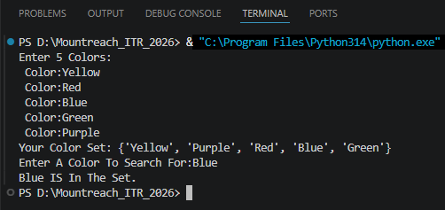

Program Code:

colors = set()
print("Enter 5 Colors:")
for i in range(5):
color = input(" Color:")
colors.add(color)

print("Your Color Set:", colors)
search = input("Enter A Color To Search For:")

if search in colors:
print(search, "IS In The Set.")
else:
print(search, "Is NOT In The Set.")

if search not in colors:
print("Confirmed:", search, "Is Not Present.")

- add(), remove(), discard()
Create a set: fruits = {' apple', ' banana', ' mango'}
Perform the following operations and print the set after each step:
- Add 'orange' using add().
- Add ' banana' again (observe the result).
- Remove ' mango' using remove().
- Try to remove 'grape' using discard() (no error should occur).

Output:

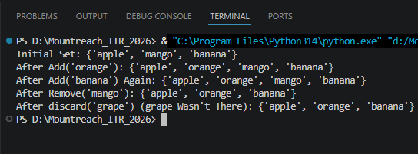

Program Code:

fruits = {'apple', 'banana', 'mango'}
print("Initial Set:", fruits)

# Add 'orange'
fruits.add('orange')
print("After Add('orange'):", fruits)

# Add 'banana' Again - No Duplicate, No Error, Set Unchanged
fruits.add('banana')
print("After Add('banana') Again:", fruits) # banana Already Exists

# Remove 'mango' - remove() Raises KeyError If Element Doesn't Exist
fruits.remove('mango')
print("After Remove('mango'):", fruits)

# discard 'grape' — discard() Does Not Raise An Error If Missing
fruits.discard('grape')
print("After discard('grape') (grape Wasn't There):", fruits)
- pop() & clear()
Create a set: s = {100, 200, 300, 400, 500)
  - Use pop() to remove and print one element.
  - Print the set after popping.
  - Clear the entire set using clear().
  - Print the final empty set.
Add comments explaining the difference between remove(), discard(), and pop().

Output:

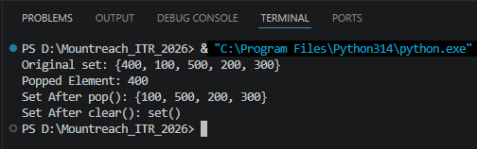

Program Code:

s = {100, 200, 300, 400, 500}
print("Original set:", s)

# pop() Removes & Returns An Arbitrary Element (Unpredictable Which One)
popped = s.pop()
print("Popped Element:", popped)
print("Set After pop():", s)

# clear() Removes All Elements From The Set
s.clear()
print("Set After clear():", s)

# Differences:
# remove(x) -> Removes Element x; Raises KeyError If x Is Not Found
# discard(x) -> Removes Element x; Does Nothing If x Is Not Found
# pop() -> Removes & Returns A Random Element; Raises KeyError If Set Is Empty

- update() & copy()
Create two sets:
set1 = {1, 2, 3)
set2 = {3, 4, 5, 6)
- Make a copy of set1.
- Update set1 with elements from set2 using update().
- Print both the original copy and the updated set.

Output:

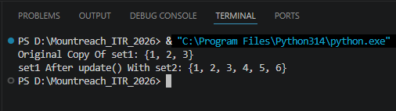

Program Code:

set1 = {1, 2, 3}
set2 = {3, 4, 5, 6}

# copy() Creates A Shallow Copy - Changes To set1 Won't Affect set1_copy
set1_copy = set1.copy()

# update() Adds All Elements From set2 Into set1 (In-Place Union)
set1.update(set2)

print("Original Copy Of set1:", set1_copy)
print("set1 After update() With set2:", set1)

- Union & Intersection
Create two sets:
A = {1, 2, 3, 4, 5)
B = {4, 5, 6, 7, 8)
- Print the union of A and B (using both .union() and operator).
- Print the intersection of A and B (using both .intersection() and & operator).
Add comments explaining what each operation does.

Output:

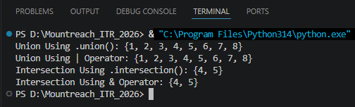

Program Code:

A = {1, 2, 3, 4, 5}
B = {4, 5, 6, 7, 8}

# Union: All Elements From Both Sets (No Duplicates)
print("Union Using .union():", A.union(B))
print("Union Using | Operator:", A | B)

# Intersection: Only Elements That Appear In Both Sets
print("Intersection Using .intersection():", A.intersection(B))
print("Intersection Using & Operator:", A & B)

# Union Gives Every Unique Element Across Both Sets.
# Intersection Gives Only The Common Elements Shared By Both Sets.

- Combined Methods
Write a program that:
- Takes 6 numbers as input from the user and stores them in a set (duplicates should be removed automatically).
- Adds two more numbers using add().
- Removes one number safely using discard().
- Prints the final set and its length using len().

Output:

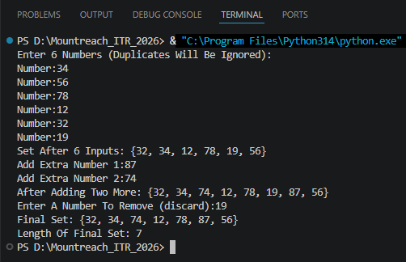

Program Code:

user_set = set()

print("Enter 6 Numbers (Duplicates Will Be Ignored):")
for i in range(6):
num = int(input("Number:"))
user_set.add(num)

print("Set After 6 Inputs:", user_set)

# Add Two More Numbers
extra1 = int(input("Add Extra Number 1:"))
user_set.add(extra1)
extra2 = int(input("Add Extra Number 2:"))
user_set.add(extra2)
print("After Adding Two More:", user_set)

# Safely Remove One Number
remove_val = int(input("Enter A Number To Remove (discard):"))
user_set.discard(remove_val) # No Error Even If Not Present

print("Final Set:", user_set)
print("Length Of Final Set:", len(user_set))

- Practical Application
Write a program to remove duplicate marks from a list of student scores using a set:
scores = [85, 92, 78, 92, 85, 88, 95, 78]
- Convert the list to a set.
- Print the unique scores.
- Convert the set back to a sorted list and print it.
- Print the total number of unique scores.

Output:

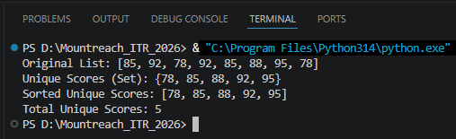

Program Code:

scores = [85, 92, 78, 92, 85, 88, 95, 78]
print("Original List:", scores)

# Convert List To Set - Duplicates Removed Automatically
unique_scores = set(scores)
print("Unique Scores (Set):", unique_scores)

# Convert Back To A Sorted List
sorted_scores = sorted(list(unique_scores))
print("Sorted Unique Scores:", sorted_scores)
print("Total Unique Scores:", len(sorted_scores))

- Mini Project - Combined Concepts
Create a Unique Item Collector program using sets:
- Repeatedly ask the user to enter items (e.g., favorite fruits, colors, or numbers).
- Store all entered items in a set (duplicates should be ignored).
- Provide a menu with options:
- Add item
- Remove item (use discard)
- Show all unique items
- Check if an item exists
- Clear all items
- Exit
Use a while loop for the menu and appropriate set methods. Add meaningful comments.

Output:

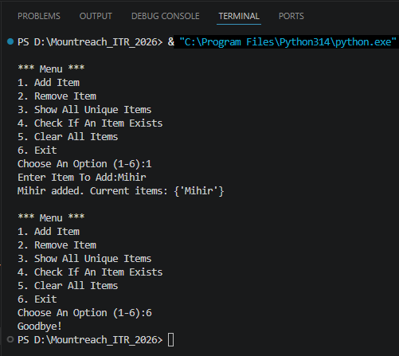
Program Code:

items = set() # Main Collection

while True:
print("\n*** Menu ***")
print("1. Add Item")
print("2. Remove Item")
print("3. Show All Unique Items")
print("4. Check If An Item Exists")
print("5. Clear All Items")
print("6. Exit")

choice = int(input("Choose An Option (1-6):"))

if choice == 1:
item = input("Enter Item To Add:")
items.add(item) # add() Ignores The Item If It Already Exists
print(item, "added. Current items:", items)

elif choice == 2:
item = input("Enter Item To Remove:")
items.discard(item) # discard() Won't Raise Error If Item Is Missing
print(item, "Removed (If It Existed). Current Items:",items)

elif choice == 3:
if items:
print("All Unique Items:", items)
else:
print("The Collection Is Empty.")

elif choice == 4:
item = input("Enter Item To Check:")
if item in items:
print(item, "Exists In The Collection.")
else:
print(item, "Does Not Exist In The Collection.")

elif choice == 5:
items.clear() # Removes All Elements; Set Becomes Empty
print("All Items Cleared.", items)

elif choice == 6:
print("Goodbye!")
break

else:
print("Invalid Choice. Please Enter A Number Between 1 & 6.")

