Task 8: Session 8 (AIML) - Assignment Questions

Name: Mihir Sopan Patil
Domain: AIML
College & Branch Name: Zeal Polytechnic, Diploma In AIML

- Creating Sets
Write a program to create the following sets:
- A set with 5 integers.
- A set with mixed data types (integer, string, float).
- An empty set using the correct method.
- A set from the string "hello" using the set() constructor.
Print each set and its type. Add comments explaining why sets automatically remove duplicates.

Output:

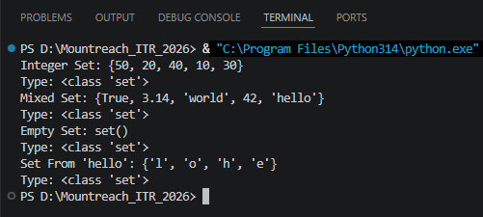

- Characteristics Of Sets
Create a set: numbers = {10, 20, 30, 20, 40, 10, 50)
- Print the set and observe the output.
- Demonstrate that sets are unordered by printing the set multiple times.
- Try to access the first element using indexing (numbers[0]) and explain the error in comments.

Output:

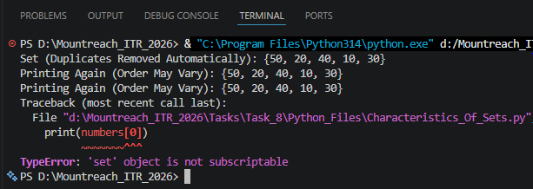

- Membership Testing
Write a program that:
- Takes a set of 5 colors as input from the user.
- Asks the user to enter a color name.
- Checks whether the color is present in the set using in and not in.
- Prints appropriate messages.

Output:

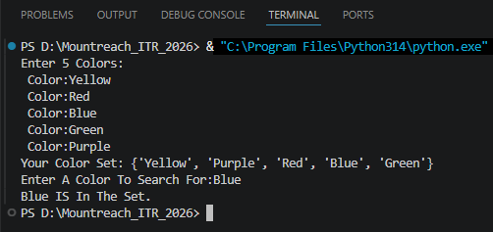

- add(), remove(), discard()
Create a set: fruits = {' apple', ' banana', ' mango'}
Perform the following operations and print the set after each step:
- Add 'orange' using add().
- Add ' banana' again (observe the result).
- Remove ' mango' using remove().
- Try to remove 'grape' using discard() (no error should occur).

Output:

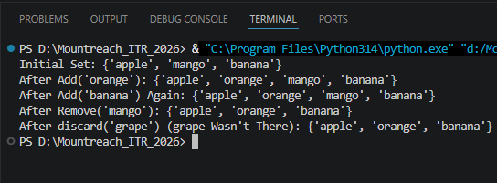

- pop() & clear()
Create a set: s = {100, 200, 300, 400, 500)
  - Use pop() to remove and print one element.
  - Print the set after popping.
  - Clear the entire set using clear().
  - Print the final empty set.
Add comments explaining the difference between remove(), discard(), and pop().

Output:

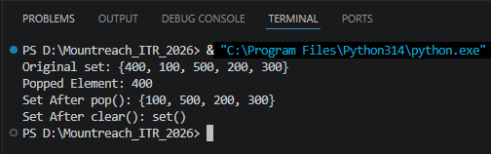

- update() & copy()
Create two sets:
set1 = {1, 2, 3)
set2 = {3, 4, 5, 6)
- Make a copy of set1.
- Update set1 with elements from set2 using update().
- Print both the original copy and the updated set.

Output:

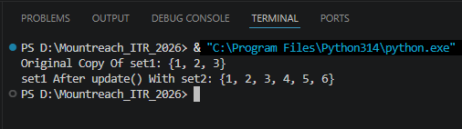

- Union & Intersection
Create two sets:
A = {1, 2, 3, 4, 5)
B = {4, 5, 6, 7, 8)
- Print the union of A and B (using both .union() and operator).
- Print the intersection of A and B (using both .intersection() and & operator).
Add comments explaining what each operation does.

Output:

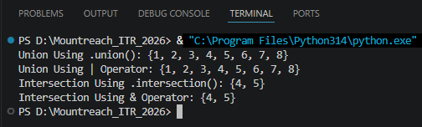

- Combined Methods
Write a program that:
- Takes 6 numbers as input from the user and stores them in a set (duplicates should be removed automatically).
- Adds two more numbers using add().
- Removes one number safely using discard().
- Prints the final set and its length using len().

Output:

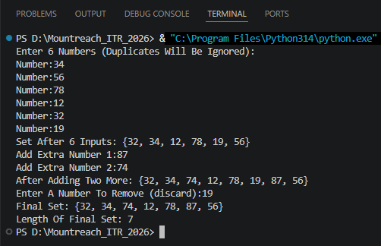

- Practical Application
Write a program to remove duplicate marks from a list of student scores using a set:
scores = [85, 92, 78, 92, 85, 88, 95, 78]
- Convert the list to a set.
- Print the unique scores.
- Convert the set back to a sorted list and print it.
- Print the total number of unique scores.

Output:

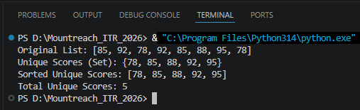

- Mini Project - Combined Concepts
Create a Unique Item Collector program using sets:
- Repeatedly ask the user to enter items (e.g., favorite fruits, colors, or numbers).
- Store all entered items in a set (duplicates should be ignored).
- Provide a menu with options:
- Add item
- Remove item (use discard)
- Show all unique items
- Check if an item exists
- Clear all items
- Exit
Use a while loop for the menu and appropriate set methods. Add meaningful comments.

Output:

