Task 9: Session 9 (AIML) - Assignment Questions

Name: Mihir Sopan Patil
Domain: AIML
College & Branch Name: Zeal Polytechnic, Diploma In AIML

- Creating Dictionaries
Write a program to create dictionaries using different methods:
- An empty dictionary using two different ways.
- A dictionary with string keys (name, city, course).
- A dictionary with integer keys.
- A mixed data type dictionary (string, int, float).
Print each dictionary and its type. Add comments explaining the syntax.

Output:

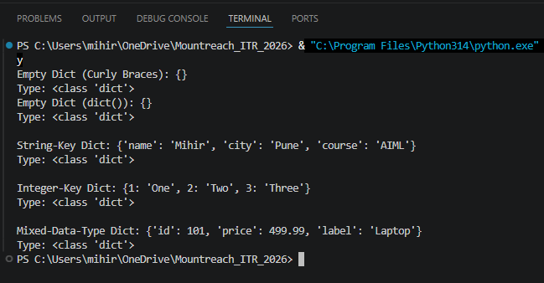

Program Code:

# Empty Dictionary - Two Different Ways
empty_dict_1 = {} # Method 1: Using Curly Braces
empty_dict_2 = dict() # Method 2: Using The dict() Constructor
print("Empty Dict (Curly Braces):", empty_dict_1)
print("Type:", type(empty_dict_1))
print("Empty Dict (dict()):", empty_dict_2)
print("Type:", type(empty_dict_2))

# Dictionary With String Keys
string_key_dict = {
"name": "Mihir",
"city": "Pune",
"course": "AIML"
}

print("\nString-Key Dict:", string_key_dict)
print("Type:", type(string_key_dict))

# Dictionary With Integer Keys
int_key_dict = {
1: "One",
2: "Two",
3: "Three"
}
print("\nInteger-Key Dict:", int_key_dict)
print("Type:", type(int_key_dict))

# Mixed Data Type Dictionary (Keys/Values Can Mix tr, int, float)
mixed_dict = {
"id": 101, # Int Value
"price": 499.99, # Float Value
"label": "Laptop" # String Value
}
print("\nMixed-Data-Type Dict:", mixed_dict)
print("Type:", type(mixed_dict))

- Accessing & Modifying Elements
Create the dictionary:
student = {
"name": "YourName",
"age": 00,
"city": "YourCity",
"marks": 00
}
- Print the value of "name" using square brackets.
- Update the "marks" to 92.
- Add a new key "grade" with value "A".
- Print the updated dictionary.

Output:

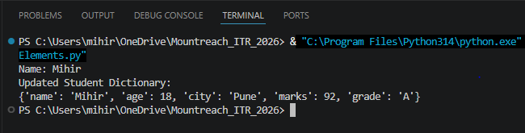

Program Code:

student = {
"name": "Mihir",
"age": 18,
"city": "Pune",
"marks": 84
}
# Accessing A Value Using Square Brackets
print("Name:", student["name"])

# Updating An Existing Key's Value
student["marks"] = 92

# Adding A New Key-Value Pair
student["grade"] = "A"

print("Updated Student Dictionary:")
print(student)
- get(), keys(), values(), items())
Create a dictionary:
person = {"name": "Priya", "age": 21, "profession": "Engineer"}
Demonstrate:
- Using get() to access "age" and a non-existing key "salary" (with default value).
- Print all keys using keys().
- Print all values using values().
- Print all key-value pairs using items().

Output:

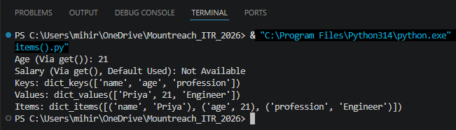
Program Code:

person = {"name": "Priya", "age": 21, "profession": "Engineer"}

# Safely Access A Key; Second Argument Is The Default If Key Is Missing
print("Age (Via get()):", person.get("age"))
print("Salary (Via get(), Default Used):", person.get("salary", "Not Available"))

# All Keys
print("Keys:", person.keys())

# All Values
print("Values:", person.values())

# All Key-Value Pairs
print("Items:", person.items())

- Nested Dictionary
Create a nested dictionary to store information of two students:
students = {
"s1": {"name": "Rahul", "age": 20, "marks": 88},
"s2": {"name": "Sneha", "age": 21, "marks": 95}
}

- Print the details of the first student.
- Print the marks of the second student.
- Add a new subject "math" with marks 90 for the first student.

Output:

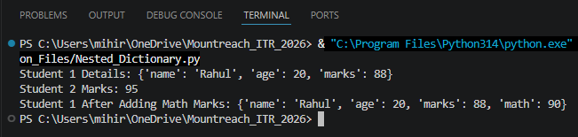

Program Code:

students = {
"s1": {"name": "Rahul", "age": 20, "marks": 88},
"s2": {"name": "Sneha", "age": 21, "marks": 95}
}

# Details Of The First Student (Entire Inner Dictionary)
print("Student 1 Details:", students["s1"])

# Marks Of The Second Student (Specific Value From Inner Dictionary)
print("Student 2 Marks:", students["s2"]["marks"])

# Adding A New Subject For The First Student
students["s1"]["math"] = 90
print("Student 1 After Adding Math Marks:", students["s1"])

- update() & pop()
Create a dictionary: info = {"brand": "Samsung", "model": "A52", "price": 25000)
- Update it with new information: {"color": "Black", "price": 24000).
- Remove the key "model" using pop() and print the removed value.
- Print the final dictionary.

Output:

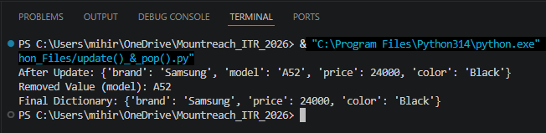

Program Code:

info = {"brand": "Samsung", "model": "A52", "price": 25000}

# update() Merges/Overwrites Keys From The Given Dictionary
info.update({"color": "Black", "price": 24000})
print("After Update:", info)

# pop() Removes A Key And Returns Its Value
removed_value = info.pop("model")
print("Removed Value (model):", removed_value)

print("Final Dictionary:", info)

- popitem() & clear()
Create a dictionary with at least 5 key-value pairs.
- Use popitem() twice and print the removed items each time.
- Clear the entire dictionary using clear().
- Print the final result.
Add comments explaining the difference between pop() and popitem().

Output:

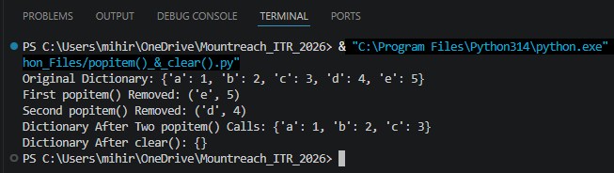

Program Code:

sample_dict = {"a": 1, "b": 2, "c": 3, "d": 4, "e": 5}
print("Original Dictionary:", sample_dict)

# popitem() Removes & Returns The Last Inserted (Key, Value) Pair
removed_1 = sample_dict.popitem()
print("First popitem() Removed:", removed_1)

removed_2 = sample_dict.popitem()
print("Second popitem() Removed:", removed_2)

print("Dictionary After Two popitem() Calls:", sample_dict)

# clear() Empties The Dictionary Completely
sample_dict.clear()
print("Dictionary After clear():", sample_dict)

# Difference Between pop() & popitem():
# - pop(key) Removes A Specific Key You Name, & Returns Its Value.
# It Raises A KeyError If The Key Doesn't Exist (Unless A Default Is Given).
# - popitem() Removes & Returns The Last Inserted (Key, Value) Pair As A Tuple.
# You Don't Choose Which Item Is Removed; Python Picks The Most Recently Added One.

- copy() & setdefault()
Create a dictionary: d = {"a": 1, "b": 2)
- Make a copy of it.
- Use setdefault() to add key "c" with value 3 (if it doesn' t exist).
- Use setdefault() again for an existing key "a".
- Print the original and copied dictionaries.

Output:

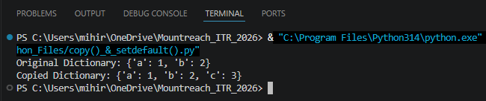

Program Code:

d = {"a": 1, "b": 2}

# copy() Creates A Separate (Shallow) Copy; Changes To One Don't Affect The Other
d_copy = d.copy()

# setdefault() Adds The Key With The Given Value ONLY If It Doesn't Already Exist
d_copy.setdefault("c", 3) # "c" Doesn't Exist -> Gets Added With Value 3
d_copy.setdefault("a", 100) # "a" Already Exists -> Value Stays Unchanged

print("Original Dictionary:", d)
print("Copied Dictionary:", d_copy)

- fromkeys() & Membership
Write a program that:
- Uses dict.fromkeys() to create a dictionary with keys ["name", "age", "city"] and default value None.
- Takes user input to fill these keys.
- Checks if a given key exists using in operator.

Output:

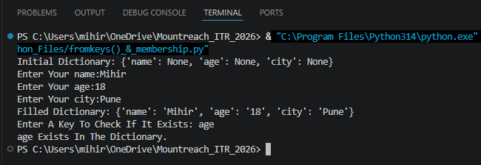

Program Code:

# Create A Dictionary With Given Keys, All Set To None Initially
user_info = dict.fromkeys(["name", "age", "city"], None)
print("Initial Dictionary:", user_info)

# Take User Input To Fill In The Keys
for key in user_info:
user_info[key] = input("Enter Your " + key + ":")

print("Filled Dictionary:", user_info)

# Membership Check Using The 'in' Operator
check_key = input("Enter A Key To Check If It Exists: ")
if check_key in user_info:
print(check_key, "Exists In The Dictionary.")
else:
print(check_key, "Does Not Exist In The Dictionary.")

- Practical Application
Write a program to store and manage contact information using a dictionary:
- Take name, phone number, and email as input.
- Store them in a dictionary with name as key.
- Allow the user to search a contact by name using get().
- Print all contacts using items().

Output:

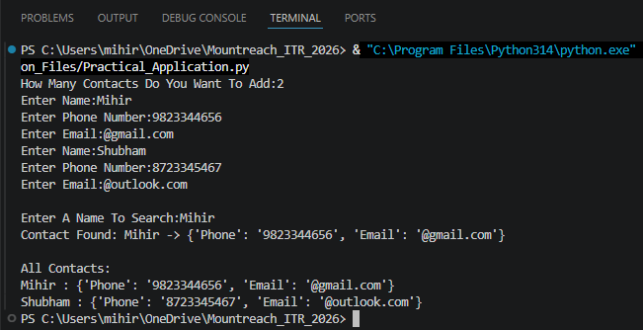

Program Code:

contacts = {}

num_contacts = int(input("How Many Contacts Do You Want To Add:"))
for _ in range(num_contacts):
name = input("Enter Name:")
phone = input("Enter Phone Number:")
email = input("Enter Email:")

# Store Each Contact's Details As A Nested Dictionary, Keyed By Name
contacts[name] = {"Phone": phone, "Email": email}

# Search A Contact By Name Using get() (Returns None If Not Found)
search_name = input("\nEnter A Name To Search:")
found_contact = contacts.get(search_name)
if found_contact:
print("Contact Found:", search_name, "->", found_contact)
else:
print("No Contact Found With The Name", search_name,)

# Print All Contacts Using items()
print("\nAll Contacts:")
for name, details in contacts.items():
print(name, ":", details)

- Mini Project - Combined Concepts
Create a Student Management System using a dictionary:
- Repeatedly ask the user to enter student details (roll number as key, and a nested dictionary containing name, age, and marks).
- Use a while loop with a menu:
- Add new student
- Update marks of a student
- Search student by roll number
- Display all students
- Remove a student
- Exit
Use appropriate dictionary methods (get(), update(), pop(), etc.). Add meaningful comments

Output:

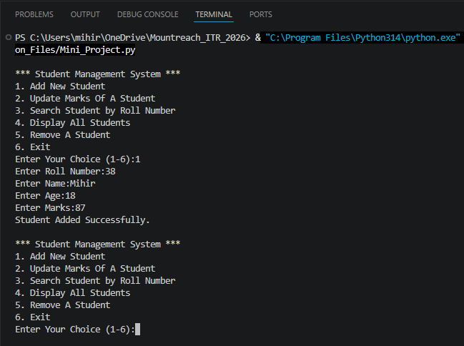

Program Code:

students_db = {} # roll (key) -> {"name", "age", "marks"} (Nested Dictionary)

def add_student():
roll = input("Enter Roll Number:")
if roll in students_db:
print("A Student With This Roll Number Already Exists.")
return
name = input("Enter Name:")
age = input("Enter Age:")
marks = input("Enter Marks:")
students_db[roll] = {"name": name, "age": age, "marks": marks}
print("Student Added Successfully.")

def update_marks():
roll = input("Enter Roll Number To Update Marks:")
if roll in students_db:
new_marks = input("Enter New Marks:")
students_db[roll]["marks"] = new_marks
print("Marks Updated Successfully.")
else:
print("Student Not Found.")

def search_student():
roll = input("Enter Roll Number To Search:")
# get() Avoids A KeyError If The Roll Number Doesn't Exist
student_record = students_db.get(roll)
if student_record:
print("Student Found -> Roll Number", roll, ":", student_record)
else:
print("Student Not Found.")

def display_all():
if not students_db:
print("No Students In The System Yet.")
return
for roll, details in students_db.items():
print("Roll Number", roll, ":", details)

def remove_student():
roll = input("Enter Roll Number To Remove: ")
removed = students_db.pop(roll, None) # Default None Avoids KeyError
if removed:
print("Removed Student:", removed)
else:
print("Student Not Found.")

def show_menu():
print("\n*** Student Management System ***")
print("1. Add New Student")
print("2. Update Marks Of A Student")
print("3. Search Student by Roll Number")
print("4. Display All Students")
print("5. Remove A Student")
print("6. Exit")

while True:
show_menu()
choice = input("Enter Your Choice (1-6):")

if choice == "1":
add_student()
elif choice == "2":
update_marks()
elif choice == "3":
search_student()
elif choice == "4":
display_all()
elif choice == "5":
remove_student()
elif choice == "6":
print("Exiting Student Management System. Goodbye!")
break
else:
print("Invalid Choice. Please Enter A Number Between 1 & 6.")

