Task 9: Session 9 (AIML) - Assignment Questions

Name: Mihir Sopan Patil
Domain: AIML
College & Branch Name: Zeal Polytechnic, Diploma In AIML

- Creating Dictionaries
Write a program to create dictionaries using different methods:
- An empty dictionary using two different ways.
- A dictionary with string keys (name, city, course).
- A dictionary with integer keys.
- A mixed data type dictionary (string, int, float).
Print each dictionary and its type. Add comments explaining the syntax.

Output:

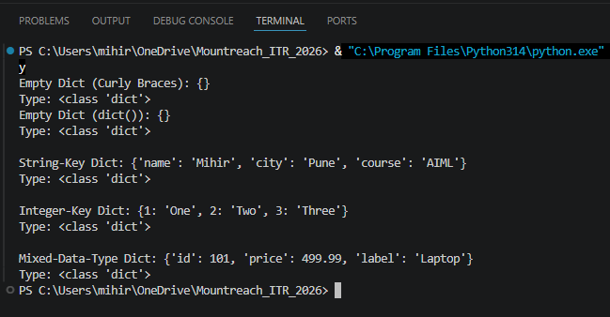

- Accessing & Modifying Elements
Create the dictionary:
student = {
"name": "YourName",
"age": 00,
"city": "YourCity",
"marks": 00
}
- Print the value of "name" using square brackets.
- Update the "marks" to 92.
- Add a new key "grade" with value "A".
- Print the updated dictionary.

Output:

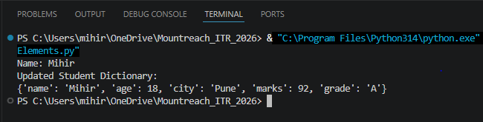

- get(), keys(), values(), items())
Create a dictionary:
person = {"name": "Priya", "age": 21, "profession": "Engineer"}
Demonstrate:
- Using get() to access "age" and a non-existing key "salary" (with default value).
- Print all keys using keys().
- Print all values using values().
- Print all key-value pairs using items().

Output:

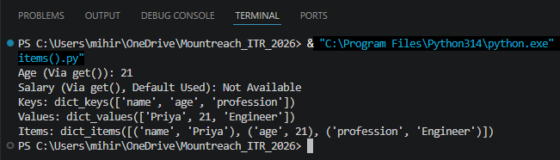

- Nested Dictionary
Create a nested dictionary to store information of two students:
students = {
"s1": {"name": "Rahul", "age": 20, "marks": 88},
"s2": {"name": "Sneha", "age": 21, "marks": 95}
}

- Print the details of the first student.
- Print the marks of the second student.
- Add a new subject "math" with marks 90 for the first student.

Output:

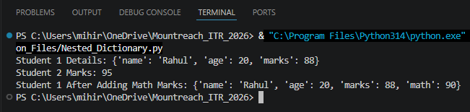

- update() & pop()
Create a dictionary: info = {"brand": "Samsung", "model": "A52", "price": 25000)
- Update it with new information: {"color": "Black", "price": 24000).
- Remove the key "model" using pop() and print the removed value.
- Print the final dictionary.

Output:

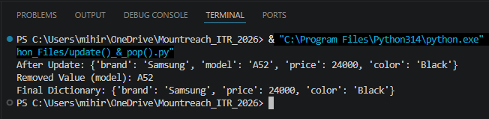

- popitem() & clear()
Create a dictionary with at least 5 key-value pairs.
- Use popitem() twice and print the removed items each time.
- Clear the entire dictionary using clear().
- Print the final result.
Add comments explaining the difference between pop() and popitem().

Output:

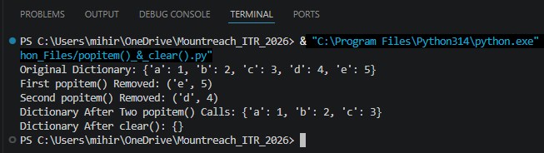

- copy() & setdefault()
Create a dictionary: d = {"a": 1, "b": 2)
- Make a copy of it.
- Use setdefault() to add key "c" with value 3 (if it doesn' t exist).
- Use setdefault() again for an existing key "a".
- Print the original and copied dictionaries.

Output:

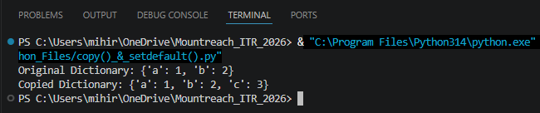

- fromkeys() & Membership
Write a program that:
- Uses dict.fromkeys() to create a dictionary with keys ["name", "age", "city"] and default value None.
- Takes user input to fill these keys.
- Checks if a given key exists using in operator.

Output:

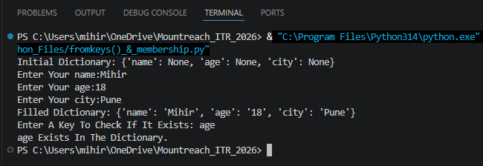

- Practical Application
Write a program to store and manage contact information using a dictionary:
- Take name, phone number, and email as input.
- Store them in a dictionary with name as key.
- Allow the user to search a contact by name using get().
- Print all contacts using items().

Output:

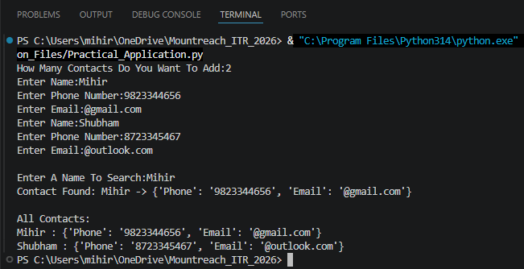

- Mini Project - Combined Concepts
Create a Student Management System using a dictionary:
- Repeatedly ask the user to enter student details (roll number as key, and a nested dictionary containing name, age, and marks).
- Use a while loop with a menu:
- Add new student
- Update marks of a student
- Search student by roll number
- Display all students
- Remove a student
- Exit
Use appropriate dictionary methods (get(), update(), pop(), etc.). Add meaningful comments

Output:

