Task 12: Session 12 (AIML) - Assignment Questions

Name: Mihir Sopan Patil
Domain: AIML
College & Branch Name: Zeal Polytechnic, Diploma In AIML

- GitHub Account Setup
Create a GitHub account (if you donʼt have one).
Create a new repository named Python-Basic-Projects.
After implementing each feature in each questionʼs solution, commit your code with a proper commit message (e.g., "Implement Loop for Counting Vowels" or “Create analyze_string function”).
After completing the full project, push everything to GitHub.

Output:

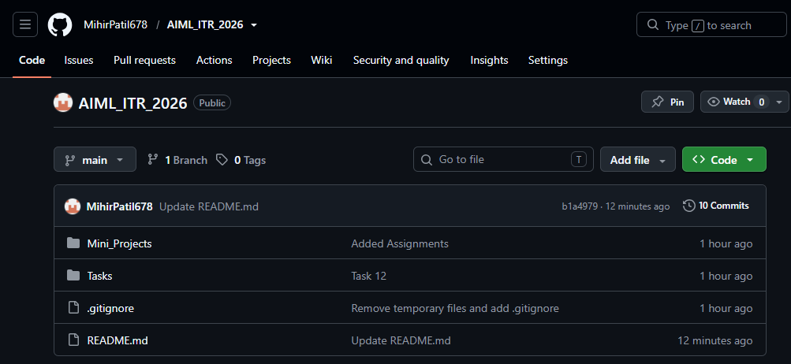

- Strings + Loops + Functions
Write a function analyze_string(s) that takes a string as input and:
- Prints its length using len().
- Prints the string in reverse using slicing.
- Counts and prints how many vowels (a,e,i,o,u) are in the string (case insensitive).
- Uses a for loop with range() to print each character with its positive and negative index.
Call this function with user input and handle empty string case.

Output:

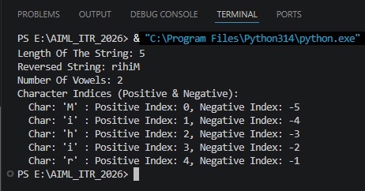

Program Code:

def analyze_string(s):
# Handle Empty String Case First
if s == "":
print("Error: The String Is Empty. Please Provide A Non-Empty String.")
return

# Length Of The String
length = len(s)
print(f"\nLength Of The String: {length}")

# Reverse The String Using Slicing
reversed_s = s[::-1]
print(f"Reversed String: {reversed_s}")

# Count Vowels (Case Insensitive)
vowels = "aeiouAEIOU"
vowel_count = 0
for j in s:
if j in vowels:
vowel_count += 1
print(f"Number Of Vowels: {vowel_count}")

# Print Each Character With Its Positive & Negative Index
print("Character Indices (Positive & Negative):")
for i in range(length):
neg_index = i - length # equivalent negative index
print(f" Char: '{s[i]}' : Positive Index: {i}, Negative Index: {neg_index}")

def main():
user_input = input("Enter A String To Analyze: ")
analyze_string(user_input)

if __name__ == "__main__":
main()

- Lists + Functions + Exception Handling
Create a function manage_marks() that:
- Takes 5 subject marks as input from the user.
- Stores them in a list.
- Handles ValueError if non-numeric input is given.
- Calculates and prints the average, highest, and lowest marks.
- Sorts the list in descending order and prints it.
Use meaningful comments.

Output:

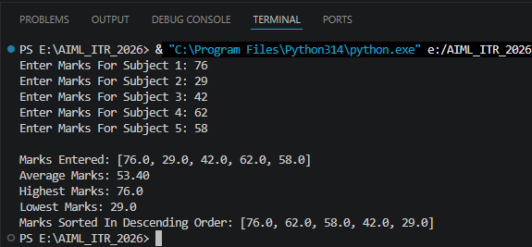

Program Code:

def manage_marks():
marks = [] # List To Store The 5 Subject Marks
subjects = 5

# Loop Until We Collect 5 Valid Numeric Marks
i = 1
while i <= subjects:
try:
value = float(input(f"Enter Marks For Subject {i}: "))
marks.append(value)
i += 1 # Only Move To Next Subject If Input Was Valid
except ValueError:
# Handle Non-Numeric Input Gracefully & Re-Prompt
print("Invalid Input! Please Enter A Numeric Value.")

# Calculate Average, Highest, & Lowest Using Built-In Functions
average = sum(marks) / len(marks)
highest = max(marks)
lowest = min(marks)

print(f"\nMarks Entered: {marks}")
print(f"Average Marks: {average:.2f}")
print(f"Highest Marks: {highest}")
print(f"Lowest Marks: {lowest}")

# Sort The List In Descending Order
marks.sort(reverse=True)
print(f"Marks Sorted In Descending Order: {marks}")

if __name__ == "__main__":
manage_marks()

- OOP + Lists + Exception Handling
Create a class Student with attributes: name, roll_no, and marks_list (a list of marks).
Include methods:
- __init__ to initialize the student.
- add_mark(mark) to add a mark to the list (handle invalid marks).
- get_average() to return the average.
- display_info() to show all details.
Create one student object, add marks using user input, and demonstrate all methods with exception handling.

Output:

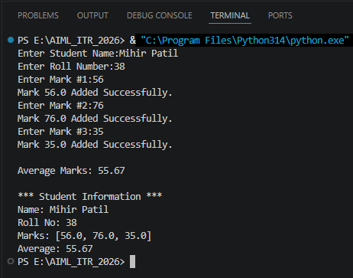

Program Code:

class Student:
def __init__(self, name, roll_no):
self.name = name
self.roll_no = roll_no
self.marks_list = [] # Start With An Empty List of marks

def add_mark(self, mark):
try:
mark = float(mark)
if mark < 0 or mark > 100:
# Basic Check For A Mark Range
print("Invalid Mark! Marks Must Be Between 0 & 100.")
return
self.marks_list.append(mark)
print(f"Mark {mark} Added Successfully.")
except ValueError:
print("Invalid Mark! Please Enter A Numeric Value.")

def get_average(self):
if not self.marks_list:
return 0
return sum(self.marks_list) / len(self.marks_list)

def display_info(self):
print("\n*** Student Information ***")
print(f"Name: {self.name}")
print(f"Roll No: {self.roll_no}")
print(f"Marks: {self.marks_list}")
print(f"Average: {self.get_average():.2f}")

def main():
# Create One Student Object
name = input("Enter Student Name:")
roll_no = input("Enter Roll Number:")
student = Student(name, roll_no)

# Add Marks Using User Input, Demonstrating Exception Handling
num_marks = 3
for i in range(num_marks):
mark_input = input(f"Enter Mark #{i + 1}:")
student.add_mark(mark_input)

# Demonstrate All Methods
print(f"\nAverage Marks: {student.get_average():.2f}")
student.display_info()

if __name__ == "__main__":
main()

- Dictionaries + Functions + Control Structures
Write a function student_database() that uses a dictionary (roll number as key) to store student records.
- Provide a menu using while loop:
- Add student (name, age, city)
- Search student by roll number
- Display all students
- Exit
Use get(), update(), and proper exception handling for invalid inputs.

Output:

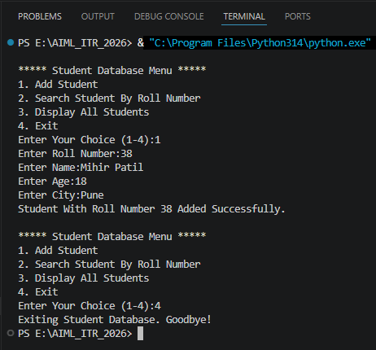

Program Code:

def student_database():
records = {} # dictionary: roll_no -> {name, age, city}

while True:
print("\n***** Student Database Menu *****")
print("1. Add Student")
print("2. Search Student By Roll Number")
print("3. Display All Students")
print("4. Exit")

try:
choice = int(input("Enter Your Choice (1-4):"))
except ValueError:
print("Invalid Input! Please Enter A Number Between 1 & 4.")
continue

if choice == 1:
try:
roll_no = int(input("Enter Roll Number:"))
name = input("Enter Name:")
age = int(input("Enter Age:"))
city = input("Enter City:")

# update() Is Used To Add/Overwrite The Record For This roll_no
records.update({roll_no: {"name": name, "age": age, "city": city}})
print(f"Student With Roll Number {roll_no} Added Successfully.")
except ValueError:
print("Invalid Age Entered! Student Not Added.")

elif choice == 2:
roll_no = int(input("Enter Roll Number To Search:"))
# get() Returns None If The Key Doesn't Exist, Avoiding A KeyError
student = records.get(roll_no)
if student:
print(f"Roll No: {roll_no} -> {student}")
else:
print("No Student Found With That Roll Number.")

elif choice == 3:
if not records:
print("No Student Records Found.")
else:
print("\nAll Student Records:")
for roll_no, info in records.items():
print(f"Roll No: {roll_no} -> {info}")

elif choice == 4:
print("Exiting Student Database. Goodbye!")
break

else:
print("Invalid Choice! Please Select An Option Between 1 & 4.")

if __name__ == "__main__":
student_database()
- Sets + Tuples + Modules
Write a program that:
- Takes 10 numbers as input and stores unique numbers in a set.
- Converts that set into a tuple.
- Uses random module to pick and print 3 random numbers from the tuple.
- Uses math module to print the square root of the sum of the tuple elements.
Handle possible exceptions.

Output:

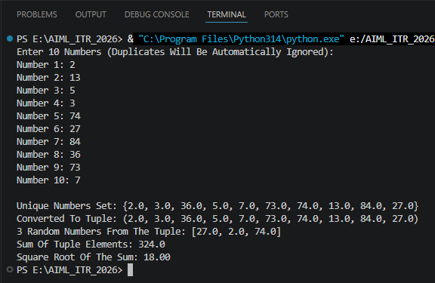

Program Code:

import random
import math

def main():
number_set = set() # Unique Numbers Only

print("Enter 10 Numbers (Duplicates Will Be Automatically Ignored):")
count = 0
while count < 10:
try:
value = float(input(f"Number {count + 1}: "))
number_set.add(value)
count += 1
except ValueError:
print("Invalid Input! Please Enter A Numeric Value.")

# Convert The Set Into A Tuple
number_tuple = tuple(number_set)
print(f"\nUnique Numbers Set: {number_set}")
print(f"Converted To Tuple: {number_tuple}")

# Use Random Module To Pick 3 Random Numbers From The Tuple
try:
sample_size = min(3, len(number_tuple))
random_numbers = random.sample(number_tuple, sample_size)
print(f"3 Random Numbers From The Tuple: {random_numbers}")
except ValueError as e:
print(f"Could Not Sample Random Numbers: {e}")

# Use Math Module To Print The Square Root Of The Sum Of Tuple Elements
try:
total = sum(number_tuple)
if total < 0:
print("Cannot Compute Square Root Of A Negative Sum.")
else:
sqrt_value = math.sqrt(total)
print(f"Sum Of Tuple Elements: {total}")
print(f"Square Root Of The Sum: {sqrt_value:.2f}")
except Exception as e:
print(f"An Error Occurred While Calculating The Square Root: {e}")

if __name__ == "__main__":
main()

- Lambda + range() + Lists + Exception Handling
Create a lambda function to calculate the square of a number.
Write a program that:
- Uses range(1, 21) to generate numbers.
- Stores the squares of these numbers in a list using the lambda function.
- Prints only the even squares from the list.
Add exception handling if needed.

Output:

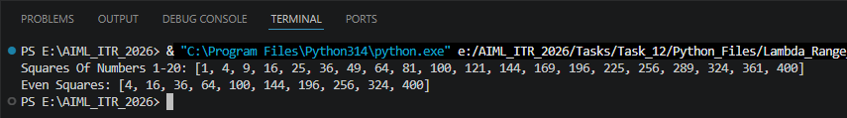

Program Code:
def main():
try:
# Lambda Function To Compute The Square Of A Number
square = lambda x: x ** 2
squares=[]

# Generate Numbers 1 To 20 & Store Their Squares
for n in range(1,21):
squares.append(square(n))
print(f"Squares Of Numbers 1-20: {squares}")

# Filter & Print Only The Even Squares
even_squares=[]
for s in squares:
if s % 2 == 0:
even_squares.append(s)
print(f"Even Squares: {even_squares}")

except Exception as e:
# General Exception Handling In Case Something Unexpected Occurs
print(f"An Error Occurred: {e}")

if __name__ == "__main__":
main()
- Tuples + Dictionaries + OOP
Create a class Employee with:
- Attributes: emp_id, name, details (a tuple containing department and salary).
- Method show_details() to print all information.
Create a dictionary where employee ID is the key and Employee object is the value.
Add 3 employees and display all using a loop.

Output:

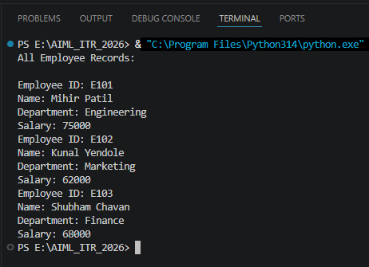

Program Code:

class Employee:
def __init__(self, emp_id, name, department, salary):
self.emp_id = emp_id
self.name = name
# details Is A Tuple Containing Department & Salary
self.details = (department, salary)

def show_details(self):
department, salary = self.details
print(f"Employee ID: {self.emp_id}")
print(f"Name: {self.name}")
print(f"Department: {department}")
print(f"Salary: {salary}")

def main():
# Dictionary: employee ID (Key) -> Employee Object (Value)
employees = {}

# Add 3 employees
employees["E101"] = Employee("E101", "Mihir Patil", "Engineering", 75000)
employees["E102"] = Employee("E102", "Kunal Yendole", "Marketing", 62000)
employees["E103"] = Employee("E103", "Shubham Chavan", "Finance", 68000)

# Display All Employees Using A Loop
print("All Employee Records:\n")
for emp_id, employee in employees.items():
employee.show_details()

if __name__ == "__main__":
main()

- Strings + Sets + Exception Handling + Modules
Write a program that:
  - Takes a sentence as input.
  - Extracts all unique words (using set) from the sentence.
  - Prints the unique words in sorted order.
  - Uses math module to print the total number of unique words raised to power 2.
  - Handle any possible exceptions gracefully.

Output:

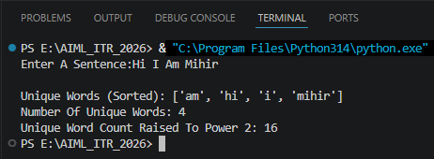

Program Code:

import math

def main():
try:
sentence = input("Enter A Sentence:")

if not sentence.strip():
print("Error: The Sentence Is Empty.")
return

# Split The Sentence Into Words & Extract Unique Words Using A Set
words = sentence.lower().split()
unique_words = set(words)

# Print Unique Words In Sorted Order
sorted_words = sorted(unique_words)
print(f"\nUnique Words (Sorted): {sorted_words}")

# Use math Module To Raise The Count Of Unique Words To Power 2
word_count = len(unique_words)
result = math.pow(word_count, 2)
print(f"Number Of Unique Words: {word_count}")
print(f"Unique Word Count Raised To Power 2: {int(result)}")

except Exception as e:
# Catch-All For Any Unexpected Errors
print(f"An Error Occurred: {e}")

if __name__ == "__main__":
main()

- Mini Project - Comprehensive
Create a Smart Calculator & Data Manager program that combines multiple concepts:
  - Use a while loop menu with these options:
  - Basic Arithmetic (use functions + exception handling)
  - Scientific Calculations (use math module)
  - Generate Random Numbers (use random module)
  - Store Results in Dictionary (with timestamp using string)
  - View History (show stored results)
  - Exit
Output:
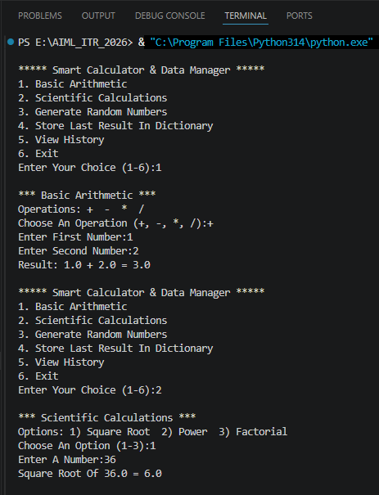
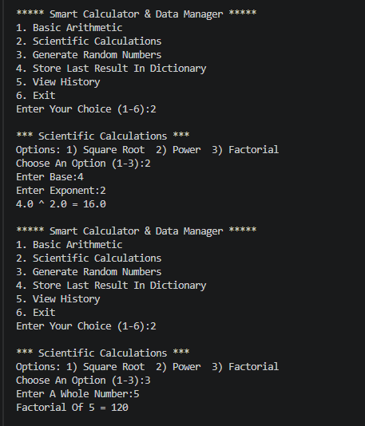

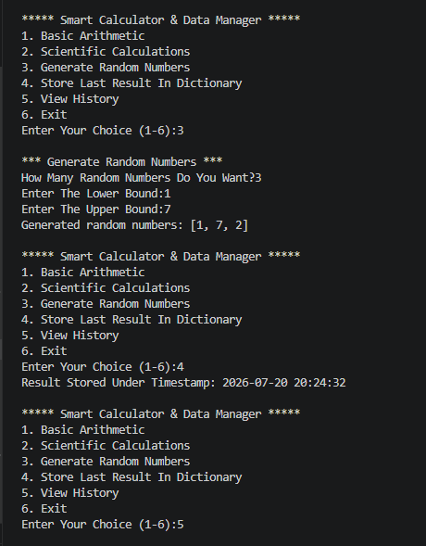

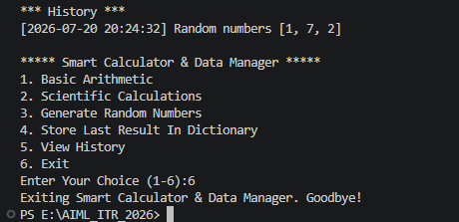

Program Code:

import math
import random
from datetime import datetime

# Dictionary To Store Results: {timestamp_string: result_description}
history = {}

def get_number(prompt):
while True:
try:
return float(input(prompt))
except ValueError:
print("Invalid Input! Please Enter A Numeric Value.")

def basic_arithmetic():
print("\n*** Basic Arithmetic ***")
print("Operations: + - * /")
op = input("Choose An Operation (+, -, *, /):").strip()

num1 = get_number("Enter First Number:")
num2 = get_number("Enter Second Number:")

try:
if op == "+":
result = num1 + num2
elif op == "-":
result = num1 - num2
elif op == "*":
result = num1 * num2
elif op == "/":
result = num1 / num2 # May Raise ZeroDivisionError
else:
print("Invalid Operation Selected.")
return None

print(f"Result: {num1} {op} {num2} = {result}")
return f"{num1} {op} {num2} = {result}"

except ZeroDivisionError:
print("Error: Division By Zero Is Not Allowed.")
return None

def scientific_calculations():
print("\n*** Scientific Calculations ***")
print("Options: 1) Square Root 2) Power 3) Factorial")
choice = input("Choose An Option (1-3):").strip()

try:
if choice == "1":
num = get_number("Enter A Number:")
if num < 0:
print("Cannot Calculate Square Root Of A Negative Number.")
return None
result = math.sqrt(num)
print(f"Square Root Of {num} = {result}")
return f"sqrt({num}) = {result}"

elif choice == "2":
base = get_number("Enter Base:")
exponent = get_number("Enter Exponent:")
result = math.pow(base, exponent)
print(f"{base} ^ {exponent} = {result}")
return f"{base}^{exponent} = {result}"

elif choice == "3":
num = int(get_number("Enter A Whole Number:"))
if num < 0:
print("Factorial Is Not Defined For Negative Numbers.")
return None
result = math.factorial(num)
print(f"Factorial Of {num} = {result}")
return f"{num}! = {result}"

else:
print("Invalid Option Selected.")
return None

except Exception as e:
print(f"An Error Occurred During Calculation: {e}")
return None

def generate_random_numbers():
print("\n*** Generate Random Numbers ***")
try:
count = int(get_number("How Many Random Numbers Do You Want?"))
low = int(get_number("Enter The Lower Bound:"))
high = int(get_number("Enter The Upper Bound:"))

if count <= 0 or low > high:
print("Invalid Range Or Count Provided.")
return None

random_numbers = []
for _ in range(count):
random_numbers.append(random.randint(low, high))

print(f"Generated random numbers: {random_numbers}")
return f"Random numbers {random_numbers}"

except Exception as e:
print(f"An Error Occurred:{e}")
return None

def store_result(description):
if description is None:
print("Nothing To Store.")
return

# Create A Timestamp String As The Dictionary Key
timestamp = datetime.now().strftime("%Y-%m-%d %H:%M:%S")
history[timestamp] = description
print(f"Result Stored Under Timestamp: {timestamp}")

def view_history():
print("\n*** History ***")
if not history:
print("No Results Have Been Stored Yet.")
return

for timestamp, description in history.items():
print(f"[{timestamp}] {description}")

def main():
last_result = None # Keeps Track Of The Most Recent Result For Storing

while True:
print("\n***** Smart Calculator & Data Manager *****")
print("1. Basic Arithmetic")
print("2. Scientific Calculations")
print("3. Generate Random Numbers")
print("4. Store Last Result In Dictionary")
print("5. View History")
print("6. Exit")

try:
choice = int(input("Enter Your Choice (1-6):"))
except ValueError:
print("Invalid Input! Please Enter A Number Between 1 & 6.")
continue

if choice == 1:
last_result = basic_arithmetic()
elif choice == 2:
last_result = scientific_calculations()
elif choice == 3:
last_result = generate_random_numbers()
elif choice == 4:
store_result(last_result)
elif choice == 5:
view_history()
elif choice == 6:
print("Exiting Smart Calculator & Data Manager. Goodbye!")
break
else:
print("Invalid Choice! Please Select An Option Between 1 & 6.")

if __name__ == "__main__":
main()

