Task 12: Session 12 (AIML) - Assignment Questions

Name: Mihir Sopan Patil
Domain: AIML
College & Branch Name: Zeal Polytechnic, Diploma In AIML
GitHub: https://github.com/MihirPatil678/AIML_ITR_2026/tree/main/Tasks/Task_12

- GitHub Account Setup
- Create a GitHub account (if you donʼt have one).
- Create a new repository named Python-Basic-Projects.
- After implementing each feature in each questionʼs solution, commit your code with a proper commit message (e.g., "Implement Loop for Counting Vowels" or “Create analyze_string function”).
- After completing the full project, push everything to GitHub.

Output:

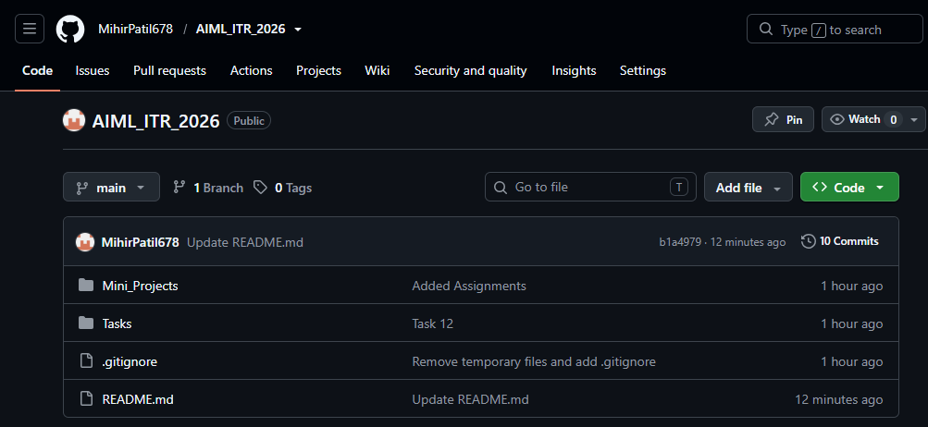

- Strings + Loops + Functions
Write a function analyze_string(s) that takes a string as input and:
- Prints its length using len().
- Prints the string in reverse using slicing.
- Counts and prints how many vowels (a,e,i,o,u) are in the string (case insensitive).
- Uses a for loop with range() to print each character with its positive and negative index.
Call this function with user input and handle empty string case.

Output:

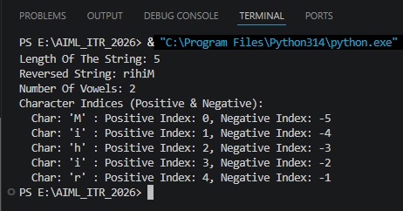

- Lists + Functions + Exception Handling
Create a function manage_marks() that:
- Takes 5 subject marks as input from the user.
- Stores them in a list.
- Handles ValueError if non-numeric input is given.
- Calculates and prints the average, highest, and lowest marks.
- Sorts the list in descending order and prints it.
Use meaningful comments.

Output:

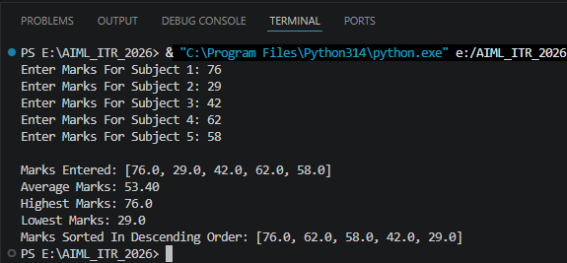

- OOP + Lists + Exception Handling
Create a class Student with attributes: name, roll_no, and marks_list (a list of marks).
Include methods:
- __init__ to initialize the student.
- add_mark(mark) to add a mark to the list (handle invalid marks).
- get_average() to return the average.
- display_info() to show all details.
Create one student object, add marks using user input, and demonstrate all methods with exception handling.

Output:

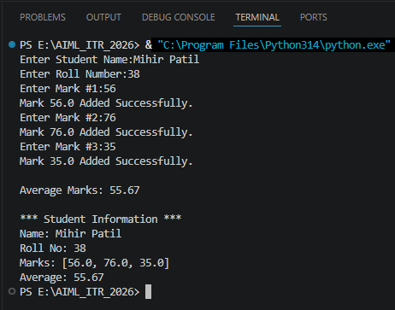

- Dictionaries + Functions + Control Structures
Write a function student_database() that uses a dictionary (roll number as key) to store student records.
- Provide a menu using while loop:
- Add student (name, age, city)
- Search student by roll number
- Display all students
- Exit
Use get(), update(), and proper exception handling for invalid inputs.

Output:

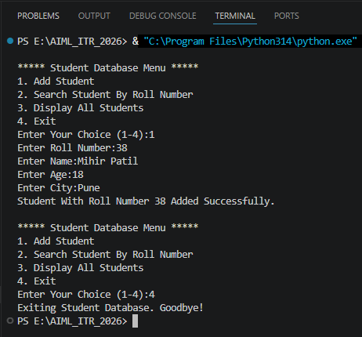

- Sets + Tuples + Modules
Write a program that:
- Takes 10 numbers as input and stores unique numbers in a set.
- Converts that set into a tuple.
- Uses random module to pick and print 3 random numbers from the tuple.
- Uses math module to print the square root of the sum of the tuple elements.
Handle possible exceptions.

Output:

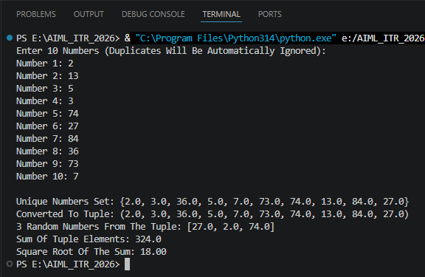

- Lambda + range() + Lists + Exception Handling
Create a lambda function to calculate the square of a number.
Write a program that:
- Uses range(1, 21) to generate numbers.
- Stores the squares of these numbers in a list using the lambda function.
- Prints only the even squares from the list.
Add exception handling if needed.

Output:

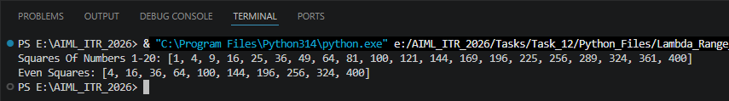

- Tuples + Dictionaries + OOP
Create a class Employee with:
- Attributes: emp_id, name, details (a tuple containing department and salary).
- Method show_details() to print all information.
Create a dictionary where employee ID is the key and Employee object is the value.
Add 3 employees and display all using a loop.

Output:

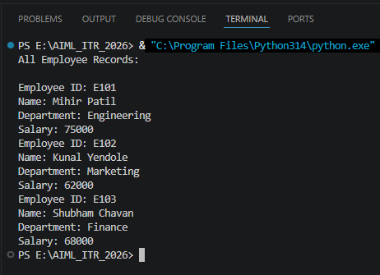

- Strings + Sets + Exception Handling + Modules
Write a program that:
  - Takes a sentence as input.
  - Extracts all unique words (using set) from the sentence.
  - Prints the unique words in sorted order.
  - Uses math module to print the total number of unique words raised to power 2.
  - Handle any possible exceptions gracefully.

Output:

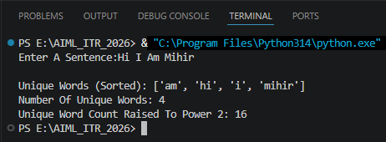

- Mini Project - Comprehensive
Create a Smart Calculator & Data Manager program that combines multiple concepts:
  - Use a while loop menu with these options:
  - Basic Arithmetic (use functions + exception handling)
  - Scientific Calculations (use math module)
  - Generate Random Numbers (use random module)
  - Store Results in Dictionary (with timestamp using string)
  - View History (show stored results)
  - Exit
Output:
