CareID – Hybrid Biometric Patient Management System
Hybrid Biometrics (Face + Fingerprint) Proposal
Summary
CareID is a robust, offline-first patient identification and adherence tracking system designed specifically for the challenges of rural HIV care. Combining advanced Facial Recognition and Fingerprint biometrics, CareID ensures every patient is accurately identified, every dose is tracked, and every missed appointment is flagged—all without requiring internet connectivity.

Unique Selling Propositions (USP)

🔐 Hybrid Biometric Support: Facial Recognition (Android camera + PC webcam), Fingerprint (Android sensor or optional external scanner)

📱 Offline-First Design: Fully functional without internet, auto-syncs when connectivity is available

💻 Device Compatibility: Minimum Android 8.0, Webcam support for PC/laptops

🏥 HIV-Focused Dashboard: Tracks Last Injection Date, Next Due, Current Medication, Missed Dose Alerts

Technical Specifications & Features
Platform Compatibility:
- Android Version: Minimum Android 8.0 (Oreo)
- PC Support: Web dashboard with webcam support for facial recognition (optional)
Core Features:
- Smart Patient Registration: Auto-capture facial biometrics with visual guidance (green check/red cross) to ensure quality enrollment.
- Instant Patient Identification: Identify returning patients in seconds using face or fingerprint.
- Duplicate Prevention: Real-time check during registration to avoid duplicate records.
- HIV Treatment Dashboard: Visual overview of patients due, completed, or missed for the day.
- One-Tap Injection Logging: Record a dose administration with a single tap.
- Bulk Data Management: Apply medication regimens and dates to multiple patients at once.
- Offline-First Architecture: All data stored locally on the device with encrypted cloud sync when internet is available.
Package Inclusions:
- Complete offline support
- External webcam and fingerprint scanner support
- Comprehensive in-person training
- 1-year premium hosting & database maintenance

Recommended Pilot Strategy
Phase 1: MVP Deployment
Deploy the CareID system in 1-2 rural clinics for initial testing and feedback. Our local representative will manage all aspects of the pilot.
Phase 2: Selective Scaling
Scale to additional clinics based on pilot success, with optional external fingerprint scanners.
Phase 3: National Integration
Connect multiple clinics into a centralized national HIV tracking system, leveraging the built-in cloud sync functionality.
Quotation - "CareID" Complete Package
Package Inclusions:

- CareID Android Application (Min. Android 8.0)
- CareID Web Dashboard (for administrators)
- Hybrid Biometric Engine (Face + Fingerprint)
- Unlimited Offline Patient Registrations & Identifications
- On-Site Deployment by our SA representative
- Comprehensive In-Person Nurse Training
- 1 Year of Premium Support & Hosting

2. Quotation - Prototype (Without External Fingerprint Device) 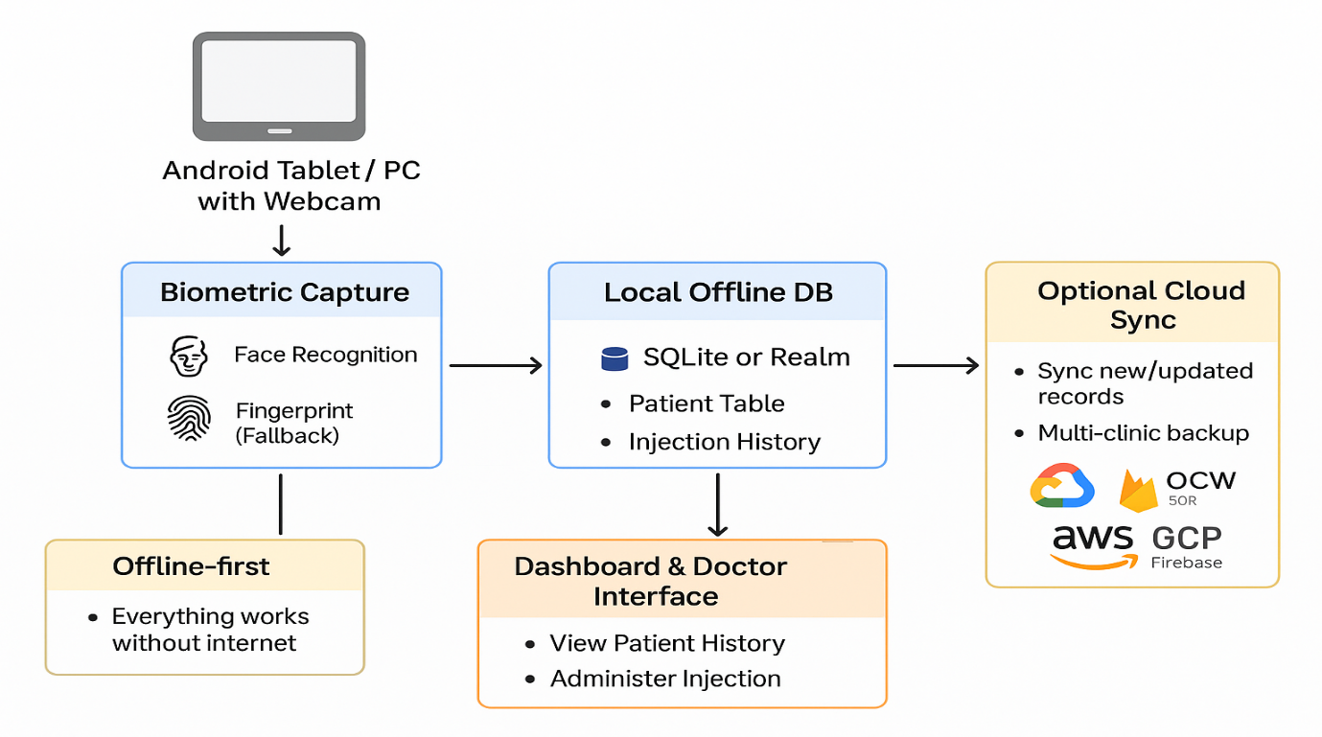

Item | Description | Price (USD)
Software Development & Customization - License Fee | CareID Android + PC/Web Dashboard + Offline DB + Facial Recognition | $5,500.00
Implementation & Training | Local South African Deployment:  • On-site setup & configuration  • In-person staff training  • Hardware logistics management | $2000
Hardware Kit | • 1x External Fingerprint Scanner (Mantra MFS100 / Futronic FS80)  • All import taxes & shipping handled | $200.00
Premium Support & Hosting (1 Year) | • 1 Year of Cloud Hosting & Sync  • Priority bug fixes & software updates  • Direct local support line | $800.00
Total Investment |  | $8500.00

Note: Pricing is for a single clinic license. Volume discounts available for multi-clinic rollouts.

Proposed MVP Workflow

User Roles
- Reception / Nurse / Attendant
  - Registers patient
  - Captures biometrics (Face + optional Fingerprint)
  - Enters basic info (Name, DOB, ID if available)
- Doctor / Clinician
  - Reviews patient history (last injection, medication history, missed doses)
  - Administers injection
  - Updates patient record (injection given, medicine provided, next appointment)
- Optional Administrator
  - Clinic dashboard overview
  - Reports on missed doses, upcoming injections

Patient Journey Flow (Refined)
- Patient Arrival
  - Patient enters clinic
  - Goes to reception/nurse desk
- Biometric Capture & Registration
  - Capture face + optional fingerprint
  - Check if patient exists in local DB
  - If new → create record
  - If existing → retrieve history
- Doctor Review
  - Doctor sees patient queue
  - Access patient history:
    - Last injection date
    - Medications consumed
    - Missed doses
  - Evaluate whether medicine is required now or next injection due
- Injection & Update
  - Administer injection
  - Update record with:
    - Injection given
    - Medicine dispensed (if any)
    - Next appointment / next injection date
  - Optional: Alert nurse for missed doses
- Exit / Optional Follow-up
  - Patient leaves
  - System syncs data if internet is available (optional)

Multi-user vs Single-user
- Reception/Nurse + Doctor are separate users → Multi-user mode recommended
  - Pros: Allows simultaneous operations
  - Cons: Need simple login/auth offline (can use local PIN or password per staff)
- Optional MVP simplification: Single-user mode (e.g., one nurse does both registration & injection update)
  - Pros: Easier offline setup
  - Cons: Less realistic for busy clinics
Recommendation:
- Start multi-user MVP (reception + doctor) with offline authentication
- Keep it simple: usernames or PINs; no complex authentication in MVP
Important Note:
For rural clinics, a mid-range Android tablet (4–6 GB RAM, 64–128 GB storage) is usually sufficient for hundreds to a few thousand patients. SQLite/Realm are lightweight and optimized for mobile devices.

