Shri Vile Parle KelavaniMandal’s

**SHRI BHAGUBHAI MAFATLAL POLYTECHNIC**

**Practical Exam December 2021**

Roll No : T018

SAP ID : 57498200018

Course: Programming in Java Code: PRJ190901

Semester: III Program: Information Technology

Date : 17-12-2021

**Question Asked**

Paste the snap shot of question being asked in the practical Exam.

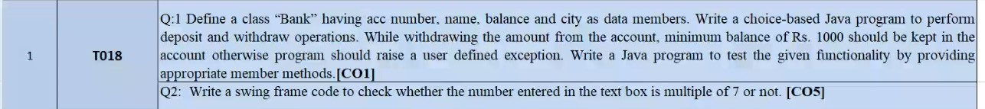

**Source Code of Problem Statement1**

**Save The file as BankMain.java**

/*Define a class Bank having acc number,name,balance and city as data members.

Write a choice based java program to perform deposit and withdraw operations .

While withdrawing the amount from the account,minimum balance of 1000 should

be kept in the account otherwise program should raise a user defined Exception

.write a java program to test functionality by providing appropriate methods.*/

import java.util.Scanner;

class InvalidBalanceException extends Exception

{

public String toString()

{

return "InvalidBalanceException Generated\nBalance Amount cannot be less than 1000";

}

}

class Bank

{

Scanner sc=new Scanner(System.in);

String accno,name,city;

float balance,deposit,withdraw,temp;

void setAccount() throws InvalidBalanceException

{

System.out.print("Enter Account Number : ");

accno=sc.nextLine();

System.out.print("Enter Account Holder Name : ");

name=sc.nextLine();

System.out.print("Enter Balance in Account "+accno+" : ");

balance=sc.nextFloat();

if(balance<1000)

{

throw new InvalidBalanceException();

}

sc.nextLine();

System.out.print("Enter City Name : ");

city=sc.nextLine();

}

void getAccount()

{

System.out.println("Account Number : "+accno);

System.out.println("Account Holder Name : "+name);

System.out.println("Balance in Account "+accno+" : "+balance);

System.out.println("City Name : "+city);

}

void depositAccount()

{

System.out.print("Enter Deposit Amount : ");

deposit=sc.nextFloat();

System.out.println("Balance Before Deposition in Account "+accno+" : "+balance);

System.out.println("Deposit Amount : "+deposit);

System.out.print("Transaction : "+balance+" + "+deposit);

balance=balance+deposit;

System.out.println(" = "+balance);

System.out.println("Balance After Deposition : "+balance);

}

void withdrawAccount() throws InvalidBalanceException

{

System.out.print("Enter Withdraw Amount : ");

withdraw=sc.nextFloat();

temp=balance-withdraw;

if(temp<1000)

{

System.out.println("Cannot Withdraw "+withdraw+" from Balance "+balance);

throw new InvalidBalanceException();

}

System.out.println("Balance Before Deposition in Account "+accno+" : "+balance);

System.out.println("Withdraw Amount : "+withdraw);

System.out.print("Transaction : "+balance+" - "+withdraw);

balance=temp;

System.out.println(" = "+balance);

System.out.println("Balance After Deposition : "+balance);

}

}

class BankMain

{

public static void main(String args[])

{

Scanner sc=new Scanner(System.in);

int choice;

Bank b=new Bank();

do

{

System.out.println("\n(1).Set Acccount");

System.out.println("(2).Get Acccount");

System.out.println("(3).Withdraw");

System.out.println("(4).Deposit");

System.out.println("(5).Exit");

System.out.print("\nEnter Choice : ");

choice=sc.nextInt();

System.out.println();

switch(choice)

{

case 1: try

{

b.setAccount();

break;

}

catch(InvalidBalanceException ibe)

{

System.out.println(ibe);

System.exit(0);

}

System.out.println();

break;

case 2 : b.getAccount();

break;

case 3 : try

{

b.withdrawAccount();

break;

}

catch(InvalidBalanceException ibe)

{

System.out.println(ibe);

}

break;

case 4 : b.depositAccount();

break;

case 5 : System.out.println("Program Terminated");

break;

default : System.out.println("Invalid Choice");

break;

}

}while(choice!=5);

}

}

**Output of Problem Statement1 (If the output is shown to the Examiner then only otherwise do not paste)**

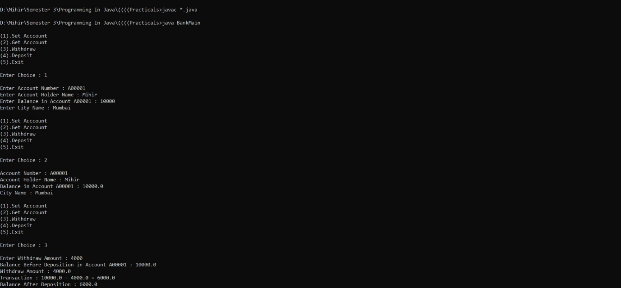

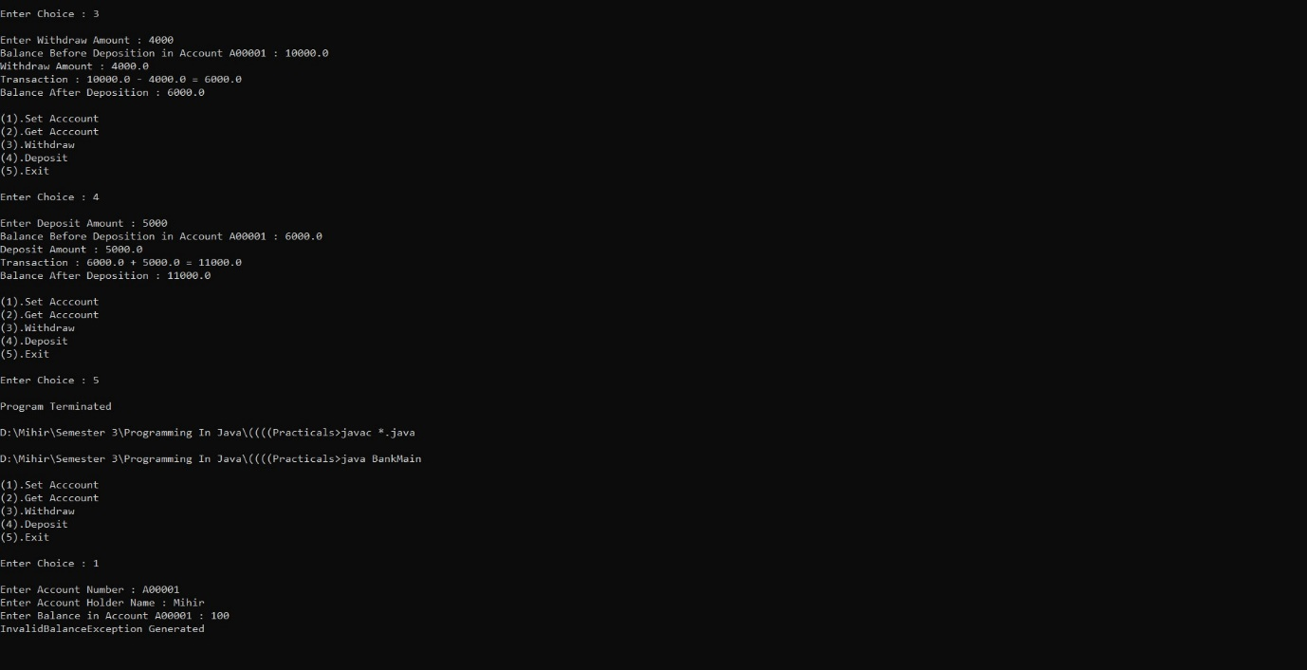

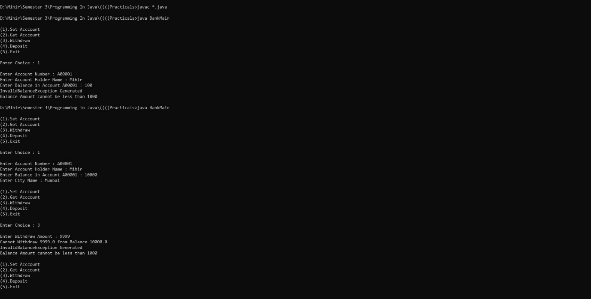

**Source Code of Problem Statement2**

**Save the File as MultipleBySevenMain.java**

/*Write a swing frame code to check whether the number entered in the text box is multiple of 7 or not*/

import java.awt.*;

import javax.swing.JFrame;

import java.awt.event.*;

import javax.swing.*;

class MultipleBySevenMain extends JFrame

{

MultipleBySevenMain()

{

JLabel lblnum,lbloutput;

JTextField txfnum,txfout;

JButton btncalc;

setSize(1570,840);

setLayout(null);

setDefaultCloseOperation(EXIT_ON_CLOSE);

//labels

lblnum=new JLabel("Enter Number : ");

lblnum.setBounds(200,200,500,70);

add(lblnum);

lbloutput=new JLabel("Output : ");

lbloutput.setBounds(200,400,500,70);

add(lbloutput);

//textfields

txfnum=new JTextField();

txfnum.setBounds(750,200,500,70);

add(txfnum);

txfout=new JTextField();

txfout.setBounds(750,400,500,70);

add(txfout);

txfout.setEditable(false);

//buttons

btncalc=new JButton("Calculate");

btncalc.setBounds(600,600,200,70);

add(btncalc);

btncalc.addActionListener(new ActionListener()

{

public void actionPerformed(ActionEvent ae)

{

String strnum=txfnum.getText();

int number=Integer.parseInt(strnum);

if(number%7==0)

{

txfout.setText(number+" is Multiple of 7");

}

else

{

txfout.setText(number+" is not Multiple of 7");

}

}

});

//visible

setVisible(true);

lblnum.setVisible(true);

lbloutput.setVisible(true);

txfout.setVisible(true);

txfnum.setVisible(true);

btncalc.setVisible(true);

}

public static void main(String args[])

{

MultipleBySevenMain mbsm=new MultipleBySevenMain();

}

}

**Output of Problem Statement2 ((If the output is shown to the Examiner, then only otherwise do not paste)**

