“Fee Management System”

Submitted in partial fulfillment of the requirements

of the degree of

Bachelor of Computer Application (CTIS)

by

Student Name URN No

Akash Shitole 2017-B-27061998

Mihir Walia 2017-B-29031999

Prerit Shah 2017-B-05111999B

Under Guidance of

**AMIT VAJPAYEE**

**MONALI BACHHAV**



School of Information Technology - iNurture

**Ajeenkya D Y Patil University, Pune**

2017-18

** School of Information Technology - iNurture**

**Ajeenkya D Y Patil University**

**Lohegaon, Pune, Maharashtra 412105**

**CERTIFICATE**

This is to certify that the Internship / Project Report entitled **“Fee Management System”** is a bonafide work of “**Akash Shitole, Mihir Walia, Prerit Shah**”submitted to the Ajeenkya D Y Patil University, Pune in partial fulfillment of the requirement for the award of the degree of **“Bachelor of Computer Application”**.

Prof. Monali Bachhav Prof. AMIT VAJPAYEE Prof.ABHIJIT POWAR

Internal-Examiner External-Examiner Head of Department

JAVA Introduction to DBMS SOIT

** School of Information Technology - iNurture**

**Ajeenkya D Y Patil University**

**Lohegaon, Pune, Maharashtra 412105**

**DECLARATION BY GUIDE**

This is to certify that the Dissertation entitled **“Fee Management System”** submitted by “**Akash Shitole, Mihir Walia, Prerit Shah**” in partial fulfillment of the requirement for the award of **Bachelor of Computer Application** at **Ajeenkya D Y Patil University, Lohegaon, Pune, Maharashtra 412105** is an authentic work carried out by him/her under my supervision and guidance. To the best of my knowledge, the matter embodied in this Seminar report has been not been submitted to any other university/Institute for award of any Degree or Diploma.

Date:

Place: Lohegaon, Pune.

**Dr. Narendra M. Powar**

(Guide)

** School of Information Technology - iNurture**

**Ajeenkya D Y Patil University**

**Lohegaon, Pune, Maharashtra 412105**

**Declaration**

I declare that this written submission represents my ideas in my own words and where others' ideas or words have been included, I have adequately cited and referenced the original sources. I also declare that I have adhered to all principles of academic honesty and integrity and have not misrepresented or fabricated or falsified any idea/data/fact/source in my submission. I understand that any violation of the above will be cause for disciplinary action by the Institute and can also evoke penal action from the sources which have thus not been properly cited or from whom proper permission has not been taken when needed.

----------------------------------------------------- **(Akash Shitole, Mihir Walia, Prerit Shah)**

Date:

Place: Lohegaon, Pune.

** School of Information Technology - iNurture**

**Ajeenkya D Y Patil University**

**Lohegaon, Pune, Maharashtra 412105**

**Acknowledgement**

I remain immensely obliged to **Prof. AMIT VAJPAYEE**, **Prof. MONALI BACHHAV** for providing me with the idea of this topic, and for his invaluable support in garnering resources for me either by way of information or computers also his guidance and supervision which made this Internship/Project happen.

I would like to thank **Dr. A. B. Kasture,** Program Coordinator BCA, and **Prof. Abhijit Powar**, Head of Department for their invaluable support.

I would like to say that it has indeed been a fulfilling experience for working out this Internship/Project.

**Akash Shitole, Mihir Walia, Prerit Shah**

**Abstract**

Developing effective mechanisms for feedback collection in learning environments is particularly important at the frontiers of new knowledge . Valuing and asking for feedback has recognized benefits for both staff and students. For Staff to provide information for course design to further develop teaching skills as well as to provide better service to the students. For Students to feel valued and 'listened' to have ownership in their own learning to develop reflective thinking to be better informed in selecting a course. The feedback collection systems, described in this project is such applications for collecting feedback through GUI, intended to support feedback collection in educational environments .This feedback system collects feedback from students of SOIT. Faculty-feedback system is intended to collect feedback about faculty, from students.

**Table of Contents**

**CHAPTER 1 : INTRODUCTION**

1.1 Company Profile…………………………………………………………….1

1.2 Existing System and Need for System………………………………………2 - 5

1.3 Scope of Work

1.4 Operating Environment - Hardware and Software

1.5 Detail Description of Technology Used

**CHAPTER 2 : PROPOSED SYSTEM**

2.1 Proposed System

2.2 Objectives of System

2.3 User Requirements

**CHAPTER 3 : ANALYSIS & DESIGN**

3.1 Data Flow Diagram (DFD)

3.2 Functional Decomposition Diagram (FDD)

3.3 Entity Relationship Diagram (ERD)

3.4 Use Case Diagrams

3.5 Module Hierarchy Diagram

3.6 Module Specifications

3.7 Table specifications ( in case back end is a database )

3.8 Data Dictionary

3.9 Test Procedures and Implementation

**CHAPTER 4 : USER MANUAL**

4.1 User Manual

4.2 Operations Manual / Menu Explanation / Report Specification

**CHAPTER 5 : Drawbacks and Limitations**

**CHAPTER 6 : Proposed Enhancements**

**CHAPTER 7: Conclusion**

**CHAPTER 8 : Bibliography**

**ANNEXURES:**

**ANNEXURE 1 : USER INTERFACE DESIGN (SCREEN)**

**ANNEXURE 2 : OUTPUT REPORTS WITH DATA**

* 1. Company Profile
  2. Existing System and Need for System

The existing method for collecting fee from the students makes use of Xml sheets and can get complex.

This is very time consuming procedure. Preparing the data and searching every students name one by one can be hectic. Hence,it can help the admin to find names using name or URN with a click.

* 1. Scope of Work
  2. Operating environment

Hardware-

Development of App

CPU – i5

RAM – 8GB

HDD – 1TB

Software-

Netbeans

MYSQL

Windows 10

* 1. Detailed Description of Technology used
     1. Java

Java is a general-purpose computer-programming language that is concurrent, class-based, object-oriented, and specifically designed to have as few implementation dependencies as possible. It is intended to let application developers "write once, run anywhere" (WORA), meaning that compiled Java code can run on all platforms that support Java without the need for recompilation. Java applications are typically compiled to bytecode that can run on any Java virtual machine (JVM) regardless of computer architecture.

* + 1. Mysql

MySQL is an open-source relational database management system(RDBMS).Its name is a combination of "My", the name of co-founder Michael Widenius's daughter,and "SQL", the abbreviation for Structured Query Language. The MySQL development project has made its source code available under the terms of the GNU General Public License, as well as under a variety of proprietary agreements. MySQL is offered under two different editions: the open source MySQL Community Server and the proprietary Enterprise Server. MySQL Enterprise Server is differentiated by a series of proprietary extensions which install as server plugins, but otherwise shares the version numbering system and is built from the same code base.

1.5.3 RELATIONAL DATABASE MANAGEMENT SYSTEM

A relational database management system (RDBMS) is a database management system (DBMS) based on the relational model invented by Edgar F. Codd, of IBM's San Jose Research Laboratory fame. Most databases in widespread use today are based on his relational database model.

RDBMSs have been a common choice for the storage of information in databases used for financial records, manufacturing and logistical information, personnel data, and other applications since the 1980s. Relational databases have often replaced legacy hierarchical databases and network databases because, they were easier to implement and administer. Nonetheless, relational databases received continued, unsuccessful challenges by object database management systems in the 1980s and 1990s, (which were introduced in an attempt to address the so-called object-relational impedance mismatch between relational databases and object-oriented application programs), as well as by XML database management systems in the 1990s. However, due to the expanse of technologies, such as horizontal scaling of computer clusters, NoSQL databases have recently begun to peck away at the market share of RDBMSs.

2.0 Proposed System

2.1 Proposed System

The proposed system is a GUI based system. The student can log in to the system with a valid ID and password, fill in a feedback form and submit the feedback to the system. The administrator can later analyze the feedback.

2.2 Objectives of system

This project aims to develop a feedback collection system, which intends to replace the old one by overcoming the drawbacks of its predecessor.

1. To provide easy access to admin.
2. To allow students to provide feedback anonymously.
3. To clear the paper clutter of feedback forms.
4. To help save earth from deforestation.

2.3 User Requirements

1. Device with preinstalled java.

2. Basic knowledge of computer operation.

3.Device with preinstalled netbeans.

3.0 Analysis and Design

3.1 DFD

Level 0

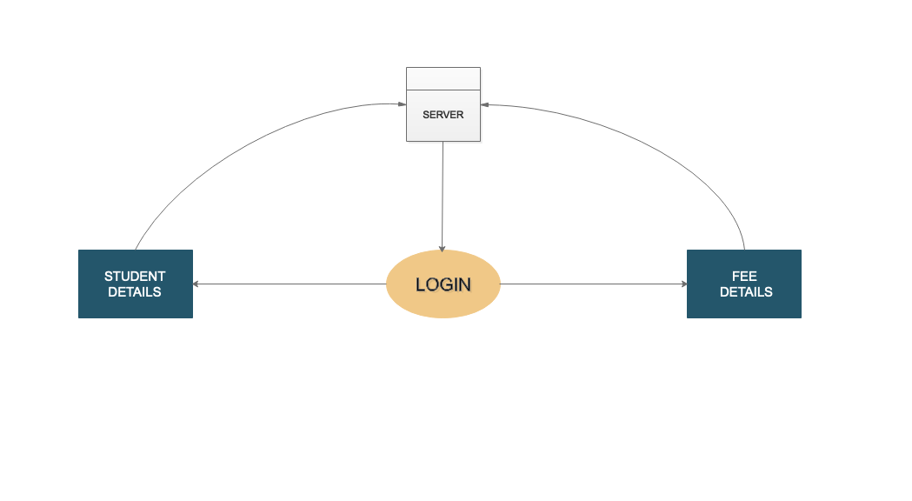

Level 1

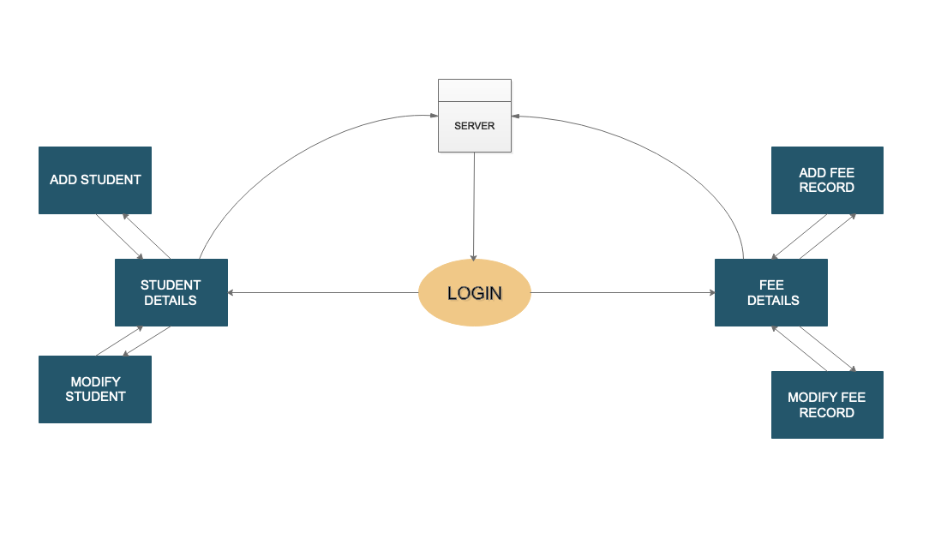

3.2 ER Diagram

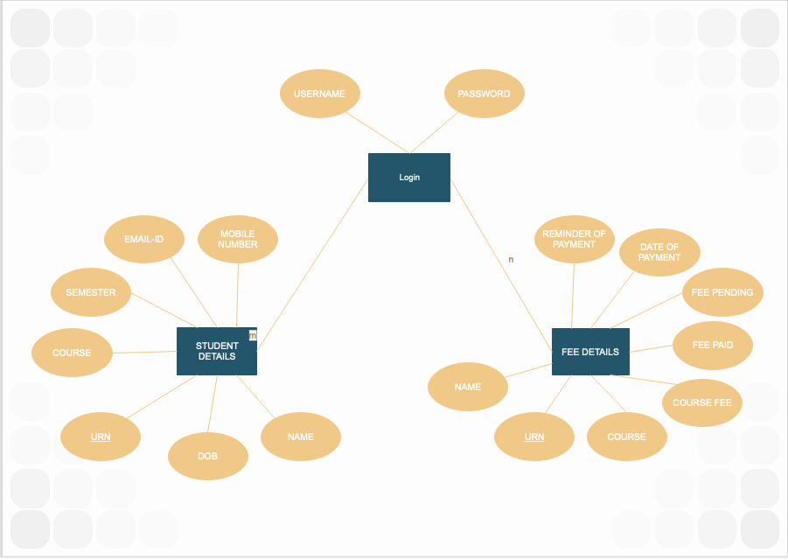

5. Drawback and limitations

5.1 Less secure

Since the system is developed on java instead of JSP it is more prone to external attacks.

The system developed doesn’t have a proper security system for the database.

5.2 Not available online

This system is based on JFrame and hence can not be executed on a web browser. Due to server costing and additional programming required we decided to make this a small yet efficient system.

5.3 Small database

Since we are using the same device for the database as well as the GUI, the database security and storage capacity is low. It can not save large numbers of entries in it.

6. Proposed Enhancement

1. The system can be developed using JSP for it to function as a web application.

2. Database capacity can be increased

3. With the change in programming language more security can be added.

4. CSS can be used instead of HTML.

7. Conclusion

A GUI based system for getting fee from the students of SOIT, which makes the fee collection hassle-free. Each user is authenticated using a username and password.Annexures

Login Page

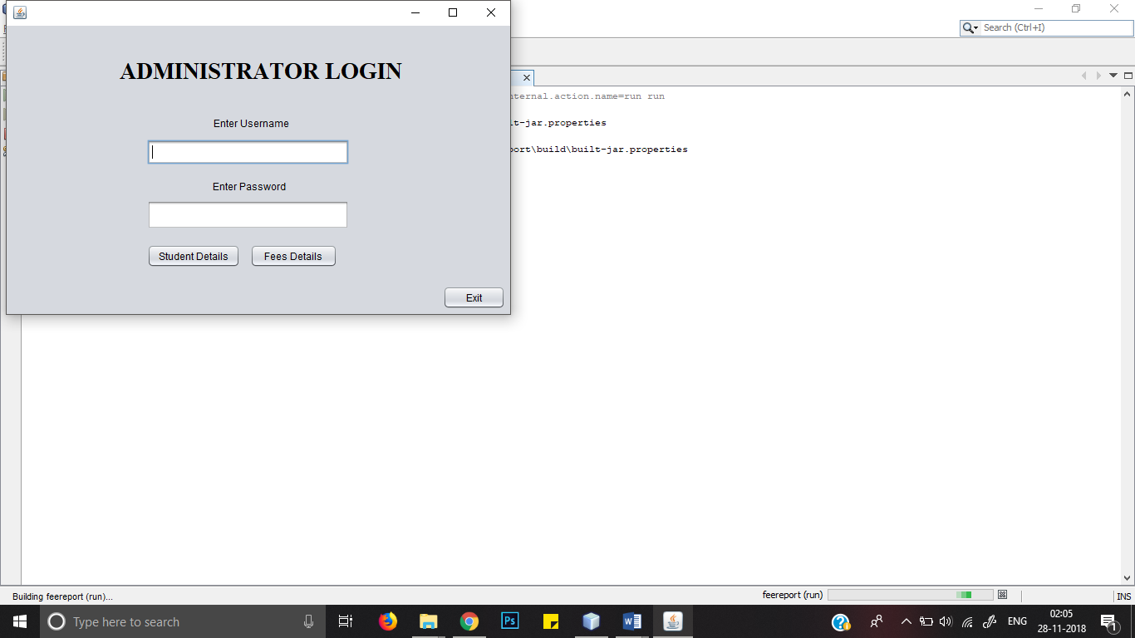

Student Details Page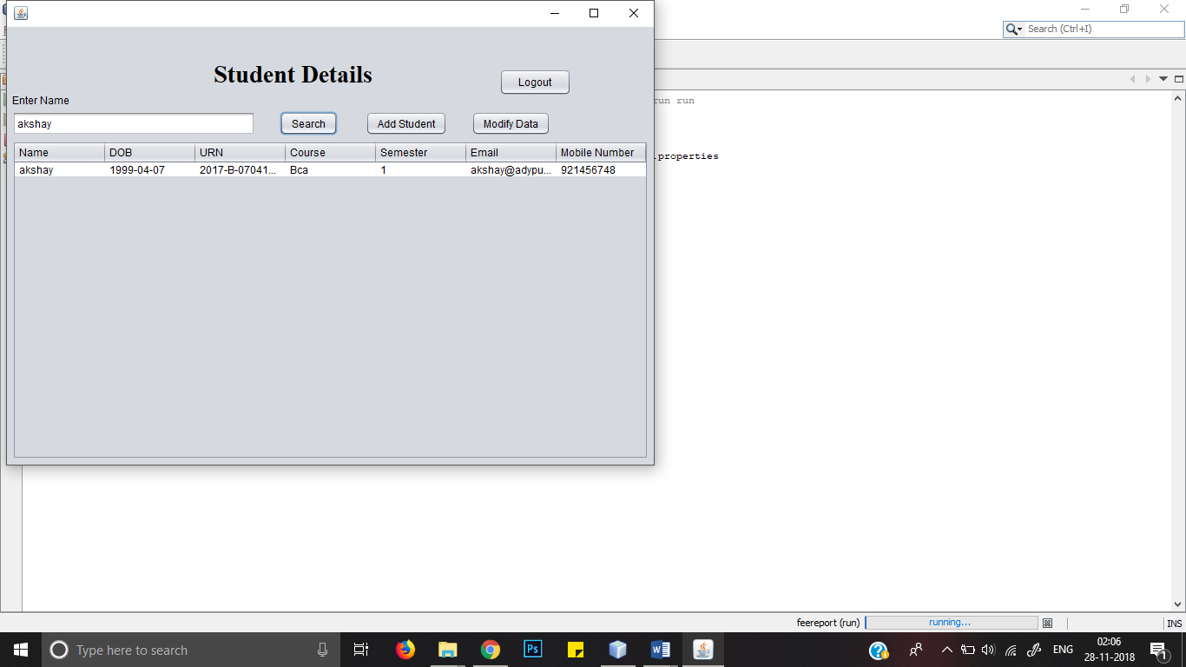

Fee Details Page

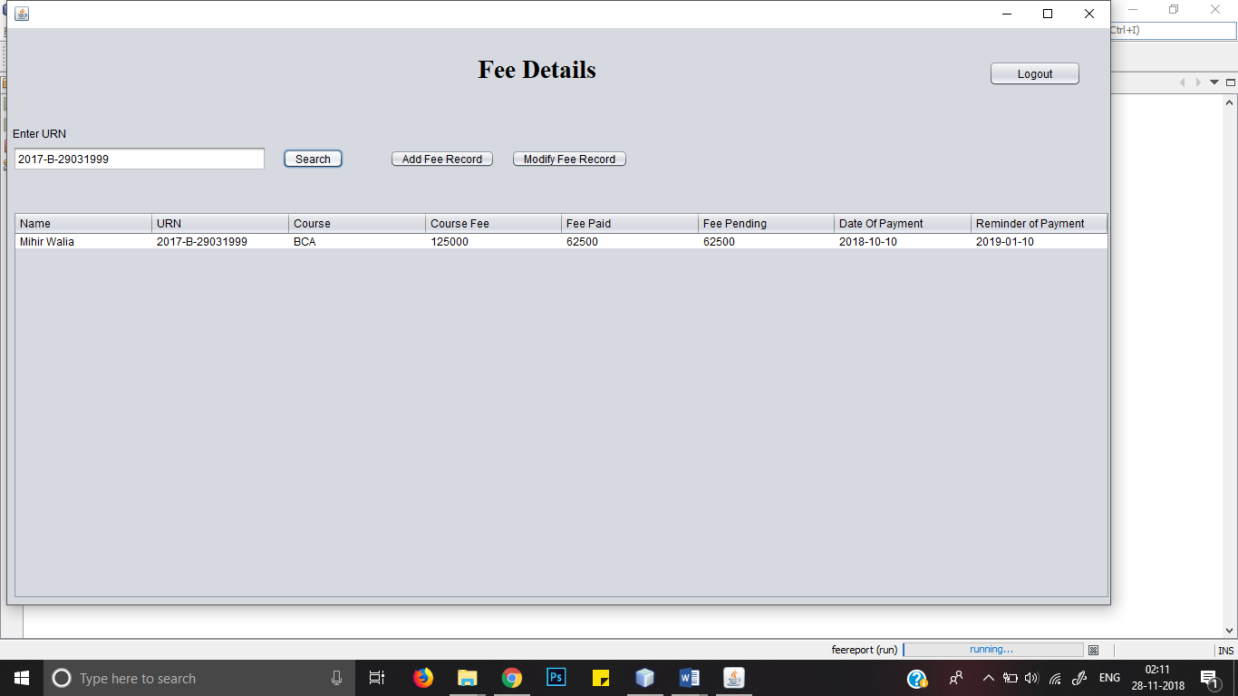

Add Student Fee Details Table

