**3. Polenum:-**

Polenum is a python script which uses the Impacted Library from CORE Security Technologies to extract the password policy information from a windows machine. This allows a non-windows (Linux, Mac OSX, BSD etc...) user to query the password policy of a remote windows box without the need to have access to a windows machine.

Supported OS

**Linux**

**How to do download GitHub repository?**

[**https://github.com/wh1t3Fox/polenum.git**](https://github.com/wh1t3Fox/polenum.git)

**Copy this link and paste on terminal.**

## Key features

* Can extract password and associated information from a windows machine
* Will connect over a NULL or authenticated share
* Supports encrypted/signed sessions

**How to Extract the Password policies from windows system?**

**Step 1: Open Kali Linux and then click on terminal**

**Step 2: Type Polenum on terminal**

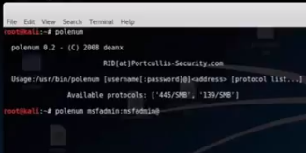

**Step 3: Type polenum msfadmin:msfadmin@192.168.154.131 ‘445/SMB’**

