|  |  |  |  |  |  |  |  |
| --- | --- | --- | --- | --- | --- | --- | --- |
| **SR.NO** | **FILE NAME** | **ORIGINAL SIZE** | **COMPRESSED SIZE** | **COMPRESSION RATIO** | **FPGA EXE TIME** | **SSIM VALUE** | **Huffman Bitlength** |
| 1. | Lena.bmp | 258 KB | 36 KB | 7.167:1 | 3.127 sec | 0.9383 | 283268 |
| 2. | Peppers.bmp | 258 KB | 46 KB | 5.60:1 | 3.150 sec | 0.9208 | 357491 |
| 3. | Goldhill.bmp | 258 KB | 54 KB | 4.78:1 | 3.178 sec | 0.9446 | 427483 |

**Structural similarity**

Structural Similarity (SSIM) Index. The SSIM metric combines local image structure, luminance, and contrast into a single local quality score. In this metric, structures are patterns of pixel intensities, especially among neighboring pixels, after normalizing for luminance and contrast. Because the human visual system is good at perceiving structure, the SSIM quality metric agrees more closely with the subjective quality score.

Because structural similarity is computed locally, ‘ssim’ can generate a map of quality over the image.

The difference with respect to other techniques mentioned previously such as MSE or PSNR is that these approaches estimate *absolute errors*; on the other hand, SSIM is a perception-based model that considers image degradation as *perceived change in structural information*, while also incorporating important perceptual phenomena, including both luminance masking and contrast masking terms. Structural information is the idea that the pixels have strong inter-dependencies especially when they are spatially close. These dependencies carry important information about the structure of the objects in the visual scene. Luminance masking is a phenomenon whereby image distortions (in this context) tend to be less visible in bright regions, while contrast masking is a phenomenon whereby distortions become less visible where there is significant activity or "texture" in the image.

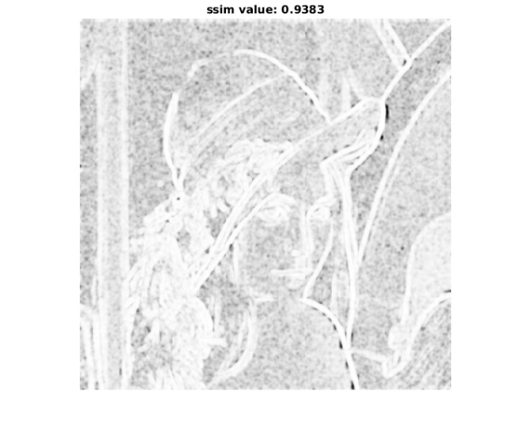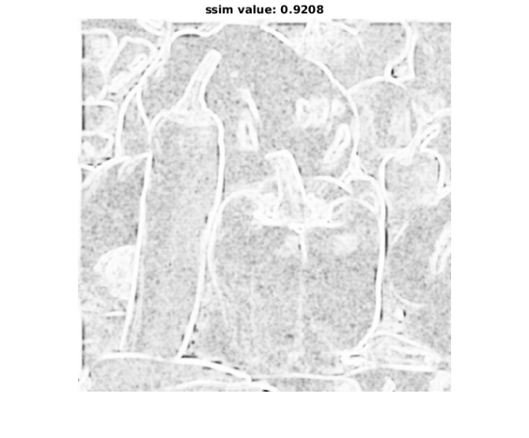

(a). Lena (b). Peppers

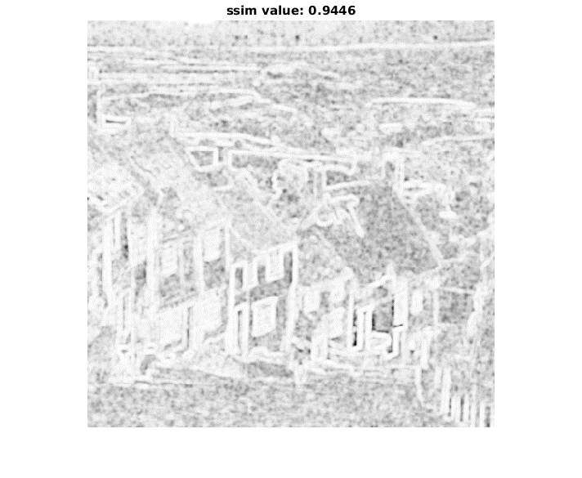

(c). Goldhill