Dispatch — Emergency Response Routing Sim
Assignment 1: Group Formation, Pillars, and Conceptualization

Group Roster
Name | NetID | Role
[Your Name] | [NetID] | Group Leader
[Member 2 Name] | [NetID] | Member
[Member 3 Name] | [NetID] | Member
[Member 4 Name] | [NetID] | Member
Bracketed fields are placeholders — replace with your actual group roster before submission.

Selected Pillars
Pathfinding & Navigation | A* search over a weighted road network selects routes for each dispatched unit, with edge costs that change live as congestion rises and roads close, forcing genuine re-routing rather than a single static shortest path.
Swarm & Boids Modeling | Units sharing a road segment or converging on the same intersection sense one another and locally adjust heading and speed to stay separated, a lightweight steering layer on top of the global A* route so multiple units moving together read as traffic, not overlapping icons.

Project Concept Summary
“Dispatch” is an interactive visual simulation of a city’s emergency response network, ambulances, fire trucks, and police units, solving the core problem real dispatch centers face: get the right unit to the right incident as fast as possible over a road network with live traffic congestion and unplanned closures, while multiple units moving through the same space still read as believable traffic rather than tokens sliding along fixed rails.
The user watches, and can interact with, a live city grid. Emergency calls spawn continuously across three types, medical, fire, and crime, each carrying a severity level. Six vehicles sit at fixed depots across the city. When a call comes in, the simulation selects the best available unit of the matching type by comparing real routing cost across the whole network with A* search, not straight-line distance. When two or more units end up sharing a road segment or converging on the same intersection, each senses the others nearby and locally adjusts its heading and speed to keep separation, a lightweight swarm-style steering layer running underneath the globally computed route rather than replacing it.
Visually, this plays out on a stylized city map: roads shift color as congestion builds, barricades appear as roads temporarily close for construction, and any unit already en route recalculates its path live if its planned road becomes blocked, visibly rerouting mid-drive. Units converging on a shared node curve smoothly around one another instead of overlapping, leave a fading motion trail, and incidents pulse with color-coded urgency, while a live sidebar tracks fleet availability, the incident queue, and running performance metrics like average response time and total calls handled.
The visual goal is a believable, legible “situation room”: dark, high-contrast, and data-dense but calm, so a viewer can tell at a glance which parts of the city are struggling and why. Over the semester we plan to tune the local avoidance layer against denser unit counts and tighter intersections, extend the routing to weigh severity against distance, support incidents that need multiple units, add smoother vehicle animation with a top-down camera, and replace today's randomly assigned congestion with simulated background traffic, ambient civilian cars that slow down for the car ahead and probabilistically diverge onto alternate roads when a street gets crowded, so congestion emerges from actual traffic behavior instead of arbitrary numbers.

AI-Generated Mockups
Console layout concept: live city map with congestion-aware roads, unit routes, and a real-time fleet/incident sidebar.
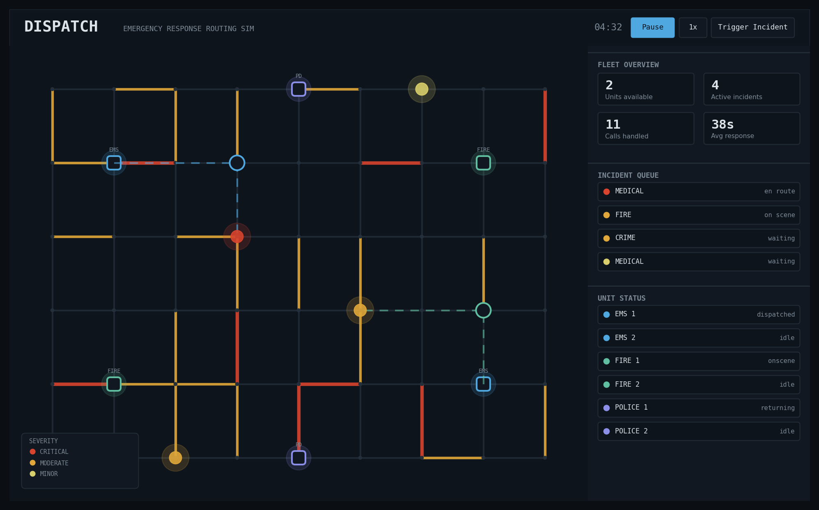
Routing + local avoidance concept: how the A* dispatcher picks a route around congestion and closures (left), and how units sense and steer around each other when converging on a shared node (right).
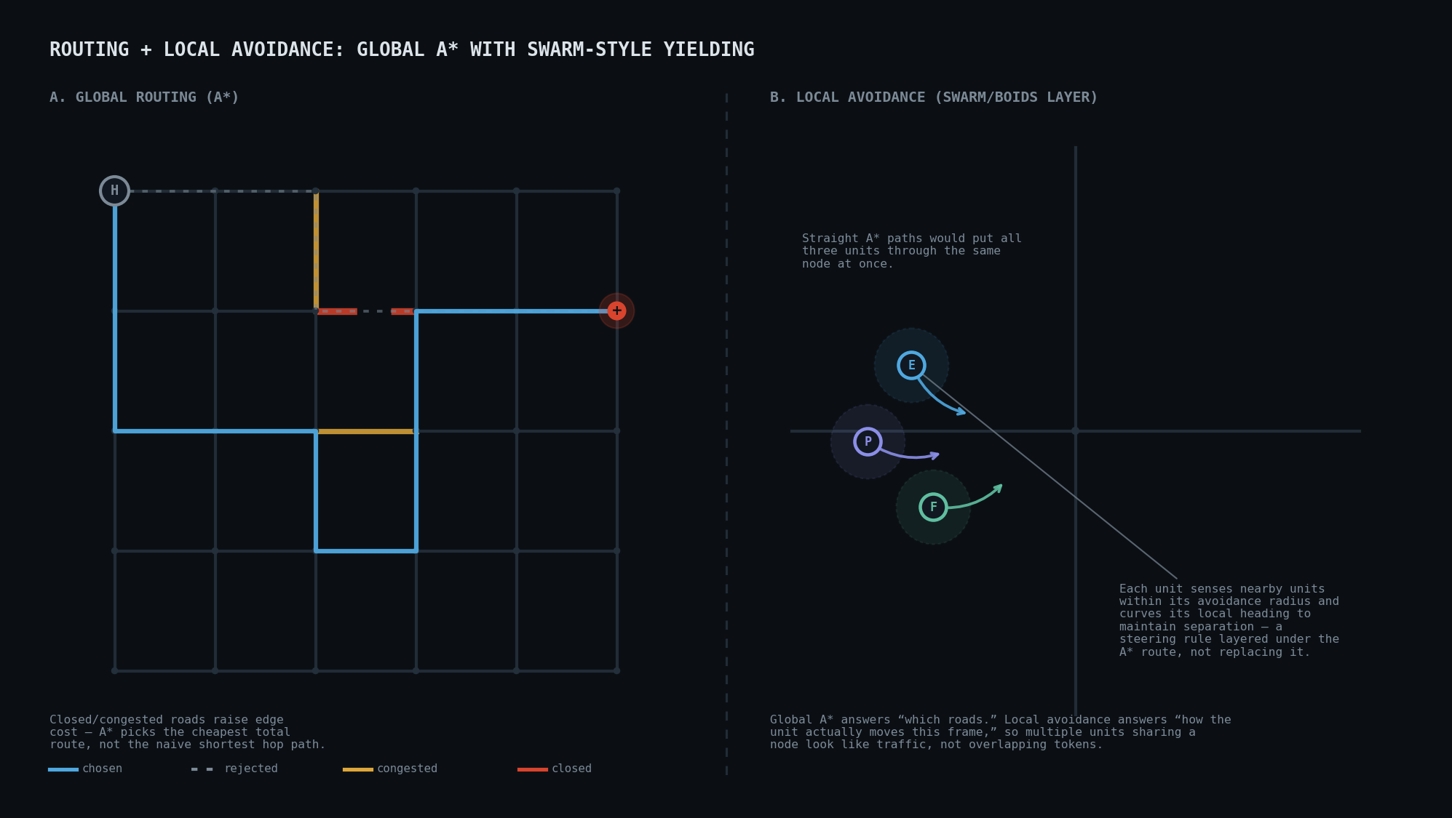

Link to Interactive Mockup
A working browser-based prototype implementing the full concept above (live A* routing, dynamic congestion, road closures with rerouting, and the dispatch/fleet UI) is available at:
https://claude.ai/artifact/E5GJ2oPHWDtJYUnxz1ckp5

