**Name: Mihir Ashish Vora**

**Nibodh Assignment 8**

Question 1:

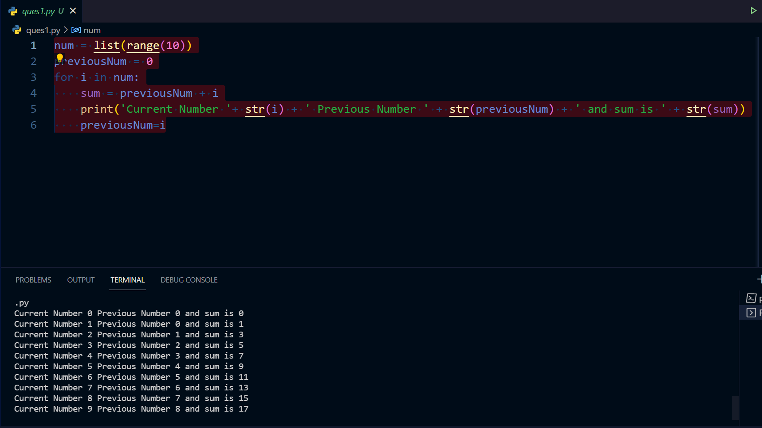

Question 2:

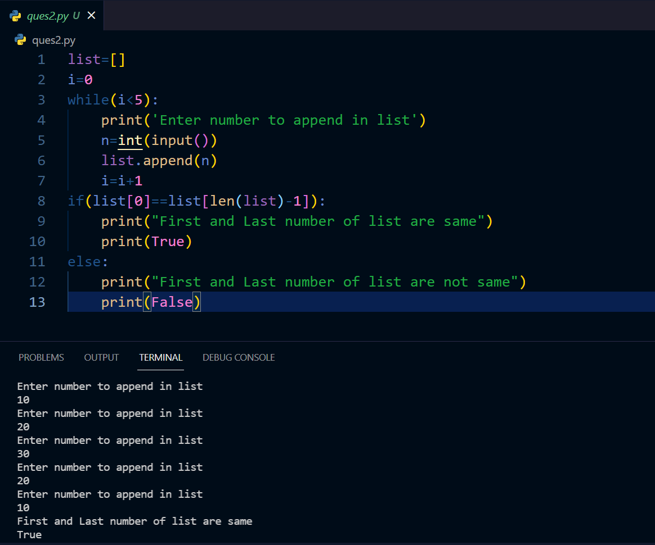

Question 3: 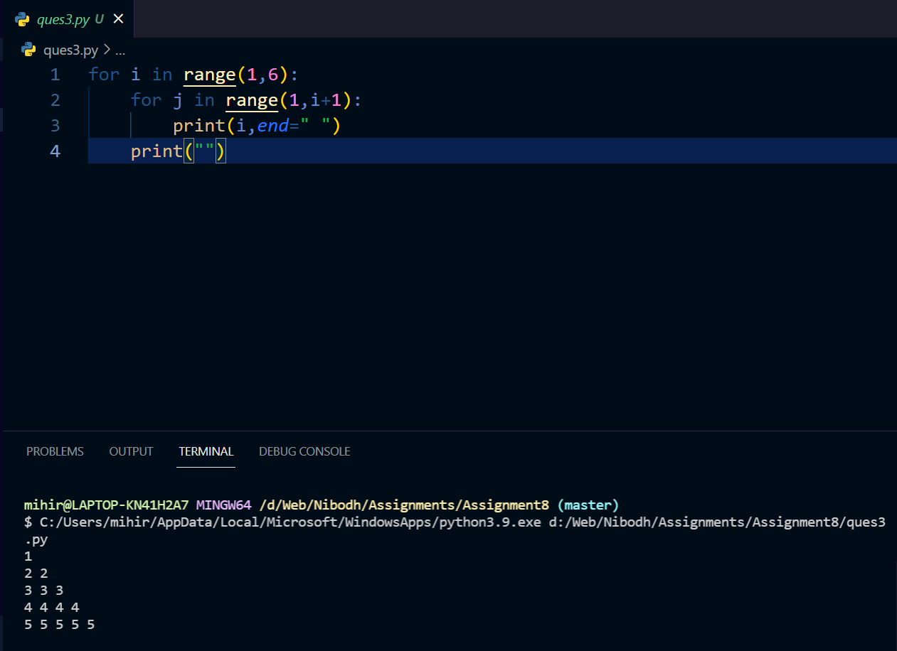

Question:4

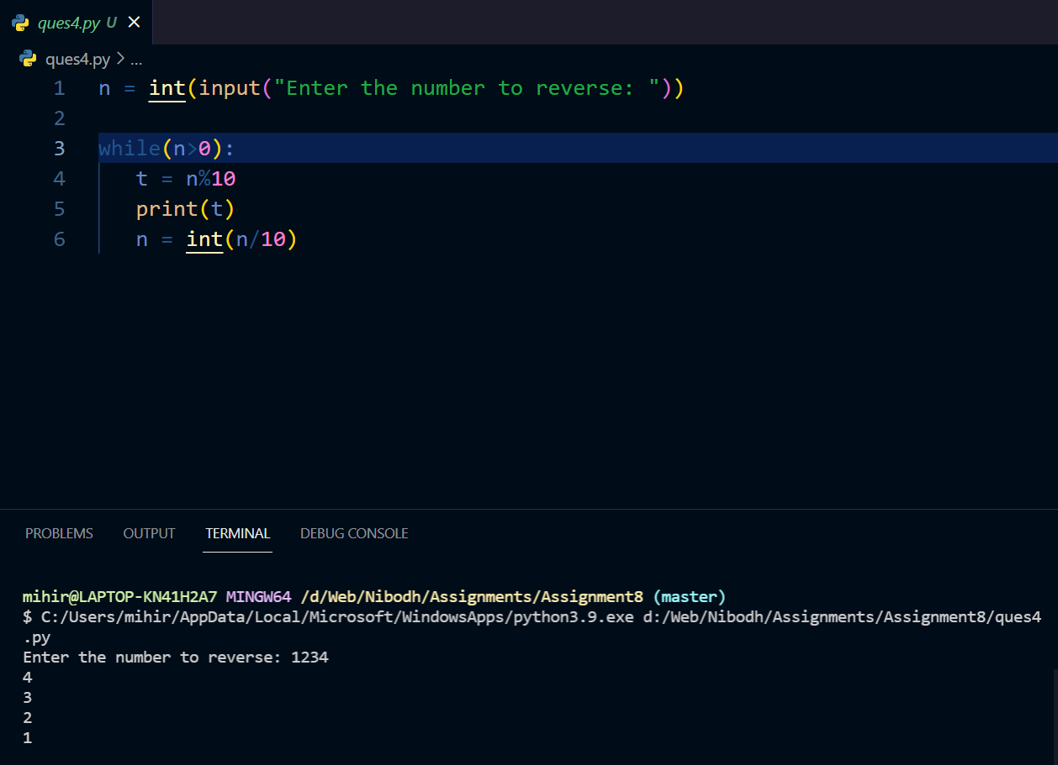

Question 5:

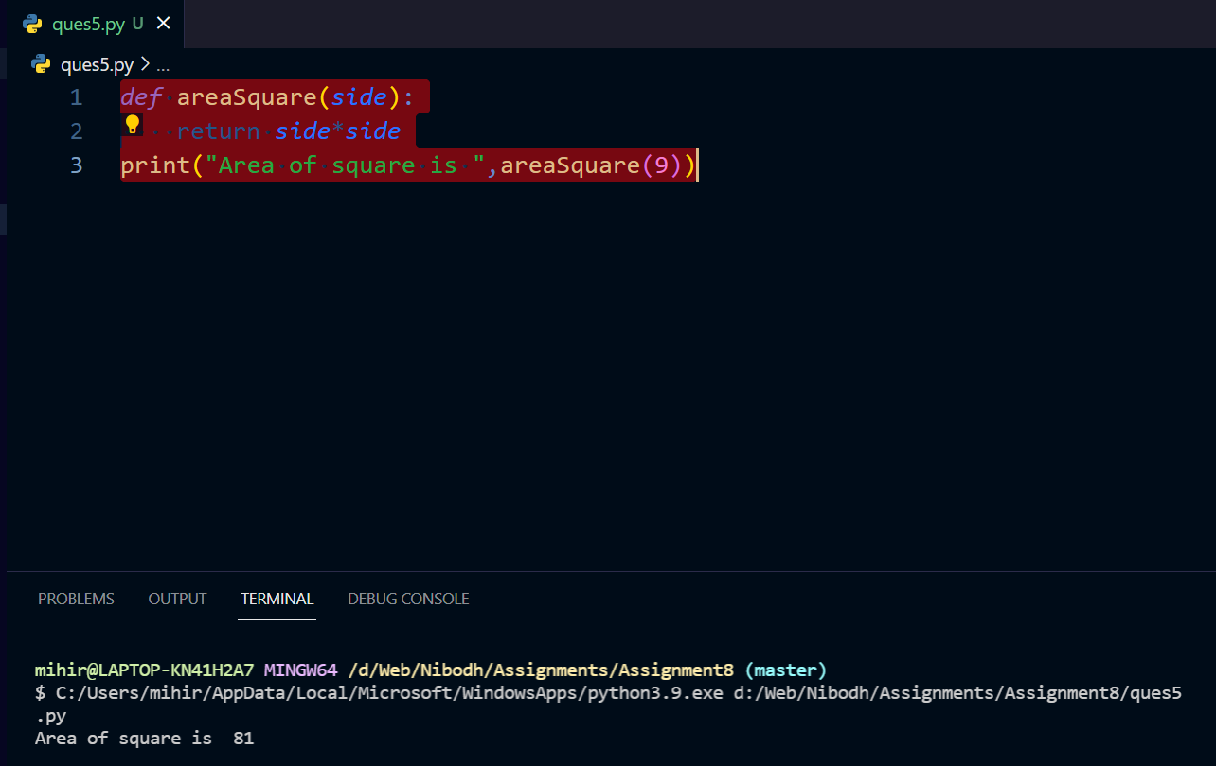

Question 6:

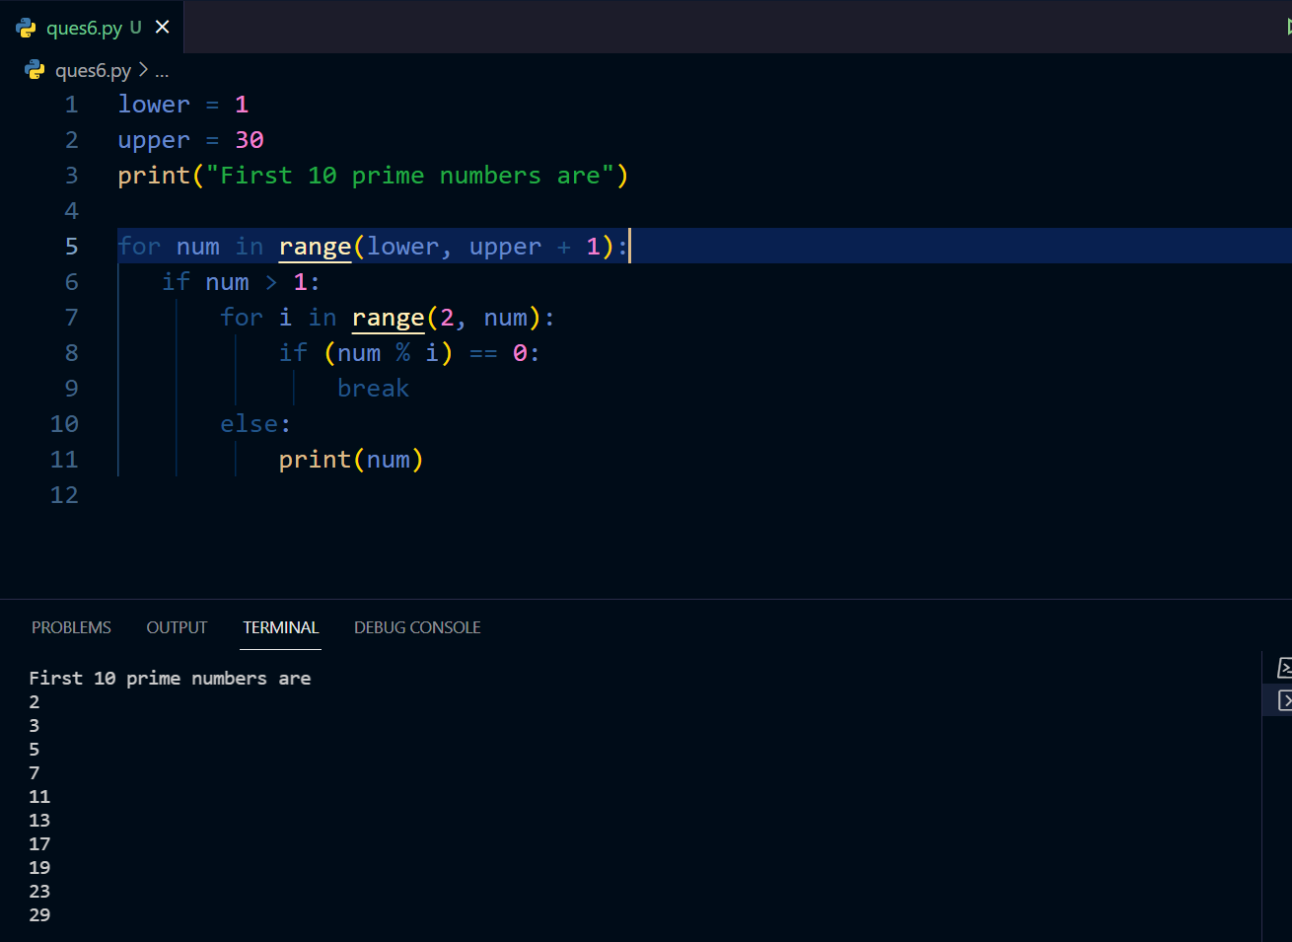

Question 7:

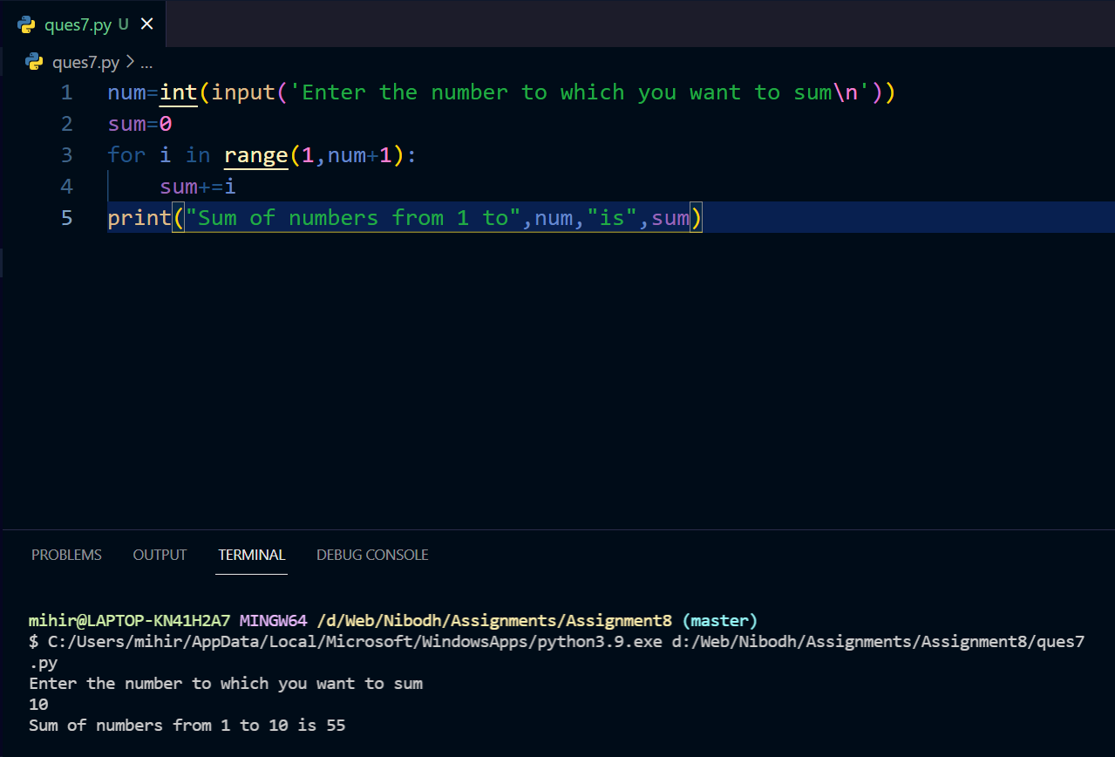

Question 8:

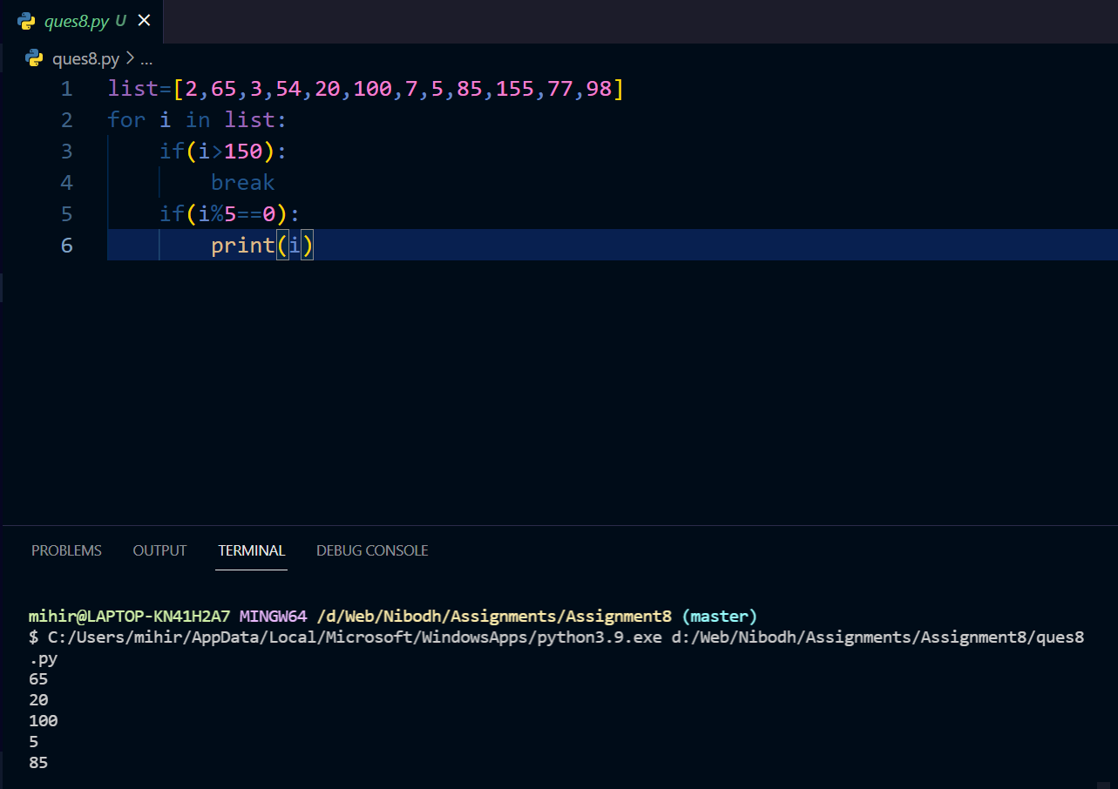

ques 9: SELECT DISTINCT DEPARTMENT FROM WORKER;

ques 10: SELECT * FROM WORKER ORDER BY FIRST_NAME;

ques 11: SELECT * FROM WORKER

         ORDER BY FIRST_NAME,DEPARTMENT DESC;

ques 12: SELECT * FROM WORKER

         WHERE FIRST_NAME='Vipul' OR FIRST_NAME='Satish';

ques 13: SELECT * FROM WORKER

         WHERE

NOT(FIRST_NAME='Vipul' OR FIRST_NAME='Satish');

ques 14: SELECT * FROM WORKER WHERE DEPARTMENT='Admin';