How Every Test Was Done
A step-by-step guide to understanding, explaining and re-doing each test yourself
Mihir Bhati (24BCE5341) · Ahana Sharan (24BCE5334)
25 October 2026 · Project folder: D:\MyClaudeProject\nlp
Why this guide exists. Your teacher allows AI use, but expects you to understand what was done and to be able to do any step yourself. Claude Code wrote the code and ran the tests. This guide teaches the recipe behind every test, gives a small example you can work out on paper, and the exact command to run it yourself, with what your screen should show.
How to use it: read Part A first, slowly: it shows where every file is and how a score is calculated from them. Then do the 30-minute rehearsal in Part E once before you present.

Contents
- Part A. The basics: what a test is, where the files are, and how a score is calculated
- Part B. Software tests: writing and running your own
- Part C. Every experiment, one by one (15 tests)
- Part D. If the teacher says "do it now"
- Part E. 30-minute rehearsal checklist
- Part F. How to explain the AI use honestly

Part A. The basics

A1. There are two kinds of "test" in this project
 | Software tests | Experiments (evaluations)
Question | Does the code do what it should? | How good is each system at the task?
Example | "If every answer is right, the scorer must give F1 = 1.0" | "How many of 100 real requests does the agent understand?"
Answer | pass or fail | a score, such as F1 = 0.974
How many | 371 | over 60 recorded runs
Run with | python -m pytest tests | the scripts in the scripts folder
Where it lives | tests folder | results in the runs folder

Both matter. Software tests prove the measuring tools work; experiments use those tools to measure the systems. A score from a broken scorer would mean nothing, which is why the scorer itself has tests.

A2. The recipe every experiment follows
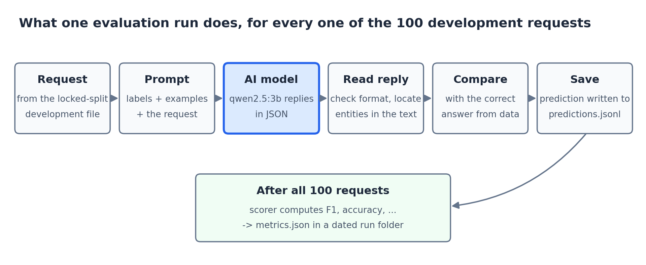
Every experiment repeats these steps for each of the 100 development requests.
- Take a request from the development file, for example "make a room darker". The dataset also gives its correct answer: intent iot_hue_lightdim, entity house_place = room.
- Build the prompt: the list of allowed intents, a few worked examples, then the request.
- Ask the AI model. It replies in JSON, e.g. {"intent": "iot_hue_lightdim", "entities": [...]}.
- Read the reply: check the format is valid and find each extracted entity in the request text.
- Compare with the correct answer: right or wrong.
- Save the prediction, then move to the next request.
- After all 100, the scorer counts rights and wrongs and computes F1, accuracy and the other scores, and saves them in a dated run folder.
That is the whole idea. The different experiments change only which system answers (B0, B1, A1, A2...) or which requests it gets (clean, with typos...).

A3. Where everything lives: the files behind every test
Before running anything, it helps to know that the whole project is just folders of files on your laptop, in D:\MyClaudeProject\nlp. Open that folder in File Explorer and you will see these:
Folder | What is inside | You will use it for
data\processed\P1\ | The requests and their correct answers for project P1 | seeing the data the systems are tested on
scripts\ | Small programs you run, one per job (walkthrough.py, explain_f1.py, demo.py...) | running every test
src\ | The framework itself: the code the scripts use | seeing how a step works
runs\ | One folder per experiment, holding its answers and its scores | checking any result
tests\ | The 371 automated tests | Part B
reports\ | Reports, charts and the files these tools save | showing results

The two files every test is built from
File 1: the correct answers. data\processed\P1\dev.jsonl holds the 100 development requests for P1 and, for each one, the correct answer. These come from the MASSIVE dataset, where people labelled every request. Open it with Notepad (right-click → Open with → Notepad). Each line is one request. The second line is:
{"case_id": "massive-24", "utt": "make a room darker", "true_intent": "iot_hue_lightdim",
"in_scope": true, "entities": [{"type": "house_place", "text": "room", "start": 7, "end": 11}], ...}

Field | Meaning | In this line
case_id | the request's ID in the MASSIVE dataset | massive-24
utt | the request, exactly as a user typed it (utterance) | make a room darker
true_intent | the correct intent | iot_hue_lightdim (dim a light)
in_scope | true = the app should handle it; false = off-topic, should be refused | true
entities | the details to extract, with their position in the sentence (counting characters from 0) | house_place = "room", characters 7 to 11

The format is called JSONL: one record per line, written as "name": value pairs.
File 2: what a system answered. Every experiment saves its answers in its own folder in runs. For A2 on P1 that is runs\20261024_1654_P1_A2-selected_0\predictions.jsonl. The folder name is the date and time (24 Oct, 16:54), the project (P1) and the system (A2). The line for the same request is:
{"case_id": "massive-24", "gold_intent": "iot_hue_lightdim", "gold_in_scope": true, "status": "ok",
"predicted_intent": "iot_hue_lightdim", "predicted_entities": [{"type": "house_place", "text": "room"}], ...}

Field | Meaning
gold_intent | the correct intent, copied from File 1 ("gold" means correct answer)
status | ok = the system answered with an intent; oos = it refused the request as off-topic; invalid or error = its reply was broken
predicted_intent | the intent the system answered
predicted_entities | the details the system extracted

Every score in this project is just these two files compared line by line. Request massive-24: correct iot_hue_lightdim, answered iot_hue_lightdim, so it is right. Section A5 shows how all 80 lines become an F1 score.

A4. The walkthrough script, explained
A script is a text file of instructions written in Python. walkthrough.py is one of them, in the scripts folder: D:\MyClaudeProject\nlp\scripts\walkthrough.py. You can open it to read it, in Notepad or in VS Code (installed on this laptop), with:
code scripts\walkthrough.py

It is a teaching tool: it does what a real experiment does, but for only three requests, and prints every step instead of doing it silently. It changes nothing and saves nothing.

What it does, step by step, and where each step's code is
Step | What happens | Files it reads | Code that does it
Start | Locks the test data, then reads the project's intents, fields and description | data\manifests\P1.json, configs\descriptions\P1.md | src\analyzer\spec.py, src\analyzer\access.py
1 | Takes a request and its correct answer | data\processed\P1\dev.jsonl (File 1) | load_cases in src\analyzer\spec.py
2 | Picks example requests to show the model (fixed, or the most similar ones) | data\processed\P1\kshot.jsonl (120 labelled examples) | src\pipelines\examples.py
3 | Writes the prompt: instructions, the list of intents, the examples, then the request | — | render_prompt in src\pipelines\catalogue.py
4 | Sends the prompt to the AI model and receives its reply | cache\ folder (the model's saved answers), or the live model with --live | src\llm\client.py, which talks to Ollama at http://127.0.0.1:11434
5 | Reads the reply: is it valid JSON with a real intent? Where is each entity in the sentence? | — | src\evaluation\output_schema.py, src\evaluation\span_rule.py
6 | Compares the answer with the correct one: right or wrong | — | inside walkthrough.py
7 | Scores the requests, with our scorer and with scikit-learn | — | src\evaluation\scorer.py and the scikit-learn library

"From the saved cache" means: when the experiments ran, every answer the model gave was saved in the cache folder. The walkthrough reuses those saved answers, so you see exactly what the experiments saw, instantly. Add --live to ask the model fresh; because the model is repeatable, it gives the same answers.

How to run it
- Open the Ollama app from the Start menu (it runs the AI model in the background).
- Open PowerShell (Start → type PowerShell → Enter).
- Go to the project folder by typing this and pressing Enter:
cd D:\MyClaudeProject\nlp

- Run the script:
python scripts/walkthrough.py

It prints three requests: two the app should handle and one off-topic one. For each, steps 1 to 6 appear under it. Here is request 2, with what each part means:
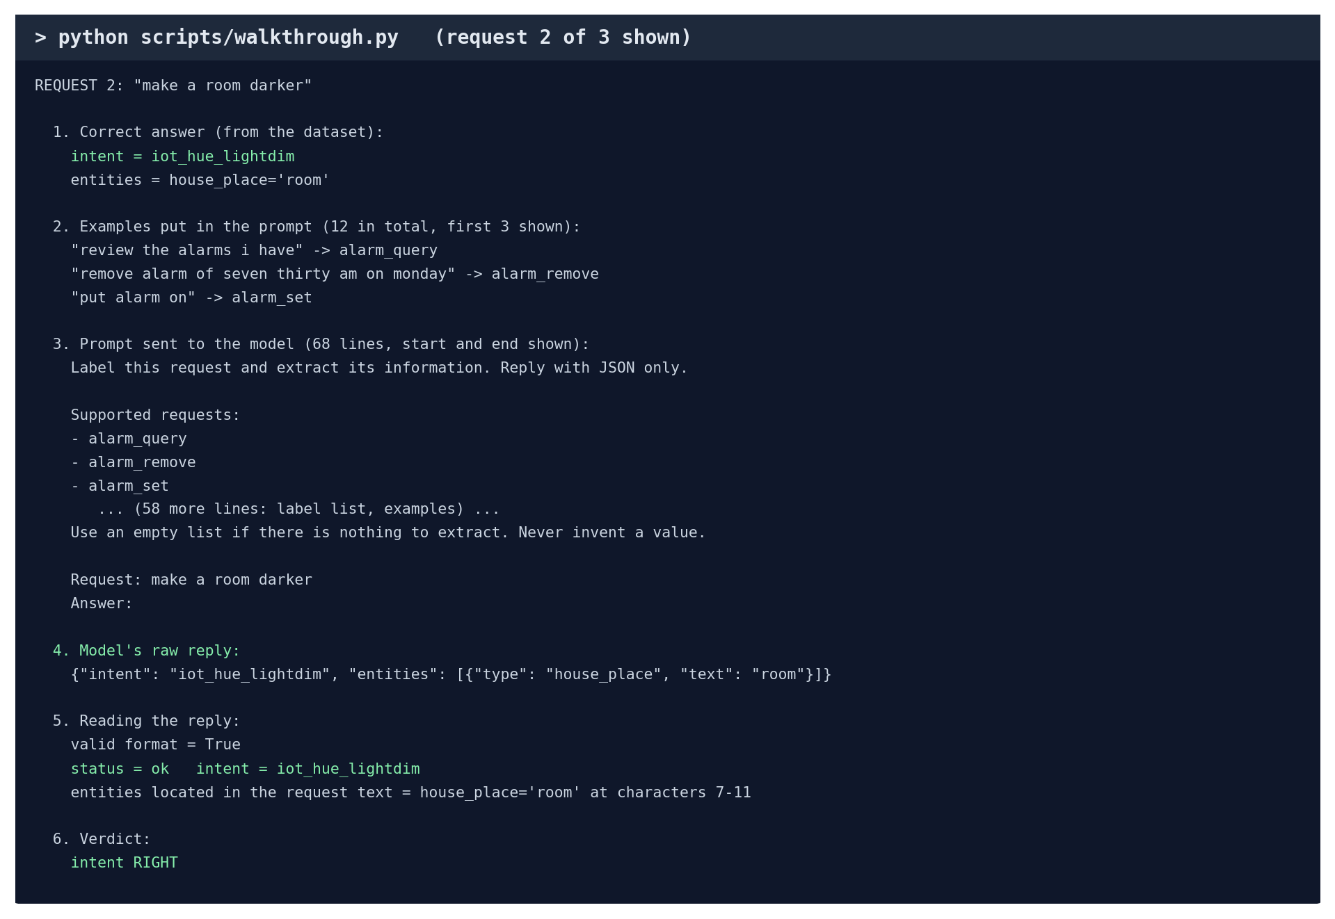
Request 2 of 3 (real output).
What you see | What it means
1. Correct answer | read from File 1: the dataset says this request is iot_hue_lightdim, with house_place = room
2. Examples put in the prompt | worked examples the model is shown first, so it learns the format (12 here: one per intent)
3. Prompt sent to the model | the full text the model receives: 68 lines, of which the start and end are shown
4. Model's raw reply | exactly what the model wrote back, as JSON
5. Reading the reply | the format is valid, the intent is a real one, and "room" is found at characters 7 to 11 of the request
6. Verdict | the answer matches the correct one, so it is right

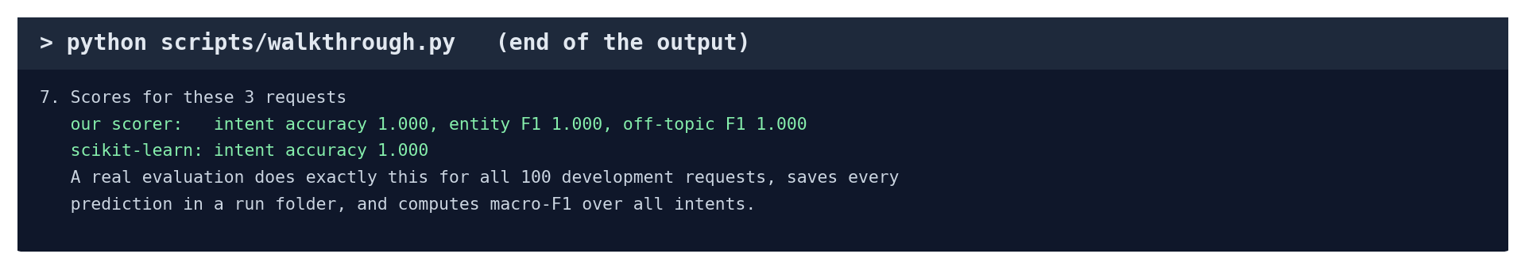
The end of the output: all three right, so every score is 1.000.
How this relates to the real experiments: an experiment runs exactly these steps, with the same code, for all 100 development requests instead of 3. It saves every answer in a predictions.jsonl file (File 2) and the scores in metrics.json, inside a new run folder.
Other things to try:
python scripts/walkthrough.py --n 5 # 5 requests instead of 3
python scripts/walkthrough.py --design schema-sim-llm # the design A2 chose
python scripts/walkthrough.py --live # ask the model fresh

A5. Work out F1 yourself, on the real results
A2's recorded intent macro-F1 on P1 is 0.974. Here is how to get that number yourself from Files 1 and 2.

Option 1: let the explain script show every step
python scripts/explain_f1.py

The script scripts\explain_f1.py reads File 1 and File 2, puts them side by side, does the counting, and prints each step. It also saves the side-by-side table as a spreadsheet file.
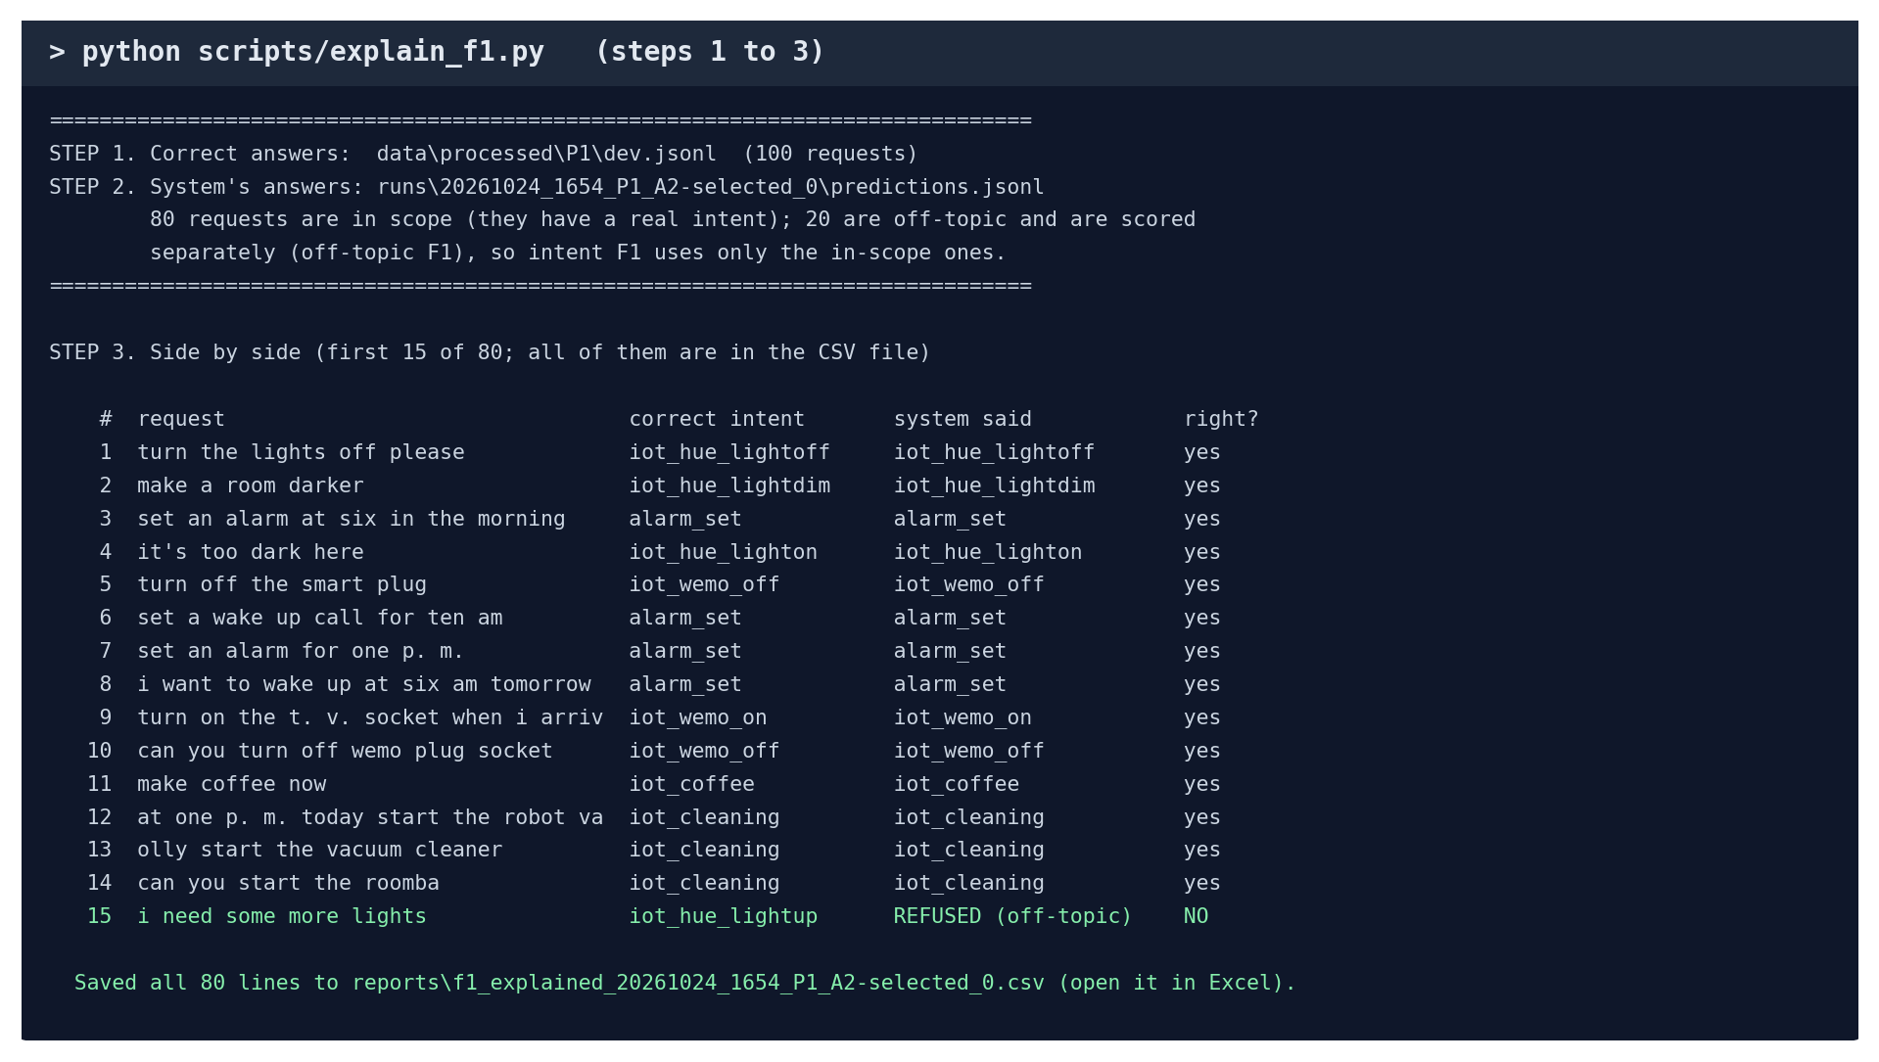
Steps 1 to 3: the two files, and the requests side by side (real output).
Why only 80 of the 100 requests? 20 are off-topic and have no correct intent; they are scored separately as off-topic F1. Look at request #15, "i need some more lights": the correct intent is iot_hue_lightup, but A2 refused it as off-topic. That is one of A2's 4 mistakes.
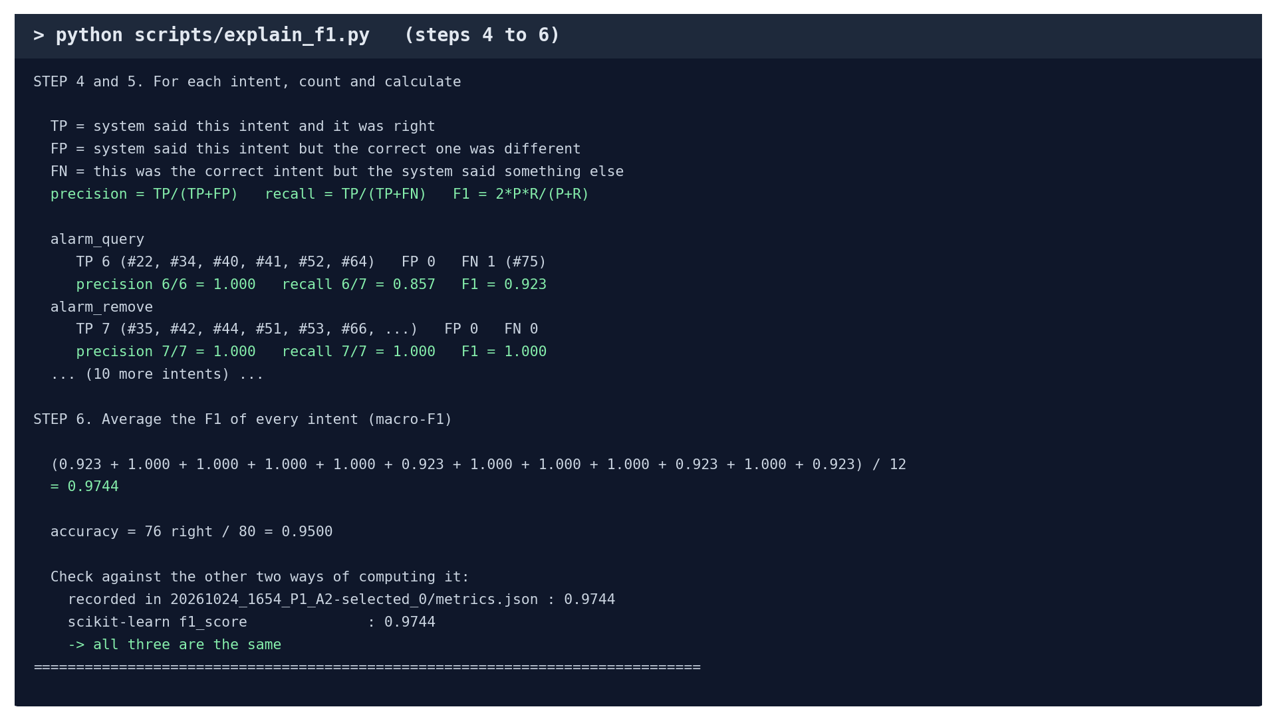
Steps 4 to 6: counting, the formula for each intent, and the average (real output).
Read the alarm_query line like this: A2 got 6 alarm_query requests right (TP 6: requests #22, #34, #40, #41, #52, #64). It never said alarm_query wrongly (FP 0). It missed one, request #75 (FN 1). So precision = 6/6 = 1.000, recall = 6/7 = 0.857 and F1 = 2 × 1.000 × 0.857 / (1.000 + 0.857) = 0.923. Doing this for all 12 intents and averaging gives 0.9744. That matches the number recorded in metrics.json and the one scikit-learn computes.
Every run works the same way. For the generic prompt B1, for example:
python scripts/explain_f1.py --run 20261013_0110_P1_B1_0

Option 2: count it yourself in a spreadsheet
The script saved all 80 lines as reports\f1_explained_20261024_1654_P1_A2-selected_0.csv. Open it in Excel, or upload it to Google Sheets (sheets.google.com → File → Import). The columns are:
A | B | C | D | E | F
# | case_id | request | correct intent | system said | right?

Pick one intent, for example alarm_query, and count three things. You can use a filter (Data → Filter), or type these formulas into any empty cell:
Count | Meaning | Formula | Answer
TP | correct intent is alarm_query AND right | =COUNTIFS(D:D,"alarm_query",F:F,"yes") | 6
FP | system said alarm_query AND wrong | =COUNTIFS(E:E,"alarm_query",F:F,"no") | 0
FN | correct intent is alarm_query AND wrong | =COUNTIFS(D:D,"alarm_query",F:F,"no") | 1

Then: precision = TP / (TP + FP) = 6/6 = 1.000; recall = TP / (TP + FN) = 6/7 = 0.857; F1 = 2 × precision × recall / (precision + recall) = 0.923. Repeat for the other 11 intents (only the name in the formula changes), add the 12 F1 values and divide by 12. You get 0.974, the recorded score.
A refused request ("REFUSED (off-topic)" in column E) counts as wrong for its correct intent (an FN), but as an FP for no intent, because the system did not claim any intent. The scorer and scikit-learn both treat it this way.

Option 3: a small practice example on paper
This table is made up for practice. It is not from the project. It has only 8 requests, so the whole calculation fits on paper. Once you can do this, you can do the real one above.
# | Correct intent | System said | Right?
1 | alarm_set | alarm_set | yes
2 | alarm_set | alarm_set | yes
3 | alarm_set | alarm_remove | no
4 | alarm_remove | alarm_remove | yes
5 | alarm_remove | alarm_set | no
6 | lights_off | lights_off | yes
7 | lights_off | lights_off | yes
8 | lights_off | alarm_set | no

Step 1. For each intent, count TP, FP and FN, exactly as in Option 2:
Intent | TP | FP | FN | Precision | Recall | F1
alarm_set | 2 (#1, #2) | 2 (#5, #8) | 1 (#3) | 2/4 = 0.500 | 2/3 = 0.667 | 0.571
alarm_remove | 1 (#4) | 1 (#3) | 1 (#5) | 1/2 = 0.500 | 1/2 = 0.500 | 0.500
lights_off | 2 (#6, #7) | 0 | 1 (#8) | 2/2 = 1.000 | 2/3 = 0.667 | 0.800

Step 2. F1 for alarm_set = 2 × 0.500 × 0.667 / (0.500 + 0.667) = 0.667 / 1.167 = 0.571.
Step 3. Macro-F1 = (0.571 + 0.500 + 0.800) / 3 = 0.624. Accuracy = 5 right / 8 = 0.625.
Step 4. Check with scikit-learn: save this as check_f1.py in the project folder and run python check_f1.py. It prints 0.624 and 0.625.
from sklearn.metrics import f1_score, accuracy_score

gold = ['alarm_set', 'alarm_set', 'alarm_set', 'alarm_remove', 'alarm_remove',
'lights_off', 'lights_off', 'lights_off']
pred = ['alarm_set', 'alarm_set', 'alarm_remove', 'alarm_remove', 'alarm_set',
'lights_off', 'lights_off', 'alarm_set']

print('macro F1', round(f1_score(gold, pred, average='macro'), 3))
print('accuracy', accuracy_score(gold, pred))

Part B. Software tests: writing and running your own

B1. What an automated test is
A test is a short program with three parts: set up an input, run the code, check the result is what it must be. If the check fails, the test fails. Here is a real-style example:
def test_a_perfect_system_scores_1():
# 1. set up: two requests and their correct answers
cases = [
{"case_id": "a", "utt": "set an alarm", "true_intent": "alarm_set",
"in_scope": True, "entities": []},
{"case_id": "b", "utt": "delete my alarm", "true_intent": "alarm_remove",
"in_scope": True, "entities": []},
]
answers = [
Prediction("a", "ok", "alarm_set", [], True, True),
Prediction("b", "ok", "alarm_remove", [], True, True),
]
# 2. run the scorer
result = score(cases, answers, labels=["alarm_set", "alarm_remove"])
# 3. check: every answer is right, so F1 must be exactly 1.0
assert result["primary"]["intent_macro_f1"] == 1.0

assert means "this must be true". The project's 371 tests are all built this way. The scorer's tests use small examples where the correct F1 was calculated by hand, like Part A4.

B2. Write and run your own first test (10 minutes)
- In the project folder, open the tests folder and create a new file called test_my_first.py.
- Paste this into it and save:
from sklearn.metrics import f1_score

from src.evaluation.scorer import Prediction, score

def test_a_perfect_system_scores_1():
cases = [
{"case_id": "a", "utt": "set an alarm", "true_intent": "alarm_set", "in_scope": True, "entities": []},
{"case_id": "b", "utt": "delete my alarm", "true_intent": "alarm_remove", "in_scope": True, "entities": []},
]
answers = [
Prediction("a", "ok", "alarm_set", [], True, True),
Prediction("b", "ok", "alarm_remove", [], True, True),
]
result = score(cases, answers, labels=["alarm_set", "alarm_remove"])
assert result["primary"]["intent_macro_f1"] == 1.0

def test_our_scorer_agrees_with_sklearn_on_one_mistake():
cases = [
{"case_id": "a", "utt": "set an alarm", "true_intent": "alarm_set", "in_scope": True, "entities": []},
{"case_id": "b", "utt": "delete my alarm", "true_intent": "alarm_remove", "in_scope": True, "entities": []},
{"case_id": "c", "utt": "wake me at six", "true_intent": "alarm_set", "in_scope": True, "entities": []},
]
answers = [
Prediction("a", "ok", "alarm_set", [], True, True),
Prediction("b", "ok", "alarm_remove", [], True, True),
Prediction("c", "ok", "alarm_remove", [], True, True), # the mistake
]
ours = score(cases, answers, labels=["alarm_set", "alarm_remove"])["primary"]["intent_macro_f1"]
theirs = f1_score(["alarm_set", "alarm_remove", "alarm_set"],
["alarm_set", "alarm_remove", "alarm_remove"], average="macro")
assert abs(ours - theirs) < 1e-9

- Run it. -vv lists each test by name:
python -m pytest tests/test_my_first.py -vv

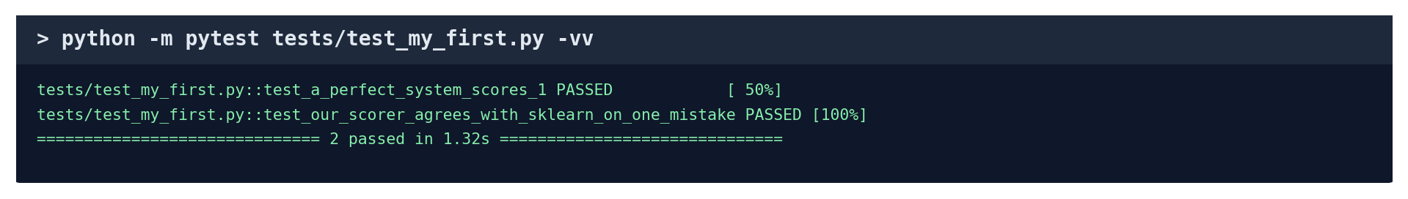
Both tests pass (real output).
- Now break it on purpose: change == 1.0 to == 0.9 and run it again. The first test now says FAILED and shows the real value (1.0). That is how tests catch mistakes.
- Change it back to 1.0. You can keep this file: it is your own test, and the total becomes 373.
The second test is a small version of the project's big independent check: our scorer and scikit-learn must agree.

B3. Run the project's own tests
python -m pytest tests # all 371, about 15 seconds
python -m pytest tests/test_scorer.py -vv # the scorer's 14 tests, by name

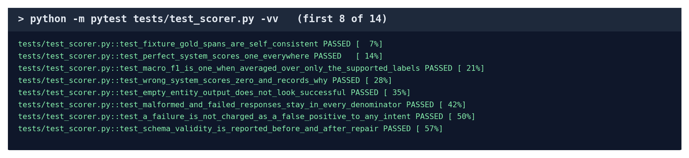
Some of the scorer's tests. Each name says what it checks.
Test file | What it checks
test_scorer.py | F1 and every score, against hand-calculated examples
test_massive.py | the dataset's answers were converted correctly
test_access.py | test data really is locked before the freeze
test_architect.py / test_architect_v2.py | the agent can only pick real designs and never exceeds 4 tries
test_runtime.py | the exported package refuses to load if tampered with
test_reproduce_metrics.py | the reproduction check catches a hand-edited number

Part C. Every experiment, one by one
Each experiment has the same seven parts: in one sentence, where its files are, how it works, run it, what the output means, check it yourself and what to say. All paths are inside D:\MyClaudeProject\nlp. Before running anything: open the Ollama app, open PowerShell, and type cd D:\MyClaudeProject\nlp.
Three tools do the "check it yourself" parts for you, on the real files:
python scripts/explain_f1.py --run <run folder name>: puts the correct answers and a run's answers side by side and works out its F1 (Part A5). It works for any run folder that has a predictions.jsonl.
python scripts/explain_stats.py bootstrap | timing | errors: shows how the confidence interval, the speed figures and the error counts were worked out.
A run folder name is a folder inside runs, such as 20261013_0110_P1_B1_0: the date and time (13 Oct, 01:10), the project (P1), the system (B1) and the seed (0).

C1. The data and the splits
In one sentence: We used real, public data and split it once, with a fixed seed, into examples, development data and locked test data.
Where its files are:
What | Where
The original dataset (downloaded) | data\raw\massive-1.1.tar.gz (Amazon MASSIVE 1.1)
Which domains each project uses | configs\projects.json
The script that builds the splits | scripts\prepare_data.py
Code that turns the dataset's labels into positions | src\evaluation\massive.py
Examples, development and test files | data\processed\P1\kshot.jsonl, dev.jsonl, holdout\test.jsonl
The record of every split | data\manifests\P1.json (counts, every request ID, file fingerprints)
The data report | docs\DATA_REPORT.md
Tests for it | tests\test_massive.py, tests\test_data_splits.py

How it works:
- Download MASSIVE: 16,521 English requests, each labelled by people with its intent and entities.
- The dataset marks entities inside the text, like wake me at [time : five am]. Convert each one to its exact position: "five am" starts at character 11 and ends at 18. All 16,521 converted with 0 errors.
- For each project, keep only its domains (P1: alarms and smart-home devices).
- Draw, using a fixed seed so the result is identical every time: 10 examples per intent (kshot.jsonl), 100 development requests (80 in scope + 20 off-topic) and 300 locked test requests.
- Save every request ID and a fingerprint (SHA-256 hash) of every file in the manifest, then check that no request appears in two files (the leakage check).
Run it (a few seconds; it only checks, it changes nothing):
python scripts/prepare_data.py --check

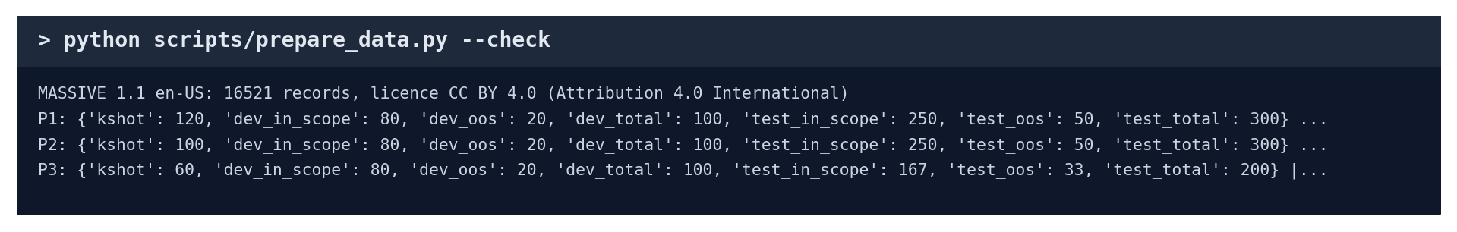
The data check (real output).
What the output means:
- kshot: 120: 120 examples for P1's 12 intents (10 each).
- dev_total: 100, test_total: 300: the development and test sizes.
- leakage id-check pass: no request is in two files.
- P3's test set is smaller (200) because the original dataset has fewer requests in its domains; the plan's fallback size was used and recorded.
Check it yourself:
- Open data\processed\P1\dev.jsonl in Notepad. The status bar shows 100 lines: one request each.
- Find "make a room darker". Its entity is "start": 7, "end": 11. Count the characters from 0: m=0, a=1, k=2, e=3, space=4, a=5, space=6, r=7, o=8, o=9, m=10, so characters 7 to 10 spell "room" (the end number is one past the last letter).
- Open data\manifests\P1.json and search (Ctrl+F) for "counts": the sizes match the screen above. Search for "sha256" to see each file's fingerprint.
Say: "The data is the public MASSIVE dataset. Every split is drawn with a fixed seed and checked for overlap, and the test data is locked."

C2. Model speed and repeatability
In one sentence: Before any experiment, we measured whether the AI model is fast enough and gives the same answer every time.
Where its files are:
What | Where
The script | scripts\throughput_test.py
The result folder | runs\20261012_0020_setup_throughput_0
Summary table | runs\20261012_0020_setup_throughput_0\summary.md
Time for every request | runs\20261012_0020_setup_throughput_0\timing.jsonl

How it works:
- Switch off the saved answers, so every request really goes to the model.
- Send 50 full-size requests and time each one with a stopwatch in the code.
- Send the same 50 again and compare the two sets of answers word for word.
- Count how many replies were valid JSON.
Run it (a few minutes: 100 live requests):
python scripts/throughput_test.py --models qwen2.5:3b

What the output means:
- median 0.42 s: half the requests took less than 0.42 seconds.
- identical repeat 1.00: all 50 answers were the same the second time.
- JSON valid 1.00: every reply was in the right format.
Check it yourself:
- Open runs\20261012_0020_setup_throughput_0\summary.md in Notepad and read the table.
- Open timing.jsonl in the same folder: one line per request with its time in seconds (latency_s).
Say: "The model answers in under half a second and gives identical answers on repeat, so anyone re-running our experiments gets the same results."

C3. B0: word matching, no AI
In one sentence: The simplest possible system, as a floor that every AI system must beat.
Where its files are:
What | Where
The code | src\baselines\b0_tfidf.py
The script | scripts\run_b0.py
Result folders | runs\20261011_1614_P1_B0_0 (the first run) and later re-runs, e.g. runs\20261025_1518_P1_B0_0

How it works:
- Turn every example sentence into word weights (TF-IDF: a word counts more if it is common in this sentence but rare overall).
- Train a standard classifier (logistic regression, from scikit-learn) on P1's 120 examples.
- For off-topic requests: if a request is too unlike every example, refuse it. The cut-off (0.3482) was chosen on development data.
- Answer the 100 development requests and score them.
Run it (a few seconds; no AI model needed):
python scripts/run_b0.py --projects P1

What the output means:
- intent macro-F1 0.780 | accuracy 0.700: the scores.
- threshold 0.3482: the cut-off for refusing off-topic requests.
- entity F1 0.000 (none extracted): B0 only picks an intent; it never extracts entities.
Check it yourself:
- Work out its F1 from the real files: python scripts/explain_f1.py --run 20261011_1614_P1_B0_0. It ends with 0.7801 (0.780 when rounded) and "all three are the same".
- Every re-run makes a new dated folder in runs with exactly the same score: that shows the result repeats.
Say: "A basic word-matching classifier gets 0.78 on P1; any AI system has to beat that to be worth it."

C4. B1: one generic prompt
In one sentence: What you get from one standard AI prompt with no design decisions.
Where its files are:
What | Where
The design it uses | joint-fixed-llm, fixed in advance (B1_CONFIG_ID in src\pipelines\catalogue.py)
The script | scripts\run_design.py
Result folder | runs\20261013_0110_P1_B1_0 (predictions.jsonl, metrics.json)

How it works:
- Use one design, chosen before any results were seen.
- Run it on the 100 development requests, following the recipe in Part A2.
- Save every answer and the scores in a new run folder.
Run it (under a minute):
python scripts/run_design.py --systems B1 --projects P1

What the output means:
- B1 joint-fixed-llm intent 0.927 entity 0.610 oos 0.870: its intent, entity and off-topic F1.
Check it yourself:
- python scripts/explain_f1.py --run 20261013_0110_P1_B1_0 shows its 80 answers, 8 of them wrong, and works out 0.9268.
- In the CSV file it saves, filter column F for "no" to see exactly which 8 requests it got wrong.
Say: "One generic prompt reaches 0.927; the agent has to beat this to show its design work adds anything."

C5. B2: a person configuring by hand
In one sentence: A team member configured the pipeline by hand, timed, so we can compare the agent with a person.
Where its files are:
What | Where
The worksheets | configs\b2\P1_worksheet.md, configs\b2\P2_worksheet.md
The script | scripts\run_b2.py (start, check, finish)
Result folders | runs\20261024_1622_P1_B2_0, runs\20261024_1630_P2_B2_0
The time and help declared | inside each result folder's config.json ("effort", "ai_assistance")

How it works:
- run_b2.py start created a worksheet with the project description and the 12 designs.
- The person chose a design, wrote a description for every intent and field, and declared any help.
- run_b2.py check scored the choices on development data; each check is added to the worksheet.
- run_b2.py finish saved the final result with the minutes and the help recorded.
Run it (the person's own time: 38 min for P1, under 6 min for P2):
python scripts/run_b2.py check --project P1

What the output means:
- intent macro-F1 0.858 | entity F1 0.586: the person's scores on P1.
Check it yourself:
- Open configs\b2\P1_worksheet.md: section 2 shows the chosen design, sections 3 and 4 the descriptions, section 5 the time and help, and the bottom shows each check's score.
- Open runs\20261024_1622_P1_B2_0\config.json and search for "ai_assistance".
- python scripts/explain_f1.py --run 20261024_1622_P1_B2_0 works out 0.858 from its answers.
Say: "By hand, a beginner got 0.858 on P1 in 38 minutes; the agent got 0.958 with no human time. On P2, a person with ChatGPT matched the agent, and we report that too."

C6. B3: the published baseline (XLM-R)
In one sentence: We compared against the model the MASSIVE paper itself used as its baseline.
Where its files are:
What | Where
The code | src\baselines\b3_encoder.py
The script | scripts\run_b3_local.py
The downloaded model | C:\Users\mihir\.cache\huggingface\hub\models--xlm-roberta-base (1.1 GB)
Result folders | runs\20261015_2240_P1_B3-k_0 and the B3-full and P2 folders
Summary of each run | summary.md inside each folder

How it works:
- Download XLM-R, a language model with 270 million parameters.
- Fine-tune it: show it the examples again and again (30 rounds) and adjust its internal numbers until it learns them. B3-k uses the same 10 examples per intent as everyone else; B3-full uses all the training data (10-30 times more).
- Choose the off-topic cut-off on development data.
- Answer the 100 development requests and score them with the same scorer as every other system.
Run it (about 11 minutes for P1 B3-k; about 85 minutes for all four. Don't run it live: open the result folder instead):
python scripts/run_b3_local.py --projects P1 --variants B3-k

What the output means:
- The summary says: fine-tuned on 120 cases for 30 epochs in 664 s, intent macro-F1 0.909, entity F1 0.650.
Check it yourself:
- Open runs\20261015_2240_P1_B3-k_0\summary.md in Notepad.
- python scripts/explain_f1.py --run 20261015_2240_P1_B3-k_0 works out 0.909 from its saved answers.
Say: "With the same data, our agent beats the published baseline on intents, and A2 also beats it on entities. B3-full, with 10-30 times more data, is only a reference."

C7. B4: random search
In one sentence: We checked whether the agent chooses designs better than luck.
Where its files are:
What | Where
The code | src\baselines\b4_search.py
The script | scripts\run_design.py
Random-search results | runs\20261013_0112_P1_B4-random_seeds (config.json, metrics.json)
All 12 designs scored | runs\20261013_0112_P1_B4-exhaustive_0 (config.json)

How it works:
- Pick 4 of the 12 designs at random: the same budget the agent gets.
- Score each on development data and keep the best, by the same rule the agent uses.
- Repeat with 5 different random seeds, so the result is not one lucky or unlucky draw.
- Also score all 12 designs: the best possible (the ceiling).
Run it (under a minute):
python scripts/run_design.py --systems B4-random --exhaustive --projects P1

What the output means:
- For each seed, the 4 designs drawn and the one kept; then the average over the 5 seeds.
Check it yourself:
- Open runs\20261013_0112_P1_B4-random_seeds\metrics.json and find "selected_intent_macro_f1": the 5 winning scores, to 4 decimals, are 0.9585, 0.9511, 0.9744, 0.9511 and 0.9585.
- Average them on a calculator: (0.9585 + 0.9511 + 0.9744 + 0.9511 + 0.9585) / 5 = 4.7936 / 5 = 0.9587, which rounds to 0.959, the B4 score. (Use 4 decimals: rounding first to 3 gives 0.958.)
- Open config.json in the same folder and search for "attempted" to see which 4 designs each seed drew.
- Open the B4-exhaustive folder's config.json and search for "ranking": all 12 designs, best first (schema-sim-llm, 0.974).
Say: "Random search averaged 0.959 on P1. A1 did not beat it; the improved A2 reached the best design, 0.974."

C8. A1 and A2: the agent
In one sentence: We ran the full framework: the Analyzer, the Architect, scoring the candidates and selecting the best.
Where its files are:
What | Where
The Analyzer | src\analyzer\analyzer.py
A1's Architect | src\architect\architect.py
A2's Architect | src\architect\architect_v2.py
Puts the steps together | src\architect\design_run.py
Scripts | scripts\run_design.py (A1), scripts\run_a2.py (A2)
Result folders | runs\20261013_0110_P1_A1_0, runs\20261024_1648_P1_A2_0 (config.json, events.jsonl)
Answers of the chosen design | runs\20261024_1654_P1_A1-selected_0, runs\20261024_1654_P1_A2-selected_0

How it works:
- Analyzer: ask the AI to write a one-line description of every intent and field (2 calls).
- Architect: ask the AI which designs to try. A1 asks it to pick 3 at once; A2 asks it to rank each design choice separately, then builds 3 designs that each change one choice.
- Score each of the 3 designs on the 100 development requests.
- Give the scores back to the Architect, which picks a 4th design.
- Keep the best of the 4. Save every choice, its reason and its score in the run folder.
Run it (under a minute):
python scripts/run_a2.py

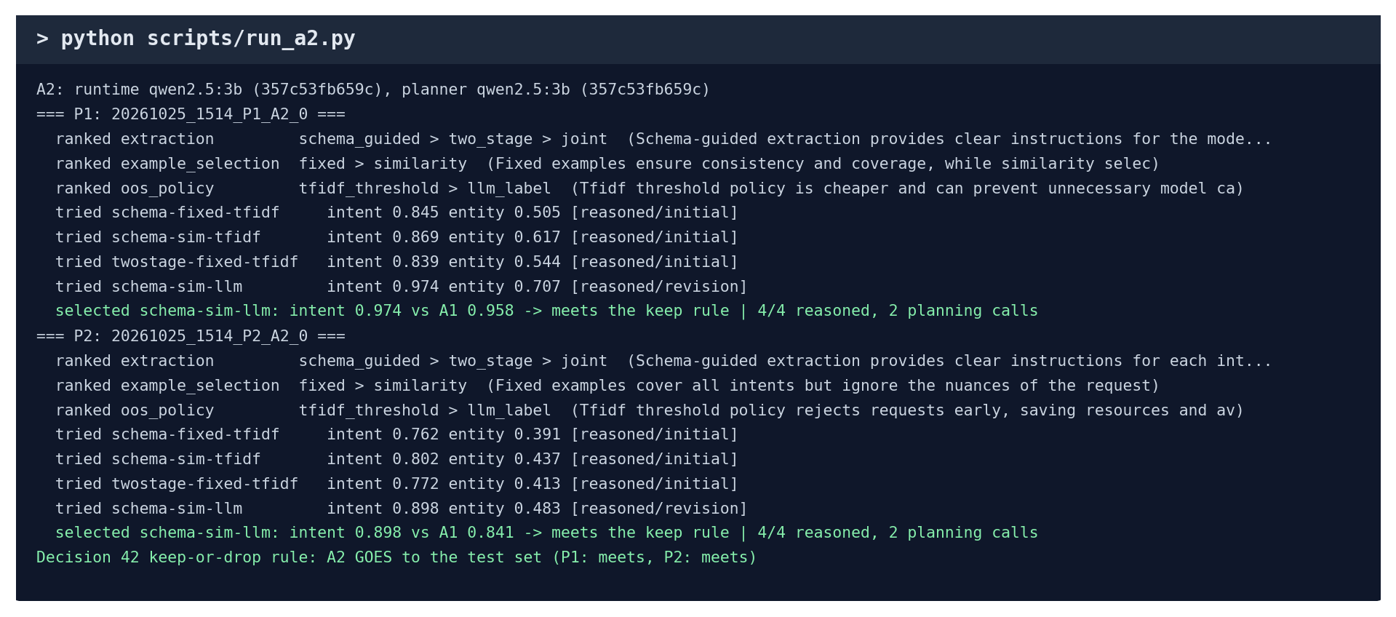
The A2 run (real output).
What the output means:
- ranked extraction schema_guided > two_stage > joint: the AI's own ranking, with its reason in brackets.
- tried ... [reasoned/initial]: the 3 first designs and their scores; [reasoned/revision]: the 4th, chosen after seeing the scores.
- selected schema-sim-llm: intent 0.974: the design kept.
Check it yourself:
- Open runs\20261013_0110_P1_A1_0\config.json and search for "attempts": the 4 designs A1 tried, each with a "rationale" (its reason) and "source": "reasoned" (the AI chose it, not a fallback).
- Search the same file for "reasoned_choices": 4, so all 4 choices came from the AI.
- python scripts/explain_f1.py --run 20261024_1654_P1_A2-selected_0 works out A2's 0.974 (Part A5).
Say: "The agent chooses designs itself and records a reason for each choice. A2 tests the alternatives one change at a time, and it reached the best of all 12 designs on both projects."

C9. Ablations
In one sentence: We removed one part of the agent at a time to find out which part matters.
Where its files are:
What | Where
The script | scripts\run_dev_analysis.py
One result folder per variant | runs\20261016_0100_P1_A1-noAnalyzer_0, ...-noReasoning_0, ...-noSelection_0, ...-oneCandidate_0, ...-noRepair_0
All numbers together | reports\dev_analysis.json (section "ablations")
The write-up | reports\DEV_ANALYSIS.md, section 1

How it works:
- No Analyzer: run the agent without the AI-written descriptions.
- No reasoning: replace the AI's choice of designs with a fixed order.
- No selection: take the Architect's first design without scoring any.
- No repair: give no second chance when the model's reply is badly formatted.
- Score each variant on the same 100 requests and compare it with the full agent.
Run it (1 to 2 minutes):
python scripts/run_dev_analysis.py --skip-timing

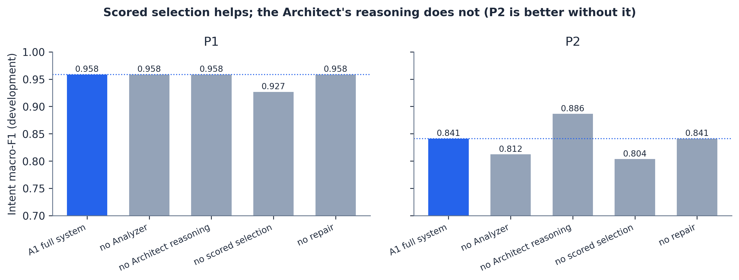
Each bar removes one part of A1 (chart from the reports\figures folder).
What the output means:
- One line per variant, e.g. A1-noReasoning joint-sim-llm intent 0.886 on P2: without the AI's reasoning, P2 scored higher than with it.
Check it yourself:
- Pick a variant and work out its score: python scripts/explain_f1.py --run 20261016_0102_P2_A1-noReasoning_0 gives 0.886.
- Compare with the full agent on P2: python scripts/explain_f1.py --run 20261024_1654_P2_A1-selected_0 gives 0.841.
Say: "Scoring the candidates helps most, by 3 to 4 points. A1's reasoning did not help, which is exactly why we built A2."

C10. Confidence intervals (bootstrap)
In one sentence: We checked whether a difference between two systems is real or could be luck.
Where its files are:
What | Where
The code | paired_bootstrap in scripts\run_dev_analysis.py
The results | reports\dev_analysis.json (section "bootstrap")
The step-by-step explainer | scripts\explain_stats.py

How it works:
- Take the 100 development requests and both systems' answers to them.
- Make a "pretend" set of 100 by drawing request numbers at random, allowing repeats: some requests appear twice, some not at all.
- Score both systems on that same pretend set and note the difference.
- Do this 1,000 times. Sort the 1,000 differences and keep the middle 95%: that range is the confidence interval.
- If the range is entirely above 0, the lead is real. If it includes 0, it could be luck.
Run it (about 20 seconds):
python scripts/explain_stats.py bootstrap

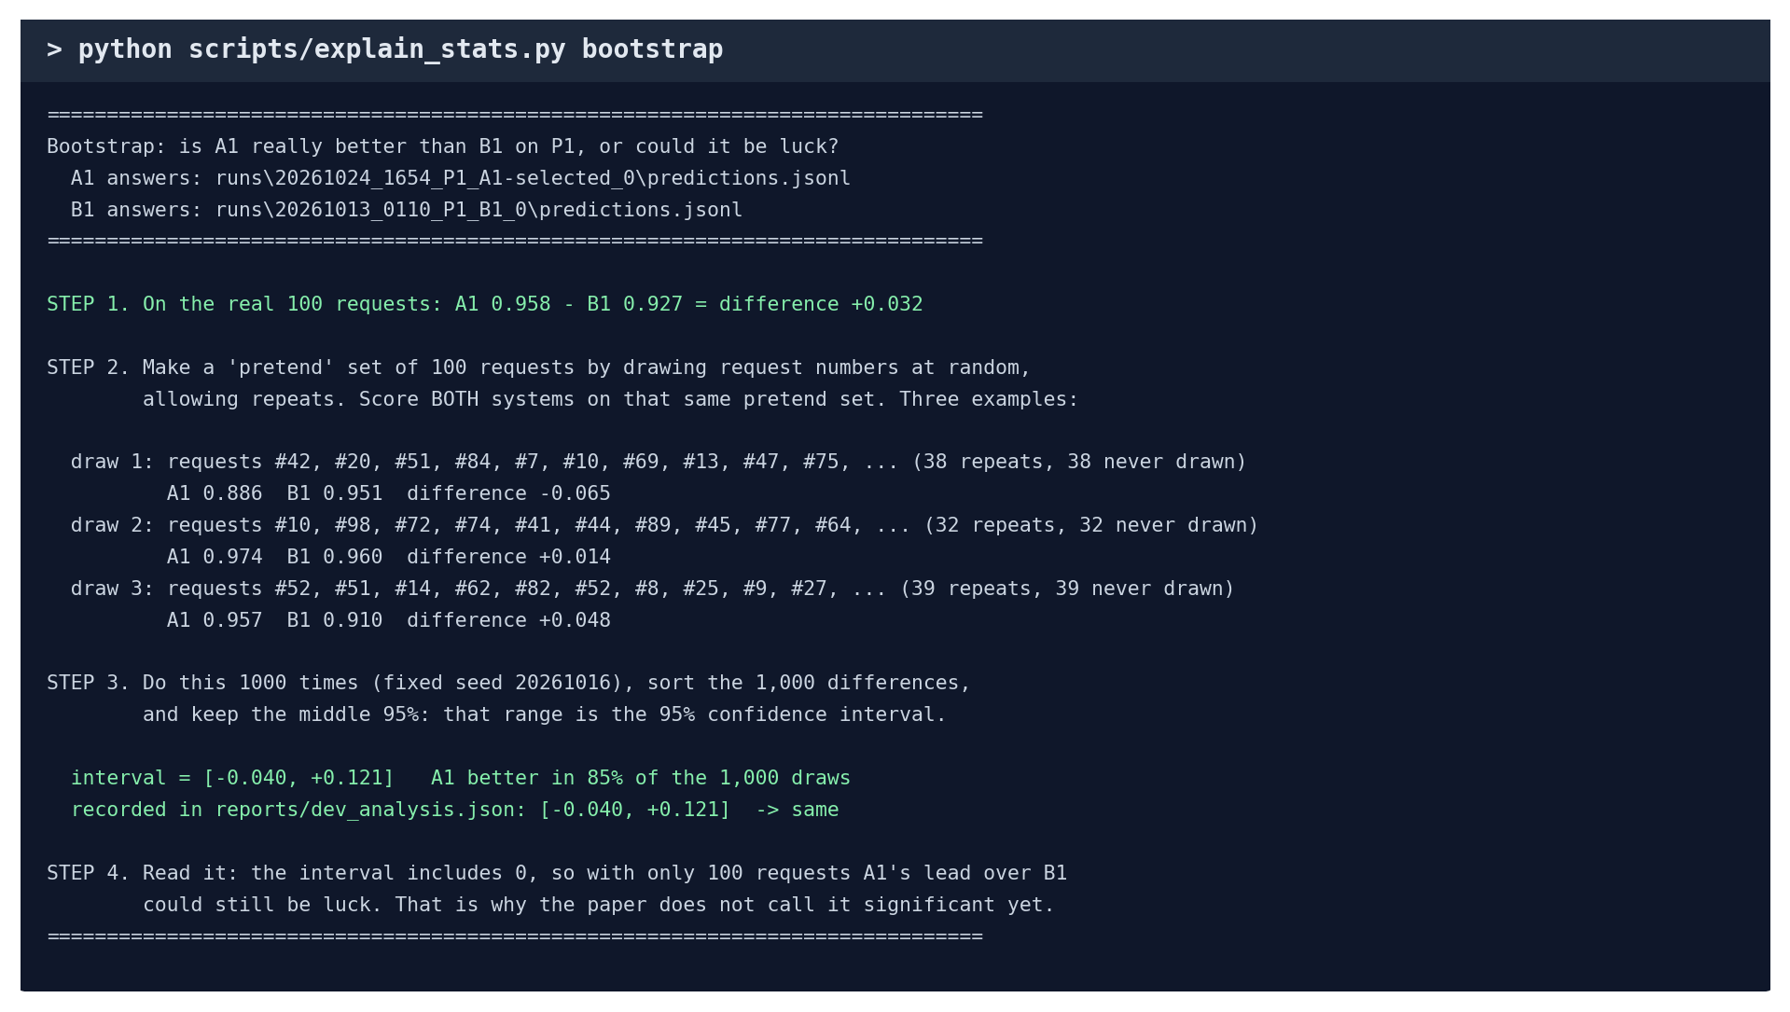
The bootstrap, step by step (real output).
What the output means:
- Step 1: on the real 100 requests A1 leads B1 by +0.032.
- Step 2: three of the 1,000 pretend sets. In draw 1 B1 actually wins (-0.065): that is how luck shows up.
- Step 3: the interval is [-0.040, +0.121]: it includes 0.
- It matches the number recorded in reports\dev_analysis.json.
Check it yourself:
- Run it for P2: python scripts/explain_stats.py bootstrap --project P2.
- Open reports\dev_analysis.json and search for "ci_low" to see every recorded interval.
Say: "With 100 development requests, A1's lead over B1 could still be luck, so we don't call it significant yet. The 300-request test sets will tell."

C11. Real speed (timing)
In one sentence: We measured how fast the final pipeline answers when nothing is saved in advance.
Where its files are:
What | Where
The code | time_requests in src\evaluation\runner.py
Time for every request | runs\20261016_0101_P1_A1-timing_0\timing.jsonl
The step-by-step explainer | scripts\explain_stats.py

How it works:
- Switch off the saved answers so every request goes to the model live.
- Send 5 warm-up requests and ignore them: the first one wakes the model up and is slow.
- Send 50 development requests and time each one with a stopwatch in the code.
- Leave out requests refused before reaching the model, so they cannot make a design look faster.
- Sort the 50 times. The median is the middle one; p95 is the one that 95% are faster than.
Run it (a second (it reads the saved times)):
python scripts/explain_stats.py timing

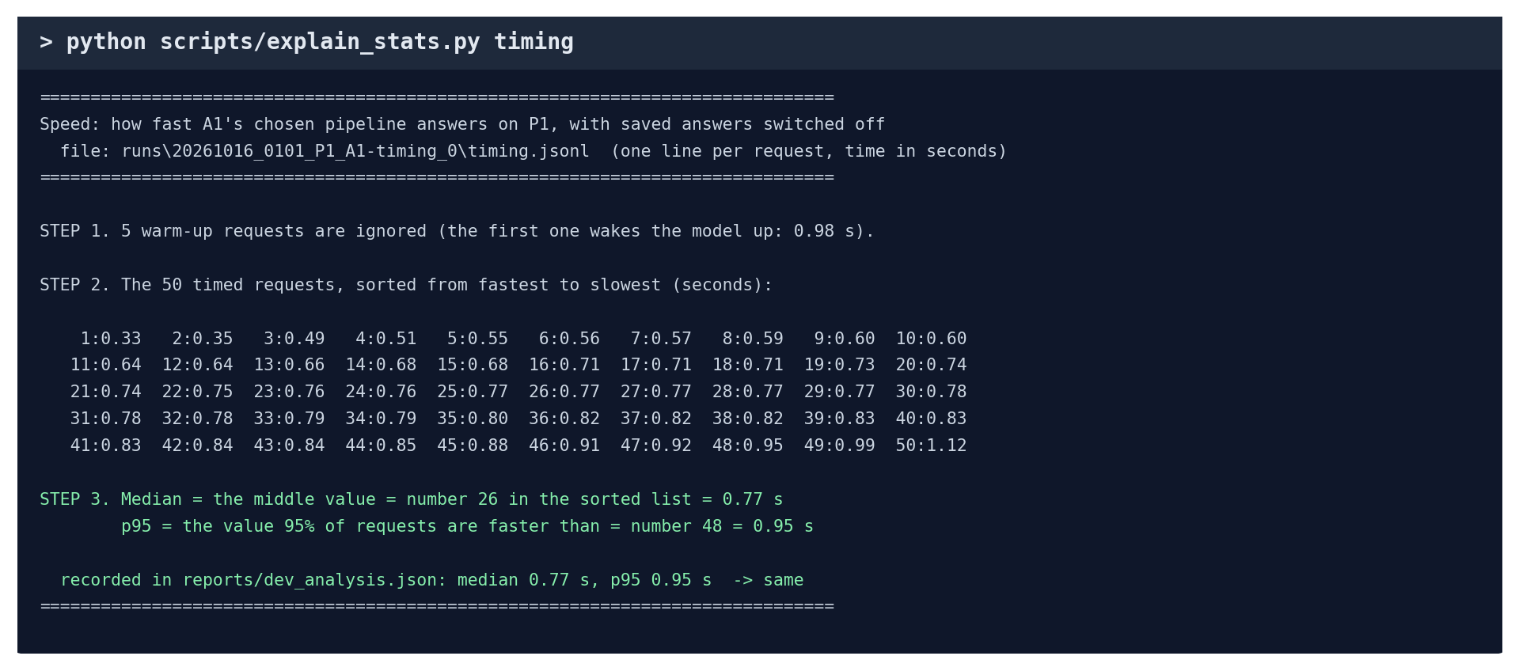
How the speed figures are worked out (real output).
What the output means:
- The 50 times sorted, numbered 1 to 50.
- Median = number 26 = 0.77 s. p95 = number 48 = 0.95 s.
- Both match what is recorded in reports\dev_analysis.json.
Check it yourself:
- Open runs\20261016_0101_P1_A1-timing_0\timing.jsonl in Notepad: each line has a request and its latency_s (seconds). The first 5 say "warmup": true.
- To measure again from scratch (about 5 minutes): python scripts/run_dev_analysis.py.
Say: "Every pipeline answers in under one second, even in the slowest 5% of requests."

C12. Error analysis
In one sentence: We looked at what kind of mistakes the agent makes, not just how many.
Where its files are:
What | Where
The code | classify_errors in scripts\run_dev_analysis.py
The results | reports\dev_analysis.json (section "errors")
The explainer | scripts\explain_stats.py

How it works:
- Go through every development request the agent got wrong.
- Put each mistake in one category: confused intent, wrongly refused, answered an off-topic request, missed entity, extra (spurious) entity, wrong entity type, wrong boundary (too much or too little text), or a value not in the request.
- Count each category, and keep real examples of each.
Run it (a second):
python scripts/explain_stats.py errors

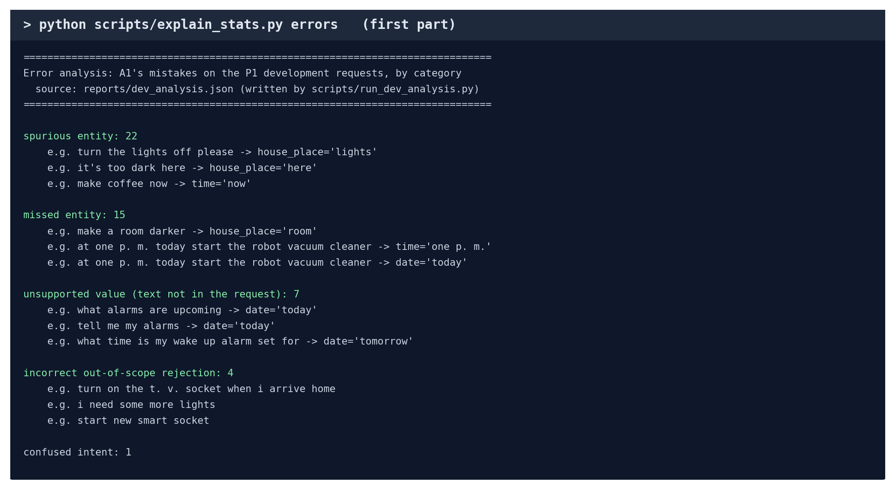
A1's mistakes by category, with real examples (real output).
What the output means:
- spurious entity: 22, e.g. "turn the lights off please -> house_place='lights'": the agent extracted "lights" as a place, which it is not.
- missed entity: 15, e.g. "make a room darker": the room was not extracted.
- incorrect out-of-scope rejection: 4, e.g. "i need some more lights" was refused as off-topic.
Check it yourself:
- Run it for P2: python scripts/explain_stats.py errors --project P2.
- Check one example against the data: find "make a room darker" in data\processed\P1\dev.jsonl; the correct entity is house_place = room.
Say: "Most of the original agent's mistakes were extra words extracted as entities, which showed us where it was weakest."

C13. Robustness to messy typing
In one sentence: We checked whether the systems still work when people type carelessly.
Where its files are:
What | Where
The script | scripts\run_robustness.py
Result folders | runs\20261016_0119_P1_A1-robust-typo_0, ...-robust-caps_0, ...-robust-filler_0 (and the same for B1 and B0)
All numbers together | reports\robustness.json
The write-up | reports\DEV_ANALYSIS.md, section 5

How it works:
- Rewrite every development request three ways, the same way every time (fixed seed):
- typos: two neighbouring letters swapped ("tunr the lights off please");
- capitals: "TURN THE LIGHTS OFF PLEASE";
- filler words: "hey, could you please turn the lights off please, thanks".
- Score B0, B1 and the agent on each rewritten set, with the same correct answers as before.
Run it (about a minute (answers saved earlier)):
python scripts/run_robustness.py

What the output means:
- One line per system and version, e.g. A1 typo intent 0.949: with typos A1 dropped only from 0.958 to 0.949.
Check it yourself:
- python scripts/explain_f1.py --run 20261016_0119_P1_A1-robust-typo_0 shows the requests with their typos ("tunr the lights off please") next to A1's answers, and works out 0.949.
- Open that folder's predictions.jsonl: each line has the rewritten request in "utt".
Say: "The AI systems lose at most about 7 points on messy input, while word matching drops by up to 27."

C14. Export and live demo
In one sentence: We saved the chosen pipeline as a package and showed another program can load and use it.
Where its files are:
What | Where
The code | src\runtime\package.py
Scripts | scripts\export_pipeline.py, scripts\demo.py
The P1 package | artifacts\P1\twostage-sim-llm-ff3d548a0af2\ (pipeline.json, examples.jsonl, manifest.json)
Tests for it | tests\test_runtime.py

How it works:
- Save the chosen design, the Analyzer's descriptions, the examples and the model's fingerprint into three files.
- Write a fingerprint of each file into manifest.json. If a file is changed later, the fingerprints no longer match and the package refuses to load.
- Load the package in a fresh program and answer normal, off-topic and invalid requests.
- These packages hold A1's choices; A2's will be exported at the freeze.
Run it (about 10 seconds each):
python scripts/demo.py --project P1
python scripts/demo.py --project P1 --interactive

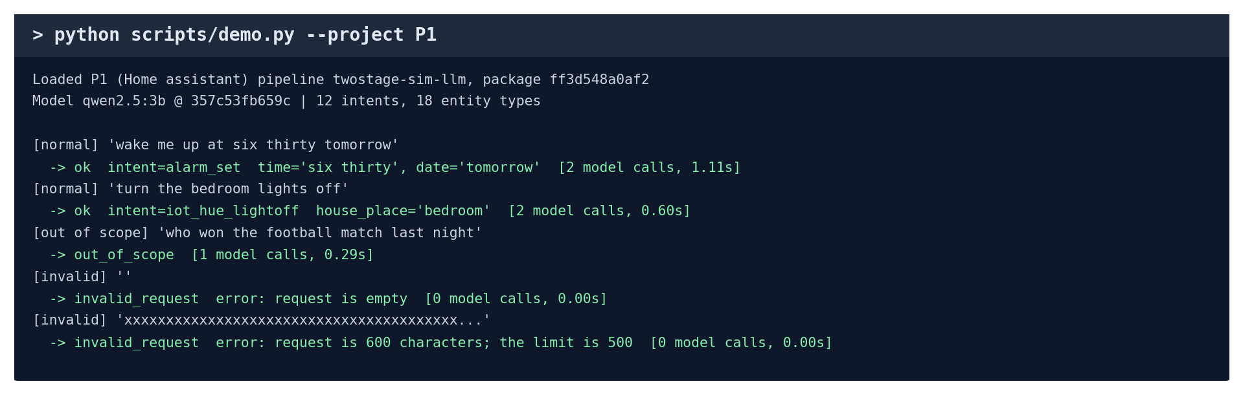
The demo (real output).
What the output means:
- -> ok intent=alarm_set time='six thirty': understood, with the details extracted.
- -> out_of_scope: refused, correctly.
- -> invalid_request: an empty or too-long request, refused before the AI is even called.
Check it yourself:
- Open artifacts\P1\twostage-sim-llm-ff3d548a0af2\manifest.json: "files" lists each file's fingerprint.
- See the tamper protection work: python -m pytest tests/test_runtime.py -vv -k modified. The test edits a package file and checks it is refused (2 passed).
- In interactive mode, type your own requests, e.g. "dim the kitchen lights", then press Enter on an empty line to stop.
Say: "The agent's choice is saved as a package any program can load, and if anyone edits it, it refuses to load."

C15. Checking the results themselves
In one sentence: We proved that no recorded number was edited or computed wrongly.
Where its files are:
What | Where
Re-score every run | scripts\reproduce_metrics.py
Independent check with scikit-learn | scripts\verify_with_sklearn.py
Every check at once | scripts\show_evidence.py (saves reports\EVIDENCE_SUMMARY.md)

How it works:
- For every run folder with a predictions.jsonl, recompute its scores from the saved answers and compare with its metrics.json.
- Separately, recompute F1, accuracy and the off-topic scores with scikit-learn, without our scorer.
- Compare to 9 decimal places.
Run it (under a minute in total):
python scripts/reproduce_metrics.py
python scripts/verify_with_sklearn.py
python scripts/show_evidence.py

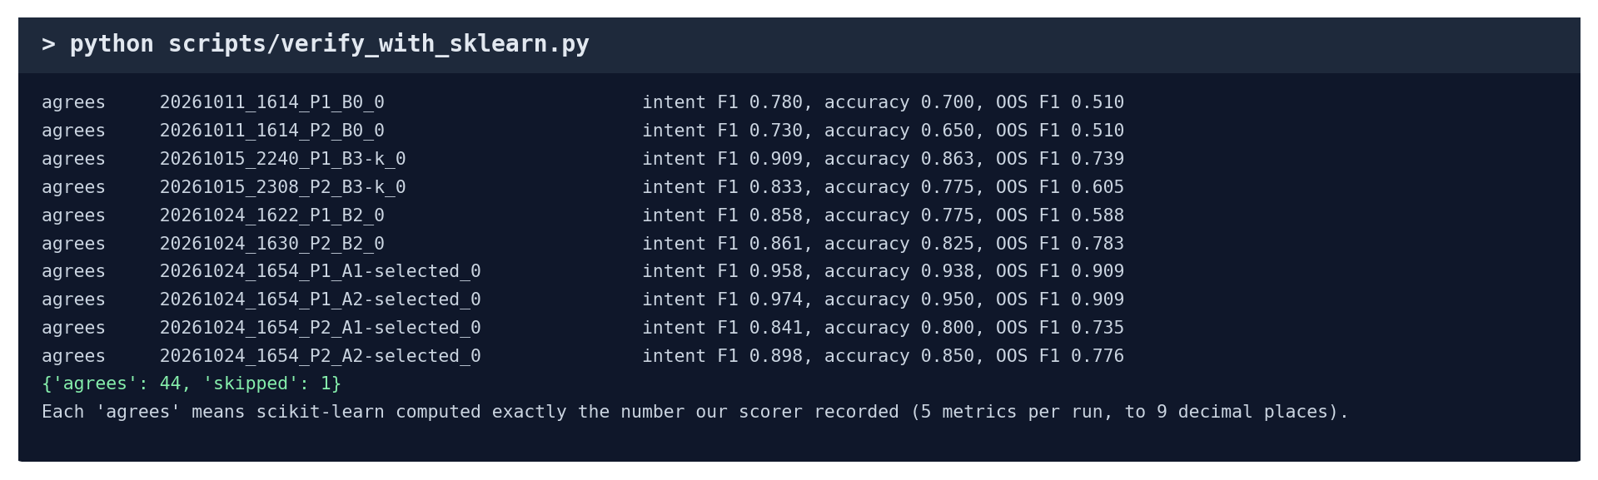
The independent check (real output).
What the output means:
- match / agrees on every line: the recorded number is exactly what recomputation gives.
- not checkable: that folder has no answers to re-score (for example a timing run). It is not a failure.
Check it yourself:
- Part A5's explain_f1 does the same three-way check for one run, showing every step: our scorer, scikit-learn and the hand calculation all give 0.9744.
- Run python scripts/show_evidence.py and find "Overall: all checks passed" on the last line.
Say: "Every recorded number can be recomputed from the raw answers, and the standard library scikit-learn gets the same numbers."

Part D. If the teacher says "do it now"
The teacher asks… | Type this | Time | What appears
"Show me a test running." | python scripts/walkthrough.py | 5 s | the six steps for three requests
"Is the difference real?" | python scripts/explain_stats.py bootstrap | 20 s | the confidence interval, worked out step by step
"How did you measure speed?" | python scripts/explain_stats.py timing | 1 s | 50 times sorted, median and p95 picked out
"Run all your tests." | python -m pytest tests | 15 s | 371 passed
"How do you compute F1?" | python scripts/explain_f1.py (Part A5) | 5 s | every count and the average, matching metrics.json
"Write a test." | the file from Part B2, then python -m pytest tests/test_my_first.py -vv | 5 min | 2 passed
"Run your agent." | python scripts/run_a2.py | under 1 min | the AI's rankings, 4 designs tried, the choice
"Run a baseline." | python scripts/run_b0.py --projects P1 | seconds | B0 score 0.780
"Is the data clean?" | python scripts/prepare_data.py --check | seconds | sizes and leakage check pass
"Are your numbers real?" | python scripts/verify_with_sklearn.py | seconds | 44 agree
"Show me it working." | python scripts/demo.py --project P1 --interactive | live | answers the teacher's own sentences
"Show me everything." | python scripts/show_evidence.py | under 1 min | Overall: all checks passed
"Retrain the published baseline." | explain C6, then open runs\20261015_2240_P1_B3-k_0 | show folder | training too long to run live (11 min to 85 min)

If something fails during a live run, it is almost always because the Ollama app is not open. Open it from the Start menu, wait 10 seconds and run the command again.

Part E. 30-minute rehearsal checklist
Do these once before presenting. Tick each one when it works on your laptop.
- ☐ Open Ollama; in PowerShell run cd D:\MyClaudeProject\nlp and ollama list.
- ☐ Open data\processed\P1\dev.jsonl and a predictions.jsonl in Notepad and explain one line of each (Part A3).
- ☐ Run python scripts/walkthrough.py and explain each of the six steps out loud (Part A4).
- ☐ Run python scripts/explain_f1.py, then count alarm_query yourself in the CSV file (Part A5).
- ☐ Work out the practice example on paper without looking, then check it with check_f1.py.
- ☐ Create tests/test_my_first.py, run it, break it, fix it.
- ☐ Run python -m pytest tests and say what the tests check (Part B3 table).
- ☐ Run python scripts/run_a2.py and explain the rankings and the 4 designs tried.
- ☐ For each experiment in Part C, say its idea in one sentence without reading.
- ☐ Run python scripts/verify_with_sklearn.py and explain why "agrees" matters.
- ☐ Run the demo in interactive mode and try three sentences of your own.
- ☐ Run python scripts/show_evidence.py and find "Overall: all checks passed".

Part F. How to explain the AI use honestly
Your teacher allows AI use. What matters is that you are open about it and understand the work. Something like:
"We planned the project and decided how it should be tested: which baselines, which data, which scores and which checks. We used Claude Code, an AI coding assistant, to write the code and run the experiments. We checked every result, and we can explain and re-run each test, for example here is a test running step by step. The AI assistance is recorded in docs\contributions.md, as our plan requires."

Then show one or two things live from Part D. Being able to run and explain a test on the spot is the proof that you understand it.

