The Paper, Piece by Piece
A screenshot of every part of our research paper, each followed by what it means in simple words
Mihir Bhati (24BCE5341) · Ahana Sharan (24BCE5334) · Guide: Vijayaprabakaran K
VIT Chennai
How to read this. Each box is cut straight from the paper. Under it: In short says what that part is telling the reader, and Words used here explains every technical word in it. A dashed line inside a picture means the text continues in the next column or on the next page. For the longer, section-by-section explanation and the teacher questions, see Research_Paper_Explained.pdf.

Five ideas to keep in your head while reading
- The task: turn a sentence into an intent (what the user wants) and entities (the details), or say "not supported".
- The design: there are 12 ways (designs) to set up the AI for this. Choosing well matters (13–16 points difference).
- Our agent: tries only 4 of the 12 on 100 practice sentences and keeps the best by a fixed rule.
- Fair testing: everything was frozen before the real test; P3 was a whole project kept secret until then.
- The result: best design found every time; wins on P1 and P2; on P3 slightly worse on intents (could be luck) but much better on entities.

Page 1: title, abstract, introduction

Title and authors
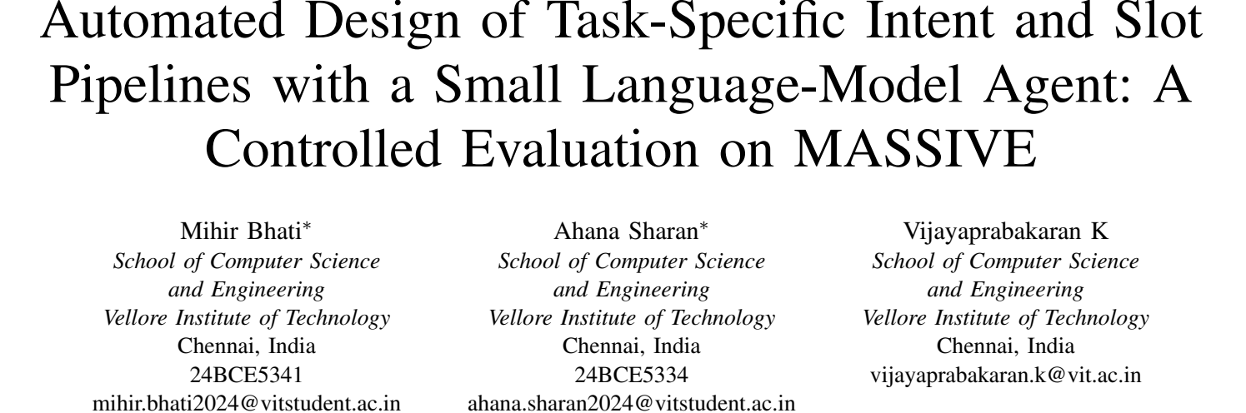
From the paper
In short: What the paper is about in one line: a small AI agent that automatically designs the part of an assistant that understands requests (intents and slots), tested carefully on the MASSIVE dataset. Then who wrote it. The * means Mihir and Ahana contributed equally.

Words used here:
- Automated design: the computer makes the design choices, not a person.
- Task-specific: built for one particular app (e.g. a smart-home app).
- Intent and slot: intent = what the user wants (alarm_set); slot = a detail (time = "seven").
- Pipeline: the full chain from the user's sentence to the final answer.
- Small language-model agent: a program that uses a small AI model (3 billion parameters) to make decisions.
- Controlled evaluation: a fair test with fixed rules decided in advance.
- MASSIVE: a public dataset of assistant requests from Amazon.

Abstract and index terms
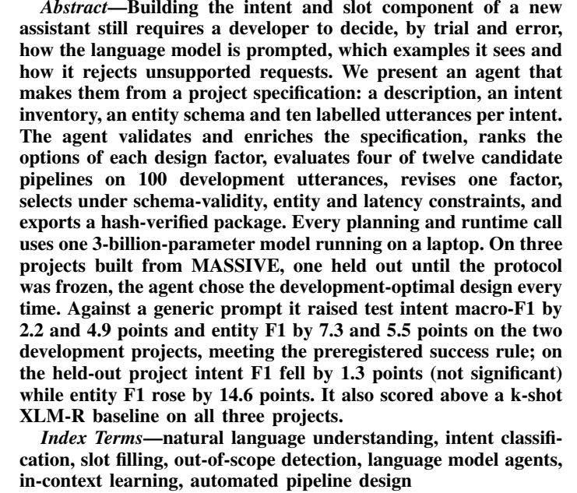
From the paper
In short: The whole paper in 198 words: the problem (choosing prompt, examples and rejection by trial and error), what we built (an agent that does it automatically), how it works (check, rank, test 4 of 12, revise, select, export) and the main numbers. Index terms are search keywords.

Words used here:
- Project specification: what the agent is given: description, list of intents, list of entity types, 10 example sentences per intent.
- Utterance: one user sentence.
- Validates and enriches: checks the input for mistakes, then writes a short description of every label.
- Design factor: one of the three choices (how to extract, which examples, how to reject).
- Development utterances: practice sentences used to choose (100 per project).
- Schema validity: the AI's reply is in the required format.
- Latency: how long one request takes.
- Hash-verified package: the saved pipeline, with fingerprints that prove nothing was changed.
- Held out until the protocol was frozen: P3 stayed locked until all rules and choices were fixed.
- Development-optimal design: the best of all 12 designs on the practice set.
- Macro-F1, points: the accuracy score (0 to 1); 1 point = 0.01.
- Preregistered success rule: the pass/fail rule we fixed before testing.
- Not significant: the difference is small enough that it could be luck.
- k-shot XLM-R: a trained model (XLM-R) given the same 10 examples per intent.

Introduction, paragraph 1: the problem
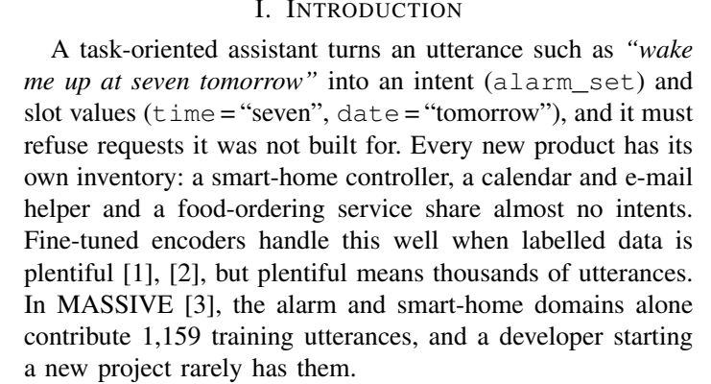
From the paper
In short: Explains the task with an example and why it is hard for a new app: every app has different intents, and trained models need thousands of labelled sentences (MASSIVE has 1,159 for alarms and smart home alone).

Words used here:
- Task-oriented assistant: an assistant built to do jobs (alarms, emails), not to chat.
- Refuse requests it was not built for: say "not supported" for out-of-scope requests.
- Inventory: the list of intents one app supports.
- Fine-tuned encoders: models such as BERT or XLM-R that learn by training on many labelled examples.
- [1], [2], [3]: reference numbers; the full papers are listed at the end.

Introduction, paragraph 2: why design matters
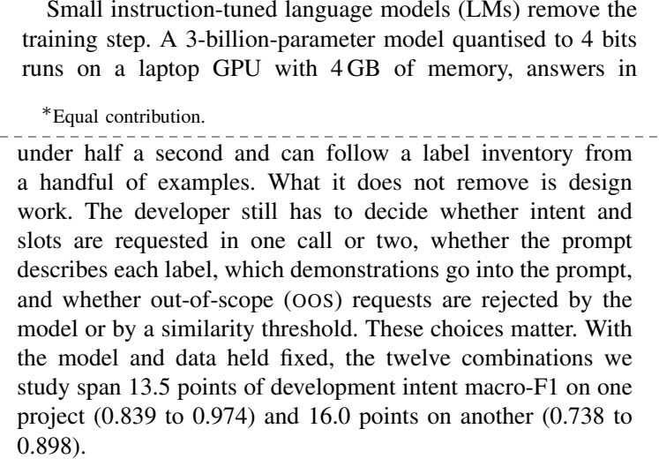
From the paper
In short: Small AI models need no training and run on a laptop, but someone must still decide how to use them. Those decisions change accuracy a lot: the 12 designs range from 0.839 to 0.974 on P1 and 0.738 to 0.898 on P2.

Words used here:
- Instruction-tuned language model (LM): an AI trained to follow written instructions.
- 3-billion-parameter, quantised to 4 bits: a small model, compressed so it fits in 4 GB of laptop memory.
- Label inventory: the list of intents.
- Demonstrations: solved example sentences placed in the prompt.
- Out-of-scope (OOS): a request the app does not support.
- Similarity threshold: reject a request if it is not similar enough to any example.
- Span 13.5 points: best minus worst design = 0.974 − 0.839 = 0.135.

Introduction, paragraph 3: what others did and what is missing
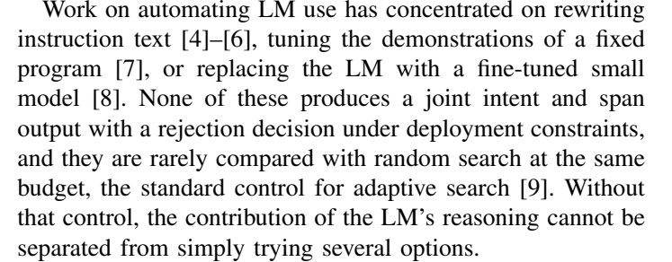
From the paper
In short: Other work rewrites instructions, tunes examples or trains a small model, but none outputs intent + entities + rejection under real limits, and they are rarely compared with random choice. Without that comparison you can't tell if the AI's reasoning helped.

Words used here:
- Fixed program: a pipeline whose structure a person already wrote.
- Joint intent and span output: giving the intent and the entity positions together.
- Deployment constraints: limits a real app has (format must be valid, must be fast).
- Random search: trying options chosen at random; the fair baseline for any smart search.
- Adaptive search: a search that uses results so far to choose what to try next.

Introduction, paragraph 4 and the three contributions
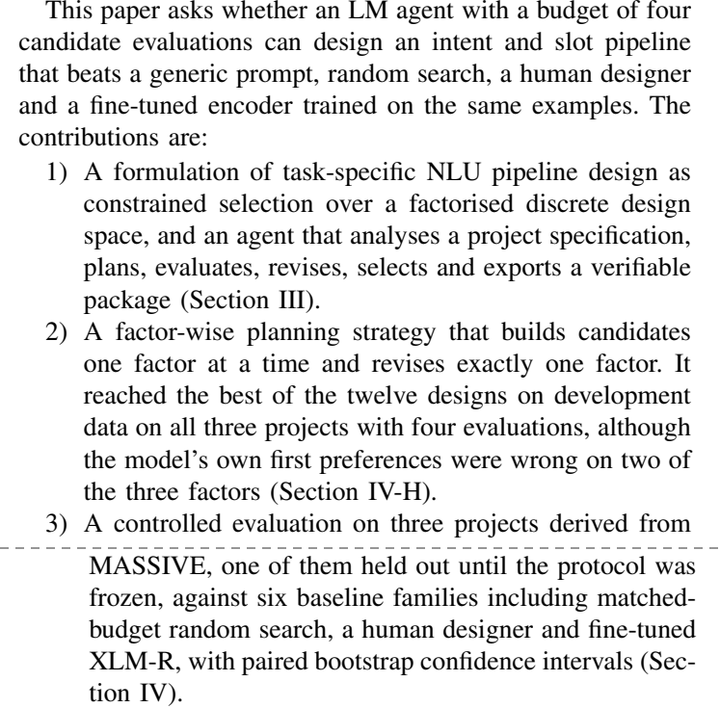
From the paper
In short: The research question (can a 4-try agent beat a generic prompt, random search, a human and a trained model?) and what the paper adds: (1) the method and agent, (2) the factor-wise planning idea that found the best design every time, (3) a careful test on three projects.

Words used here:
- Candidate evaluations: designs actually tested; the budget is 4.
- Generic prompt: the default setup with no design effort (our B1).
- Constrained selection over a factorised discrete design space: pick the best from a fixed list of combinations of 3 choices, while obeying rules.
- Verifiable package: an output whose files can be checked for changes.
- Factor-wise planning: decide each of the 3 choices separately, then test them in a fixed pattern.
- Baseline families: the different kinds of systems we compare against.
- Matched-budget random search: random search allowed the same 4 tries.
- Paired bootstrap confidence intervals: a statistics method to tell real differences from luck.

Pages 2–3: literature survey (15 papers)
Each paragraph is one earlier paper: what it did, then (last sentence) how it connects to our work.

Survey intro and A. MASSIVE [3]
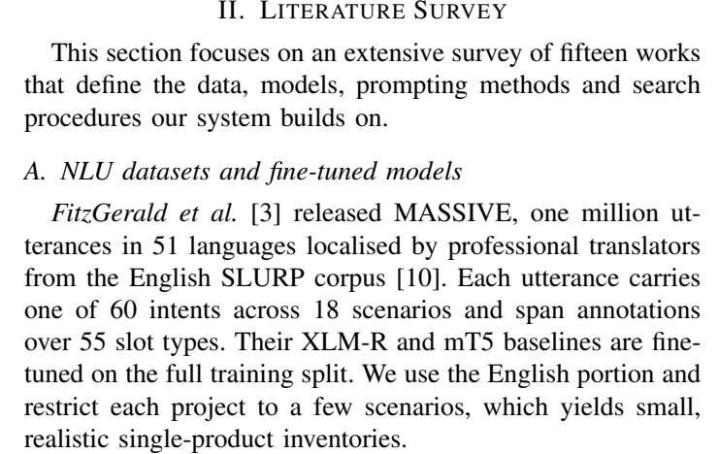
From the paper
In short: MASSIVE is our dataset: 1 million requests in 51 languages, 60 intents, 18 topics, 55 slot types. We use only English and split it into small apps.

Words used here:
- Survey: a review of earlier research.
- Localised by professional translators: translated and adapted for each language by humans.
- SLURP corpus [10]: the English collection MASSIVE was built from.
- Scenario: a topic group, like alarm or email.
- Span annotations: markings of exactly which words are each slot.
- mT5: another model used as a baseline by MASSIVE's authors.
- Single-product inventories: intent lists for one app each.

Larson et al. [11]: out-of-scope requests
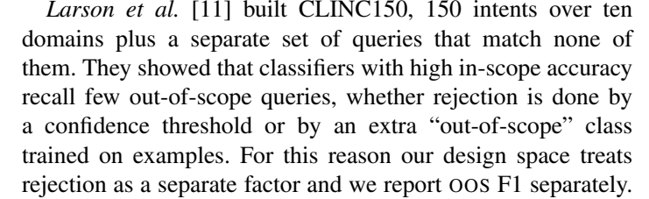
From the paper
In short: A dataset with off-topic questions showed models that are accurate on normal requests still miss most off-topic ones. That is why rejection is one of our three design choices and why we report OOS F1 separately.

Words used here:
- CLINC150: their dataset (150 intents).
- In-scope accuracy: accuracy on requests the app does support.
- Recall few out-of-scope queries: they catch only a small share of off-topic requests.
- Confidence threshold: reject if the model is not confident enough.
- OOS F1: our score for how well a system refuses off-topic requests.

Chen et al. [1]: BERT for intent and slots
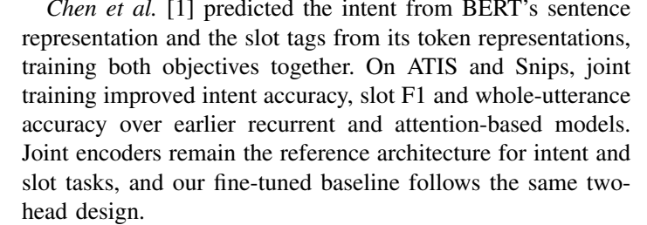
From the paper
In short: One BERT model with two outputs (one for the intent, one for each word's slot), trained together, beat older models. Our XLM-R baseline uses the same two-output design.

Words used here:
- BERT: a famous encoder model from Google.
- Sentence representation / token representations: the model's summary of the whole sentence / of each word.
- Objectives: what the model is trained to get right.
- ATIS and Snips: two older intent-and-slot datasets.
- Two-head design: one model, two outputs.

Conneau et al. [2]: XLM-R
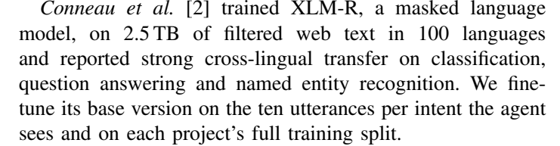
From the paper
In short: XLM-R is a big encoder trained on web text in 100 languages. We train its base version as baseline B3, on our 10 examples per intent and on the full training data.

Words used here:
- Masked language model: learns by guessing hidden words in sentences.
- 2.5 TB of filtered web text: an enormous amount of training text.
- Cross-lingual transfer: learning in one language helps in others.
- Named entity recognition: finding names of people, places etc.
- Fine-tune: train an existing model further on your own data.

B. Brown et al. [12]: GPT-3 and in-context learning
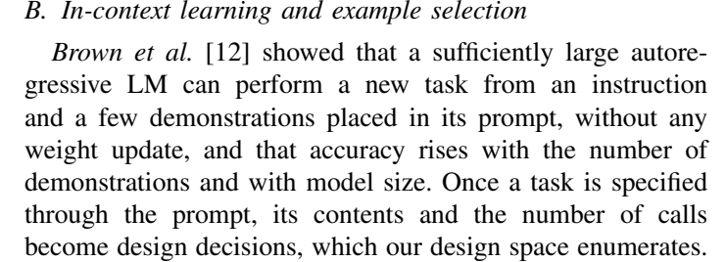
From the paper
In short: A big AI can do a new task just from instructions and a few examples in the prompt, with no training. Once the prompt is the program, what goes in it becomes a design decision, which is what our 12 designs are.

Words used here:
- In-context learning: learning a task from examples inside the prompt.
- Autoregressive LM: a model that writes text one piece at a time.
- Weight update: changing the model's numbers (training). Not needed here.
- Enumerates: lists all the options.

Liu et al. [13]: choosing good examples
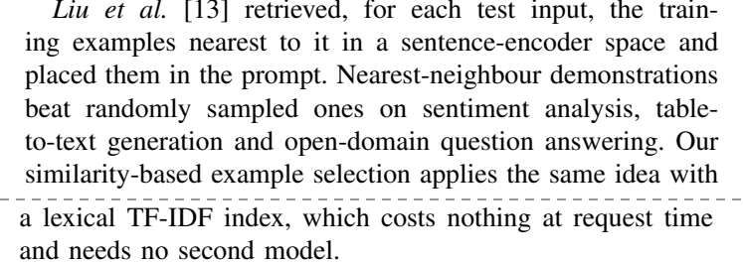
From the paper
In short: Putting the examples most similar to the question into the prompt works better than random examples. Our "similarity examples" option does the same with a cheap word-matching method (TF-IDF).

Words used here:
- Sentence-encoder space: sentences turned into numbers so similar ones are close together.
- Nearest-neighbour demonstrations: the most similar examples.
- TF-IDF index: a word-based way to measure how similar two sentences are; rare shared words count more.

C. Zhou et al. [4]: APE (automatic prompt engineer)
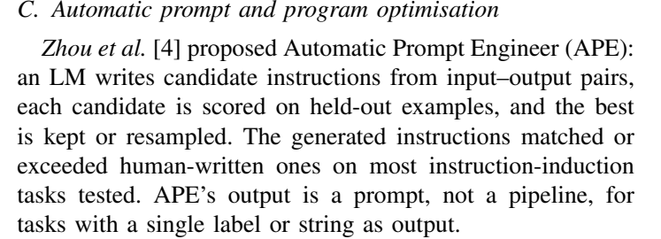
From the paper
In short: An AI writes many possible instructions, each is scored, and the best is kept; often as good as human-written ones. But it produces one prompt for simple tasks, not a full pipeline.

Words used here:
- Input–output pairs: example questions with their answers.
- Held-out examples: examples kept aside for scoring.
- Resampled: generate more candidates around the good ones.
- Instruction-induction tasks: tasks where the model must work out the instruction from examples.

Pryzant et al. [5]: fixing prompts from their mistakes
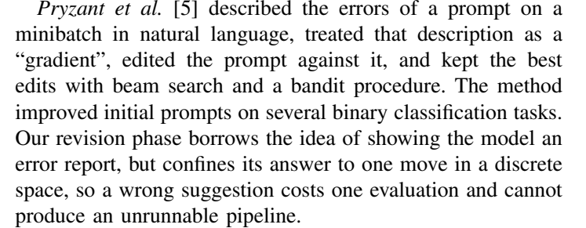
From the paper
In short: Describe a prompt's errors in words, edit the prompt to fix them, keep the best edits. Our revision step also shows the AI an error report, but allows only one move from a fixed list, so a bad suggestion can't break anything.

Words used here:
- Minibatch: a small group of examples.
- "Gradient": here, a written description of what is wrong (borrowed from training maths).
- Beam search, bandit procedure: ways of keeping the most promising options while searching.
- Binary classification: yes/no tasks.
- Discrete space: a fixed list of options (our 12 designs).

Yang et al. [6]: OPRO (AI as optimiser)
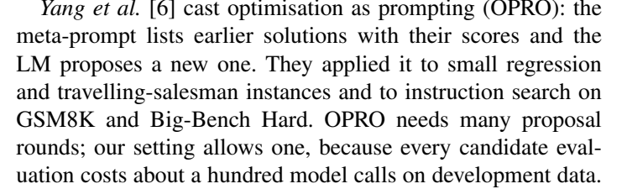
From the paper
In short: Show the AI earlier attempts with their scores and ask for a better one, over many rounds. We can only afford one round of revision because each test costs about 100 AI calls.

Words used here:
- Meta-prompt: a prompt that contains past attempts and scores.
- Travelling-salesman, GSM8K, Big-Bench Hard: standard test problems (route planning, maths, hard reasoning).

Khattab et al. [7]: DSPy
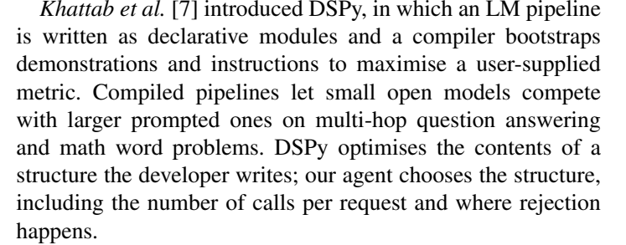
From the paper
In short: Write an AI pipeline as building blocks; a tool automatically picks good examples and instructions. DSPy tunes what is inside a structure you wrote; our agent picks the structure itself.

Words used here:
- Declarative modules: blocks that say what to do, not how.
- Compiler bootstraps demonstrations: automatically creates good examples.
- Multi-hop question answering: questions that need several facts combined.

D. Viswanathan et al. [8]: Prompt2Model
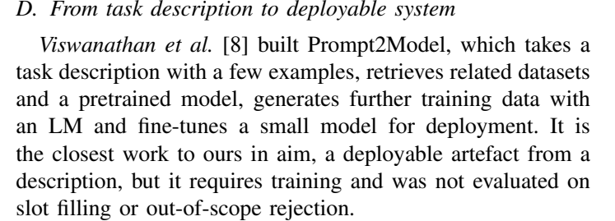
From the paper
In short: From a task description, finds data, makes more data and trains a small model to deploy. Closest to our goal (description → working system), but needs training and was not tested on slots or rejection.

Words used here:
- Deployable artefact: something ready to use in a real app.
- Pretrained model: a model already trained on general data.

E. Madaan et al. [14]: Self-Refine
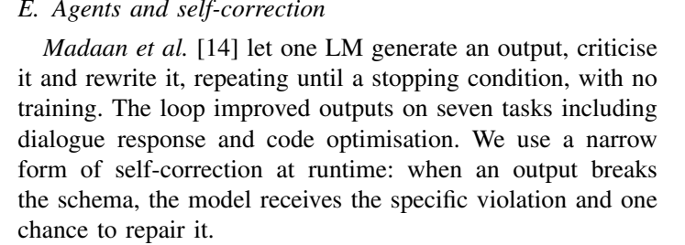
From the paper
In short: The AI writes an answer, criticises it and rewrites it. We use a small version: if a reply breaks the format, the AI gets one chance to repair it.

Words used here:
- Self-correction: the model fixing its own output.
- Schema: the required reply format.
- Violation: the specific way the reply broke the format.

Yao et al. [15]: ReAct
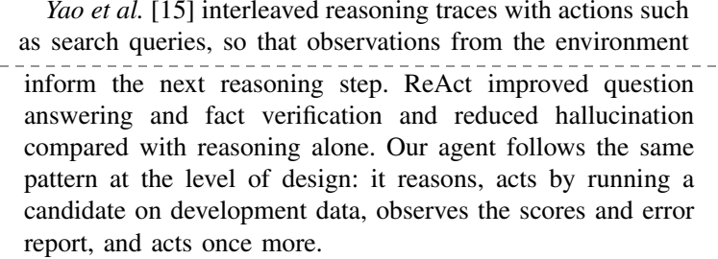
From the paper
In short: The AI alternates thinking and acting and learns from what it observes. Our agent does the same at design level: think, test a design, look at the scores, act once more.

Words used here:
- Reasoning traces: the model writing out its thinking.
- Actions / observations: doing something (like a search) and seeing the result.
- Hallucination: the AI making things up.

F. Bergstra and Bengio [9]: random search
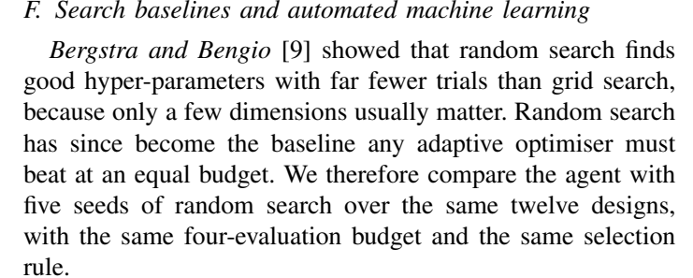
From the paper
In short: Random search finds good settings faster than trying everything in a grid. It is the baseline any smart search must beat, so we compare the agent with 5 runs of random search using the same 4 tries and the same rule.

Words used here:
- Hyper-parameters: settings you choose before training.
- Grid search: trying every combination in a table.
- Adaptive optimiser: a search that learns from results as it goes.
- Seed: a starting number that makes a random choice repeatable.

He et al. [16]: AutoML survey
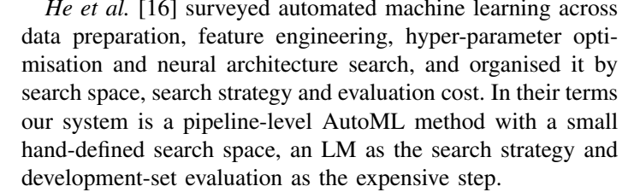
From the paper
In short: Automated machine learning searches over data steps, features, settings and network designs. In those terms, ours has a small hand-made search space, an AI as the search method, and practice-set testing as the costly step.

Words used here:
- AutoML: automating the choices in building machine-learning systems.
- Neural architecture search: automatically designing neural networks.
- Search space / search strategy / evaluation cost: what you search over / how / how expensive each try is.

G. Research gap
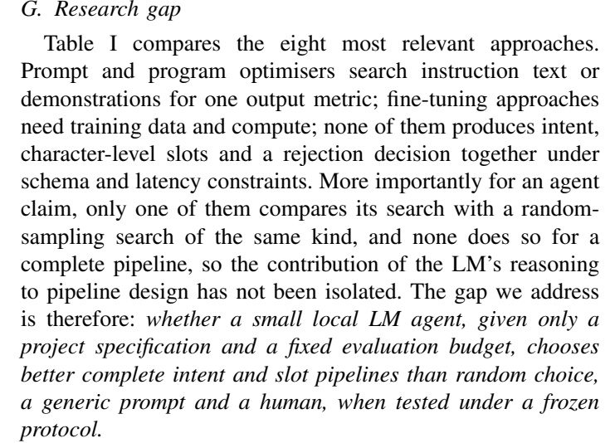
From the paper
In short: What is missing in earlier work, in one sentence: nobody tested whether a small local AI agent with a fixed budget picks better complete intent + slot pipelines than random choice, a generic prompt and a human, under frozen rules. That is exactly what we test.

Words used here:
- Research gap: the open question a paper answers.
- Character-level slots: entities given as exact character positions.
- Frozen protocol: all rules fixed before the final test.

Table I: comparison with related work
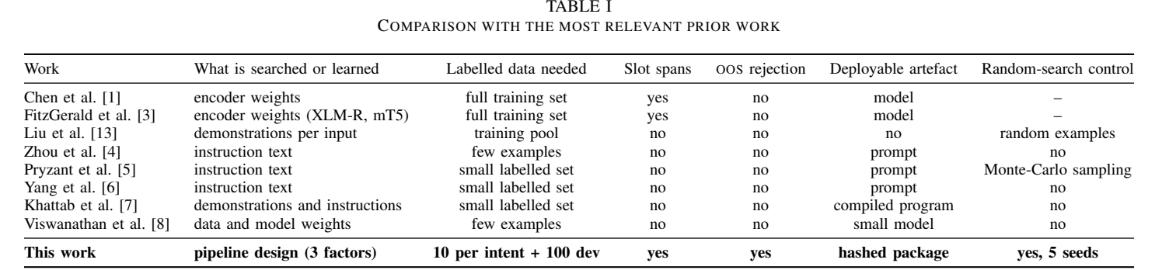
From the paper
In short: A side-by-side summary of 8 earlier works and ours. Only our system outputs slot spans, handles out-of-scope requests, gives a verified package and is compared with random search over the same space.

Words used here:
- What is searched or learned: what each method changes (model weights, instruction text, examples, or our pipeline design).
- Labelled data needed: how many labelled examples it needs.
- Slot spans: does it output entities with positions?
- OOS rejection: does it refuse off-topic requests?
- Deployable artefact: what you get at the end.
- Random-search control: was it compared against random choice?

Pages 3–5: proposed methodology

III-A. Problem formulation
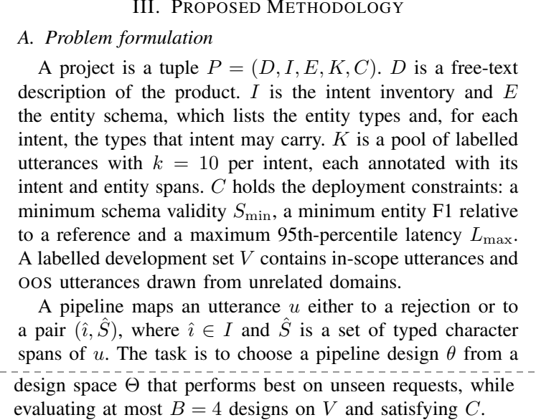
From the paper
In short: Describes the task in symbols: a project P is made of a description D, intents I, entity schema E, example pool K and constraints C, plus a practice set V. The goal: pick the design θ from the 12 that will work best on new requests, testing at most 4 and obeying the constraints.

Words used here:
- Tuple P = (D, I, E, K, C): a bundle of the five inputs.
- S_min: minimum share of valid replies (0.98).
- L_max: maximum allowed slow-case time per request.
- 95th-percentile latency (p95): 95% of requests are faster than this.
- î (i-hat), Ŝ (S-hat): the predicted intent and predicted spans; the hat means "predicted".
- θ (theta) and Θ (Theta): one design, and the set of all 12.
- B = 4: the budget of designs to test.

Figure 1: system architecture
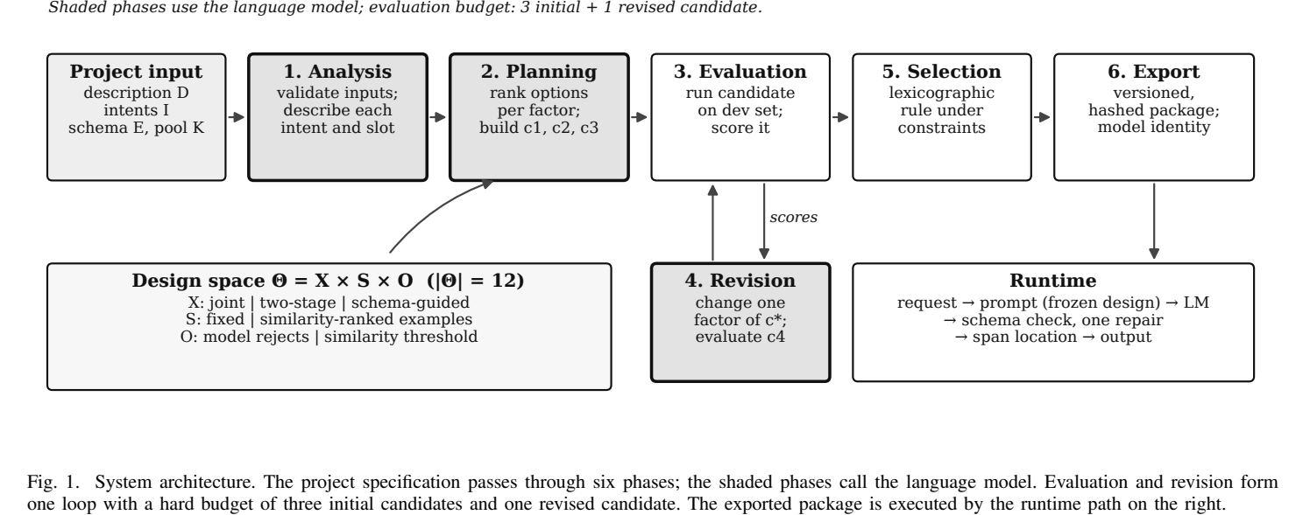
From the paper
In short: The picture of the whole system. Left to right: project input → 1 Analysis → 2 Planning → 3 Evaluation → 5 Selection → 6 Export. Below: 4 Revision loops back with evaluation (3 tries + 1 revised try). Grey boxes use the AI. The design space box lists the 3 choices; the runtime box shows what happens to one request.

Words used here:
- Shaded phases: the steps where the AI model is called.
- c1, c2, c3, c4: the four candidate designs tested.
- Lexicographic rule: compare by intent score first, then entity score, then speed.
- Θ = X × S × O (|Θ| = 12): 3 extraction × 2 example × 2 rejection options = 12 designs.
- Span location: turning the entity text into its position in the sentence.

III-B. Design space: extraction and example selection, equation (1)
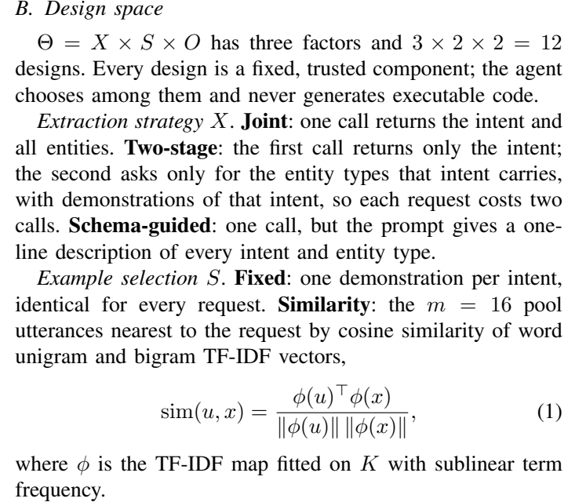
From the paper
In short: The 12 designs come from 3 choices. Extraction: joint (one call), two-stage (intent first, then its details), or schema-guided (one call with a description of every label). Examples: fixed (same one per intent) or similarity (16 most similar). Equation (1) measures how similar two sentences are.

Words used here:
- Trusted component: pre-written, tested code; the agent never writes code.
- Cosine similarity: a 0-to-1 score of how much two sentences use the same words (1 = same).
- φ (phi), TF-IDF map: turns a sentence into a list of word weights.
- Unigram, bigram: single words, and pairs of words next to each other.
- Sublinear term frequency: a word repeated many times does not count proportionally more.

Rejection policy, equation (2) and the prompt limit
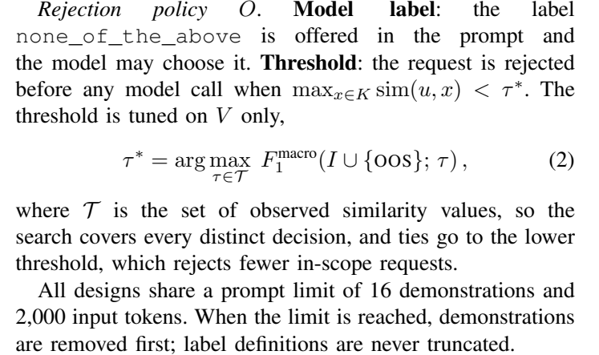
From the paper
In short: Two ways to refuse off-topic requests: let the AI answer none_of_the_above, or refuse before calling the AI if the request is not similar enough to any example. Equation (2) picks that cut-off (τ*) on practice data. Prompts may hold at most 16 examples and 2,000 tokens.

Words used here:
- τ\* (tau-star):** the best similarity cut-of
- arg max: "the value that gives the highest score".
- I ∪ {OOS}: all intents plus the off-topic class.
- Ties go to the lower threshold: if two cut-offs score the same, choose the one that refuses fewer real requests.
- Token: a piece of a word (about 4 characters).
- Truncated: cut short.

III-C/D. Phase 1 (analysis) and start of Phase 2
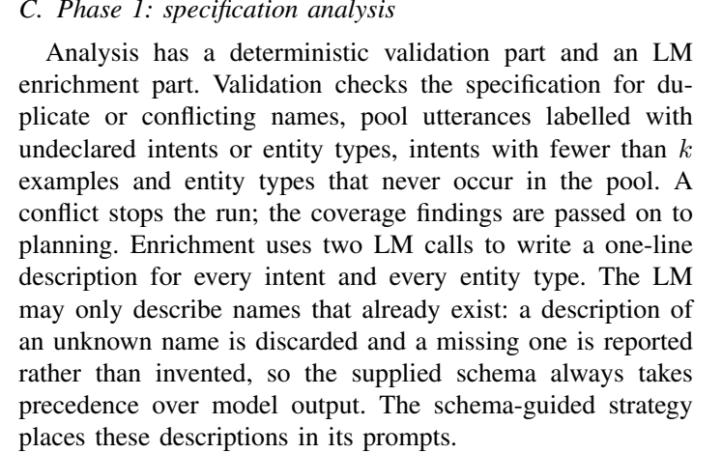
From the paper
In short: Phase 1 checks the input for problems without the AI (duplicate names, unknown labels, too few examples), then uses 2 AI calls to write a one-line description of every intent and entity type. The AI may only describe existing names, never add or rename.

Words used here:
- Deterministic: always gives the same result; no AI involved.
- Coverage findings: notes such as "this entity type never appears in the examples".
- Enrichment: adding the descriptions.
- Takes precedence: the given schema always wins over what the AI writes.

Phase 2: the two planners (A1 and A2), equation (3)
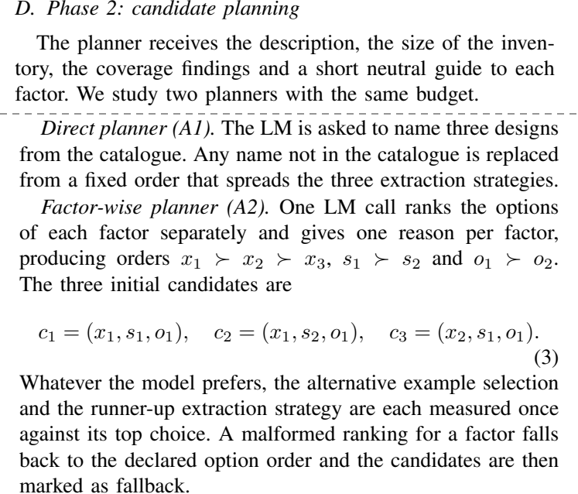
From the paper
In short: A1 just asks the AI to name 3 designs. A2 asks the AI to rank the options of each choice separately, then builds: c1 = all favourites, c2 = favourites but the other example option, c3 = favourites but the second-best extraction. So the alternatives are always tested, even if the AI's favourites are wrong.

Words used here:
- Planner: the part that decides which designs to try.
- x1 ≻ x2 ≻ x3: x1 is preferred to x2, which is preferred to x3.
- Runner-up: second choice.
- Fallback: a fixed default used when the AI's answer is unusable.

Phase 3: evaluation
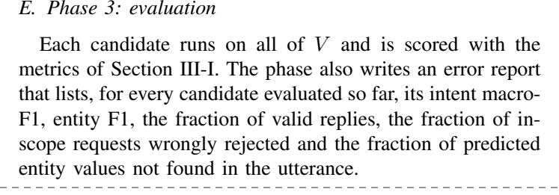
From the paper
In short: Each candidate design is run on all 100 practice requests and scored. An error report lists each candidate's scores, share of valid replies, share of real requests wrongly refused, and share of invented entity values.

Words used here:
- Error report: the summary shown to the AI before revision.
- Wrongly rejected: a supported request the system refused.
- Not found in the utterance: the AI returned a detail that is not in the sentence (invented).

Phase 4: revision, equation (4)
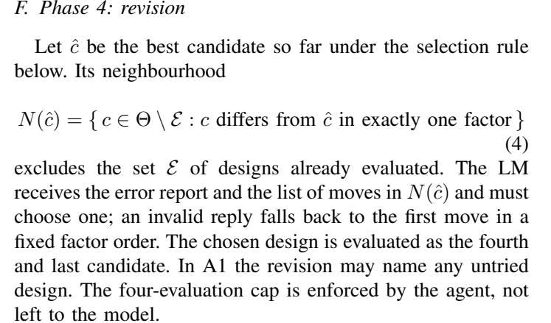
From the paper
In short: The AI sees the error report and picks one change from the best design so far; it may change only one of the three choices and only to an untried design. That design is the 4th and last test. The limit of 4 is enforced by our code, not left to the AI.

Words used here:
- ĉ (c-hat): the best candidate so far.
- N(ĉ), neighbourhood: untried designs that differ from ĉ in exactly one choice.
- Θ \ ℰ: all designs minus the ones already tested.

Phase 5: selection, equations (5) and (6)
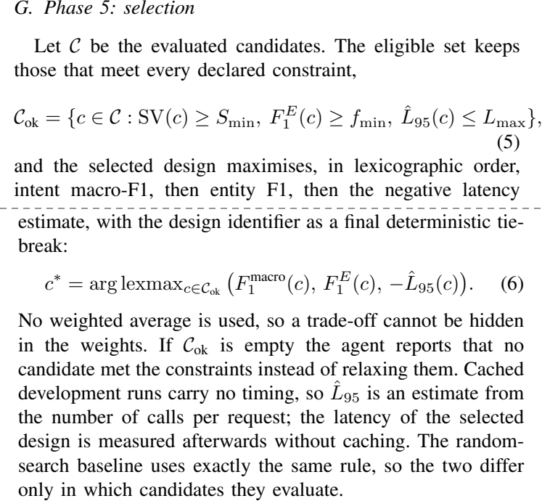
From the paper
In short: First remove candidates that break a rule (too many invalid replies, entity score too low, too slow). Then pick the highest intent score; on a tie the higher entity score; then the faster one. No weighted average, and if nothing qualifies the agent says so. Random search uses this same rule.

Words used here:
- 𝒞_ok: the eligible candidates.
- SV(c) ≥ S_min: valid-reply share at least the minimum.
- arg lexmax: pick the best by comparing criteria in order, like sorting words alphabetically.
- Weighted average: mixing scores with weights; avoided so trade-offs can't be hidden.
- L̂95: an estimate of the slow-case time (cached runs have no real timing).

Phase 6: export, and what happens at runtime
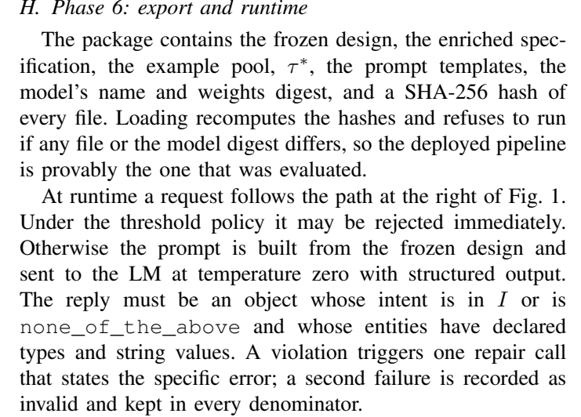
From the paper
In short: The final pipeline is saved with a fingerprint of every file and the model's identity; it refuses to run if anything changed. At runtime: optionally refuse by threshold, build the prompt, ask the AI, check the reply's format, allow one repair, and turn entity text into positions.

Words used here:
- SHA-256 hash: a file fingerprint; changes if even one character changes.
- Weights digest: the fingerprint of the AI model itself.
- Temperature zero: the AI always gives its single most likely answer (repeatable).
- Structured output: the AI must reply in JSON format.
- Repair call: one extra try, telling the AI exactly what was wrong.
- Kept in every denominator: a failed reply still counts against the score; nothing is hidden.

The span-location rule
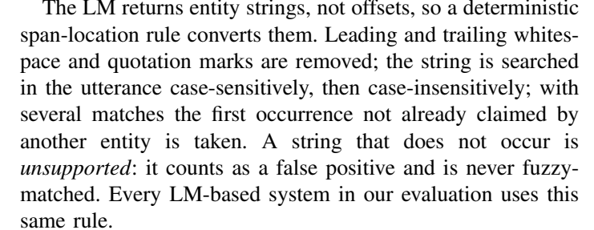
From the paper
In short: The AI returns entity text ("seven"), not positions. We find that exact text in the sentence (first exactly, then ignoring capitals). If it is not there, it counts as wrong. No near-matches are accepted, and every AI system uses this same rule.

Words used here:
- Offsets: character positions (start and end).
- Case-sensitive / case-insensitive: capitals must match / capitals ignored.
- Unsupported: an entity text that is not in the sentence (invented).
- False positive: a wrong answer the system gave.
- Fuzzy-matched: accepting a similar but not exact spelling (we never do this).

III-J. Evaluation metrics, equations (7) and (8)
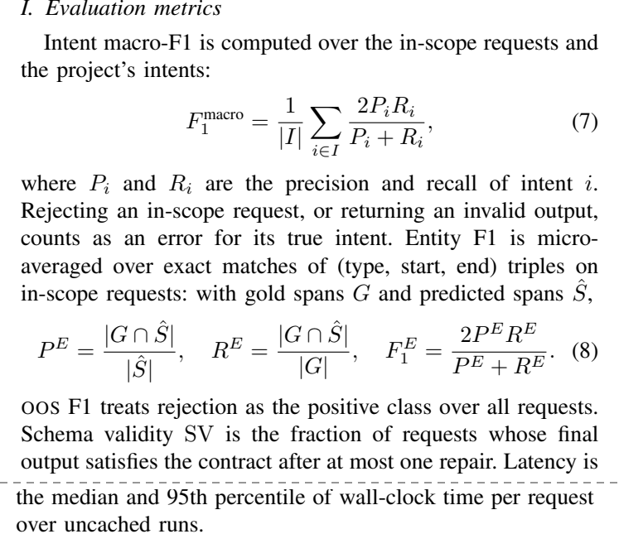
From the paper
In short: How we score. Intent macro-F1: F1 per intent, then averaged. Entity F1: a hit only if type, start and end all match, counted over all requests together. OOS F1: how well refusals are caught. Plus valid-reply share and speed.

Words used here:
- Precision (P): of the answers given, how many were right.
- Recall (R): of the right answers, how many were found.
- F1 = 2PR / (P + R): one number combining both; 1 is perfect.
- Macro (averaged per intent): rare intents count as much as common ones.
- Micro-averaged: all hits and misses counted together.
- G ∩ Ŝ: spans in both the true set and the predicted set (the hits).
- Wall-clock time: real seconds measured by a clock.
- Uncached runs: the AI really called, not a saved answer replayed.

Pages 5–6: implementation (data, model, baselines, statistics)

IV-A. Dataset and projects
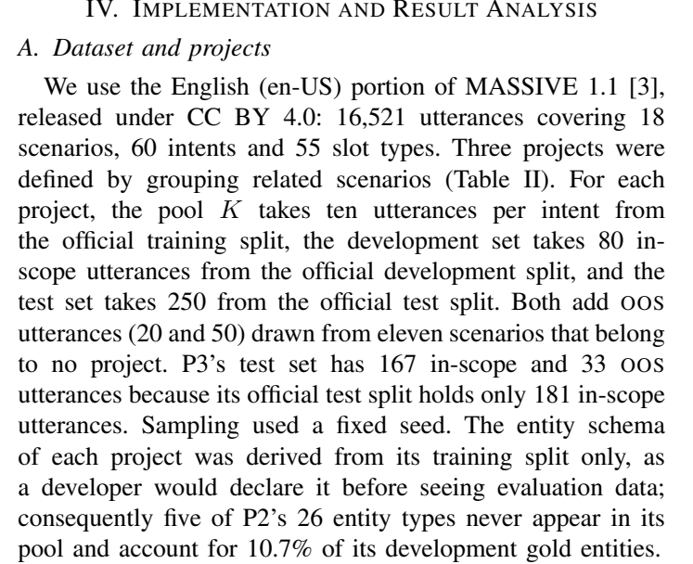
From the paper
In short: We use the English part of MASSIVE (16,521 sentences) and build three apps from it. Each gets 10 examples per intent, 100 practice requests and 300 test requests (P3: 200), with off-topic requests from 11 unrelated topics. The entity list comes only from training data, like a real developer.

Words used here:
- CC BY 4.0: a free licence: you may use it if you credit the authors.
- Official training / development / test split: MASSIVE's own division of its data.
- Fixed seed: the random sampling can be repeated exactly.
- Gold entities: the correct, human-labelled entities.

Table II: the three projects
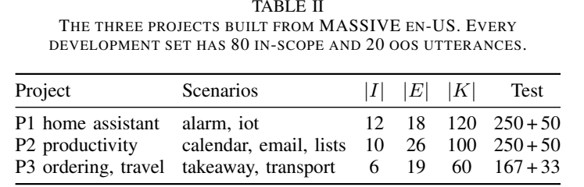
From the paper
In short: Each project's topics, number of intents |I|, number of entity types |E|, number of examples |K|, and test size (in-scope + off-topic).

Words used here:
- P1 home assistant: alarms and smart devices; 12 intents.
- P2 productivity: calendar, email, lists; 10 intents.
- P3 ordering, travel: takeaway food and transport; 6 intents; held out.
- |…|: "the number of".

How P3 was kept secret
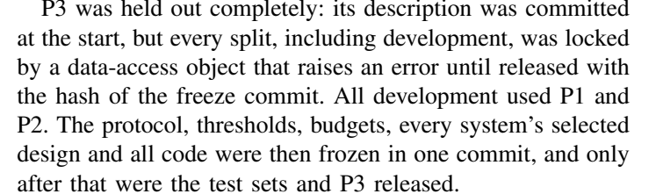
From the paper
In short: P3's data was locked by code that raises an error unless the freeze commit's fingerprint is given. All development used only P1 and P2. Everything was frozen in one commit before test data and P3 were opened.

Words used here:
- Data-access object: the piece of code that guards the data.
- Freeze commit: the single saved version (in git) where all rules and choices were locked.

IV-B. Model and environment
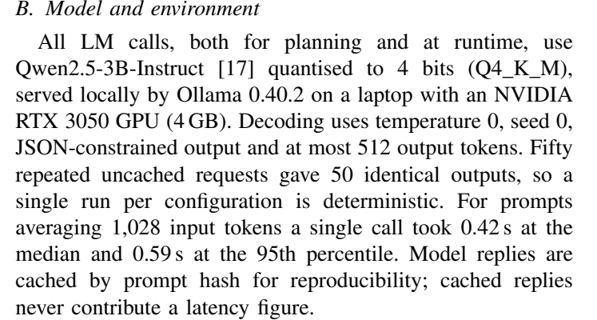
From the paper
In short: Which AI and computer: Qwen2.5-3B-Instruct, compressed to 4 bits, run by Ollama on a laptop with an RTX 3050 (4 GB). Settings make it give the same answer every time (50 of 50 identical). One call takes 0.42 s typically.

Words used here:
- Qwen2.5-3B-Instruct [17]: the AI model (by Alibaba's Qwen team).
- Q4_K_M: the 4-bit compression format.
- Ollama: the free program that runs the model on the laptop.
- Seed 0: fixed randomness setting.
- Deterministic: same input, same output, every time.
- Cached by prompt hash: answers saved so experiments can be replayed; never used for timing.

IV-C. Baselines (the systems we compare against)
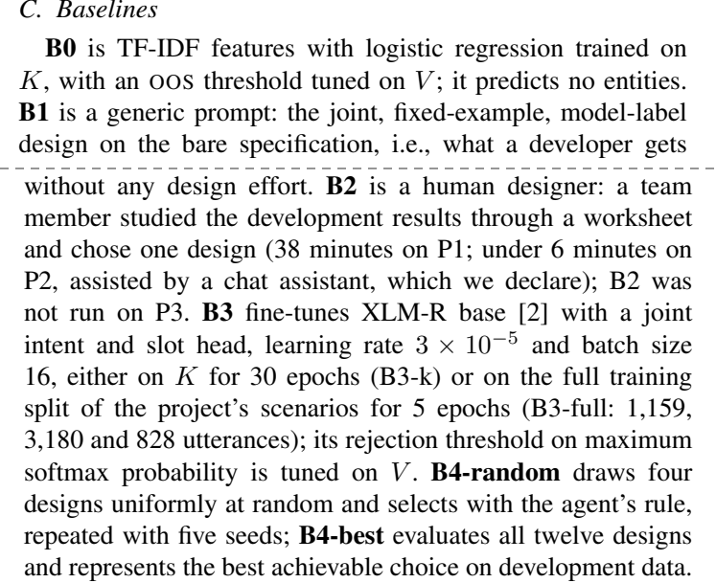
From the paper
In short: B0 = simple word-based classifier. B1 = generic prompt (no design effort). B2 = a person choosing the design. B3 = XLM-R trained on the same 10 examples (B3-k) or all training data (B3-full). B4 = 4 random designs (5 times); B4-best = best of all 12 on practice data.

Words used here:
- Logistic regression: a simple, classic classifier.
- Bare specification: the input without the AI-written descriptions.
- Worksheet: the form the person used to choose a design.
- Epochs: passes over the training data.
- Learning rate 3×10⁻⁵, batch size 16: training settings (step size; 16 sentences at a time).
- Maximum softmax probability: the trained model's top confidence; low means maybe off-topic.

IV-D. Statistics and the success rule
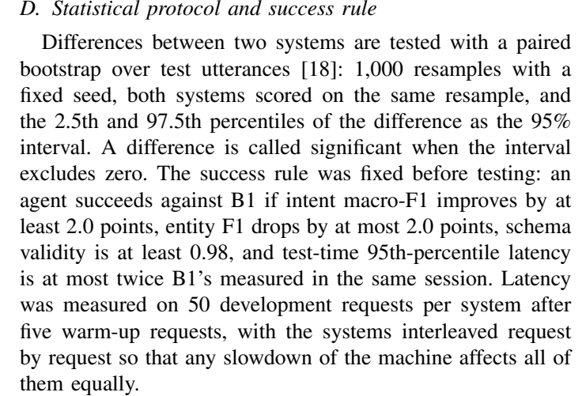
From the paper
In short: How we decide if a difference is real: resample the test set 1,000 times (paired bootstrap) and look at the middle 95% of differences. The success rule (fixed in advance): +2.0 points intent, at most −2.0 entity, valid replies ≥ 0.98, and no slower than twice B1. Timing alternates systems request by request so it is fair.

Words used here:
- Paired bootstrap [18]: draw test sets with replacement, score both systems on the same draw, repeat.
- Percentile: the value below which that share of results lies.
- 95% interval: the range where the true difference probably is.
- Significant: the interval does not include zero.
- Warm-up requests: first requests not timed, so start-up slowness doesn't count.
- Interleaved: B1, A1, A2, B1, A1, A2… in turn.

Pages 6–8: results

Table III: the main test results
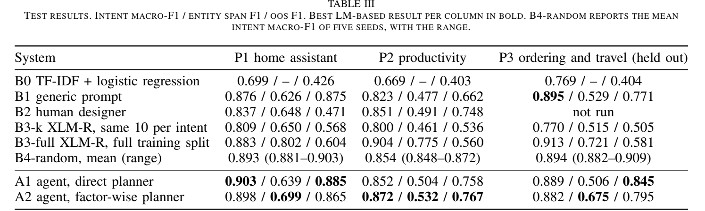
From the paper
In short: The most important table. Each cell is intent F1 / entity F1 / OOS F1 on locked test data. Bold = best AI-based result per column. A2 has the best entity score of the AI systems on all three projects; B1 has the best intent score on P3; B3-full (lots of training data) has the best entities overall but weak refusal.

Words used here:
- –: B0 does not predict entities.
- Mean (range): average of 5 random-search runs, with lowest and highest.
- Held out: P3, never used during development.

IV-E. Overall results: which designs were chosen
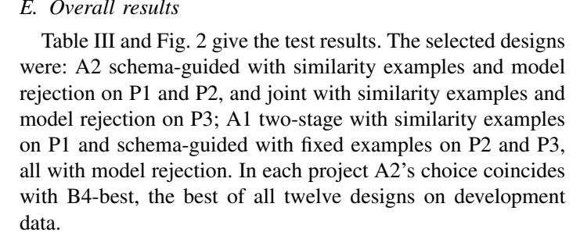
From the paper
In short: A2 chose schema-guided + similarity examples + AI rejection on P1 and P2, and joint + similarity + AI rejection on P3. Each time this equals the best of all 12 on practice data.

Words used here:
- B4-best: the best of all 12 designs on practice data (the ceiling).

Figure 2: intent scores as bars
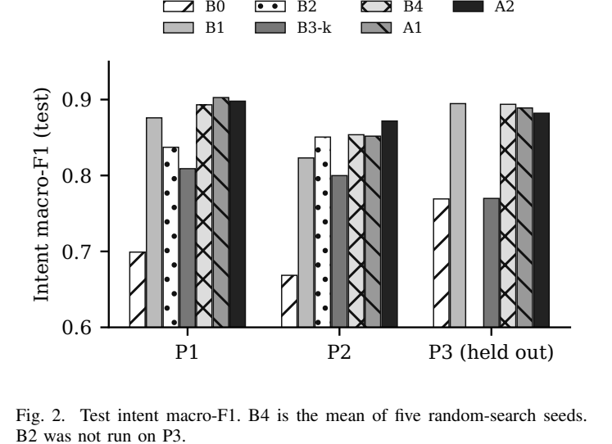
From the paper
In short: The intent numbers of Table III as a bar chart. Each pattern is one system. On P1 and P2 the agents (A1, A2) are among the tallest bars; on P3, B1 and the random-search average are slightly taller. The gap on P3 is B2 (not run there).

Words used here:
- Intent macro-F1 (test): the vertical axis; higher is better.

The success rule result
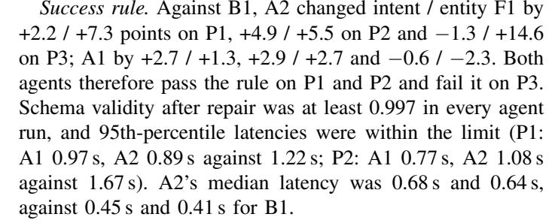
From the paper
In short: Compared with B1: A2 gained +2.2/+7.3 points (intent/entity) on P1, +4.9/+5.5 on P2, and −1.3/+14.6 on P3. So both agents pass on P1 and P2 and fail on P3. Valid replies ≥ 0.997, speed within the limit.

Words used here:
- Pass / fail: whether all four conditions of the rule were met.
- Median latency: typical time per request (A2 0.68 s vs B1 0.45 s on P1).

Significance: which differences are real
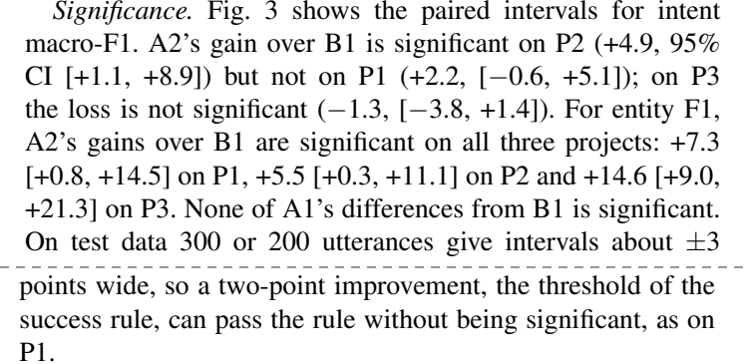
From the paper
In short: A2's intent gain over B1 is real (significant) on P2, not proven on P1, and the P3 loss is not significant. A2's entity gains are significant on all three. With only 200–300 test requests the intervals are about ±3 points wide, so a 2-point gain can pass the rule without being provable.

Words used here:
- CI [+1.1, +8.9]: the 95% interval of the difference in points.
- n.s.: not significant.

Figure 3: confidence intervals
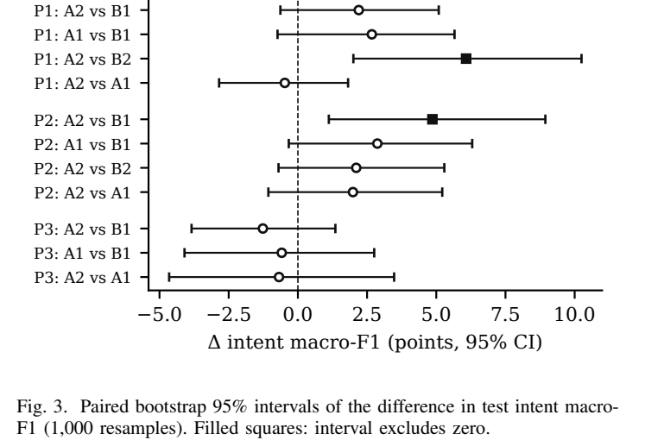
From the paper
In short: Each line is one comparison. The dot is the measured difference; the line is the 95% range. If the line does not cross the dashed zero line (filled square), the difference is real. Only P1 "A2 vs B2" and P2 "A2 vs B1" clear zero for intent.

Words used here:
- Δ (delta): difference.
- Filled square / open circle: significant / not significant.

IV-F. Agent vs random search
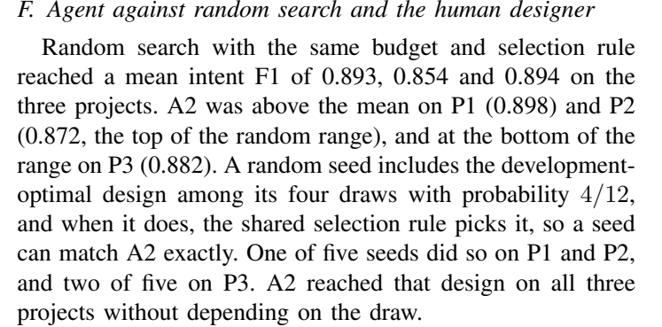
From the paper
In short: Random search averaged 0.893, 0.854, 0.894. A2 was above that on P1, at the top on P2, at the bottom on P3. Random search finds the best practice design only by luck (1 of 5 runs on P1/P2, 2 of 5 on P3); A2 found it every time.

Words used here:
- Probability 4/12: chance that 4 random picks include one specific design.

Agent vs the human designer
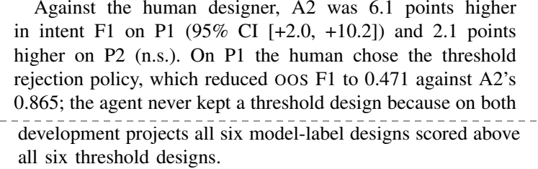
From the paper
In short: A2 beat the person by 6.1 points on P1 (real) and 2.1 on P2 (not proven). On P1 the person chose threshold rejection, which made refusals much worse (0.471). On practice data every AI-rejection design beat every threshold design, so the agent never kept a threshold design.

IV-G. Agent vs trained XLM-R
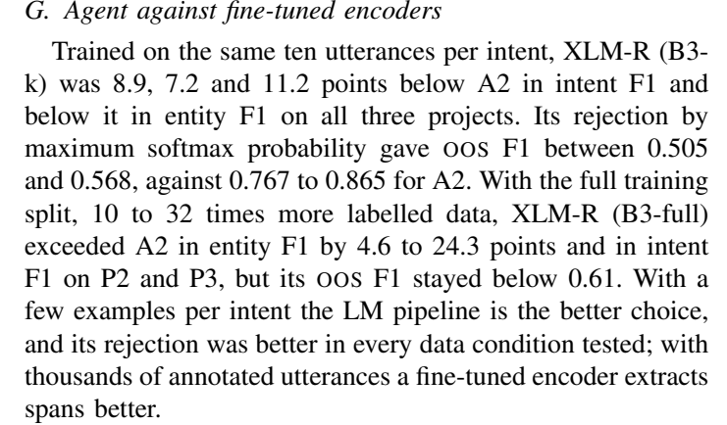
From the paper
In short: With the same 10 examples, XLM-R was 7–11 points worse on intents, worse on entities and much worse at refusing. With 10–32 times more data, XLM-R wins on entities but still refuses badly. So: few examples → use our pipeline; thousands of labelled sentences → a trained model is better at entities.

Words used here:
- 10 to 32 times more labelled data: 1,159 / 3,180 / 828 training sentences vs 120 / 100 / 60.

IV-H. Why factor-wise planning worked
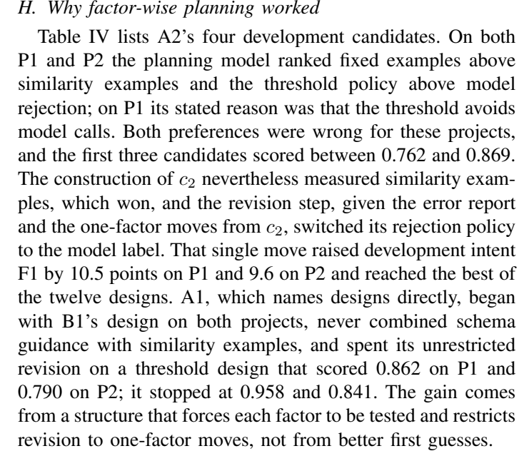
From the paper
In short: The key story. The AI's favourite options (fixed examples, threshold rejection) were both wrong, and the first three tries scored 0.76–0.87. But c2 always tests the other example option (similarity won), and the revision switched rejection to the AI label: +10.5 and +9.6 points, the best of all 12. A1 never found it. The structure, not the AI's guesses, made the difference.

Words used here:
- Unrestricted revision: A1 could pick any untried design, and picked a poor one.

Table IV: A2's four tries on practice data
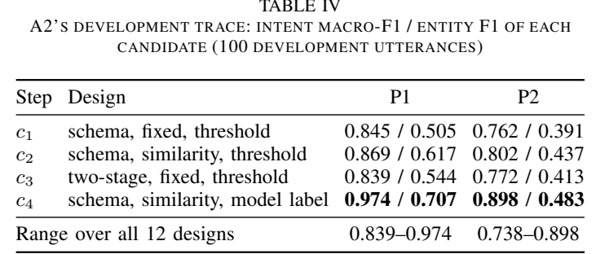
From the paper
In short: The scores of c1, c2, c3 and the revised c4 on P1 and P2. c4 (schema, similarity, AI label) is the best and equals the top of the range of all 12 designs.

Words used here:
- Range over all 12 designs: worst to best when every design is tested.

Honesty note
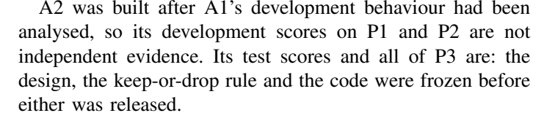
From the paper
In short: A2 was designed after we studied A1's practice results, so A2's practice scores are not independent proof. Its test scores and all of P3 are, because everything was frozen before those were opened.

Words used here:
- Independent evidence: results not influenced by the people who built the system.
- Keep-or-drop rule: a rule fixed in advance for whether A2 would be tested at all.

IV-I. Held-out project P3
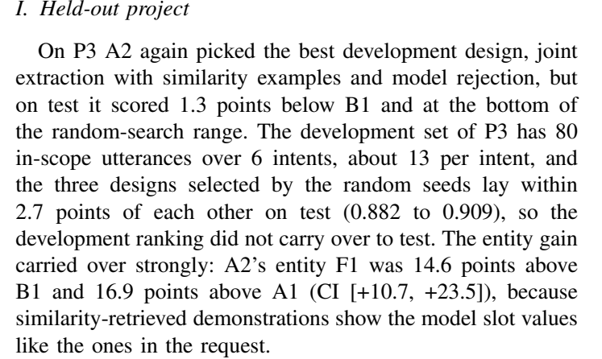
From the paper
In short: On P3 A2 again picked the best practice design, but on test it was 1.3 points below B1. P3's practice set had only about 13 requests per intent and the designs were very close (0.882–0.909), so the practice ranking did not carry over. Entities improved strongly (+14.6 over B1).

IV-J. Ablations
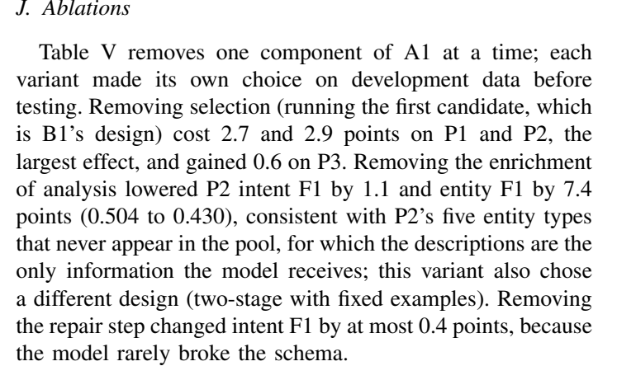
From the paper
In short: Remove one part of A1 at a time to see what matters. Removing selection hurts most (−2.7, −2.9). Removing the descriptions hurts P2 entities a lot (−7.4) because some entity types have no examples. Removing repair barely matters because the AI rarely broke the format.

Words used here:
- Ablation: removing a component to measure its value.
- Without selection: just use the first candidate (which is B1's design).

Table V: ablation scores
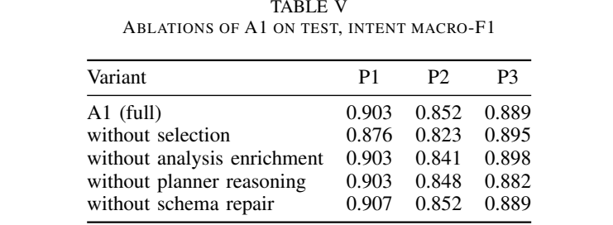
From the paper
In short: Intent F1 on test for A1 and each variant with one part removed, on all three projects.

Words used here:
- Planner reasoning: the AI's choice of designs (replaced by a fixed order in that variant).

IV-K. Cost and reproducibility
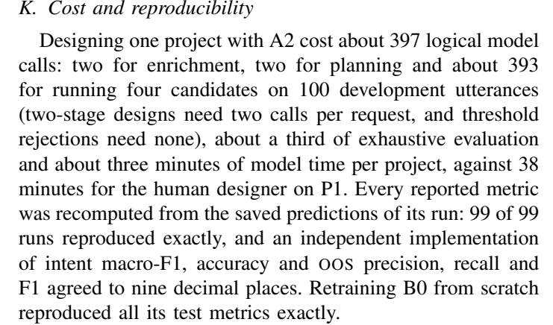
From the paper
In short: Designing one project costs A2 about 397 AI calls (about 3 minutes), against 38 minutes for the person. Every number was recomputed from saved answers (99 of 99 runs matched), checked by an independent library to 9 decimal places, and B0 retrained from scratch gave identical results.

Words used here:
- Logical model calls: calls the method needs (counting cached ones too).
- Exhaustive evaluation: testing all 12 designs.
- Reproduced exactly: same numbers when recomputed.

Page 8: conclusion, acknowledgment, references

V. Conclusion
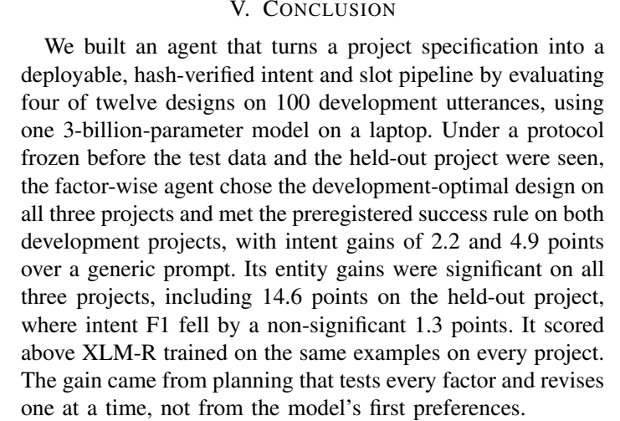
From the paper
In short: A short restatement of what was built and found: best practice design on all three projects, success on P1 and P2, significant entity gains everywhere, the honest P3 result, better than XLM-R on the same data, and why it worked. No limitations or future work here (our teacher's rule).

Acknowledgment
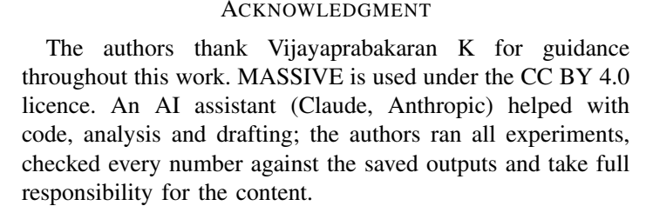
From the paper
In short: Thanks the guide, states the dataset licence, and declares the use of an AI assistant.

References
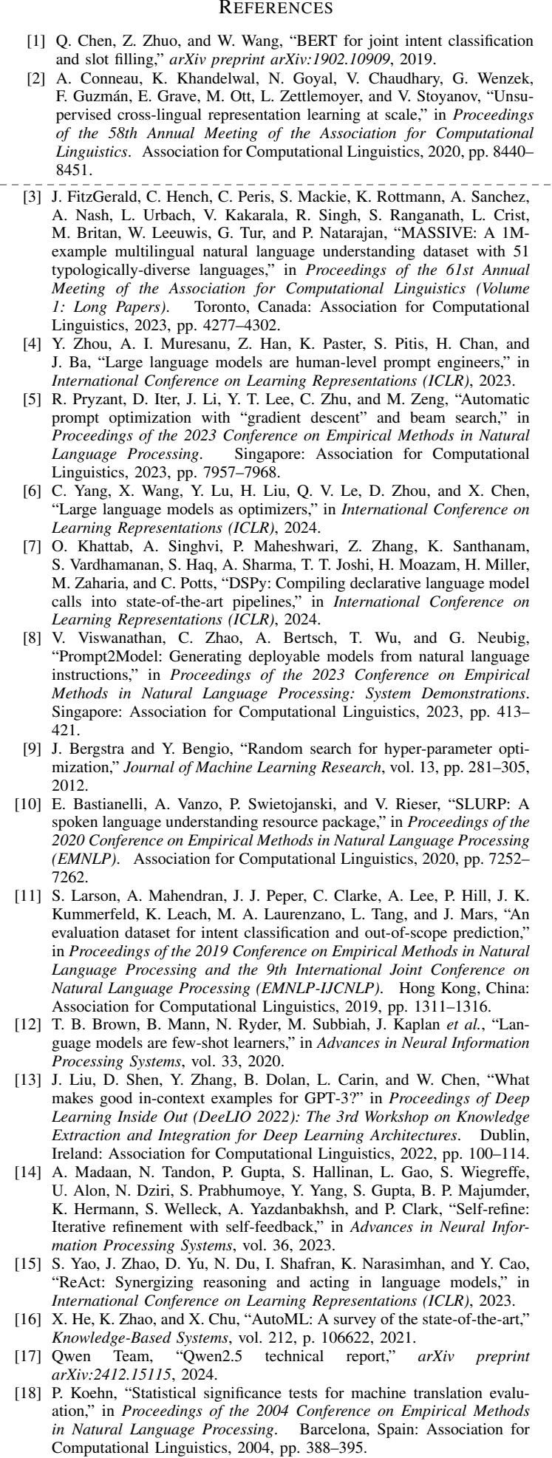
From the paper
In short: The 18 papers cited, in IEEE style, numbered in the order they first appear in the text. Each entry gives authors, title, where it was published, year and pages.

Words used here:
- arXiv preprint: a paper posted online before or without formal publication.
- Proceedings of …: the book of papers from a conference (ACL, EMNLP, ICLR, NeurIPS are top AI/NLP conferences).
- vol., pp.: volume and page numbers.

