How Our System Works
What the project builds, how it works, and how it compares, explained simply
Mihir Bhati (24BCE5341) · Ahana Sharan (24BCE5334)
25 October 2026 · Project folder: D:\MyClaudeProject\nlp
The project in one sentence. Our framework takes a description of any new app and automatically designs, tests and delivers the best way for a ready-made AI model to understand that app's requests. We compared it with a generic template, a person, random choices and a trained published model.

Contents
- The problem: turning a sentence into something a program can act on
- Two words to keep apart: intents and designs
- "If we already have the answers, why do we need the project?"
- Two ways to build the understanding part: train a model, or give instructions
- XLM-R explained: what it is and what it does in our project
- qwen explained: the AI our framework uses
- The "note" (prompt): what it is and how it is made
- The 12 designs: 12 ways of writing the note
- What our framework does, step by step (with the real run)
- Once the pipeline is running: what happens to one request
- Testing is not training
- The exam: how our system is compared with XLM-R and the others
- All the systems we compared, and the results
- Is it innovative? An honest answer
- Why it chooses from 12 designs, and what comes next
- What to say: the whole system in a few sentences

1. The problem: turning a sentence into something a program can act on
Imagine a home-assistant app. A user types:
"turn off the bedroom lights"

A computer program cannot act on a sentence. It needs something precise:
- intent = iot_hue_lightoff: what the user wants to do
- entity house_place = bedroom: the details needed to do it
Turning a sentence into that precise answer is called language understanding. The set of steps that does it is the NLP pipeline: text goes in, a precise answer comes out.
"turn off the bedroom lights" -> [ NLP pipeline ] -> intent = iot_hue_lightoff, house_place = bedroom

Every app needs its own pipeline, because every app has different requests. A hospital app needs intents such as book_appointment and cancel_appointment; a home assistant needs alarm_set and iot_hue_lightoff.

2. Two words to keep apart: intents and designs
In project P1 there happen to be 12 of each, which is confusing. They are completely different things:
 | What it is | How many | Examples
Intents | the possible answers: the types of request the app understands | different for each project: 12 for P1, 10 for P2 | set alarm, remove alarm, lights on, lights off, dim lights, start coffee machine...
Designs | the ways of building the pipeline (the ways of writing the note, section 8) | always 12, for every project | joint-fixed-llm, schema-sim-llm, twostage-sim-tfidf...

Our framework's job: for a given project, pick the best of the 12 designs, so the AI correctly identifies which of that project's intents each new sentence is.

3. "If we already have the answers, why do we need the project?"
We have answers for only a small number of sentences, not for everything users will ever say. For the home assistant, the MASSIVE dataset gives us:
- 120 example sentences with their correct answers (10 for each intent)
- 100 practice sentences with their correct answers (development data)
- 300 exam sentences with their correct answers (test data, kept locked)
But a real app receives new sentences every day that nobody has answered: "kill the lights", "I'm going to bed, lights off", "can you make it less bright in here". Nobody can write the answer for every possible sentence, so the app must work it out itself.
The sentences with answers are used for only two things: as examples that show the AI what kind of answer we want, and as test questions to check how often the system gets new sentences right (we hide the answers from it and compare afterwards). Like school: the teacher has the answer key for the practice test, but the point is whether the student can answer new questions later.
For each labelled sentence the dataset gives two things: the intent ("make a room darker" is iot_hue_lightdim) and the details ("room" is a house_place). People labelled them by hand.
In a real project such as a hospital app, the developer writes the list of request types and about 10 example sentences for each, perhaps an hour's work. Our framework then builds a system that handles thousands of new patient messages automatically.

4. Two ways to build the understanding part
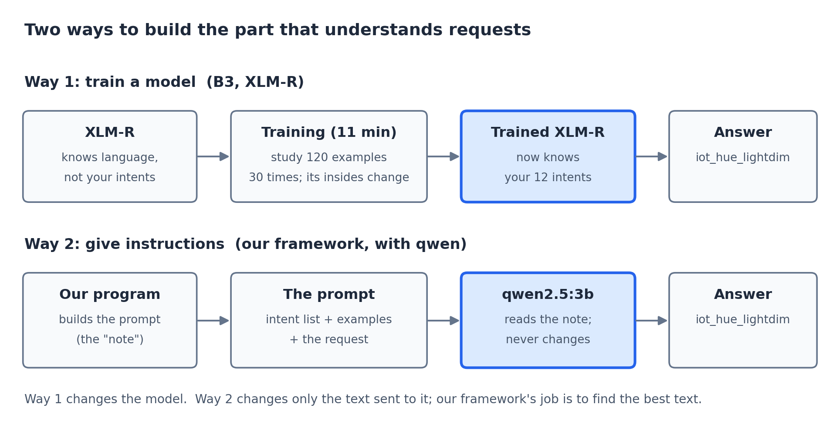
Way 1 changes the model. Way 2 changes only the text sent to it.
An everyday picture: a new waiter. The waiter speaks English perfectly but does not know your restaurant's menu. A customer says "I'd like something hot to drink", and the waiter has to work out which menu item that is.
 | Way 1: memorise the menu | Way 2: hand the waiter a note
What happens | before starting work, the waiter studies the menu again and again until they know it by heart | every time a customer speaks, you hand the waiter a note: "these are the only things on our menu... example: 'something warm with milk' means coffee... what does this customer want?"
The waiter's brain | changes: this is training | never changes: they read the note, answer, and forget it
In our project | XLM-R (system B3) | qwen, with the note written by our framework

XLM-R memorises the answers. qwen reads a note each time. Our framework's job is to find the best note.

5. XLM-R explained: what it is and what it does in our project
What it is. XLM-R is a language model: a program that has read huge amounts of text in about 100 languages and learned how words relate to each other. It is not a chatbot: it cannot chat or write answers. It was made by Meta (Facebook) researchers, and the creators of the MASSIVE dataset used it as their own reference system in their published paper.
What it knows, and what it does not. It knows English. It does not know our intents: it has never heard of iot_hue_lightoff or book_appointment. And it does not build pipelines; it cannot build anything.
What we do with it (system B3), step by step:
- Load XLM-R. It knows language, but nothing about our app.
- Add a small extra layer on top, with one output per intent (12 for P1).
- Train it on our examples: show it the 120 labelled sentences 30 times. Each time it gets one wrong, its internal numbers are adjusted a little. This is called fine-tuning, and it took about 11 minutes.
- After training, it is the pipeline: give it a sentence and it directly answers with the intent. No prompt, no instructions.
"make a room darker" -> [ trained XLM-R ] -> an intent

So what? Now it can sit the same exam as our system (section 12). XLM-R is not part of our framework: it is a competitor, showing how the standard, published approach (Way 1) does against ours (Way 2).
We trained two versions: B3-k on the same 10 examples per intent as every other system (the fair comparison), and B3-full on all the training data, 10 to 30 times more (only a reference, not a fair fight).

6. qwen explained: the AI our framework uses
qwen2.5:3b is a small version of something like ChatGPT, made by Alibaba. It runs on the laptop inside the Ollama app, so nothing is sent to the internet. "3b" means 3 billion internal numbers, small enough for the laptop's 4 GB graphics card.
- It is already trained and never changes in our project: nobody trains it.
- It understands language and follows instructions: give it a note and it answers.
- It plays two roles: an advisor while our framework designs the pipeline (section 9), and the worker that labels each request once the pipeline runs (section 10).
Our framework is not a model. It is a Python program (the code in the src folder). It does not understand language itself; it writes notes for qwen, sends them, and reads qwen's answers.

7. The "note" (prompt): what it is and how it is made
The note is the prompt: the block of text our program sends to qwen with each request. Here is the real note A2 uses on P1 for the request "make a room darker", produced by the project's own code:
Label this request and extract its information. Reply with JSON only.

Supported requests:
- alarm_query: Query alarms and their details.
- alarm_remove: Remove an existing alarm.
- alarm_set: Set a new alarm.
- iot_cleaning: Start the cleaning robot.
- iot_coffee: Start the coffee machine.
- iot_hue_lightchange: Change the color of a light.
- iot_hue_lightdim: Dim a light.
- iot_hue_lightoff: Turn off a light.
- iot_hue_lighton: Turn on a light.
- iot_hue_lightup: Increase the brightness of a light.
- iot_wemo_off: Turn off a smart device.
- iot_wemo_on: Turn on a smart device.
- none_of_the_above: the request is not one of the supported requests above

Information to extract, copied exactly as written in the request:
- alarm_type: Type of alarm (e.g., time, date)
- business_name: Business name for devices (e.g., coffee machine)
- business_type: Type of business (e.g., coffee machine, cleaning robot)
- change_amount: Amount to change (e.g., brightness, colour intensity)
- coffee_type: Type of coffee (e.g., espresso, cappuccino)
- color_type: Color type (e.g., RGB, HSL)
- date: Date for alarm (e.g., day, month, year)
- device_type: Type of device (e.g., light, socket, cleaning robot)
- event_name: Event name for devices (e.g., start, stop)
- general_frequency: General frequency for devices (e.g., daily, weekly)
- house_place: Place in the house (e.g., kitchen, bedroom)
- order_type: Order type for devices (e.g., on, off, dim, bright)
- place_name: Name of the place (e.g., living room, bathroom)
- player_setting: Setting for devices (e.g., volume, brightness)
- relation: Relation to other entities (e.g., off, on, dimmer)
- time: Time for alarm (e.g., hour, minute)
- time_zone: Time zone for time and date
- timeofday: Time of day for alarm (e.g., morning, evening)

Examples:
Request: turn room light off
Answer: {"intent": "iot_hue_lightoff", "entities": [{"type": "house_place", "text": "room"}]}
Request: make me happy juice
Answer: {"intent": "iot_coffee", "entities": [{"type": "coffee_type", "text": "happy juice"}]}
Request: olly make the lights blue please
Answer: {"intent": "iot_hue_lightchange", "entities": [{"type": "color_type", "text": "blue"}]}
Request: it's dark in the living room
Answer: {"intent": "iot_hue_lighton", "entities": [{"type": "house_place", "text": "living room"}]}
Request: dim the lights at the living room
Answer: {"intent": "iot_hue_lightdim", "entities": [{"type": "house_place", "text": "living room"}]}
Request: turn the lights off in the living room
Answer: {"intent": "iot_hue_lightoff", "entities": [{"type": "house_place", "text": "living room"}]}
Request: olly make me coffee at eight am
Answer: {"intent": "iot_coffee", "entities": [{"type": "time", "text": "eight am"}]}
Request: turn the living room lights to one percent
Answer: {"intent": "iot_hue_lightchange", "entities": [{"type": "house_place", "text": "living room"}, {"type": "change_amount", "text": "to one percent"}]}
Request: i can't see let's make it brighter
Answer: {"intent": "iot_hue_lightup", "entities": []}
Request: i would love a less bright up room
Answer: {"intent": "iot_hue_lightdim", "entities": []}
Request: i want the coffee machine to make me coffee
Answer: {"intent": "iot_coffee", "entities": [{"type": "device_type", "text": "coffee machine"}]}
Request: modify the light colors of the house and make them dark instead
Answer: {"intent": "iot_hue_lightchange", "entities": [{"type": "color_type", "text": "dark"}]}
Request: turn off my smart plug socket
Answer: {"intent": "iot_wemo_off", "entities": [{"type": "device_type", "text": "smart plug socket"}]}
Request: brighten the lights on the front porch
Answer: {"intent": "iot_hue_lightup", "entities": [{"type": "house_place", "text": "front porch"}]}
Request: put alarm on
Answer: {"intent": "alarm_set", "entities": []}
Request: remove dust with vacuum cleaner
Answer: {"intent": "iot_cleaning", "entities": [{"type": "device_type", "text": "vacuum cleaner"}]}

Reply exactly: {"intent": "<one name>", "entities": [{"type": "<a type>", "text": "<text copied exactly from the request>"}]}
Use an empty list if there is nothing to extract. Never invent a value.

Request: make a room darker
Answer:

It is long, but it is built from seven pieces, and qwen wrote only one of them:
# | Piece of the note | Where it comes from | Who made it
1 | "Label this request and extract its information..." | fixed text in our code | written once, in our program
2 | the list of intents (alarm_query, alarm_remove...) | the project's own intent list | the dataset
3 | the short description after each intent ("Dim a light.") | the Analyzer step | qwen: the only piece it wrote
4 | the list of fields and their descriptions | names from the project; descriptions from the Analyzer | names from the dataset; descriptions by qwen
5 | the 16 examples ("turn room light off" -> iot_hue_lightoff...) | real sentences from the dataset, labelled by people | picked by our program; nobody wrote them
6 | "Reply exactly: {...} ... Never invent a value." | fixed text in our code | written once, in our program
7 | "Request: make a room darker" | the user | the user

qwen does not invent example sentences. The examples are real labelled sentences; our program only chooses which ones go on the note. The "similar" designs pick the 16 most similar to the request, which is why this note is full of light and room examples.
Not everything qwen writes is good. Look at piece 4: "color_type: Color type (e.g., RGB, HSL)" or "relation: ... (e.g., off, on, dimmer)". That is one reason the framework tests every design instead of trusting qwen's advice.

8. The 12 designs: 12 ways of writing the note
The designs use the same pieces, arranged differently. Each design makes three choices:
Choice | Options | What changes on the note
How to ask | joint (one question) · twostage (intent first, then details) · schema (one question, with descriptions) | schema adds pieces 3 and 4; twostage asks qwen twice
Which examples | fixed (the same one per intent, every time) · sim (the most similar to the request) | which real sentences go in piece 5
How to refuse off-topic requests | llm (qwen may answer none_of_the_above) · tfidf (refused before asking qwen if unlike every example) | whether none_of_the_above is on the intent list

3 × 2 × 2 = 12 designs, named like schema-sim-llm. Every project has the same 12, whatever its intents.

9. What our framework does, step by step (with the real run)
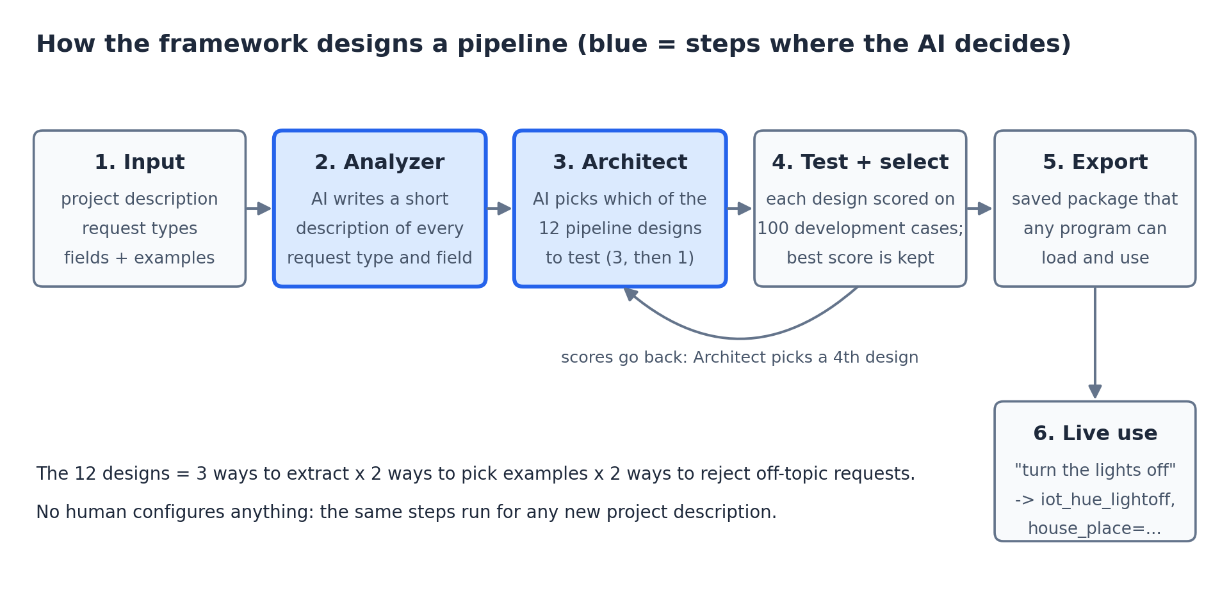
The framework's steps. The blue steps are where qwen gives advice.
Testing every design costs time, so the agent tests only 4 of the 12 and has to choose wisely which ones. This is exactly what happened on P1 in the real A2 run:
Step | Our program | qwen
1. Analyzer | "Write a short description of each intent and field." | writes them, e.g. "alarm_set: Set a new alarm."
2. Architect | "For this home assistant, which way of writing the note is best? Rank each choice." | advises: descriptions first; fixed examples better than similar ones; refuse off-topic with the cut-off
3. Test | builds 3 notes from that advice, and tests each on 100 practice sentences | answers the practice sentences with each note
 | results: 0.845, 0.869, 0.839
4. Revise | "Here are the scores. Change one thing from the best note. What should it be?" | advises: let the model refuse off-topic itself
5. Test | builds that 4th note and tests it: 0.974 | answers the practice sentences
6. Select | keeps the best note (0.974) and saves it as the pipeline | nothing

"Advisor" means qwen is asked for its opinion on how to write its own note. Our program asks the questions, builds the notes, runs the tests, does the scoring and makes the final choice. qwen's first advice was partly wrong (fixed examples turned out worse); the testing caught that, and the best note won anyway.
System | Designs tested | How they are chosen
Our agent (A1, A2) | 4 | the AI reasons about which ones to try
B4 random search | 4 | at random
B4 exhaustive | all 12 | tries everything: the best possible score

The original agent (A1) did not beat random choices. The improved agent (A2) searches in a more structured way and matched the best of all 12 on both projects while testing only 4.

10. Once the pipeline is running: what happens to one request
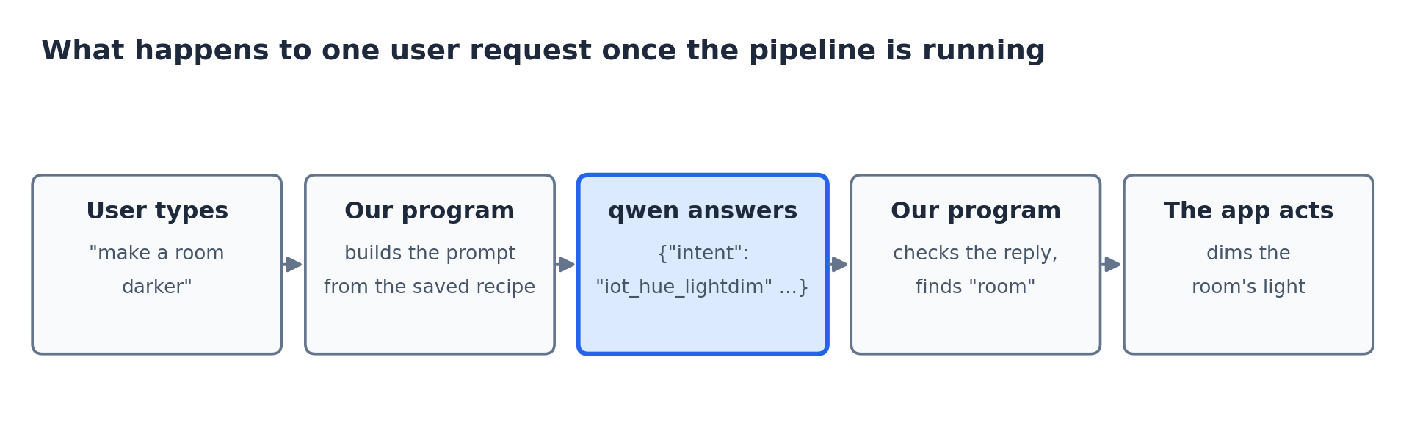
Every request a user types goes through these steps.
The saved pipeline is a recipe: which design, which examples, which descriptions. When a user types something, our program builds the note from the recipe, qwen answers, our program checks the answer and finds the details in the sentence, and the app acts on it. The pipeline = our program's recipe + qwen doing the understanding.

11. Testing is not training
 | Training (XLM-R) | Testing notes (our framework)
What changes | the model itself: its internal numbers | only the text sent; qwen never changes
Does it remember? | yes, permanently: that is the point | no: qwen forgets after each request; the note is sent fresh every time
The practice sentences are for... | not used for learning (it learns from the 120 examples) | comparing note designs, to keep the one that gets the most right
Picture | a student studying until they memorise | open-book practice exams with 4 different note sheets; keep the sheet that scored best

In one line: our framework does not teach qwen anything. It measures which version of the note helps qwen answer best, and keeps that version. That is choosing, not training.

12. The exam: how our system is compared with XLM-R and the others
Both XLM-R and our system have exactly the same job: read a request and say its intent. So they sit the same exam: the same 80 requests, whose correct answers we know. Real answers on P1:
Request | Correct | XLM-R (B3-k) said | Our system (A2) said
turn the lights off please | iot_hue_lightoff | right | right
make a room darker | iot_hue_lightdim | wrong: iot_cleaning | right
switch on the lights | iot_hue_lighton | wrong: refused it | right
start up the coffee machine | iot_coffee | wrong: refused it | right
please remove any alarms that i have set | alarm_remove | wrong: refused it | right
start new smart socket | iot_wemo_on | right | wrong: refused it

The full count on 80 requests: both right on 68; only our system right on 8; only XLM-R right on 1. Turned into F1: our system 0.974, XLM-R 0.909.
Why XLM-R struggled: 10 examples per intent is very little to learn from, so it was often unsure and refused normal requests. qwen did not need to learn the intents: they are written on its note.
So what does the comparison tell us? For a new app with only about 10 examples per intent, giving a ready-made AI the right note (our way) got more answers right than training the published model (the standard way), and needed no training.

13. All the systems we compared, and the results
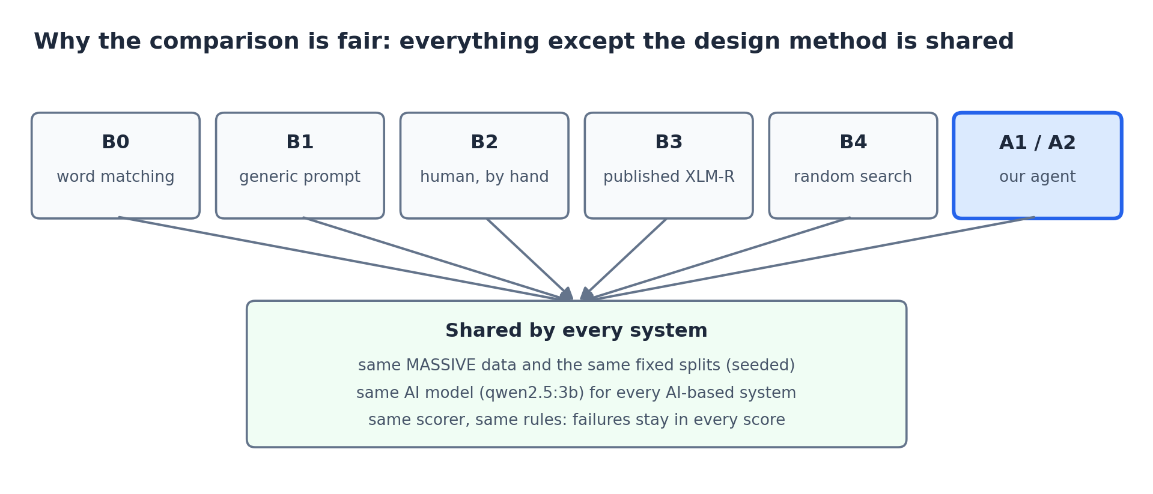
Every system shares the data, the AI model and the scorer.
System | What it is | In the waiter picture | P1 intent F1 | P2 intent F1
B0 | simple word matching, no AI | a keyword list | 0.780 | 0.730
B1 | one standard note, the same for every app | a generic template, never tailored | 0.927 | 0.804
B2 | a person writes the note by hand (P2 with ChatGPT) | a human manager | 0.858 | 0.861
B3-k | XLM-R trained on the same examples | a waiter who memorised the menu | 0.909 | 0.833
B4 | 4 notes chosen at random (average of 5) | a manager choosing by luck | 0.959 | 0.878
A1 | our original agent | our automatic manager | 0.958 | 0.841
A2 | our improved agent | our automatic manager, better search | 0.974 | 0.898

All are development scores on 100 practice requests per project; the final reported scores come from the locked test data. Two honest points: under the plan's full rule (which also limits the drop in entity F1), the original agent A1 fails against B1 on P2, while A2 passes on both projects; and A2 was designed after seeing these development results, so only the test data can confirm it.

14. Is it innovative? An honest answer
What the project can fairly claim:
- The whole design process is automated: description in, tested and exported pipeline out, with no human configuring anything.
- It is tested rigorously against a generic note, a person, random search and the published model, which many similar projects skip.
- A real finding: letting the AI simply pick designs (A1) was no better than random; structuring how it searches (A2) found the best design while testing only 4 of 12.
What it cannot claim: a new kind of pipeline, or an AI that invents designs. The final pipeline is always one of the 12 designs, customised with the project's intents, descriptions and examples. Choosing from a fixed set is a modest contribution; related work such as DSPy already tunes prompts automatically.

15. Why it chooses from 12 designs, and what comes next
Why a fixed set of 12 (the project plan chose this on purpose):
- Safety: the AI never writes or runs new code.
- Proof: with fixed options we can prove whether the agent is smart, by comparing it with random choices, a person and trying all 12. With unlimited options there is no fair way to measure that.
- A small AI: qwen 3B already invents designs that do not exist, writes some poor descriptions and gives some wrong advice; with complete freedom it would likely build worse pipelines.
- Too little data to judge: 100 practice sentences are too few to trust an open-ended design.
What comes next: A3, "choose, then refine" (decision 45). After the current work, the agent will start from the best of the 12 and then rewrite its own note for the project, using its mistakes: write its own instructions, rewrite descriptions it keeps getting wrong, add rules against extracting extra words, change how many examples it shows. Each change is tested and kept only if the score improves. It still never writes code, so it stays safe and measurable, but the pipeline becomes personalised to the project. A rule for keeping or dropping A3 will be fixed before building it, and A1, A2 and A3 will all be reported on the locked test data.
 | Choose from 12 (A1/A2, now) | Choose, then refine (A3, next) | Fully free design (future work)
Personalised to the project | partly | yes | yes
Safe: no AI-written code runs | yes | yes | no
Can we prove it is better? | yes | yes | hard
Works with a small 3B model? | yes | probably | unlikely

Fully free design, where the agent builds any pipeline from scratch, is recorded as future work, for the reasons above.

16. What to say: the whole system in a few sentences
"An app needs an NLP pipeline to turn what users type into an intent and its details. You can build one by training a model such as XLM-R on examples, or by giving a ready-made AI such as qwen a well-written prompt. Our framework automates the second way: from a description of the app, it writes descriptions of the intents, chooses which of 12 prompt designs to try, tests them on practice requests, keeps the best and saves it for the app. qwen never changes; we only choose the best prompt. We compared it with a generic prompt, a person, random choices and a trained XLM-R, all on the same requests with the same scorer. The improved agent found the best design on both projects while testing only 4 of 12. Next we plan to let it refine the prompt from its own mistakes."

For each question your teacher might ask, the matching section here: what an NLP pipeline is (1), intents versus designs (2), why we need the project (3), what XLM-R is (5), what qwen does (6), what the prompt contains (7), what the agent does (9), why it is not training (11), how the comparison works (12), whether it is innovative (14), why only 12 designs (15).

Final results on the locked test data
Read this section for the final numbers. Everything above was written during development and uses development scores (100 practice requests). On 25 October 2026 the protocol, every system's choice and all code were frozen in one commit (0ee6b22b); only then were the test requests and the held-out project P3 unlocked. These are the results reported in the paper.

What was tested
- P1 home assistant and P2 productivity: 300 test requests each (250 in scope + 50 off-topic).
- P3 ordering and travel, held out: never used during development; 200 test requests (167 + 33).
- Every system's design was chosen on development data before the freeze and replayed, not re-chosen, on test.

The results (intent F1 / entity F1 / off-topic F1)
System | P1 | P2 | P3 (held out)
B0 word matching | 0.699 / – / 0.426 | 0.669 / – / 0.403 | 0.769 / – / 0.404
B1 generic prompt | 0.876 / 0.626 / 0.875 | 0.823 / 0.477 / 0.662 | 0.895 / 0.529 / 0.771
B2 person | 0.837 / 0.648 / 0.471 | 0.851 / 0.491 / 0.748 | not run
B3-k XLM-R, same examples | 0.809 / 0.650 / 0.568 | 0.800 / 0.461 / 0.536 | 0.770 / 0.515 / 0.505
B3-full XLM-R, all training data | 0.883 / 0.802 / 0.604 | 0.904 / 0.775 / 0.560 | 0.913 / 0.721 / 0.581
B4 random search (mean intent, range) | 0.893 (0.881–0.903) | 0.854 (0.848–0.872) | 0.894 (0.882–0.909)
A1 first agent | 0.903 / 0.639 / 0.885 | 0.852 / 0.504 / 0.758 | 0.889 / 0.506 / 0.845
A2 improved agent | 0.898 / 0.699 / 0.865 | 0.872 / 0.532 / 0.767 | 0.882 / 0.675 / 0.795

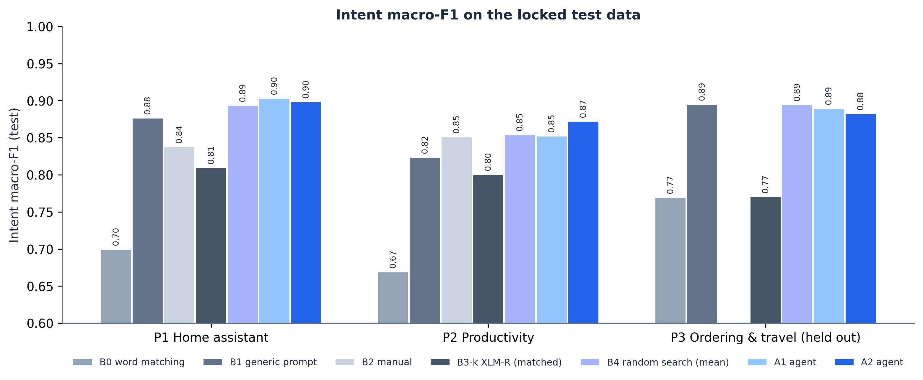
Intent F1 on the locked test data for every system and project.

What the results mean
- A2 found the best design every time. On all three projects it picked the design that is best of all 12 on development data, while testing only 4.
- A2 beat the generic prompt (B1) on P1 and P2 and met the success rule. Intent difference in points with 95% interval: P1 +2.2 [-0.6, +5.1], P2 +4.9 [+1.1, +8.9]. Entity: P1 +7.3 [+0.8, +14.5], P2 +5.5 [+0.3, +11.1]. The P2 intent gain and both entity gains are significant (interval above zero).
- On the held-out P3 it did not beat B1 on intents: -1.3 [-3.8, +1.4] points, an interval that includes zero, so it could be luck. On entities it was much better: +14.6 [+9.0, +21.3]. P3's practice set had only about 13 requests per intent, and the designs were very close on test.
- Against the person (B2): A2 was +6.1 [+2.0, +10.2] points higher on P1 (significant) and +2.1 [-0.7, +5.3] on P2 (not significant). On P1 the person chose the similarity threshold for off-topic requests, and off-topic F1 fell to 0.471.
- Against XLM-R with the same 10 examples per intent (B3-k): A2 was 7 to 11 points higher on intents, higher on entities and far better at refusing off-topic requests on every project. With 10 to 32 times more labelled data (B3-full), XLM-R is better at entities but still refuses badly.
- Against random search (B4): A2 was above the random average on P1, at the top of the random range on P2, and at the bottom of the range on P3.
- A1 passed the success rule on P1 and P2 too, but none of its differences from B1 is significant, and it failed on P3.

Speed and reliability
- 95th-percentile time per request (limit = 2 × B1 in the same session): P1 A2 0.89 s (limit 1.22 s), P2 A2 1.08 s (limit 1.67 s). Median about 0.65 s.
- Valid replies after repair: at least 0.997 for every agent run (needed 0.98).
- Designing one project costs A2 about 397 model calls, about 3 minutes, against 38 minutes for the person on P1.

Proof the numbers are real
- python scripts/reproduce_metrics.py: 99 of 99 runs recomputed from their saved answers match exactly.
- python scripts/verify_with_sklearn.py: scikit-learn recomputes the same scores to 9 decimal places.
- python scripts/reproduce_live.py --freeze-commit 0ee6b22b86894aebbe253fae3b00eb97c542c575: B0 retrained from scratch is identical, and A2 asked live with the cache off gave 50 of 50 answers identical to the recorded test answers.
- python scripts/show_evidence.py runs every check and the live demo in one go (reports/EVIDENCE_SUMMARY.md).
Full details: the paper (paper/main.tex and its PDF), paper/Research_Paper_Explained.pdf, docs/REPRODUCTION.md and reports/final_test.json.

