Automatic NLP Pipeline Design with an AI Agent
What we built, every test we ran, and how anyone can verify the results
Mihir Bhati (24BCE5341) · Ahana Sharan (24BCE5334)
Status as of 24 October 2026 · Project folder: D:\MyClaudeProject\nlp
How to read this document
Section 1 explains the project in plain words. Section 2 explains every technical term. Sections 3 and 4 describe what we built and what we compared it against. Section 5 lists every test with its result and where the proof is. Section 6 explains why the results can be trusted. Section 7 is a step-by-step guide to checking everything yourself, with what your screen should show. Section 8 answers questions a teacher is likely to ask.

Contents
- The project in one page
- Key terms explained simply
- What we built
- What we compared it against
- Every test we ran, and the results
- Why the results can be trusted
- How to verify everything yourself, step by step
- Questions a teacher may ask, with answers
- Honest limitations
- Where everything is

1. The project in one page
The problem. Every app that understands what users type or say, such as a home assistant or a booking bot, needs a language-understanding pipeline. A developer must decide how to ask the AI model, which examples to show it, and how to reject requests the app cannot handle. Today that takes hours of trial and error for every new project.
Our solution. A framework that makes those decisions automatically. You give it a written description of the app and its list of request types; an AI agent analyses the project, decides which pipeline designs to test, tests them on real data, picks the best and exports it as a package any program can use.
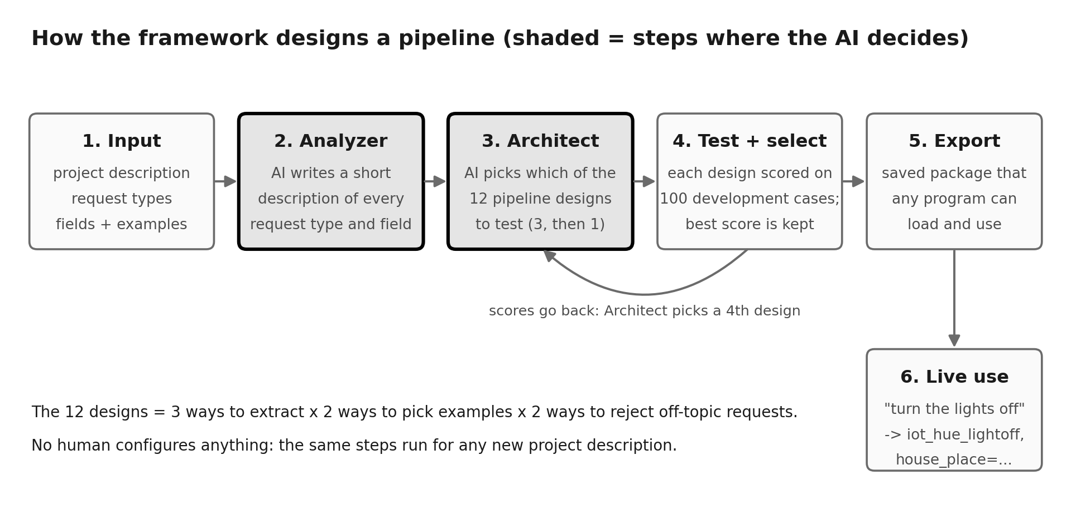
Figure 1. How the framework works. Shaded boxes with a thick border are the steps where the AI agent makes decisions.
Why it is called agentic: the AI does not just answer questions. It makes design decisions, looks at the results of its own choices, and revises them, with no human configuring anything.
The main result (development data, intent macro-F1, higher is better):
System | P1 Home assistant | P2 Productivity assistant
B1 one generic prompt | 0.927 | 0.804
B2 a person configuring by hand | 0.858 | 0.861 (with ChatGPT's help)
B3-k published model (XLM-R), same data | 0.909 | 0.833
B4 random search, same budget (average of 5) | 0.959 | 0.878
A1 our original agent | 0.958 | 0.841
A2 our improved agent | 0.974 | 0.898
Best of all 12 designs (the ceiling) | 0.974 | 0.898

In plain words: the improved agent found the best possible design on both projects and beat every comparison system on these development scores. The original agent did not beat random search, and we report that too. These are development scores; the final, reportable numbers come from locked test data after the freeze (Section 9).

2. Key terms explained simply
You already know accuracy and F1. Here is every term this project uses, with an example.
Term | What it means | Example
Intent | What the user wants to do. Every request has exactly one. | "wake me at 7" → alarm_set
Entity (field) | A detail inside the request that the system must pull out. | "7" is the time
Out-of-scope (OOS) | A request the app cannot handle. It must be refused, not forced into a wrong action. | "who won the match?" to a home assistant
Accuracy | Share of requests whose intent was right. | 75 of 80 right = 0.9375
Precision | Of the answers the system gave for a label, how many were right. | said alarm_set 10 times, 9 right = 0.9
Recall | Of the requests that truly had a label, how many the system found. | 12 real alarm_set, found 9 = 0.75
F1 | One number combining precision and recall (their harmonic mean). Punishes a system that is good at one and bad at the other. | precision 0.9, recall 0.75 → F1 0.818
Macro-F1 | F1 worked out for each intent separately, then averaged. Every intent counts equally, so rare intents matter. | 12 intents → average of 12 F1 scores
Entity span F1 | F1 for details: a detail counts as right only if its type AND its exact position in the sentence are right. | "seven am" as time, characters 17-25
Development (dev) data | Data we were allowed to look at while building and choosing designs. | 100 requests per project
Test data | Data locked away and used only once at the end, so the final score is honest. | 300 requests per project
Baseline | A simpler system we compare against, to show our system is actually better. | B0 to B4
Ablation | Removing one part of the system to see how much that part contributes. | the agent without its Analyzer
Confidence interval | A range showing how much a score could change by chance. If it includes 0, a difference may be luck. | +0.032 [-0.040, +0.121]
Robustness | Whether the system still works on messy input. | typos, CAPITALS, filler words
Reproduction | Recomputing a result from saved raw data to check it was not changed. | 44 of 44 runs match
LLM / model | Large language model: the AI that reads and writes text. Ours is qwen2.5:3b, run locally. | 3 billion parameters
Prompt / few-shot | The text sent to the model; few-shot means it includes a few worked examples. | 10 examples per intent
Fine-tuning | Training a model's internal numbers on your data. B3 does this; our agent does not. | XLM-R trained on examples
Seed | A fixed starting number for anything random, so the same split or draw happens every time. | seed 20261016

3. What we built

3.1 The parts of the framework
Part | What it does | Code
LLM client | Talks to the local AI model; saves every answer so it is never paid for twice; counts every call | src/llm/client.py
Data preparation | Downloads MASSIVE, builds the three projects, fixes the splits with a seed | scripts/prepare_data.py
Scorer | One scoring code for every system, so no system gets friendlier rules | src/evaluation/scorer.py
Catalogue | The 12 pipeline designs and the code that runs them | src/pipelines/catalogue.py
Analyzer | AI writes a description of each intent and field; checks the project for contradictions | src/analyzer/analyzer.py
Architect (A1) | AI picks 3 designs, sees their scores, picks a 4th | src/architect/architect.py
Architect (A2) | Improved: AI ranks each design choice separately; the search tests alternatives one change at a time | src/architect/architect_v2.py
Selector | Picks the best tested design by a fixed rule shared with random search | src/evaluation/selection.py
Export and runtime | Saves the chosen pipeline as a hash-protected package and answers live requests | src/runtime/package.py
Test-data lock | Code that refuses to hand out test data before the freeze | src/analyzer/access.py

3.2 The 12 pipeline designs
Every design combines three choices. The agent's job is to pick which combinations to test.
Choice | Options | Trade-off
How the AI extracts | joint (one call) · twostage (intent first, then details) · schema (one call that includes written descriptions) | twostage costs two calls; schema is the only one that uses the descriptions
Which examples it sees | fixed (always the same) · sim (most similar to the request) | similar examples help with unusual wording
How it rejects off-topic requests | llm (the AI may answer none_of_the_above) · tfidf (a word-similarity cut-off before the AI) | tfidf saves calls but is crude

3 × 2 × 2 = 12 designs, named like schema-sim-llm.

3.3 The data
MASSIVE (Amazon, ACL 2023): 16,521 real English requests, 18 domains, 60 intents, 55 field types, free under the CC BY 4.0 licence. We built three projects from it:
Project | App | Domains | Role
P1 | Home assistant | alarms, smart lights and devices | development
P2 | Productivity assistant | calendar, email, lists | development
P3 | Ordering and travel | takeaway, transport | held out, never seen until the end

All 16,521 entity annotations were converted to exact character positions with 0 mismatches (checked by tests/test_massive.py).

4. What we compared it against
A demo shows that something runs. Comparisons show whether it is better. Each baseline answers one question:
System | What it is | Question it answers
B0 | Word-matching classifier, no AI model | Does an AI model help at all?
B1 | One generic AI prompt, no design choices | Does project-specific design beat a generic setup?
B2 | A team member configures the pipeline by hand, timed | Does the agent match a person, for less effort?
B3-k | XLM-R fine-tuned on the same 10 examples per intent (the MASSIVE paper's baseline) | How does it compare with published work?
B3-full | XLM-R trained on all training data (10-30× more) | An upper reference, not a fair comparison
B4 | Random search: 4 of the 12 designs drawn at random, 5 different seeds | Does the agent choose better than luck?
A1 | Our original agent
A2 | Our improved agent (better search, same model)

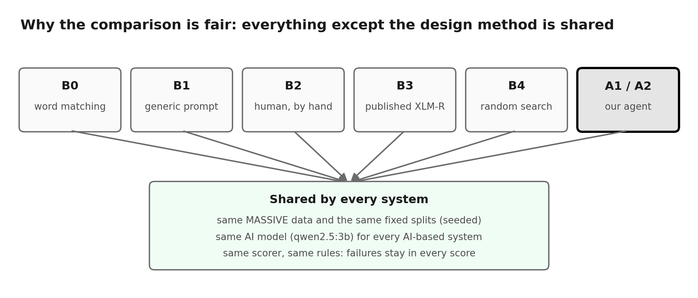
Figure 2. Every system shares the data, the AI model and the scorer, so differences come only from the design method.

5. Every test we ran, and the results
Each row is a separate test. "Proof" is the file or command that shows it.
# | Test | Question it answers | How it was done | Result | Proof
1 | Automated tests | Does every part work as designed? | 371 small programs check the code, including hand-calculated scores | 371 passed | python -m pytest tests
2 | Data conversion check | Are the gold answers correct? | Every annotation converted and re-checked against the sentence | 16,521 / 16,521, 0 errors | docs/DATA_REPORT.md
3 | Speed and repeatability of the model | Is the model fast and does it give the same answer twice? | 50 full-size requests, run twice, saved answers switched off | 0.42 s median; 50 / 50 identical | runs/20261012_0020_setup_throughput_0
4 | All 12 designs run | Does every design work on real data? | Each design run on real P1 and P2 requests | 12 / 12 ran; 2 bugs found and fixed | docs/EVIDENCE_LOG.md (S04)
5 | Main comparison | Which system is best? | Every system scored on the same 100 dev requests per project | A2 best: 0.974 / 0.898 | docs/FINDINGS.md
6 | Random search (B4) | Does the agent beat luck? | 5 random draws of 4 designs, same scorer | A1 no; A2 yes | FINDINGS F1, F8
7 | Published baseline (B3) | How does it compare with published work? | XLM-R fine-tuned locally on the same data | Agent wins intent; A2 also wins entities | FINDINGS F4
8 | Human baseline (B2) | Is the agent as good as a person? | Team member configured each project by hand, timed, help declared | P1: agent +10 points; P2: tie with ChatGPT-assisted human | FINDINGS F7
9 | Ablations | Which part of the agent matters? | Each part removed in turn and re-scored | Scored selection matters most | reports/DEV_ANALYSIS.md §1
10 | Confidence intervals | Are the differences real or luck? | 1,000 paired bootstrap resamples | Not significant at 100 cases yet | DEV_ANALYSIS §2
11 | Real speed | How fast is the final pipeline? | 50 live requests with saved answers off | under 1 s at p95 | DEV_ANALYSIS §3
12 | Error analysis | What mistakes does it make? | Every dev error put in one of 9 categories | mostly entity over-extraction | DEV_ANALYSIS §4
13 | Robustness | Does it cope with messy typing? | Requests rewritten with typos, capitals, filler words | AI systems hold up; word matching drops up to 27 points | DEV_ANALYSIS §5
14 | Export and demo | Can the chosen pipeline be reused? | Saved package loaded by a fresh program; tampered package refused | works; normal, off-topic and invalid requests handled | python scripts/demo.py
15 | Reproduction check | Was any number changed by hand? | Every result re-scored from its saved predictions | 44 / 44 match | python scripts/reproduce_metrics.py
16 | Independent check | Is our F1 calculated the standard way? | scikit-learn recomputes F1, accuracy and OOS scores | 44 / 44 agree | python scripts/verify_with_sklearn.py
17 | Improved agent (A2) | Can the agent's weak search be fixed? | New search design, same model, keep-or-drop rule fixed in advance | reached the best design on both projects | FINDINGS F8

5.1 Full results (development data)
System | P1 intent | P1 entity | P1 OOS | P2 intent | P2 entity | P2 OOS
B0 word matching | 0.780 | 0.000 | 0.510 | 0.730 | 0.000 | 0.510
B1 generic prompt | 0.927 | 0.610 | 0.870 | 0.804 | 0.451 | 0.691
B2 manual (P2: with ChatGPT) | 0.858 | 0.586 | 0.588 | 0.861 | 0.394 | 0.783
B3-k published, matched | 0.909 | 0.650 | 0.739 | 0.833 | 0.448 | 0.605
B3-full, all data (reference) | 0.936 | 0.768 | 0.579 | 0.923 | 0.797 | 0.432
A1 original agent | 0.958 | 0.597 | 0.909 | 0.841 | 0.365 | 0.735
A2 improved agent | 0.974 | 0.707 | 0.909 | 0.898 | 0.483 | 0.776

B0 extracts no entities by design, so its entity score is 0. B3-full trains on far more data and is shown only as a reference.
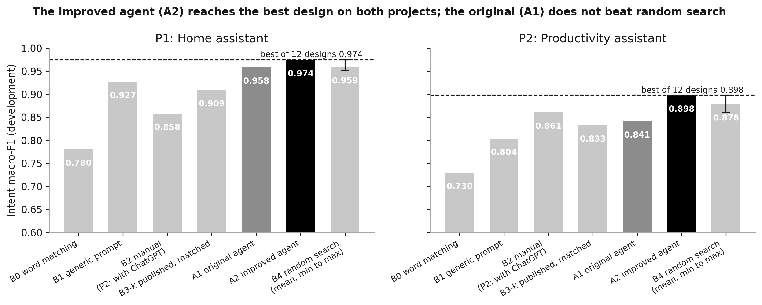
Figure 3. Intent macro-F1 for every system. The dashed line is the best of all 12 designs.
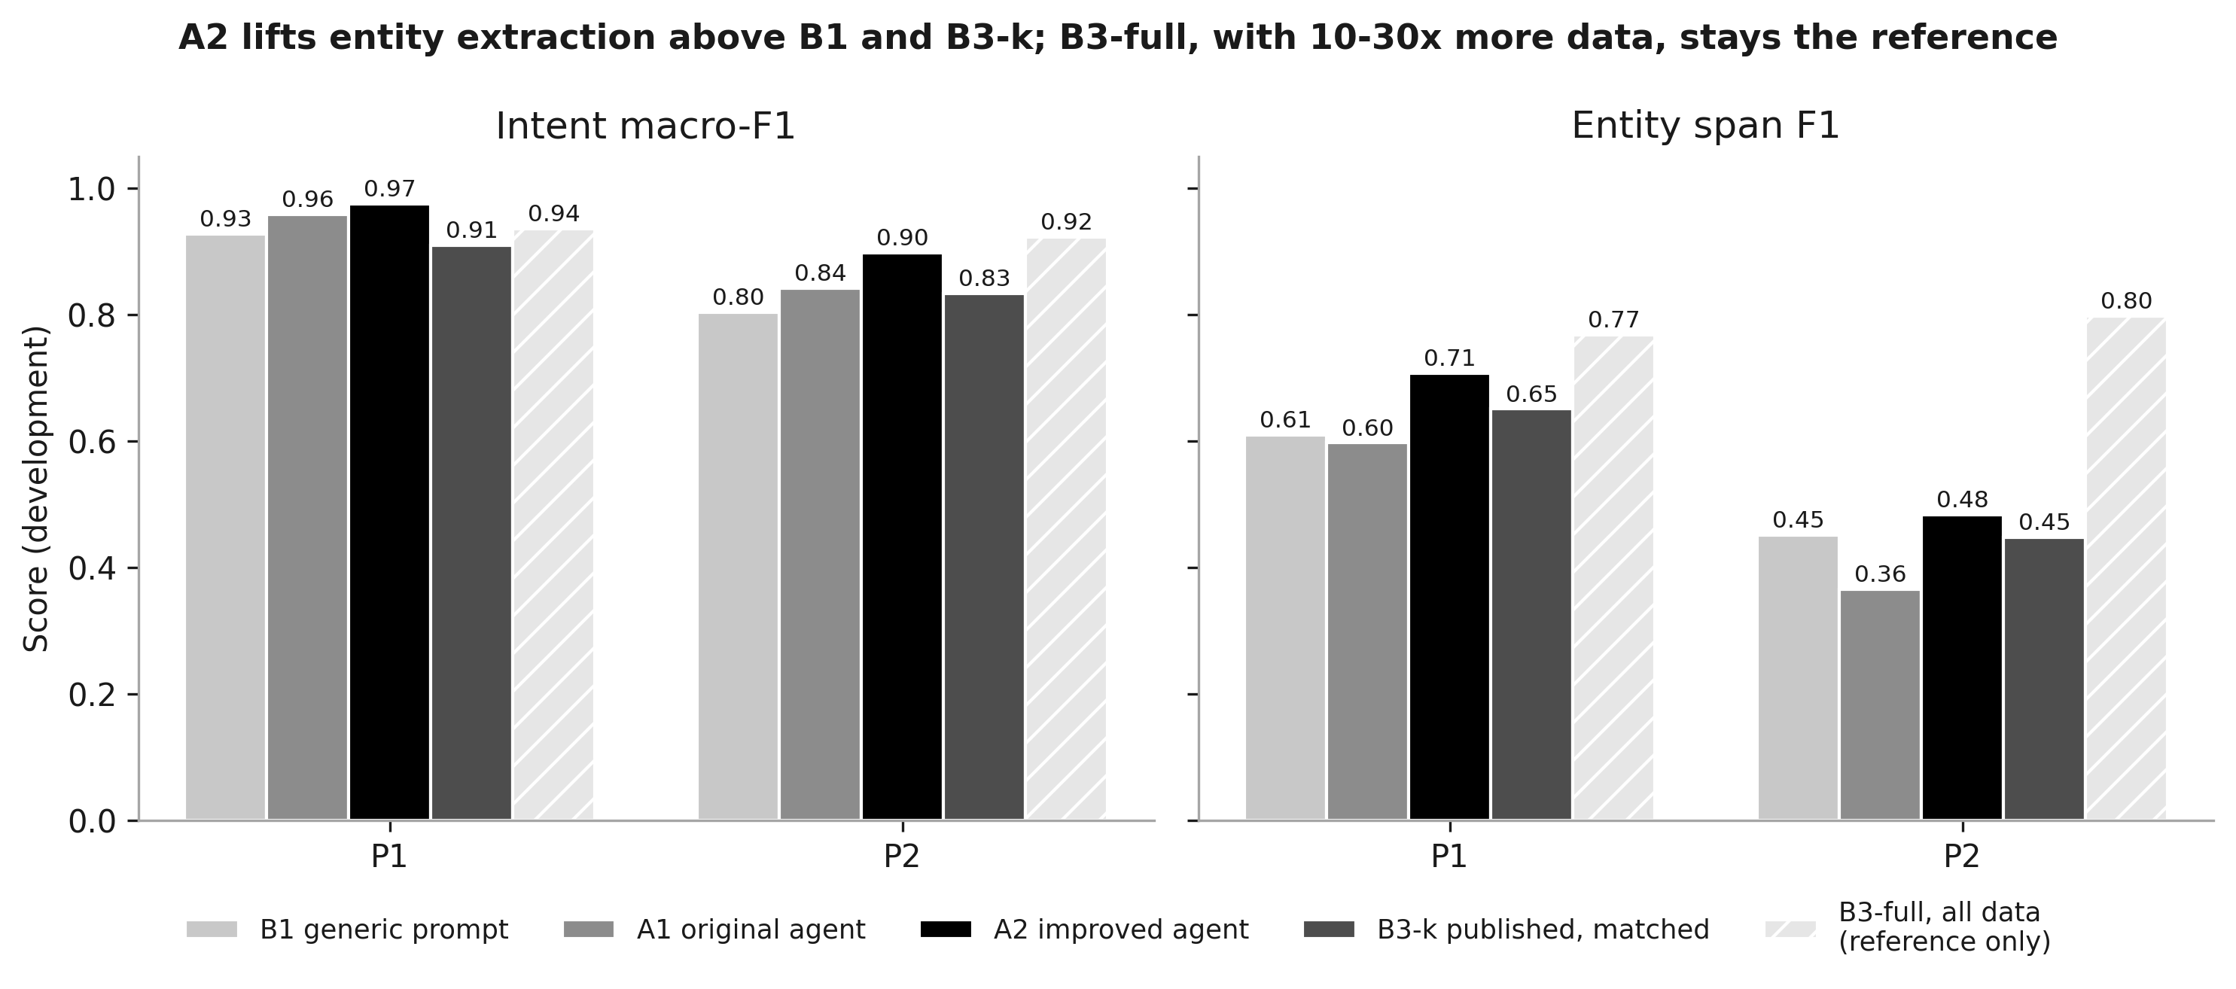
Figure 4. Intent and entity scores side by side.
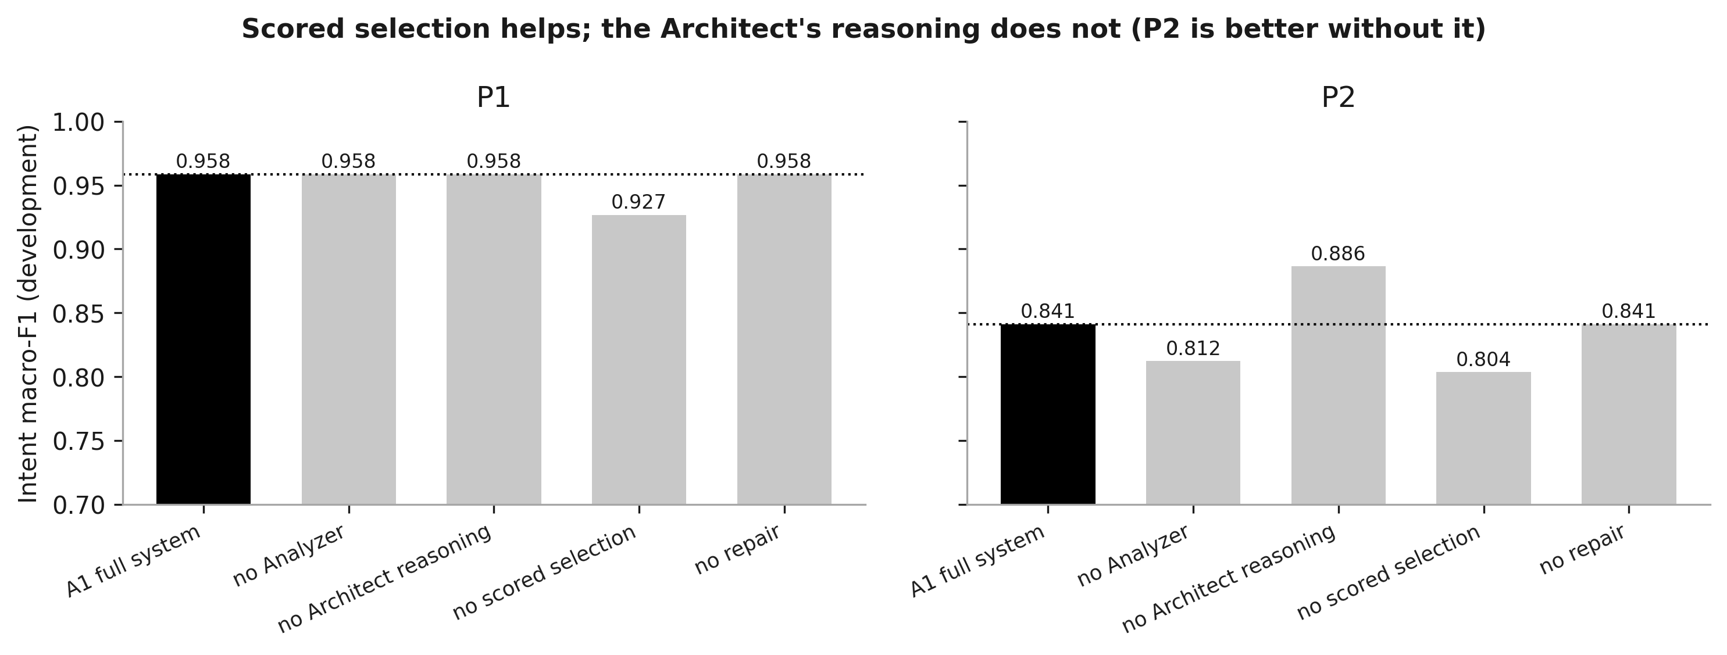
Figure 5. Ablations: each bar removes one part of the original agent (A1).
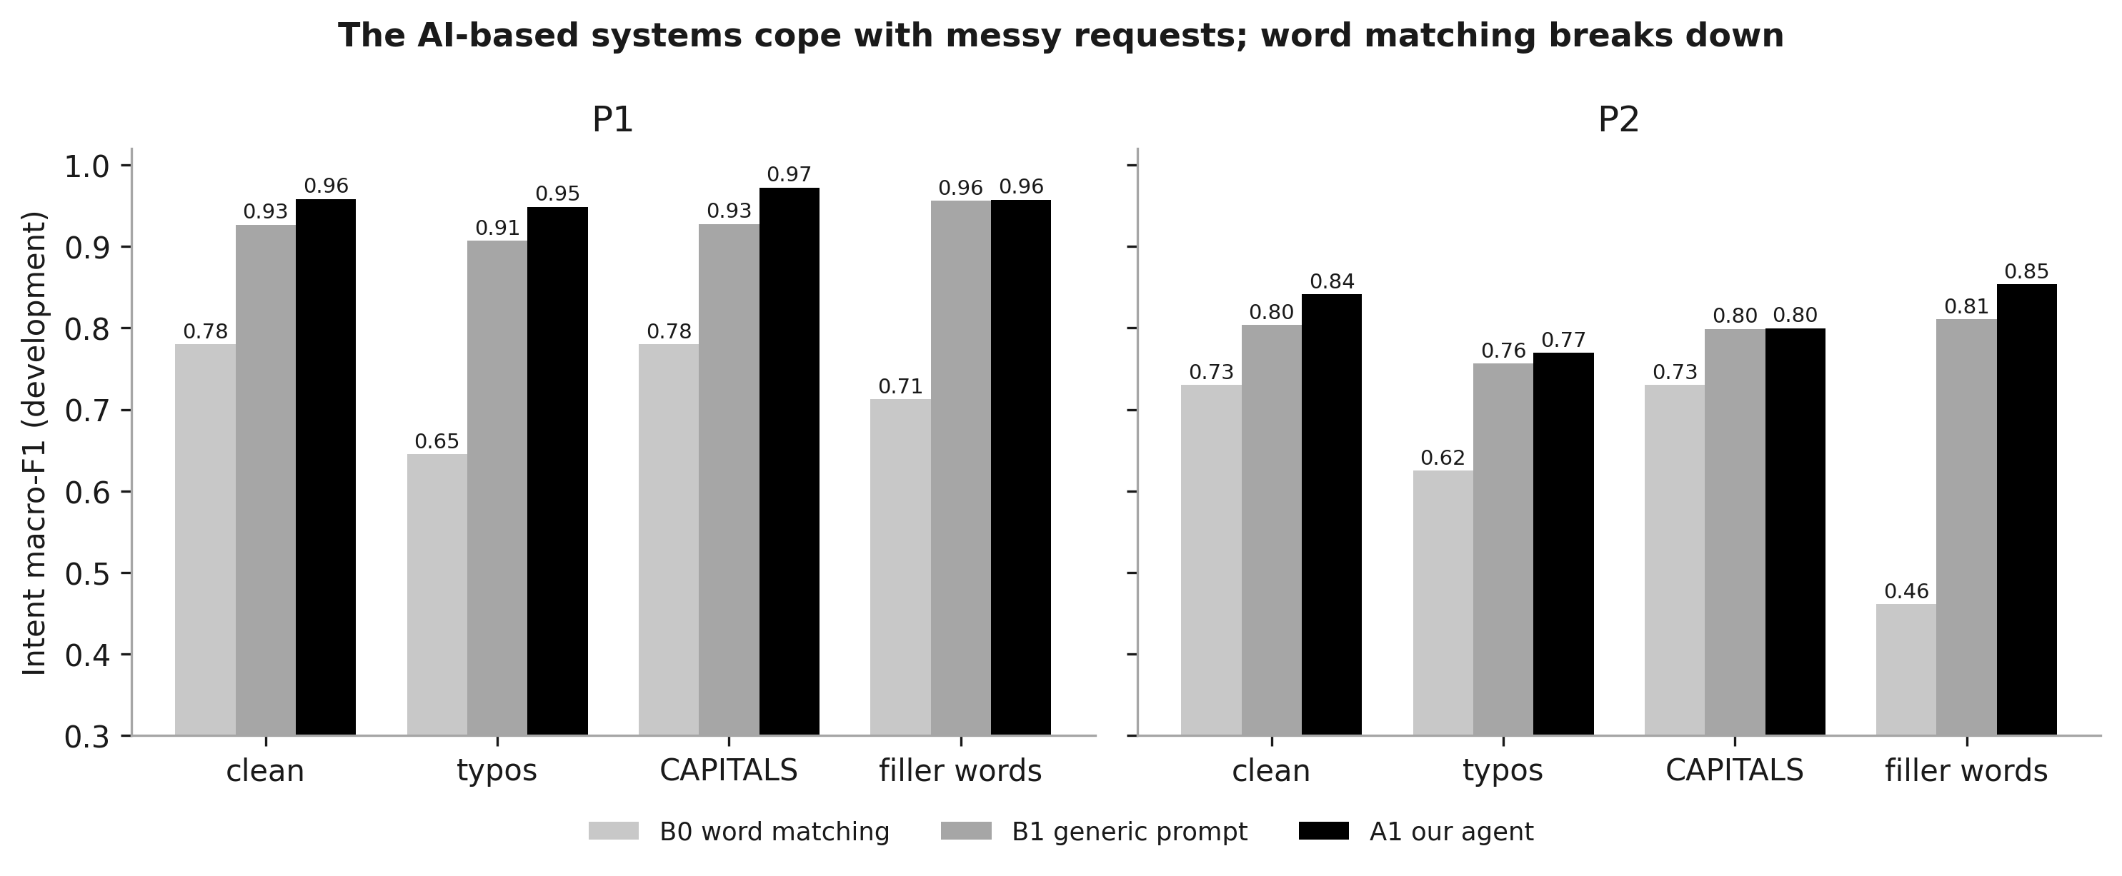
Figure 6. Robustness to messy requests.

6. Why the results can be trusted
About verification websites. There is no website that certifies machine-learning results. In research, proof means that anyone can re-run the work and get the same numbers. That is the standard every published paper is judged by, and this project is built for it. Uploading the project to GitHub would add a public, dated copy, but the real proof is the re-running described in Section 7.

Ten reasons a sceptical reader can believe the numbers:
- Public data. MASSIVE is a published Amazon dataset anyone can download. Its file fingerprint (SHA-256) is recorded, so anyone can check they have the same file.
- Fixed splits. Every split is drawn with a fixed seed, so it comes out identical every time.
- Every answer is saved. Each run folder keeps every individual prediction (predictions.jsonl), not just the final score.
- Every result is recomputed. reproduce_metrics.py re-scores all 44 checkable runs from their saved predictions: 44 of 44 match exactly.
- An independent library agrees. scikit-learn, the standard machine-learning library used worldwide, recomputes F1, accuracy and OOS scores without our code: 44 of 44 agree to 9 decimal places.
- The scorer is tested against hand calculations. Every expected number in tests/test_scorer.py was worked out by hand.
- Every run records its exact setup. manifest.json stores the code version (git commit), the AI model's fingerprint and the data fingerprints.
- The model is repeatable. Asked the same 50 questions twice, it gave 50 identical answers, so a re-run gives the same results.
- The test data is locked by code. The program refuses to hand out test data before the freeze; a test checks this.
- Bad results are reported, not hidden. The original agent losing to random search, the ChatGPT-assisted human tying the agent on P2 and every bug found are all in docs/FINDINGS.md. A record that only showed wins would be less believable.
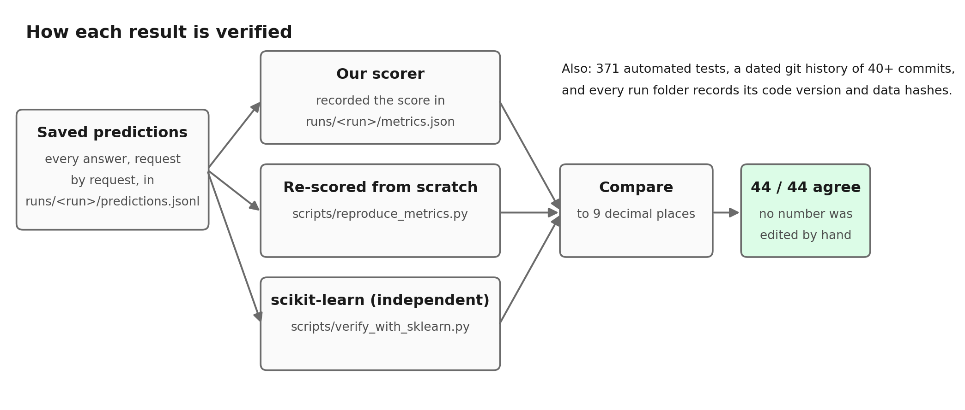
Figure 7. How each result is checked three ways.

7. How to verify everything yourself, step by step
Each step gives the command to type, what it does, and what your screen should show. All of it works offline. The screen images were made from the actual output of each command, run on 24 October 2026; small details such as timings will differ slightly on a re-run.

Step 0. Get ready (2 minutes)
- Open a terminal: press Start, type PowerShell, press Enter.
- Start the AI model: open the Ollama app from the Start menu (or type ollama serve in a second terminal).
- Go to the project folder:
cd D:\MyClaudeProject\nlp

Check the model is there; you should see qwen2.5:3b in the list:
ollama list

Step 1. Run every check at once
python scripts/show_evidence.py

This runs the tests, the reproduction check, the scikit-learn check and the demo, then prints a summary and saves it to reports\EVIDENCE_SUMMARY.md. The last line should read Overall: all checks passed.
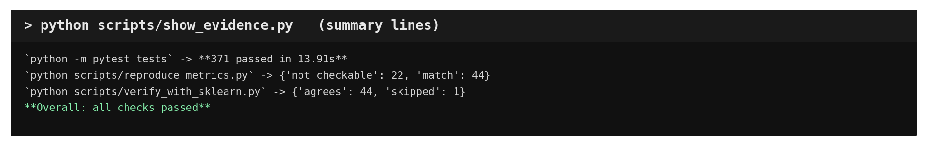
What the summary lines look like.

Step 2. The automated tests
python -m pytest tests

Runs all 371 tests in about 15 seconds. Each dot is one passed test. The last line should be 371 passed.
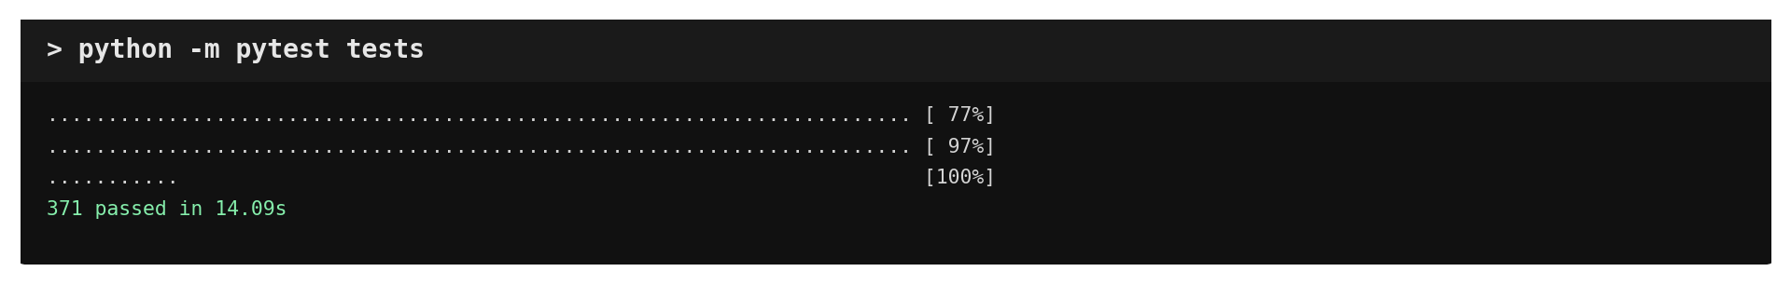
Expected output.
To see each test by name, add -v. Good ones to show: python -m pytest tests/test_scorer.py -v (hand-calculated scores).

Step 3. Recompute every result from saved predictions
python scripts/reproduce_metrics.py

Every line should say match. "not checkable" means that run folder holds no predictions to re-score (for example the speed measurements), never a failure.
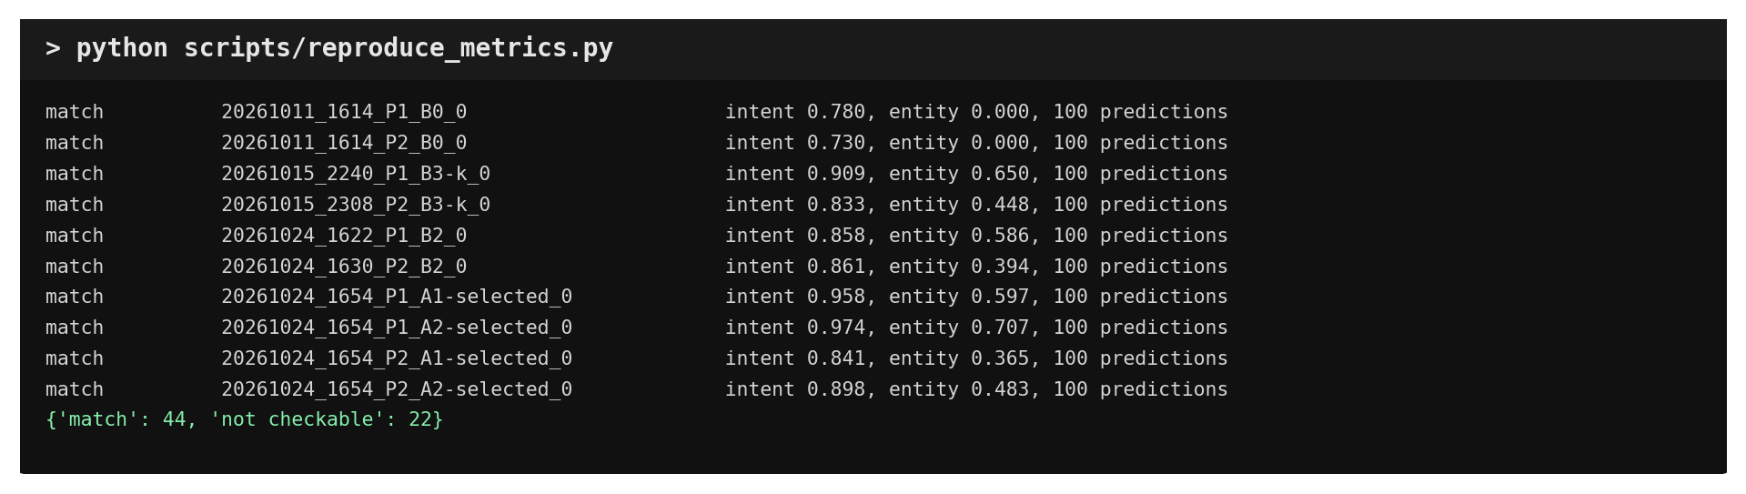
Expected output (a selection of lines plus the final count).

Step 4. Independent check with scikit-learn
python scripts/verify_with_sklearn.py

Every line should say agrees: scikit-learn computed exactly the number our scorer recorded.
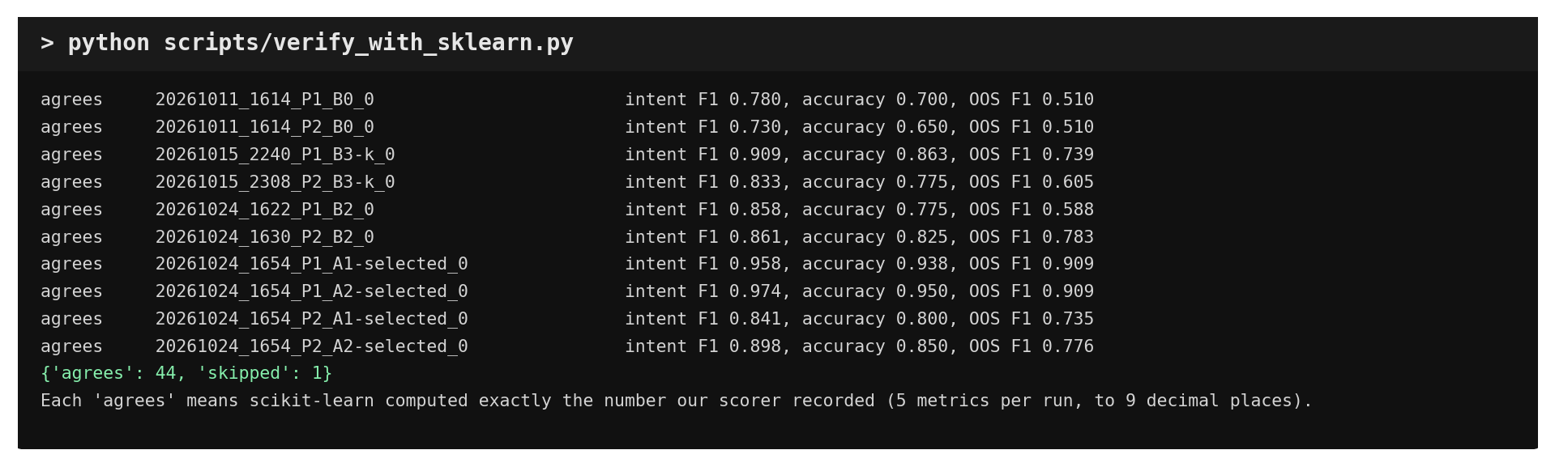
Expected output.

Step 5. Check one result by hand
Open the folder runs\20261024_1654_P1_A2-selected_0 in File Explorer. It holds:
File | What it shows
predictions.jsonl | One line per request: the correct answer (gold_intent) and the system's answer (predicted_intent)
metrics.json | The scores: look for "intent_macro_f1": 0.974...
manifest.json | Code version (git commit), model fingerprint, data fingerprints
config.json | Which design was used and why

Open predictions.jsonl in Notepad and compare gold_intent with predicted_intent on a few lines. They should match on most lines. That is what the score summarises.

Step 6. Live demo
python scripts/demo.py --project P1

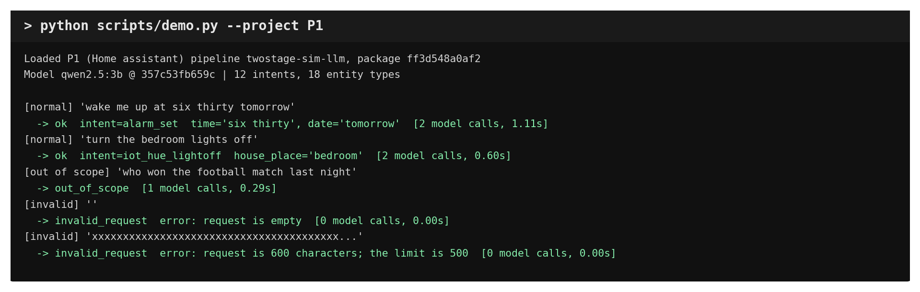
Expected output: normal, off-topic and invalid requests.
To type your own requests, add --interactive. A teacher can try anything, e.g. "dim the kitchen lights".

Step 7. The dated history of the work
git log --reverse --format="%ad %s" --date=format:"%d %b %H:%M"

Shows every saved step from 11 October, oldest first: setup, data, scorer, the 12 designs, Analyzer, Architect, export, baselines and tests.
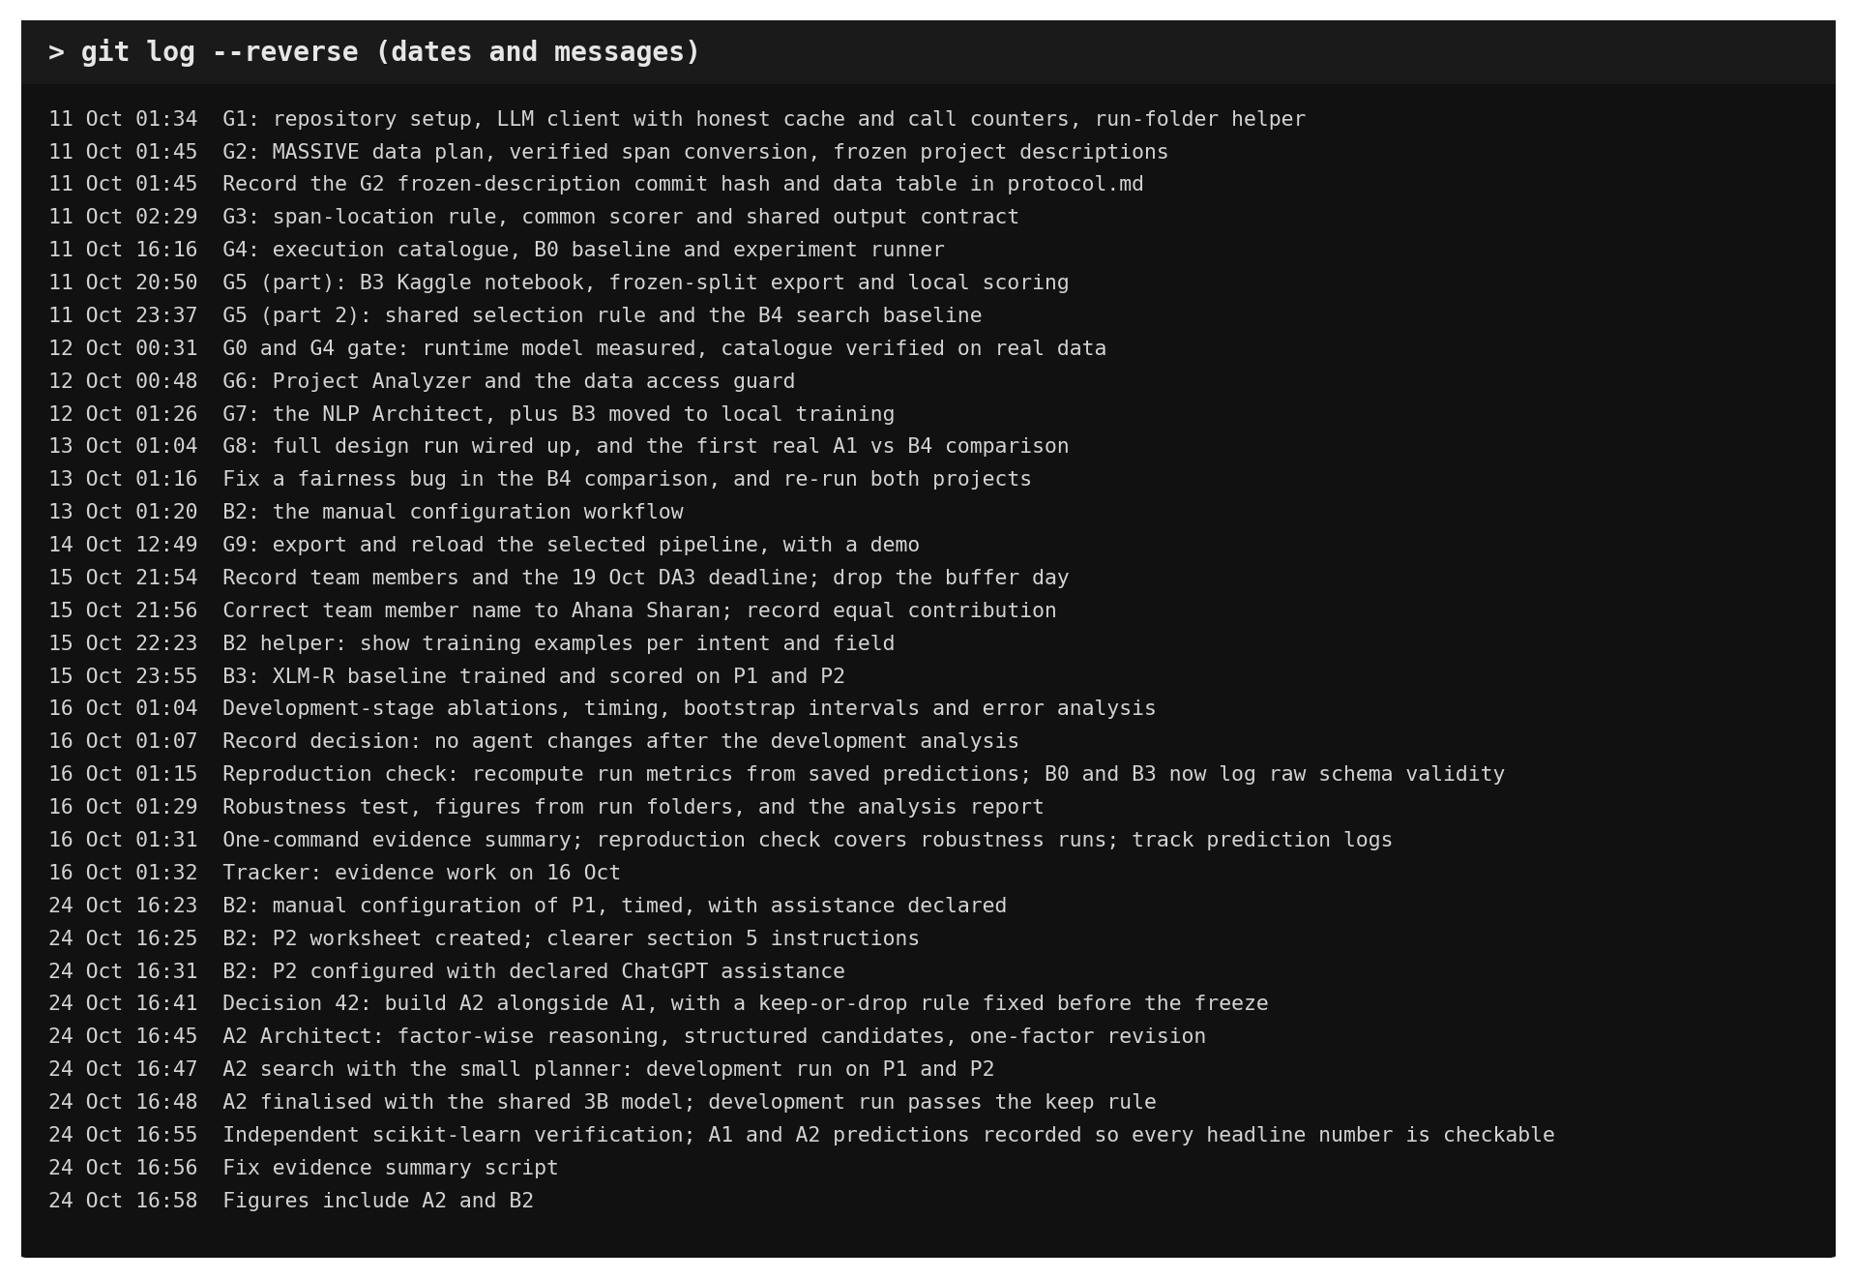
The project history.

8. Questions a teacher may ask, with answers
Q: How did you build this?
A: We planned the project (the plan with gates G0-G12 is in docs\PROJECT_PLAN.md), made the design decisions, checked every result, and used Claude Code, an AI coding assistant, to write much of the code and run the experiments. That assistance is recorded in docs\contributions.md, as the plan requires.
Q: Why is it agentic and not just a script?
A: A script follows fixed rules. Here the AI reads the project, decides which designs to test, gives a reason for each, sees the scores and revises its choice. The reasons are saved in each run's config.json.
Q: What is F1 and why not just accuracy?
A: Accuracy can look good while a rare request type is always missed. Macro-F1 scores every request type separately and averages them, so a system cannot hide its failures on rare ones.
Q: Why did the original agent not beat random search?
A: Its AI kept choosing one kind of example and never tried the best design. On P1, 5 of the 12 designs score within 6 points of the best, so 4 random picks usually include a good one. The improved agent fixes this with a better search structure, using the same model.
Q: How do we know you did not tune on the test data?
A: The test data is locked by code until the freeze, and project P3 is fully hidden. A test checks that the design run never touches the test split. All results so far are on development data.
Q: Can I see it run again?
A: Yes, Section 7. Every result can be recomputed, and the model gives identical answers on repeat.
Q: Which model did you use and why?
A: qwen2.5:3b, run locally with Ollama. It fits our 4 GB graphics card, answers in about 0.4 s, always returned valid output and gave identical answers on repeat.
Q: Is B2 fair, given you built the agent?
A: It is a single, non-blind measurement, and we say so. On P1 the person worked by hand; on P2 they used ChatGPT and declared it. Both are reported separately with their caveats.

9. Honest limitations
- All results here are development scores. The final numbers come from the locked test data after the freeze. The improved agent (A2) was designed after seeing development results, so only its test result counts as evidence.
- Small development sets (100 cases per project): the confidence intervals show most differences could still be chance.
- One small model (3B) for every AI-based system; a larger model was not tested because of the 4 GB graphics card.
- B2 is one person per project, a beginner on the team that built the agent; P2 used ChatGPT.
- Two development projects; the held-out project P3 is still to be run.
- Entity extraction remains the weakest area, mainly extracting words that are not fields.

10. Where everything is
What | Where
The plan | docs\PROJECT_PLAN.md
Day-by-day progress | docs\PROGRESS_TRACKER.md
Every design decision, with reasons | docs\decisions.md
Findings with caveats | docs\FINDINGS.md
Full analysis report | reports\DEV_ANALYSIS.md
One-command evidence summary | reports\EVIDENCE_SUMMARY.md
Charts and their sources | reports\figures\ (SOURCES.md lists the run behind every value)
Every experiment run | runs\ (131 folders)
Demo presentation guide | the "NLP Project: Demo and Proof Guide" document
Team and AI-assistance record | docs\contributions.md

