**IT16149090**

**Abeysingha M.H**

**0x00sec.org_linuxShellcoding**

First install nasm by running sudo apt-get install nasm in your linux terminal.  
Write the below assembly code and rename the file as shell.asm

section .data

msg db '/bin/sh'

section .text

global _start

_start:

mov eax, 11

mov ebx, msg

mov ecx, 0

int 0x80

mov eax, 1

mov ebx, 0

int 0x80

save the .asm file  
  
When compiling, if we use  
nasm -f elf -o shell.o shell.asm and  
ld -o shell shell.o  
  
In my case it will get an error because the assembly code is written in x86 architecture.

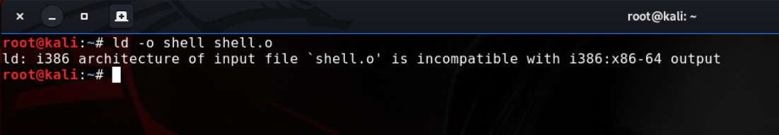

To address this issue we can use,  
nasm -f elf64 -o shell.o shell.asm and  
ld -m elf_x86_64 -s -o shell shell.o  
as the compiling commands. And then we can use ./shell to spawn a shell.

