Sheldon2_phase1

Phase1 - Yellow

Give execute permission to the file sheldon 2 and then run it using ./sheldon2

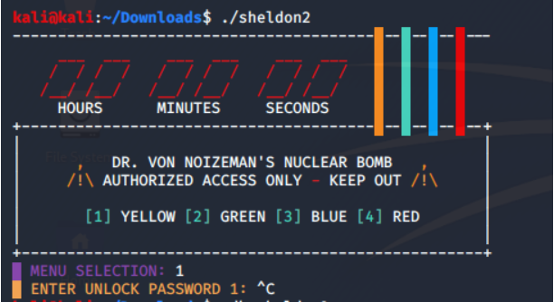

Select Yellow for phase 1

MENU SELECTION: 1

Use gdb with sheldon 2.

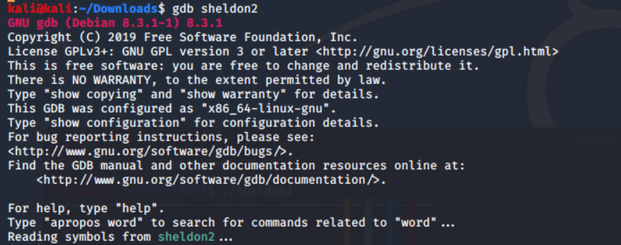

Use gdb's disassemble command to get all available assembler code for function yellow in sheldon2.

This basically reads in your input from stdin after selecting ‘yellow’ and compares it character for character with a “fixed” sequence. So Just convert all these 0x3Y values to ASCII and enter it as a password.

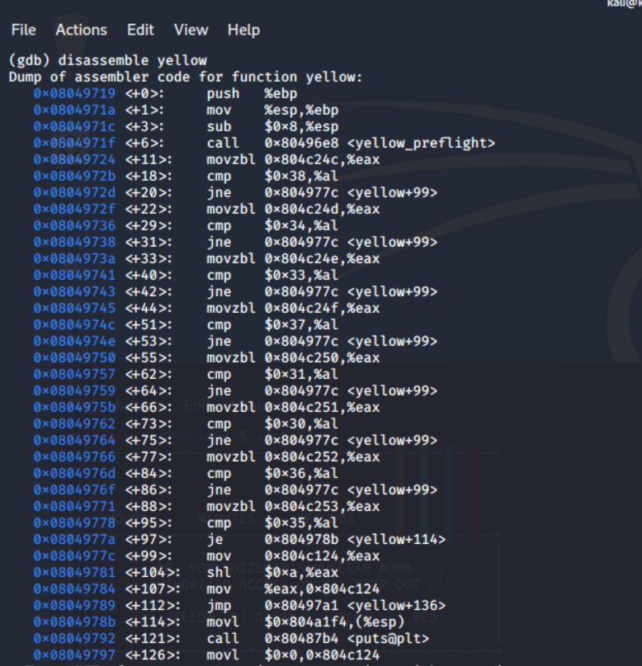

According to the ASCII values:

0x0804972b <+18>: cmp $0x38,%al =>> 8

0x08049736 <+29>: cmp $0x34,%al =>> 4

0x08049741 <+40>: cmp $0x33,%al =>> 3

0x0804974c <+51>: cmp $0x37,%al =>> 7

0x08049757 <+62>: cmp $0x31,%al =>> 1

0x08049762 <+73>: cmp $0x30,%al =>> 0

0x0804976d <+84>: cmp $0x36,%al =>> 6

0x08049778 <+95>: cmp $0x35,%al =>> 5

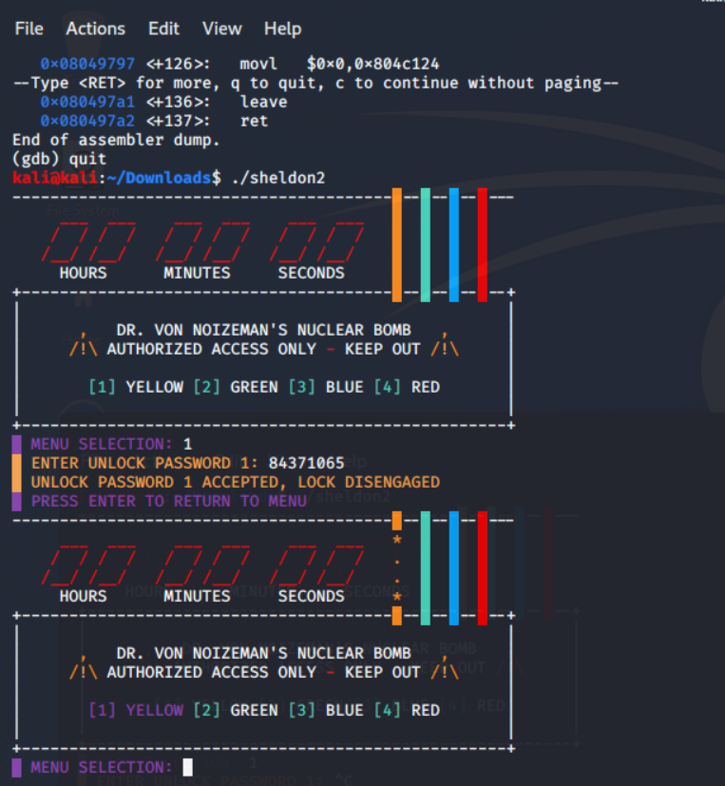

ENTER UNLOCK PASSWORD 1: 84371065