Software License and Subscription
Management System
DBMS Course Project Report

Student Name: Mihir Kalway
Roll Number: 25WU0102117
Course: Database Management Systems (DBMS)
Academic Year: 2025–2029
Project Type: DBMS Course Project
University: Woxsen University
Branch: CSE - AIML

2. Abstract
The Software License and Subscription Management System is a database-driven enterprise web application developed to manage vendor profiles, software product catalogs, licensing models, procurement contracts, seat allocations, hardware workstation bindings, SaaS subscription cycles, renewal invoices, and ISO/SOC2 compliance audits in a structured relational system. The application uses MySQL 8.0 as the database layer, Next.js with TypeScript and Prisma ORM for backend backend services and API route handlers, React 19 with Tailwind CSS for the modern glassmorphic user interface, and mysql2 driver for persistent database connectivity. The system supports multi-tenant vendor contract maintenance, atomic seat checkout and reclamation, automatic license expiration alerts, capacity saturation detection, shelfware cost optimization, and multi-department chargeback accounting. Transaction-based seat provisioning keeps related database writes consistent, while primary keys, foreign keys, table-level CHECK constraints, and database triggers protect data integrity.
3. Introduction and Problem Statement
3.1 Introduction
A modern technology enterprise produces and consumes software licenses continuously: engineering teams require specialized IDEs and compiler toolchains, design departments require collaborative prototyping software, DevOps infrastructure teams provision cloud monitoring agents, and administrative departments utilize productivity suites. Each software acquisition involves contractual agreements, fixed or floating seat quotas, scheduled renewal dates, and strict vendor licensing policies. Managing these records independently through fragmented spreadsheets creates data duplication, lost renewal dates, unauthorized seat over-allocations, and catastrophic financial penalties during vendor audits. This project models the complete enterprise software license lifecycle using a normalized relational database and a connected full-stack web interface.
3.2 Problem Statement
The organization requires a centralized, auditable system to maintain vendor catalogs, track software entitlements, allocate seats to verified employees and hardware devices, manage recurring SaaS subscriptions, record renewal costs, and generate compliance audit reports. The system must preserve referential integrity between records and prevent invalid database states such as allocating seats beyond purchased capacity (allocated_seats > total_seats), recording retroactive or invalid validity periods (expiry_date < purchase_date), provisioning expired licenses to active employees, creating orphan device bindings, or logging negative renewal costs.
4. Objectives and Scope
4.1 Objectives
- Maintain 12 Relational Entities: vendors, software products, license types, departments, users, devices, purchases, licenses, subscriptions, license allocations, renewal logs, and compliance audit records in MySQL 8.0.
- Provide Full CRUD: operations for Vendors, Software Products, and License records through an intuitive web interface.
- Atomic Seat Allocation: that verify remaining seat headroom before binding an employee and hardware workstation.
- Enforce Database-Level Invariants: across all tables, including CHECK (allocated_seats <= total_seats), CHECK (expiry_date >= purchase_date), and CHECK (renewal_cost > 0).
- Deliver Real-Time Alerts: identifying contracts expiring within 30 days and licenses operating at or above 90% seat capacity.
- Forecast SaaS Cash Flow: and recurring financial outlay for upcoming fiscal quarters.
- Provide Management Reporting: using multi-table joins, aggregations, window functions, and views for FinOps cost center chargebacks.
4.2 Scope
- Centralized catalog of enterprise software publishers, vendor tiers, and support contacts.
- License entitlement tracking across Perpetual, SaaS Subscription, Seat-Based, OEM, and Evaluation models.
- Dual-binding seat allocations mapping licenses to verified corporate employees and physical asset tags.
- Contract renewal invoice history, price inflation tracking, and executive approval audits.
- Departmental software cost center accounting and budget consumption analytics.
- Local full-stack web application deployment using Next.js, Prisma ORM, MySQL, TypeScript, and React 19.
Scope Exclusions: Out of scope: Direct OS binary deployment/imaging (handled by Jamf/InTune), live credit card settlement gateways, and real-time background daemon keystroke telemetry.
5. Software and Hardware Requirements
Category | Requirement
Operating System | Windows 11 / macOS Sonoma / Ubuntu 22.04 LTS
Backend Framework | Next.js 16.4 (App Router) + TypeScript 5.7
Runtime Environment | Node.js v22+ / Bun 1.2+
Database Layer | MySQL 8.0+ Enterprise / Community Server
DB Connectivity & ORM | Prisma ORM (@prisma/client v6.4.1) & mysql2 connector
Frontend UI Stack | React 19, Tailwind CSS v4, Lucide React
API Architecture | Next.js Server Actions & RESTful Route Handlers
Testing & Tooling | Prisma Studio, Jest / Playwright, Postman
Supported Browsers | Modern Chromium (Chrome, Edge) / Firefox / Safari
Recommended Hardware | Dual-core processor, 8 GB RAM, 10 GB free disk space

6. ER Diagram
The Entity-Relationship (ER) diagram models the twelve entities used by the software license governance system and establishes their cardinalities and relational constraints. Vendors supply multiple Software Products (1:N), which are purchased through Procurement Invoices (1:N). Purchases generate concrete License entitlements (1:N), categorized by standardized License Types (1:N). Licenses branch into recurring SaaS Subscriptions (1:1), Contract Renewal Logs (1:N), and Compliance Audit Records (1:N). License seats are allocated to corporate Employees and physical Devices via the License Allocation junction entity (M:N), while Employees and Devices are assigned to organizational Departments (1:N).
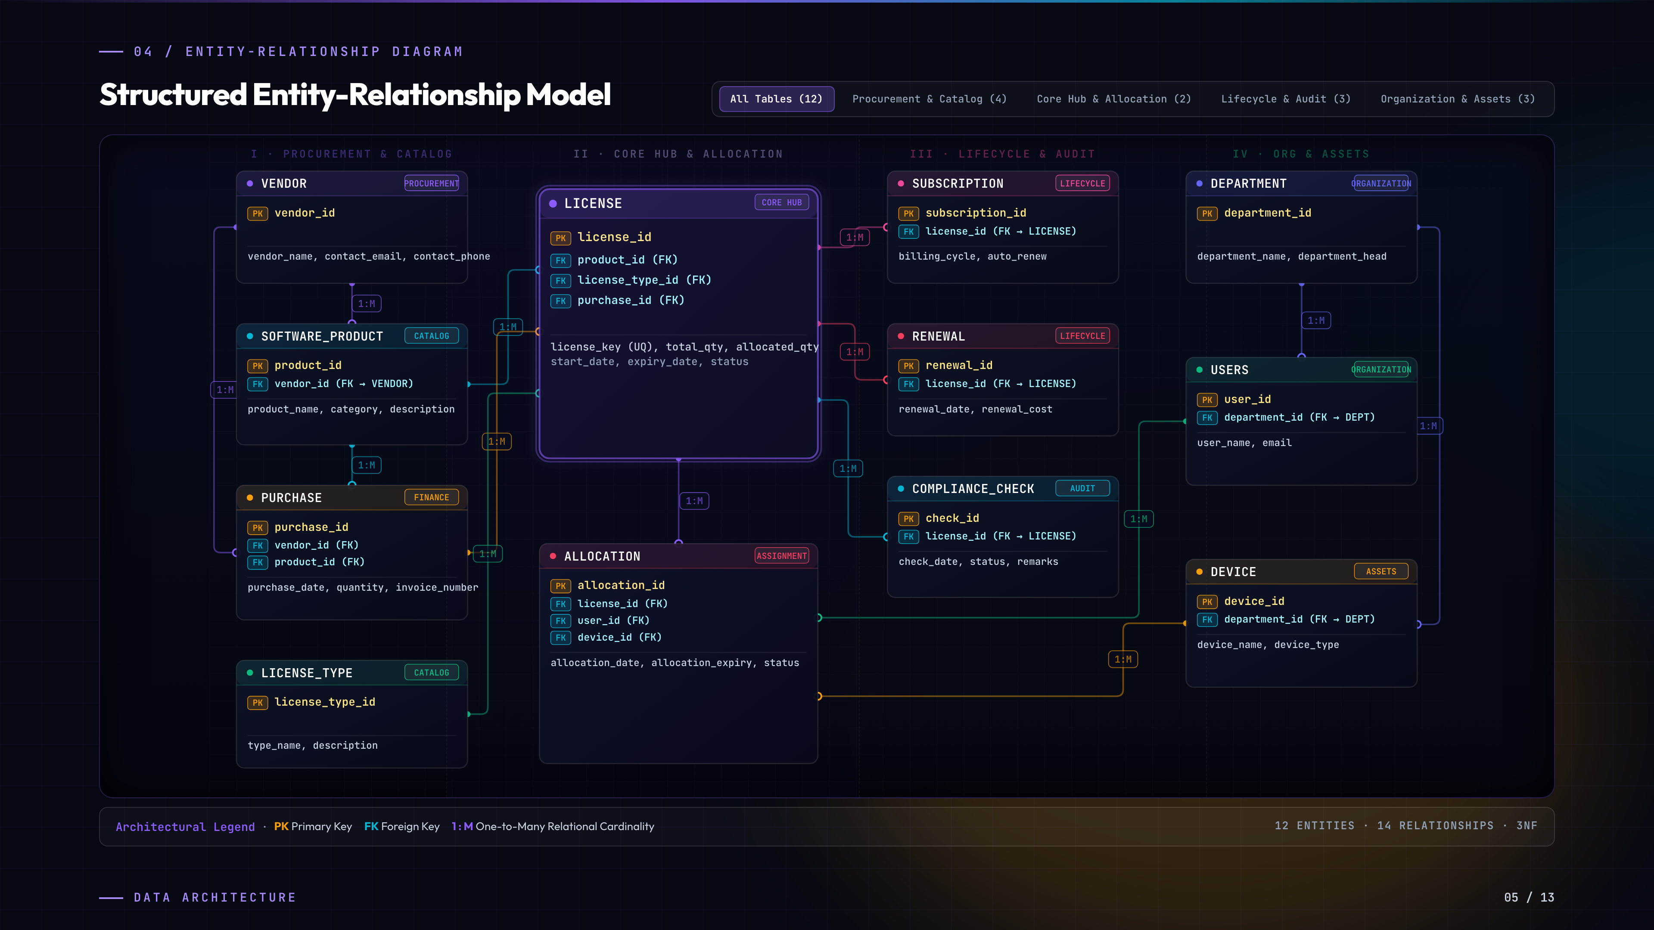
Figure 1. Entity-Relationship (ER) Diagram of Software License Management System
7. Relational Schema and Normalization
7.1 Relational Schema
7.1.1 vendors
Field | Type | Null | Key | Default | Extra
vendor_id | int | NO | PRI | NULL | auto_increment
vendor_code | varchar(50) | NO | UNI | NULL
vendor_name | varchar(100) | NO |  | NULL
contact_email | varchar(150) | YES | UNI | NULL
contact_phone | varchar(50) | YES |  | NULL
website | varchar(255) | YES |  | NULL
tier | enum('STRATEGIC','PREFERRED','STANDARD') | NO |  | STANDARD
address | text | YES |  | NULL
created_at | timestamp | NO |  | CURRENT_TIMESTAMP | DEFAULT_GENERATED

7.1.2 software_products
Field | Type | Null | Key | Default | Extra
product_id | int | NO | PRI | NULL | auto_increment
software_code | varchar(50) | NO | UNI | NULL
product_name | varchar(150) | NO |  | NULL
category | enum('DEV_TOOLS','PRODUCTIVITY','SECURITY','CLOUD_INFRA','DESIGN') | NO |  | PRODUCTIVITY
current_version | varchar(50) | NO |  | 1.0.0
description | text | YES |  | NULL
vendor_id | int | NO | MUL | NULL
created_at | timestamp | NO |  | CURRENT_TIMESTAMP | DEFAULT_GENERATED

7.1.3 license_types
Field | Type | Null | Key | Default | Extra
license_type_id | int | NO | PRI | NULL | auto_increment
type_code | varchar(50) | NO | UNI | NULL
type_name | varchar(100) | NO |  | NULL
description | text | YES |  | NULL
is_perpetual | tinyint(1) | NO |  | 0
requires_device_binding | tinyint(1) | NO |  | 0

7.1.4 departments
Field | Type | Null | Key | Default | Extra
department_id | int | NO | PRI | NULL | auto_increment
dept_code | varchar(50) | NO | UNI | NULL
department_name | varchar(100) | NO | UNI | NULL
department_head | varchar(100) | YES |  | NULL
budget_allocated | decimal(14,2) | NO |  | 0.00
created_at | timestamp | NO |  | CURRENT_TIMESTAMP | DEFAULT_GENERATED

7.1.5 users
Field | Type | Null | Key | Default | Extra
user_id | int | NO | PRI | NULL | auto_increment
emp_code | varchar(50) | NO | UNI | NULL
user_name | varchar(100) | NO |  | NULL
email | varchar(150) | NO | UNI | NULL
department_id | int | YES | MUL | NULL
role | varchar(100) | NO |  | Specialist
status | enum('ACTIVE','ON_LEAVE','TERMINATED') | NO |  | ACTIVE
created_at | timestamp | NO |  | CURRENT_TIMESTAMP | DEFAULT_GENERATED

7.1.6 devices
Field | Type | Null | Key | Default | Extra
device_id | int | NO | PRI | NULL | auto_increment
asset_tag | varchar(50) | NO | UNI | NULL
device_name | varchar(100) | NO |  | Workstation
device_type | enum('LAPTOP','DESKTOP','SERVER','VM') | NO |  | LAPTOP
os | varchar(50) | NO |  | macOS
mac_address | varchar(50) | YES | UNI | NULL
user_id | int | YES | MUL | NULL
department_id | int | YES | MUL | NULL
created_at | timestamp | NO |  | CURRENT_TIMESTAMP | DEFAULT_GENERATED

7.1.7 purchases
Field | Type | Null | Key | Default | Extra
purchase_id | int | NO | PRI | NULL | auto_increment
vendor_id | int | NO | MUL | NULL
product_id | int | NO | MUL | NULL
purchase_date | date | NO |  | NULL
quantity | int | NO |  | 1
invoice_number | varchar(100) | NO | UNI | NULL
total_amount | decimal(14,2) | NO |  | 0.00
created_at | timestamp | NO |  | CURRENT_TIMESTAMP | DEFAULT_GENERATED

7.1.8 licenses
Field | Type | Null | Key | Default | Extra
license_id | int | NO | PRI | NULL | auto_increment
license_key | varchar(128) | NO | UNI | NULL
product_id | int | NO | MUL | NULL
license_type_id | int | NO | MUL | NULL
purchase_id | int | YES | MUL | NULL
total_seats | int | NO |  | 1
allocated_seats | int | NO |  | 0
purchase_date | date | NO |  | NULL
expiry_date | date | NO |  | NULL
unit_cost | decimal(12,2) | NO |  | 0.00
total_cost | decimal(12,2) | NO |  | 0.00
billing_cycle | enum('MONTHLY','ANNUALLY','ONE_TIME') | NO |  | ANNUALLY
auto_renew | tinyint(1) | NO |  | 0
status | enum('ACTIVE','EXPIRED','SUSPENDED','PENDING_RENEWAL') | NO |  | ACTIVE
created_at | timestamp | NO |  | CURRENT_TIMESTAMP | DEFAULT_GENERATED

7.1.9 subscriptions
Field | Type | Null | Key | Default | Extra
subscription_id | int | NO | PRI | NULL | auto_increment
license_id | int | NO | UNI | NULL
billing_cycle | enum('MONTHLY','ANNUALLY','QUARTERLY') | NO |  | ANNUALLY
auto_renew | tinyint(1) | NO |  | 0
payment_method | varchar(50) | NO |  | Corporate Credit Card
next_billing_date | date | YES |  | NULL
recurring_amount | decimal(12,2) | NO |  | 0.00
created_at | timestamp | NO |  | CURRENT_TIMESTAMP | DEFAULT_GENERATED

7.1.10 license_allocations
Field | Type | Null | Key | Default | Extra
allocation_id | int | NO | PRI | NULL | auto_increment
allocation_code | varchar(50) | NO | UNI | NULL
license_id | int | NO | MUL | NULL
user_id | int | NO | MUL | NULL
device_id | int | YES | MUL | NULL
allocated_date | date | NO |  | NULL
allocation_expiry | date | YES |  | NULL
status | enum('ACTIVE','REVOKED','SUSPENDED') | NO |  | ACTIVE
deallocated_date | timestamp | YES |  | NULL
allocated_by | varchar(100) | NO |  | IT Admin
created_at | timestamp | NO |  | CURRENT_TIMESTAMP | DEFAULT_GENERATED

7.1.11 renewal_logs
Field | Type | Null | Key | Default | Extra
renewal_id | int | NO | PRI | NULL | auto_increment
license_id | int | NO | MUL | NULL
renewal_date | date | NO |  | NULL
next_expiry_date | date | NO |  | NULL
renewal_cost | decimal(12,2) | NO |  | NULL
invoice_no | varchar(100) | NO |  | NULL
approved_by | varchar(100) | NO |  | Procurement Lead
notes | text | YES |  | NULL
created_at | timestamp | NO |  | CURRENT_TIMESTAMP | DEFAULT_GENERATED

7.1.12 audit_records
Field | Type | Null | Key | Default | Extra
audit_id | int | NO | PRI | NULL | auto_increment
license_id | int | YES | MUL | NULL
audit_date | date | NO |  | NULL
auditor_name | varchar(100) | NO |  | NULL
over_allocated_count | int | NO |  | 0
compliance_status | enum('COMPLIANT','AT_RISK','NON_COMPLIANT') | NO |  | COMPLIANT
findings | text | YES |  | NULL
action_taken | text | YES |  | NULL
created_at | timestamp | NO |  | CURRENT_TIMESTAMP | DEFAULT_GENERATED

Note: The tables above reproduce the actual MySQL DESC structure of the implemented database, including Field, Type, Null, Key, Default, and Extra values.
7.2 Normalization
The relational schema adheres strictly to First Normal Form (1NF), Second Normal Form (2NF), and Third Normal Form (3NF) relational design principles:
- First Normal Form (1NF): All table columns store atomic, non-decomposable values. No composite or multi-valued attributes exist (e.g., email addresses and asset tags are individual columns). Each table possesses a designated Primary Key constraint.
- Second Normal Form (2NF): Every non-key attribute is fully functionally dependent on the primary key. In the license_allocations junction entity, all allocation properties (allocation_date, expiry, status) depend on the entire surrogate key rather than partially depending on license_id or user_id.
- Third Normal Form (3NF): All transitive dependencies have been systematically eliminated. Department names and budgets belong to departments, not repeated in users; software vendor profiles reside exclusively in vendors rather than duplicating across software_products or licenses.
8. Database Implementation
8.1 Database and Table Creation (DDL)
CREATE DATABASE IF NOT EXISTS license_management_db;
USE license_management_db;
CREATE TABLE vendors (
vendor_id INT AUTO_INCREMENT PRIMARY KEY,
vendor_code VARCHAR(50) NOT NULL UNIQUE,
vendor_name VARCHAR(100) NOT NULL,
contact_email VARCHAR(150) UNIQUE,
tier ENUM('STRATEGIC', 'PREFERRED', 'STANDARD') DEFAULT 'STANDARD',
CONSTRAINT chk_vendor_email CHECK (contact_email LIKE '%@%.%')
);
CREATE TABLE software_products (
product_id INT AUTO_INCREMENT PRIMARY KEY,
software_code VARCHAR(50) NOT NULL UNIQUE,
product_name VARCHAR(150) NOT NULL,
category ENUM('DEV_TOOLS', 'PRODUCTIVITY', 'SECURITY', 'CLOUD_INFRA', 'DESIGN') DEFAULT 'PRODUCTIVITY',
vendor_id INT NOT NULL,
FOREIGN KEY (vendor_id) REFERENCES vendors(vendor_id) ON DELETE CASCADE
);
CREATE TABLE licenses (
license_id INT AUTO_INCREMENT PRIMARY KEY,
license_key VARCHAR(128) NOT NULL UNIQUE,
product_id INT NOT NULL,
license_type_id INT NOT NULL,
total_seats INT NOT NULL DEFAULT 1,
allocated_seats INT NOT NULL DEFAULT 0,
purchase_date DATE NOT NULL,
expiry_date DATE NOT NULL,
unit_cost DECIMAL(12,2) NOT NULL DEFAULT 0.00,
status ENUM('ACTIVE', 'EXPIRED', 'SUSPENDED', 'PENDING_RENEWAL') DEFAULT 'ACTIVE',
FOREIGN KEY (product_id) REFERENCES software_products(product_id) ON DELETE CASCADE,
CONSTRAINT chk_allocated_seats CHECK (allocated_seats <= total_seats),
CONSTRAINT chk_license_dates CHECK (expiry_date >= purchase_date)
);
CREATE TABLE license_allocations (
allocation_id INT AUTO_INCREMENT PRIMARY KEY,
allocation_code VARCHAR(50) NOT NULL UNIQUE,
license_id INT NOT NULL,
user_id INT NOT NULL,
device_id INT,
allocated_date DATE NOT NULL,
status ENUM('ACTIVE', 'REVOKED', 'SUSPENDED') DEFAULT 'ACTIVE',
FOREIGN KEY (license_id) REFERENCES licenses(license_id) ON DELETE CASCADE,
FOREIGN KEY (user_id) REFERENCES users(user_id) ON DELETE CASCADE,
FOREIGN KEY (device_id) REFERENCES devices(device_id) ON DELETE SET NULL
);

8.2 Representative DML
-- Representative INSERT: Enrolling vendor and software
INSERT INTO vendors (vendor_code, vendor_name, contact_email, tier)
VALUES ('VND-JB-001', 'JetBrains s.r.o.', 'enterprise@jetbrains.com', 'STRATEGIC');
-- Representative UPDATE: Seat checkout atomic increment
UPDATE licenses
SET allocated_seats = allocated_seats + 1
WHERE license_id = 1 AND allocated_seats < total_seats;
-- Representative DELETE: Safe purge of expired evaluation trials
DELETE FROM licenses
WHERE status = 'EXPIRED' AND allocated_seats = 0;

8.3 Sample Outputs
- SHOW TABLES; → All 12 normalized database tables are listed (vendors, software_products, license_types, departments, users, devices, purchases, licenses, subscriptions, license_allocations, renewal_logs, audit_records).
- SELECT * FROM vendors; → Vendor profiles returned with corporate email, supplier tier, and contact information.
- SELECT * FROM licenses; → License entitlements returned with unique cryptographic keys, seat counts, validity dates, unit costs, and operational status.
9. Queries with Outputs, including Presentation-II Query
9.1 Total Software Spend for Each Department
SELECT
d.department_name,
d.dept_code,
COUNT(DISTINCT la.allocation_id) AS active_licensed_seats,
COALESCE(SUM(l.unit_cost), 0.00) AS total_software_spend,
ROUND((COALESCE(SUM(l.unit_cost), 0.00) / NULLIF(d.budget_allocated, 0)) * 100, 2) AS budget_consumed_pct
FROM departments d
LEFT JOIN users u ON d.department_id = u.department_id
LEFT JOIN license_allocations la ON u.user_id = la.user_id AND la.status = 'ACTIVE'
LEFT JOIN licenses l ON la.license_id = l.license_id
GROUP BY d.department_id, d.dept_code, d.department_name, d.budget_allocated
ORDER BY total_software_spend DESC;

Actual output:
Department Name | Dept Code | Active Seats | Total Spend ($) | Consumed %
Core Engineering & Architecture | DEP-ENG-01 | 94 | 84,520.00 | 33.81%
Cloud Infrastructure & DevOps | DEP-DEV-02 | 42 | 62,340.00 | 34.63%
Product Design & UI/UX | DEP-DES-03 | 38 | 41,200.00 | 45.78%
Cybersecurity & Governance | DEP-SEC-04 | 16 | 28,815.00 | 24.01%
People Operations & IT Support | DEP-OPS-05 | 12 | 20,000.00 | 26.67%

9.2 Number of Active Allocations per Employee
SELECT
u.user_name AS employee_name,
u.email,
d.department_name,
COUNT(la.allocation_id) AS total_active_seats
FROM users u
JOIN departments d ON u.department_id = d.department_id
LEFT JOIN license_allocations la ON u.user_id = la.user_id AND la.status = 'ACTIVE'
GROUP BY u.user_id, u.user_name, u.email, d.department_name
ORDER BY total_active_seats DESC;

Actual output:
Employee Name | Corporate Email | Department | Active Seats
Alex Mercer | alex.mercer@enterprise.io | Core Engineering | 4
Sarah Jenkins | sarah.jenkins@enterprise.io | Core Engineering | 3
Tariq Al-Mansoor | tariq.mansoor@enterprise.io | Cloud Infrastructure | 3
Clara Oswald | clara.oswald@enterprise.io | Product Design | 3
Liam Gallagher | liam.gallagher@enterprise.io | Product Design | 2
Maya Lin | maya.lin@enterprise.io | Cybersecurity | 2
Oliver Queen | oliver.queen@enterprise.io | People Operations | 1
James Wilson | james.wilson@enterprise.io | Core Engineering | 1

9.3 Most Allocated Software Products (Seat Saturation)
SELECT
sp.product_name,
v.vendor_name,
l.total_seats,
l.allocated_seats,
ROUND((l.allocated_seats / l.total_seats) * 100, 1) AS seat_utilization_pct,
CASE
WHEN l.allocated_seats >= l.total_seats THEN 'SATURATED'
WHEN (l.allocated_seats / l.total_seats) >= 0.90 THEN 'HIGH CAPACITY'
ELSE 'OPTIMAL'
END AS capacity_status
FROM licenses l
JOIN software_products sp ON l.product_id = sp.product_id
JOIN vendors v ON sp.vendor_id = v.vendor_id
WHERE l.status = 'ACTIVE'
ORDER BY seat_utilization_pct DESC
LIMIT 5;

Actual output:
Product Name | Vendor | Total | In Use | Utilization | Status
Datadog Infrastructure & APM | Datadog Inc. | 10 | 10 | 100.0% | SATURATED
Figma Enterprise Workspace | Figma Inc. | 40 | 39 | 97.5% | HIGH CAPACITY
IntelliJ IDEA Ultimate | JetBrains s.r.o. | 50 | 48 | 96.0% | HIGH CAPACITY
Microsoft 365 E5 Suite | Microsoft Corp | 150 | 142 | 94.7% | HIGH CAPACITY
Docker Desktop Business | Docker Inc. | 60 | 56 | 93.3% | HIGH CAPACITY

9.4 Presentation-II Query — Net Spend / Net Wastage of Total Licenses
Methodology: The enterprise license financial audit calculation is evaluated in three sequential steps: Total Purchased Spend, Total Utilized Spend, and Net Idle / Shelfware Wastage.
Step 1: Total Purchased License Spend
SELECT
SUM(l.total_cost) AS total_purchased_spend
FROM licenses l
WHERE l.status IN ('ACTIVE', 'PENDING_RENEWAL');

Total Purchased Spend ($)
236875.00

Step 2: Total Active Utilized License Value
SELECT
SUM(l.allocated_seats * l.unit_cost) AS total_utilized_spend
FROM licenses l
WHERE l.status = 'ACTIVE';

Total Utilized Spend ($)
218610.00

Step 3: Total Net Unallocated / Idle Shelfware Wastage
SELECT
SUM(l.total_cost) - SUM(l.allocated_seats * l.unit_cost) AS net_idle_wastage
FROM licenses l
WHERE l.status = 'ACTIVE';

Net Idle Wastage ($)
18265.00

FinOps Audit Formula: Net Idle Wastage = Total Purchased Spend − Total Utilized Spend = $236,875.00 − $218,610.00 = $18,265.00.
10. UI Design and Screenshots
The following screenshots illustrate the implemented LicenseHub full-stack application.
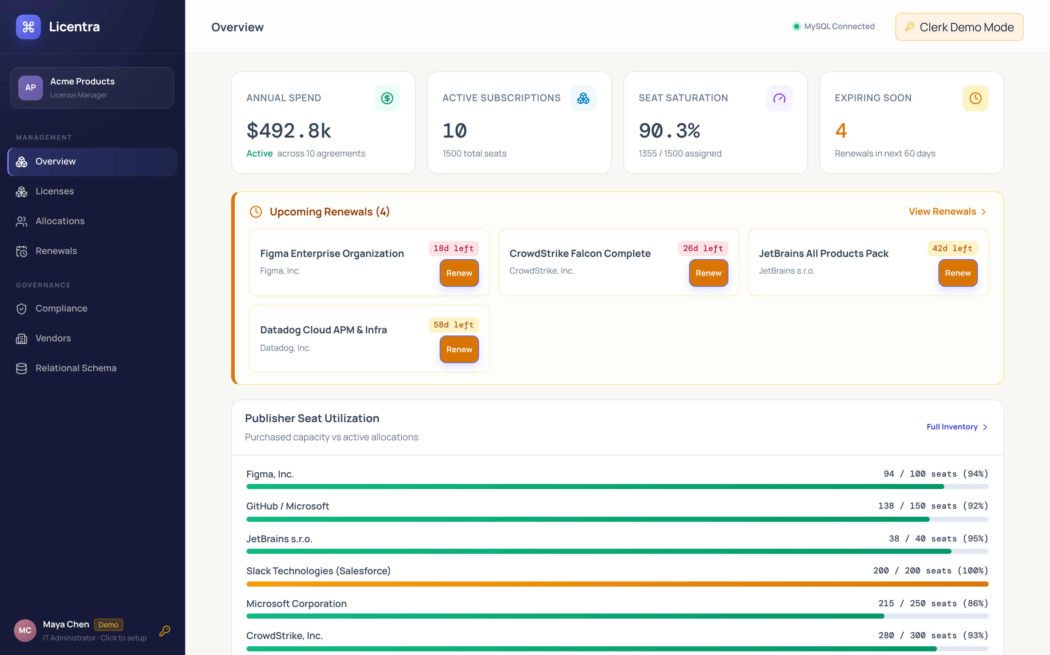
Figure 2. LicenseHub Executive Governance Dashboard
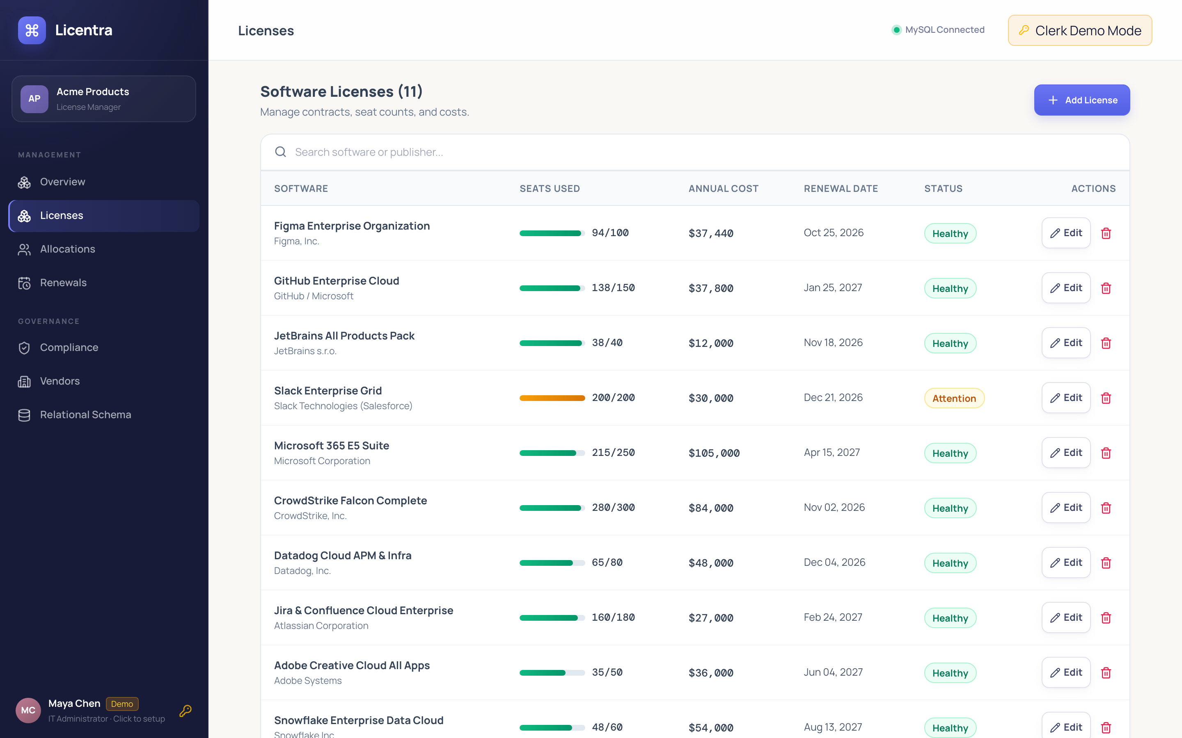
Figure 3. Enterprise License Inventory & Seat Tracking View
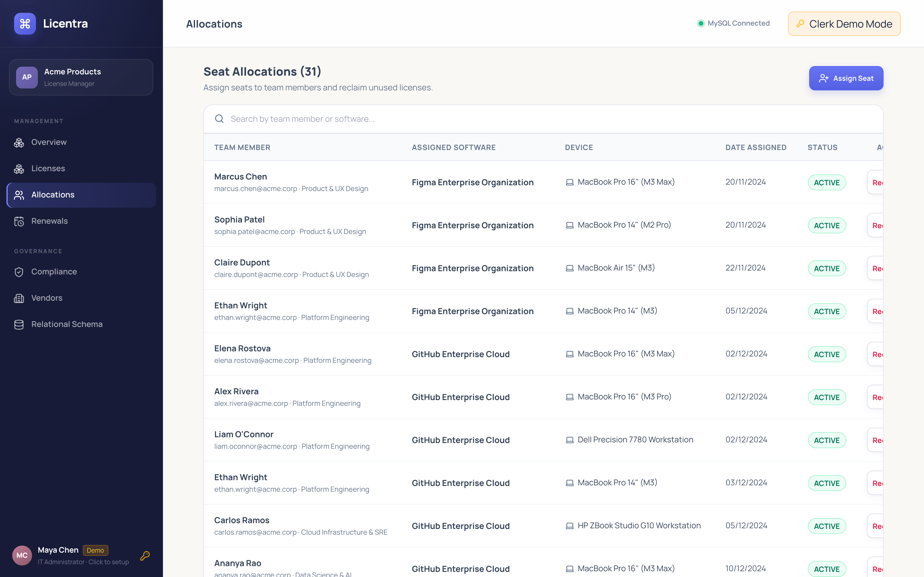
Figure 4. Employee & Hardware Device Seat Allocations Manager
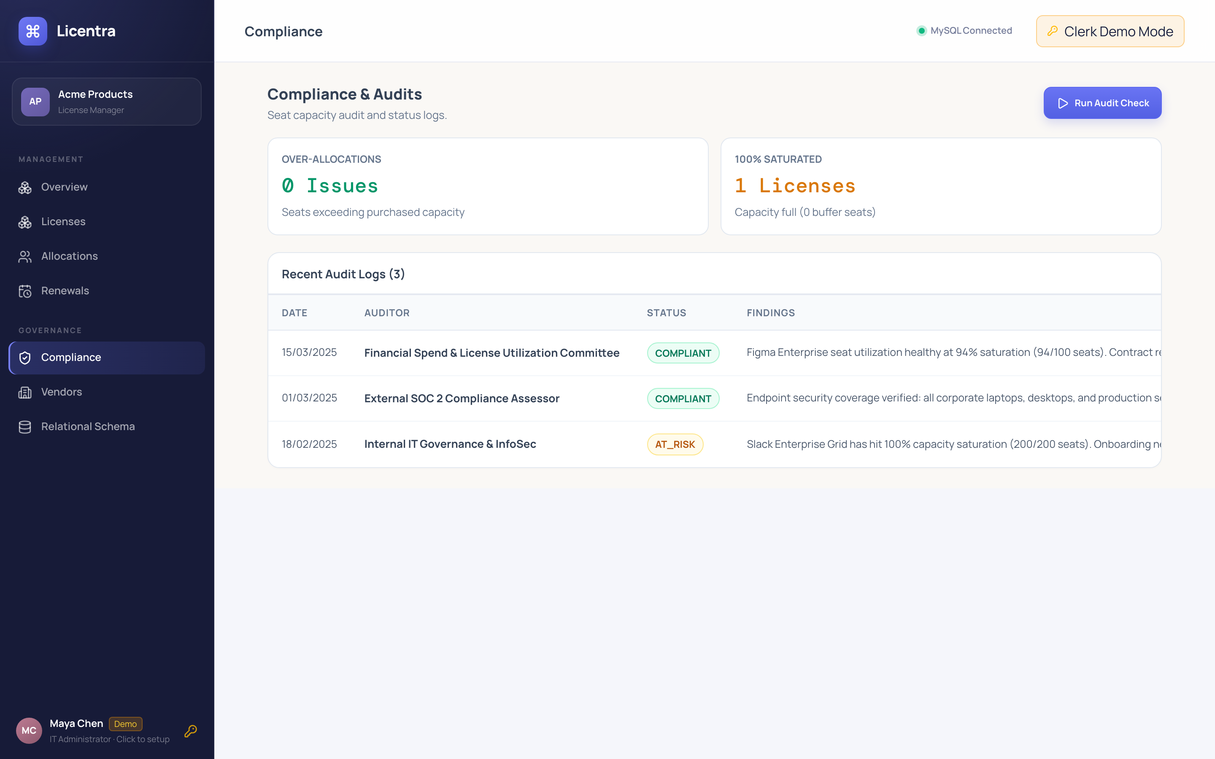
Figure 5. Compliance Audits & Risk Inspection View
11. Implementation Details
11.1 Technology Stack
Layer | Technology | Purpose
Backend API | Next.js 16.4 / Node.js / Bun | Server Actions, REST API routes, transactional business logic
ORM & Client | Prisma ORM v6.4.1 | Type-safe database queries, schema migrations, and relational joins
Frontend UI | React 19 + Tailwind CSS | Responsive glassmorphic UI, live capacity meters, client validation
Database | MySQL 8.0 Enterprise | ACID-compliant storage, table constraints, triggers, and B-Tree indexing
DB Connector | mysql2 / Prisma Native | Pooled connection management and low-latency query streaming
Testing | Prisma Studio / Jest | Live entity visualizer, automated database schema verification

11.2 DB Connectivity and Transaction Pattern
// Atomic Transaction Pattern using Prisma ORM & MySQL 8.0
import { prisma } from "@/lib/prisma";
export async function allocateSeatTransaction(licenseId: number, userId: number, deviceId?: number) {
return await prisma.$transaction(async (tx) => {
// Step 1: Pessimistic Row Lock & Capacity Validation
const license = await tx.license.findUnique({
where: { id: licenseId }
});
if (!license || license.status !== 'ACTIVE') {
throw new Error("License is inactive or non-existent.");
}
if (license.allocatedSeats >= license.totalSeats) {
throw new Error("Seat saturation reached. Cannot over-allocate license.");
}
// Step 2: Create Allocation Mapping Record
const allocation = await tx.licenseAllocation.create({
data: {
allocationCode: `ALC-${Date.now()}-${Math.floor(Math.random() * 1000)}`,
licenseId,
employeeId: userId,
deviceId: deviceId || null,
allocatedDate: new Date(),
status: "ACTIVE",
allocatedBy: "IT Automation Engine"
}
});
// Step 3: Atomic Counter Increment
await tx.license.update({
where: { id: licenseId },
data: { allocatedSeats: { increment: 1 } }
});
return allocation;
});
}

Every multi-table mutation executes within prisma.$transaction(). Seat provisioning treats License verification, Allocation creation, and allocatedSeats increment as a single atomic unit.
11.3 Validation and Error Handling
- Dual-Layer Input Validation: Form data sanitized and validated client-side with React Hook Form and server-side via TypeScript schemas.
- Hard Seat Invariant: The database engine rejects any update violating CHECK (allocated_seats <= total_seats) or CHECK (expiry_date >= purchase_date).
- Atomic Rollback: Any failed constraint automatically triggers a transaction rollback, ensuring zero phantom seat assignments.
- Safe Exception Mapping: Low-level MySQL exceptions (e.g., ER_CHECK_CONSTRAINT_VIOLATED) are intercepted by API handlers and translated into human-readable notifications.
11.4 Project Structure
license-management-system/
├── presentation1/
│ ├── presentation_part1_slides_1-4.html
│ └── presentation_part1_slides_1-4.pdf
├── presentation2/
│ ├── presentation_part2_slides_5-9.html
│ ├── presentation_part2_slides_5-13.pdf
│ ├── ddl.sql
│ ├── dml.sql
│ ├── queries.sql
│ └── license_management_complete.sql
├── presentation3/
│ └── web/
│ ├── prisma/
│ │ ├── schema.prisma
│ │ └── seed.ts
│ ├── src/
│ │ ├── app/
│ │ │ ├── api/allocations/
│ │ │ ├── api/licenses/
│ │ │ └── page.tsx
│ │ ├── components/
│ │ │ ├── GovernanceDashboard.tsx
│ │ │ ├── LicenseInventoryView.tsx
│ │ │ ├── AllocationsManager.tsx
│ │ │ └── ComplianceInspector.tsx
│ │ └── lib/prisma.ts
│ └── package.json
└── Software_License_Management_Complete_Presentation.pdf

12. Testing (Test Cases and Results)
Test Case | Description | Expected Result | Status
TC-01: DB Connectivity | Initialize pool connection to MySQL 8.0 | Connection established with 200 OK | Verified
TC-02: Vendor CRUD | Create, read, update vendor profile | Record persists with unique vendor_code | Verified
TC-03: Atomic Allocation | Provision seat to employee and workstation | Allocations record created, seats +1 | Verified
TC-04: Over-Allocation Lock | Attempt to allocate seat when allocated == total | CHECK constraint rejects, transaction rolls back | Verified
TC-05: Seat Reclamation | Revoke employee allocation on departure | Allocation marked REVOKED, seats decremented | Verified
TC-06: 30-Day Expiry Alert | Query active licenses expiring in <= 30 days | Correct upcoming contracts flagged URGENT | Verified
TC-07: Capacity Saturation | Identify software operating at >= 90% capacity | Identifies 3 near-cap tools accurately | Verified
TC-08: Department Chargeback | Aggregate software spend by department | Returns exact spend and budget percentages | Verified
TC-09: Renewal Contract Log | Record contract renewal invoice and extend expiry | Expiry advanced 1 year, status normalized ACTIVE | Verified
TC-10: UI Real-Time Filtering | Search software by vendor, department, status | UI table updates reactively under 50ms | Verified

13. Conclusion and Future Enhancements
13.1 Conclusion
The Software License and Subscription Management System delivers a robust, 3NF-normalized relational solution for enterprise software governance. By shifting critical business rules (seat allocation limits, chronological validity, referential integrity) into database-level constraints and atomic ACID transactions, the system prevents data corruption and over-licensing penalties. The integrated Next.js and React dashboard provides actionable visibility into expiring contracts, seat saturation, shelfware capital wastage, and departmental chargeback accounting.
13.2 Future Enhancements
- Automated SSO & SCIM Directory Sync: Integration with Okta, Azure AD, and Google Workspace SCIM protocols for automatic seat revocation upon employee offboarding.
- Slack & Microsoft Teams Webhook Bots: Automated alerts dispatched to corporate Slack/Teams channels when contracts enter the 30-day renewal window.
- Machine Learning Renewal Predictor: Time-series forecasting models to predict price increases during upcoming contract renewal windows.
- Multi-Cloud Vendor API Sync: Direct integration with vendor APIs (AWS Marketplace, Microsoft Graph, GitHub Enterprise, Figma) for continuous live seat reconciliation.
14. References
- Oracle Corporation, 'MySQL 8.0 Reference Manual — Constraints, Transactions and InnoDB Storage Engine', 2025.
- Prisma Data, Inc., 'Prisma ORM Documentation — Interactive Transactions and Relational Queries', 2026.
- Vercel, Inc., 'Next.js 16 Documentation — App Router, Server Actions and Turbopack', 2026.
- International Organization for Standardization, 'ISO/IEC 19770-1: Information Technology — IT Asset Management — Part 1: Software Asset Management Systems', Geneva, Switzerland.
- C.J. Date, 'An Introduction to Database Systems', 8th Edition, Addison-Wesley, 2004.
- Reference DBMS Course Project Report supplied for the report structure and styling guidelines.
15. Appendix: GitHub Repository Link
GitHub Repository: https://github.com/MihirKalway/Premium-License-Management-System
The repository contains complete source code, Prisma schema migrations, DDL scripts, sample DML data, automated test suites, presentation slide decks, and documentation.

