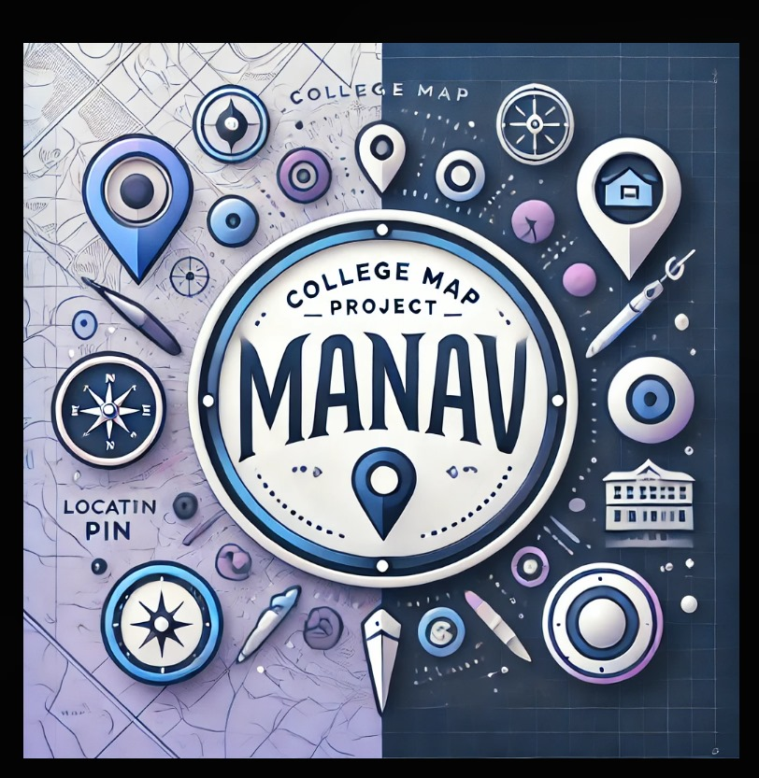
PROJECT MANAV

BY MIHIR SINGH, EKANSH SINGAL, ADITYA SINGH, ADITYA MITTAL, PRANJAL PRAKHAR , ARHAM JAIN

Problem Statement:
A map navigation system tailored for IIT Mandi to provide accurate data and detailed information, for example updated buildings, new paths and to display them in an interactive 3D model to account for the terrain factor which is omitted in 2D Maps.

Current Limitation with Google Maps:
- Lack of Specific Campus features: Google Maps currently does not show the specific features available in a specific building, for example: If you want to know what specific labs are present in A-18 building, there is no separate list for that.
- 2D does not account for terrain and in the mountainous region terrain plays a very important part. Currently, there is no feature in Google Maps which accounts for it. So, we have created a 3D model of the campus with a good approximation.
- Google Maps does not always show the shortest distance between 2 points and because it is in 2D we cannot accurately see if there is a shorter path. Although we have not added navigation yet, in 3D you can see what other paths are available for the destination besides the one shown by yourself.
- Future-proof design: We can easily add any future changes on map, including new academic buildings, sports facilities, or labs etc.
- Some buildings are not mentioned according to Google Maps, for example B16, B21, B22 etc. and wrongly located like Satellite library is being shown in Tulsi Mess.

Objective:
We aspire to create a map which caters specifically to the needs of IIT Mandi residents and visitors, targeted to improve accuracy and ease of campus navigation, to map essential campus facilities like academic buildings, sports facilities, Student Clubs etc.

Challenges (Current and upcoming):

Technological aspect:
- Learning new language and frameworks.
- Compatibility between different file types and framework, for example .glb file of 3D model into different frameworks like Three.js.
- The major challenge was merging React App with Three.js library to add our 3D model in our website.

Logical Aspect:
- The challenge that we face now is finding the way to map the shortest path available between two given points on the map. The uneven terrain also created certain difficulties in this.
- Approximation of different building and their height in the 3D model because we are in a mountainous region and adding the z-coordinate for a point becomes difficult in such terrain.

Overcoming Challenges:
- We overcame the challenge of compatibility of merging different frameworks by learning three.js library (as much as we could in the given time.)
- We approximated the length and height of buildings and the floors in the building by having a rough idea of the dimensions
- To make our UI (user interface) more interactive we learnt new features of CSS

Future prospect
- We will be adding navigation (route tracing) through shortest path to our map.
- Gradually with time we will also do this for our south campus and also nearby area of Kamand which are not much accessible on the google maps.
- The terrain of our campus was approximated by us but we hope to increase its accuracy in the future.

Technologies Used
- FRONTEND WORK:
- HTML-HTML is the backbone of the website structure. It sets the basic layout and components on the webpage, ensuring that the various sections such as the search bar, dropdowns, and other UI elements are correctly organized and accessible.
- CSS-CSS is responsible for styling the website, ensuring that the user interface is visually appealing. It defines the appearance of elements like dropdowns, buttons, search bars, and the overall layout, giving your project a user-friendly design. It also ensures that the 3D model viewer and its surrounding UI components maintain consistent positioning and styling.
- NODE.JS,REACT,THREE.JS
- REACT-React is used to build the dynamic and interactive components of the website. It manages the enabling features like the search bar, dropdown selection, and handling the building locations. The modular structure of React allows you to efficiently manage and update the user interface based on user interactions.
- THREE.JS-Three.js inserts the 3D model viewer in your project. It renders the 3D model of the campus, allowing users to interact with it through zooming, rotating, and selecting specific buildings. Three.js enables real-time rendering and manipulation of the 3D objects, providing an immersive navigation experience.
- NODE.JS-Node.js was used as the backend technology for handling server. It manages the server operations, such as serving the web pages, and handling any back-end processes like data retrieval or interaction with databases. It allows for smooth communication between the client-side (React) and the server, enabling the application to fetch necessary data (like building coordinates or paths) and respond to user interactions in real-time.

BUDGET COMPONENT:
- No expense as of now

LEARNINGS INCLUDED FROM TIP SESSIONS
“By leveraging the basics of programming, we ensured that our code was both efficient and scalable, which is crucial for handling the dynamic nature of our interactive map.”
“Our experience with profile management allowed us to create a personalized user experience, letting users save their favourite locations and tailor their map view.”
“SolidWorks’ principles of detailed design helped us in creating a visually appealing and user-friendly interface, ensuring a seamless navigation experience.”
“GitHub’s version control system was indispensable for our team collaboration, allowing us to manage code changes and maintain high code quality.”
“Product management techniques guided our project planning and user-centred design, helping us deliver a product that effectively meets the needs of our campus community.”

