Software Requirements Specification
for
Tinkermind
Version 1.3 approved
Prepared by Neremzoiu Ionuț-Dragoș, Toporan Radu Gabriel, Dumitrescu Mihnea Ionuț
ACE.UCV
27.02.2021
Table of Contents
Table of Contents ii
Revision History ii
1. Introduction 1
1.1 Purpose 1
1.2 Document Conventions 1
1.3 Intended Audience and Reading Suggestions 1
1.4 Product Scope 1
1.5 References 1
2. Overall Description 2
2.1 Product Perspective 2
2.2 Product Functions 2
2.3 User Classes and Characteristics 2
2.4 Operating Environment 2
2.5 Design and Implementation Constraints 2
2.6 User Documentation 2
2.7 Assumptions and Dependencies 3
3. External Interface Requirements 3
3.1 User Interfaces 3
3.2 Hardware Interfaces 3
3.3 Software Interfaces 3
3.4 Communications Interfaces 3
4. System Features 4
4.1 System Feature 1 4
4.2 System Feature 2 (and so on) 4
5. Other Nonfunctional Requirements 4
5.1 Performance Requirements 4
5.2 Safety Requirements 5
5.3 Security Requirements 5
5.4 Software Quality Attributes 5
5.5 Business Rules 5
6. Other Requirements 5
Appendix A: Glossary 5
Appendix B: Analysis Models 5
Appendix C: To Be Determined List 6

Revision History
Name | Date | Reason For Changes | Version
Neremzoiu Dragos | 05.03.2021 | Changes to the Chapter 1 and 2 | 1.1
Toporan Radu | 08.03.2021 | Changes to the Chapter 2 and 3 | 1.2
Dumitrescu Mihnea | 10.03.2021 | Changes to the Chapter 4 and 5 | 1.3

Introduction

Purpose
This document is meant to serve as an introduction to the Tinkermind software application. The document will target different types of users such as students, teachers and university staff.

Document Conventions
Term | Abbreviation | Abbreviation Description
UI | User Interface | The way the users interact with the application
DB | Database | Storage space for the entities made in the application
SRS | Software Requirements Specifications | Software required for the web application to work
OS | Operating System | A system software that manages computer hardware, software resources, and provides common services for computer programs
ID | Identity card | A way of identifying an entity

Intended Audience and Reading Suggestions
The document is intended only for the use of the following categories of people in the educational field:
- students
- professors
- university staff
Depending on the kind of user the reader is, it is suggested to consult the overview of the document (2.3 User Classes) and proceed to the section which is addressed to that type of user.

Product Scope
The scope of this application is to streamline the more aspects of school project work. This application can be marketed to universities and all pre-university institutions. The benefits of acquiring this software are:
- It offers students a reliable virtual environment in which their work is transmitted in a much quicker and easier way.
- Students can be given updates about their project without requiring them to be physically present at the institution.
- Professors have all the work that their students have made so far in a single place where they can download, review, grade and most importantly notify students about their work (either by sending them review on assignments or by letting them know their grade).

References

Overall Description

Product Perspective
The context for the creation of this application is the need for a more efficient and less time-consuming way of turning in and grading school work projects for universities, and all pre-university institutions. Moreover, this application is meant to be a self-contained product.

Product Functions
The system will provide facilities to students and teachers after they successfully log in [password and identifier] (the username and password are already considered generated):
- Viewing account information
- Password change
- Uploading projects by the student
- Professors can visualize the project files and all necessary data (such as name of the student and the time the student uploaded the project/assignment) regarding the student who uploaded them

User Classes and Characteristics
As it was mentioned in 1.4 Product Scope, this section contains more detailed information on what to expect from this application depending on what kind of user the person reading is:
- Student:
- can log in with the id and password generated by the secretary staff and sent by them on student’s e-mail address>
- can upload school related content when having to turn in an assignment
- can check his/her received grade
- can leave public or private comments on any public post uploaded by any professor
- can change his/her password
- can see the deadline of the assignment allocated to them
- Professor:
- can upload any announcement which only students enrolled in the virtual classroom can see
- can grade students’ assignment
- can see if any student turned in late an assignment or if the assignment is missing
- can download students’ assignments
- University staff:
- can update students’ data except grade (university year, current courses, etc.)
- creates accounts for students and professors

Operating Environment
The minimal requirements for this application are:
- OS: Windows 7/8/10, Linux, Mac, Android, IOS
- Web browsers: Google Chrome, Mozilla Firefox, Microsoft Edge, Opera, etc.
- RAM: 2.5GB
- Video card: not necessarily required, but recommended in general not only for this app
- CPU: Intel Pentium 4 processor or later than SSE3 (for use of chrome browser on Windows or Linux), OS X El Captain 10.11 or later (for use of chrome browser on Mac), Android Lollipop 5.0 (for use of chrome browser on Android device)

Design and Implementation Constraints
There are no corporate or regulatory policies, because this is a self-contained product that doesn’t rely on other licensed software to function. For the UI, the user needs to know enough English such that he/she can understand the functionalities of the application.

User Documentation
A video tutorial will be provided for both students and professors so they can learn how to use the application accordingly.

Assumptions and Dependencies
- Students can only send files and can’t assign grades to projects.
- Professors can only grade projects that they themselves have assigned.
- Secretary staff cannot alter the grade given by professors.

External Interface Requirements

User Interfaces

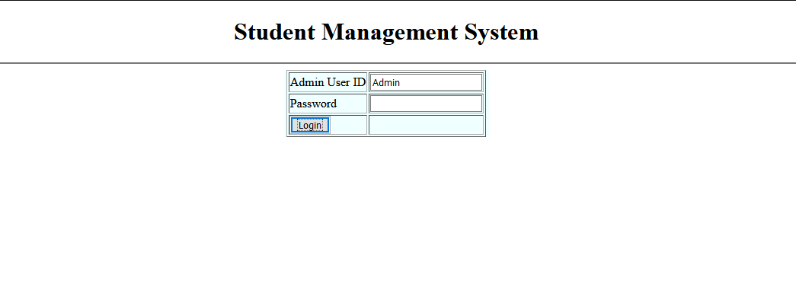

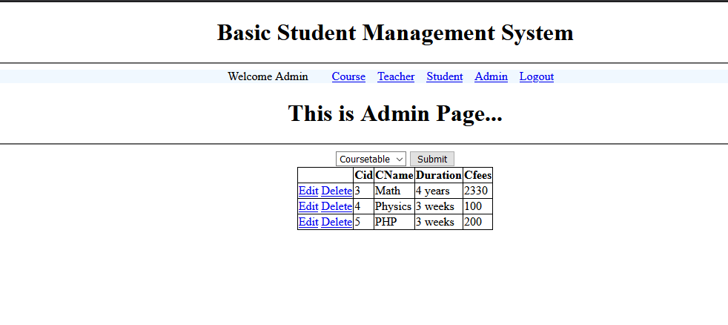

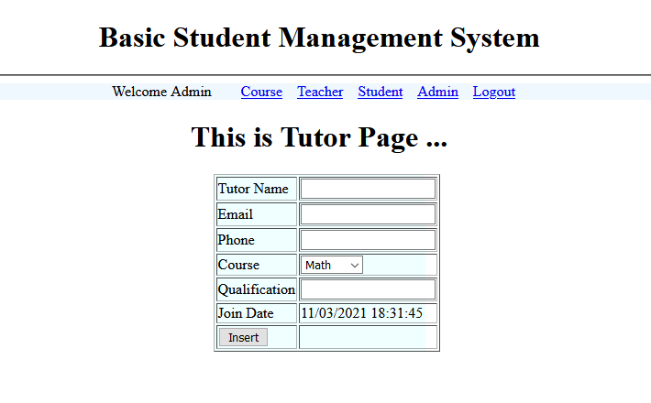

Hardware Interfaces
Not applicable

Software Interfaces
The product will be connected to an internal database which will store all the individual entities such as: students, courses, teachers etc.

Communications Interfaces
The users in order to access the product require an internet connection and an email account. These are necessary for logging in to the main platform.

System Features

Turning in projects
4.1.1 Description
The students will be able to submit the files necessary for the project in order to be graded by their teacher.

4.1.2 Requirements

-The user must be a student.
-The user must turn in a file.

Grading the projects
4.2.1 Description
The teachers can give grades to the projects of each specific student.

4.1.2 Requirements

-The user must be a professor.
-The user must return a grade to the project.

Adding students
4.3.1 Description
The administrator can add students to the database and assign them to a specific course.

4.1.2 Requirements

-The user must be an administrator.
-The user must add a first name, a last name, the student’s father’s name and phone number, an email, phone number and a course for the student.

Adding Professors
4.4.1 Description
The administrator can add professors to the database and assign them to different courses.

4.1.2 Requirements

-The user must be an administrator.
-The user must add a first name, a last name, an email, phone number, a course and a qualification.

Adding Courses
4.5.1 Description
The administrator can add courses to the database.

4.1.2 Requirements

-The user must be an administrator.
-The user must add a name for the course and the course duration.

Adding Projects
4.6.1 Description
The professors can add projects to the database and assign them to different students.

4.1.2 Requirements

-The user must be a professor.
-The user must add a project name, the project requirements and a deadline for the project.

Editing Students
4.7.1 Description
The administrator can edit students from the database and change the elements of each profile.

4.7.2 Requirements

-The user must be an administrator.
-The user must change any of the elements of a student’s account such as name or email.

Editing Professors
4.8.1 Description
The administrator can edit professors from the database and change the elements of each profile.

4.8.2 Requirements

-The user must be an administrator.
-The user must change any of the elements of a professors account such as name or email.

Editing Projects
4.9.1 Description
The professors can add new projects for students.

4.9.2 Requirements

-The user must be professor.
-The user must change any of the elements of a projects such as name or requirements.

Editing Courses
4.10.1 Description
The administrator and professors can edit courses and change the elements of each course such as the name and length of the course.

4.10.2 Requirements

-The user must be an administrator or professor.
-The user must change any of the elements of the course such as the name and length.

Deleting Students
4.11.1 Description
The administrator can delete students from the database.

4.11.2 Requirements

-The user must be an administrator.

Deleting Professors
4.12.1 Description
The administrator can delete different professors.

4.12.2 Requirements

-The user must be an administrator.

Deleting Courses
4.13.1 Description
The administrator can delete different courses.

4.13.2 Requirements

-The user must be an administrator.

Logging in
4.14.1 Description
Users can log in to certain accounts by using a username and password.

4.14.2 Requirements

-The user must have an account, username and password.

Logging out
4.15.1 Description
Users can log out from one account using a log out button.

4.15.2 Requirements

-The user must have an account already made.
-The user must be logged on to the service.

Viewing all the students
4.16.1 Description
The administrator and professors can view all the students.

4.16.2 Requirements

-The user must be an administrator or a professor.
-The user must be logged on to the service.

Viewing all the professors
4.17.1 Description
The administrator can view all the professors.

4.17.2 Requirements

-The user must be an administrator.
-The user must be logged on to the service.

Viewing all the Courses
4.18.1 Description
The administrator and professors can view all the courses. Students can see all the courses that they are assigned to.

4.18.2 Requirements

-The user must be an administrator, a professor or a student.
-The user must be logged in to the service.

Viewing all the Projects
4.19.1 Description
The administrator and professors can view all the projects. Students can see all the projects that they have to turn in.

4.19.2 Requirements

-The user must be an administrator, a professor or a student.
-The user must be logged in to the service.

Other Nonfunctional Requirements

Performance Requirements
Not applicable

Safety Requirements
Not applicable

Security Requirements
In order to log in, the user must fill in the ID and password fields. There are sent via e-mail by university staff to students and professors. Students and professors MUST not reveal, by any means, their password to anyone in order to avoid getting their student/professor account lost. Security-wise, the password will consist of 9 characters which can be letters (be them capital or not) and numbers, so that the chances of having their accounts stolen are much lower. In the unfortunate case that a student/professor’s account gets hacked, the student/professor must notify the university staff as soon as possible in order to block the account, to prevent from leaking the student’s or the professor’s data and to restore the student’s/professor’s data.

Software Quality Attributes
Specify any additional quality characteristics for the product that will be important to either the customers or the developers. Some to consider are: adaptability, availability, correctness, flexibility, interoperability, maintainability, portability, reliability, reusability, robustness, testability, and usability. Write these to be specific, quantitative, and verifiable when possible. At the least, clarify the relative preferences for various attributes, such as ease of use over ease of learning.

Business Rules
This software product is meant to be used only by those involved in the field of education.

Other Requirements

Not applicable

