Triviador Profiling

In this document we will follow our application’s performance based on GPU, CPU and memory usage:

1.Server’s launch :

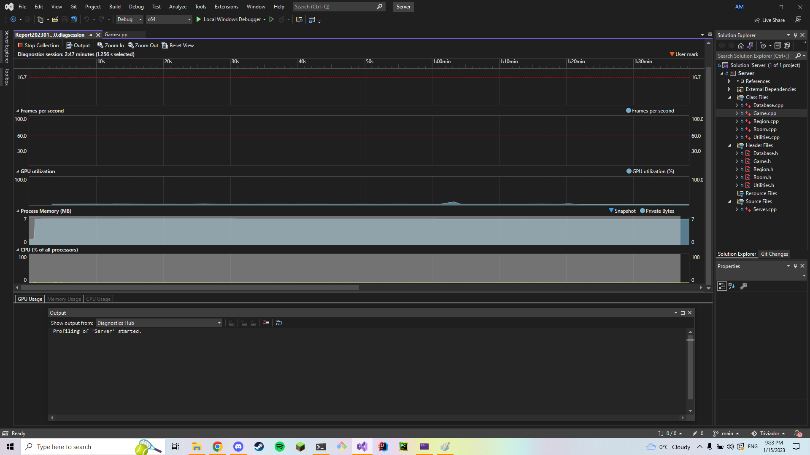

After the server’s launch we can see that there are almost no fluctuations.

2.Application’s launch :

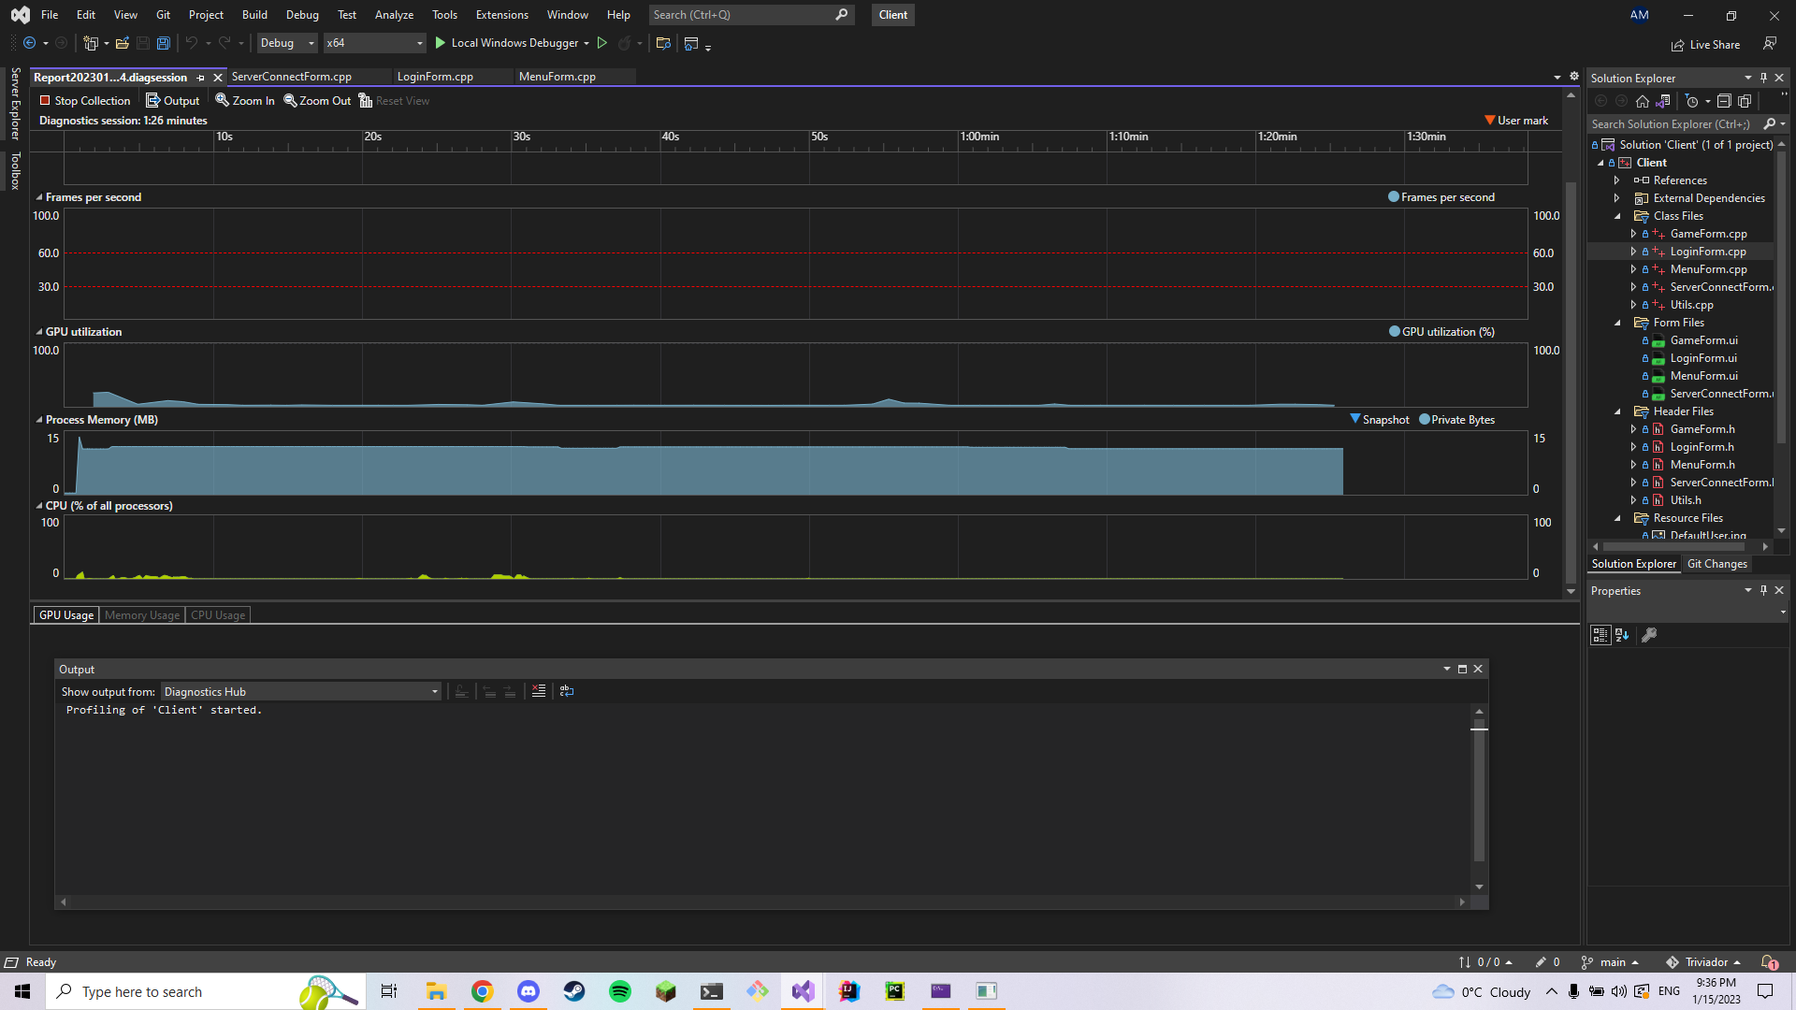

After we launch the application we can see it’s stable, without fluctuations.

3.Performance when the app connects to the server :

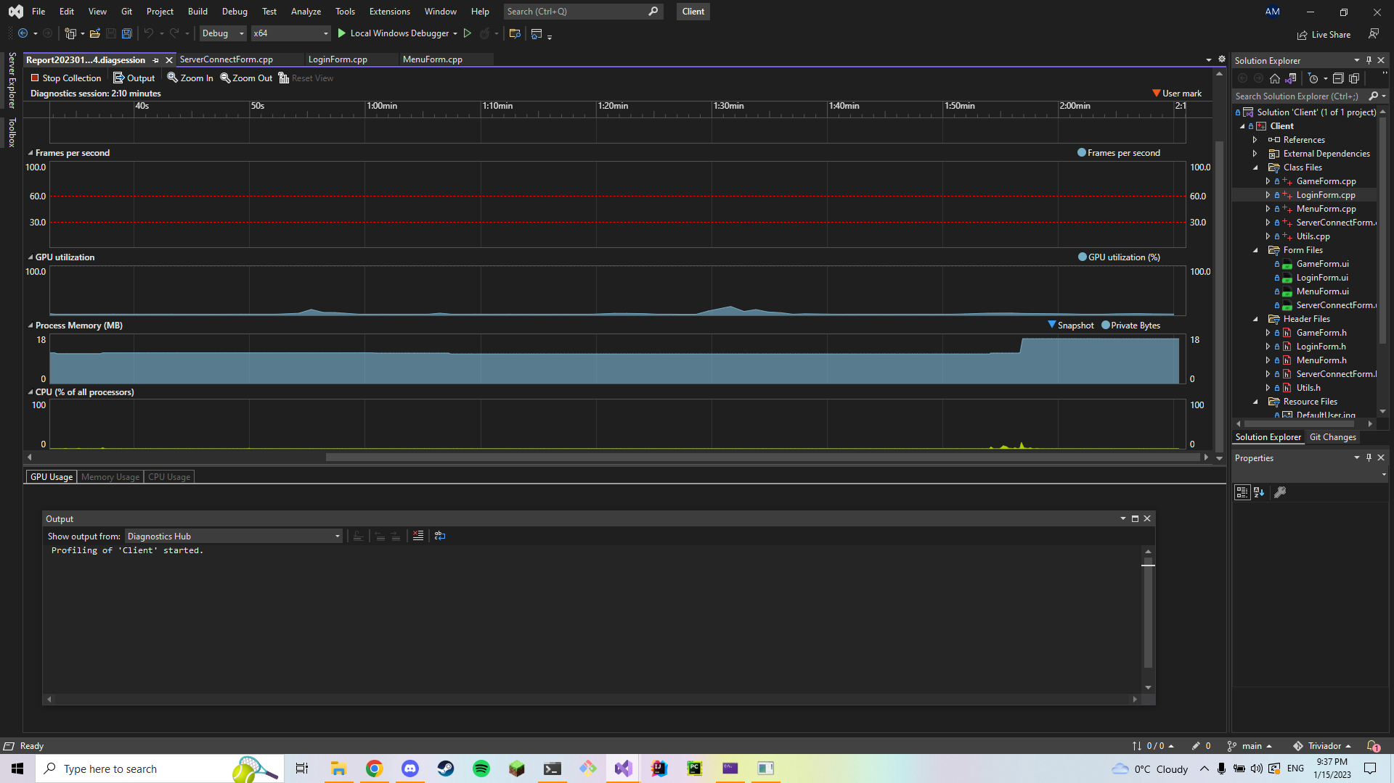

After we connect to the server we can see there is a small memory spike that doesn’t fluctuate.

4.Performance after the user has logged into his account :

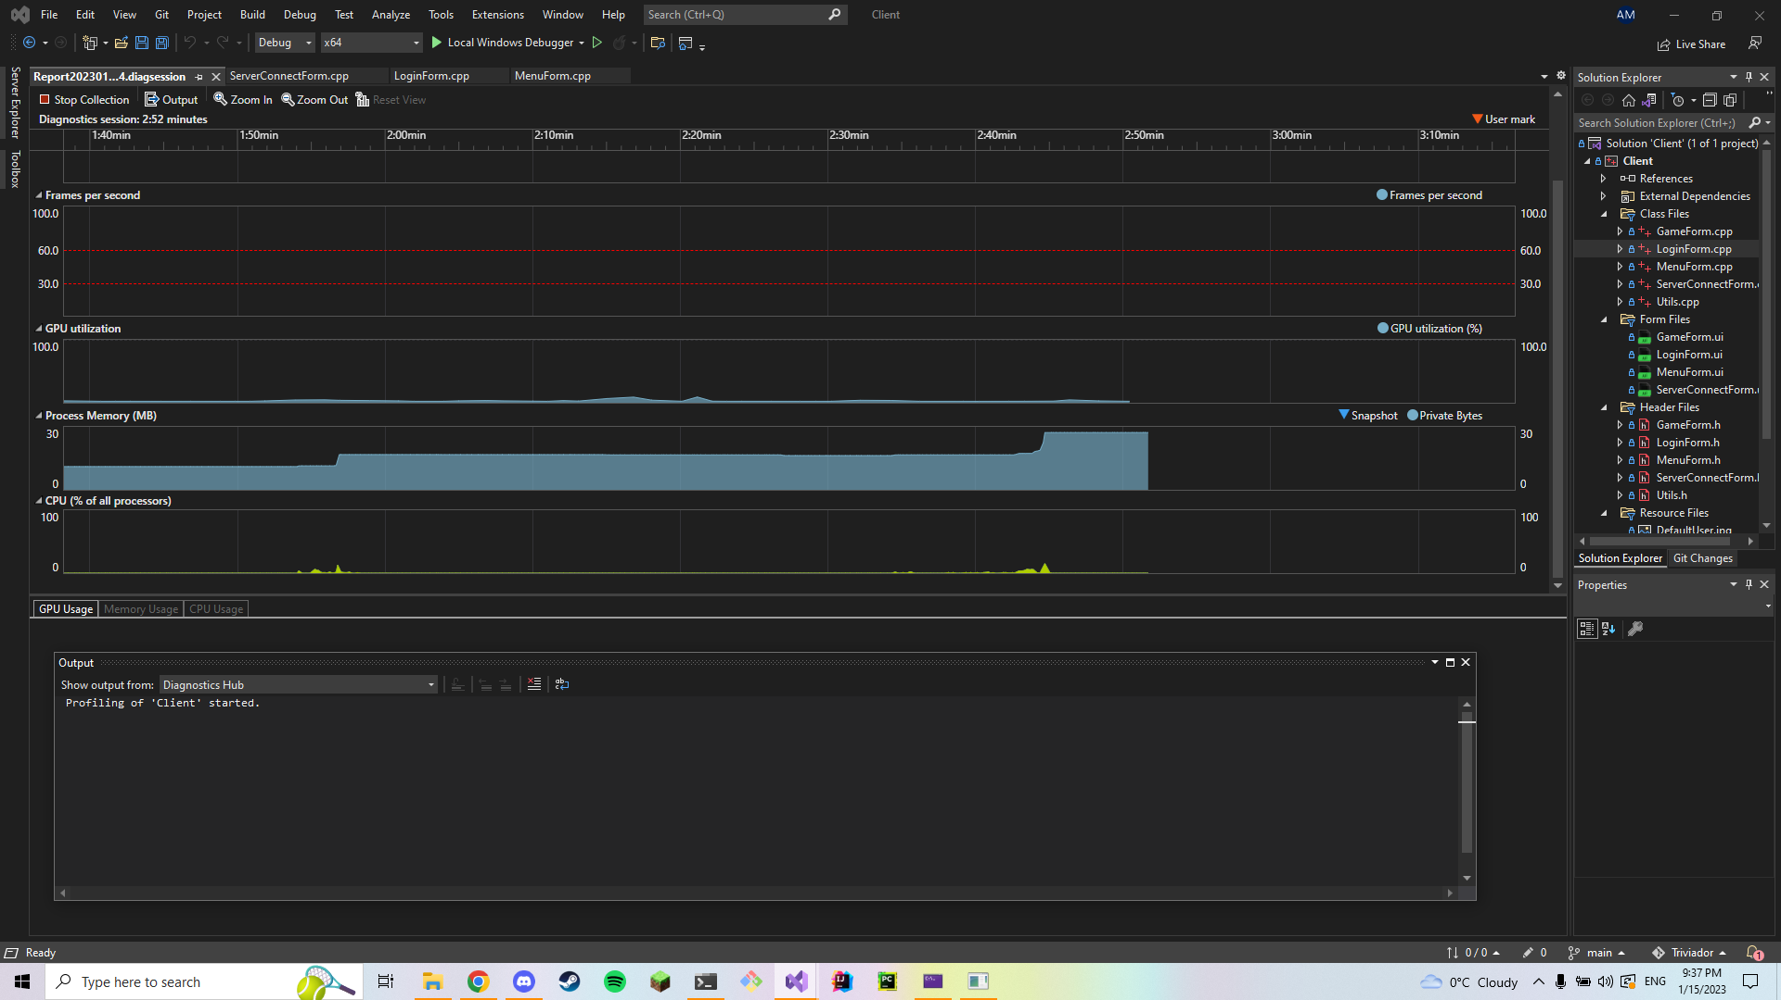

After the log in we can see a small spike in the memory usage, but after the action we can see that it runs smoothly.

5.Performance after the game room’s creation :

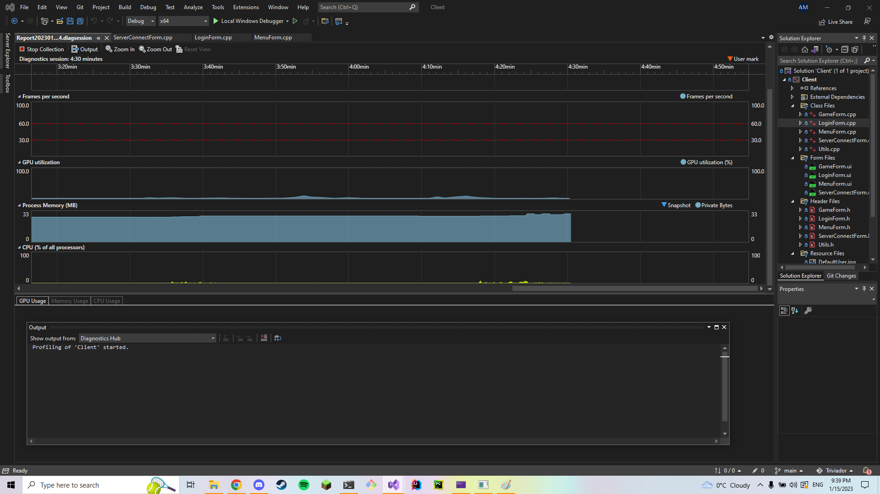

After the creation of the room, we can see that the app still runs smoothly, without any major spikes in the memory usage.

6.Performance after the Triviador game itself has started :

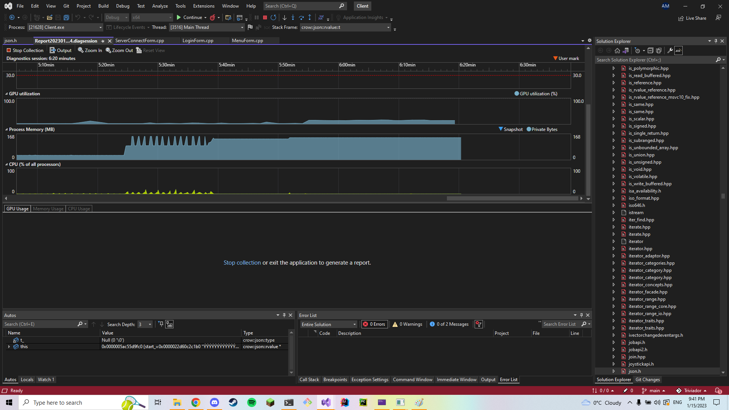

After the game launches, we can see the memory and CPU usage fluctuating for a small bit of time as well as the GPU usage increasing. However the spikes are short-lived and the game runs smoothly.