UNIVERSITATEA POLITEHNICA BUCURESTI

FACULTATEA DE AUTOMATICA SI CALCULATOARE

DATA BASE DESIGN

Project

Online shop



*Gheorghiu Mihnea,*

*344C2*

**Idea and project description:**

Write and online shop for computers. Project will contain a database with 5 tables/5 interfaces and functions to work for a real case. User will be able to order products through the php interface accesible from any web browser and will be able to keep constant track of his order. Buying will be done by clicking on the desired product, and it will appear in the cart and the total cost will be updated.

The shopping cart can be modified from the graphical interface by the user if he changes his mind.

The database can be mentained either from the graphical interface or from the compshop.sql file

**Creation and development of the project:**

To write this project is used:

-a virtual machine running ubuntu804desktop

-a LAMP solution(apache2/mysql/php5)

-engine: Mysql

-interface for users: php

-because php requires a server i installed apache2 with related libraries for php 5

-mysql server and client

-phpmyadmin 2.11.3deb1ubuntu1 to be able to create and manage users and the database

-phpmyadmin is necessary to import the database

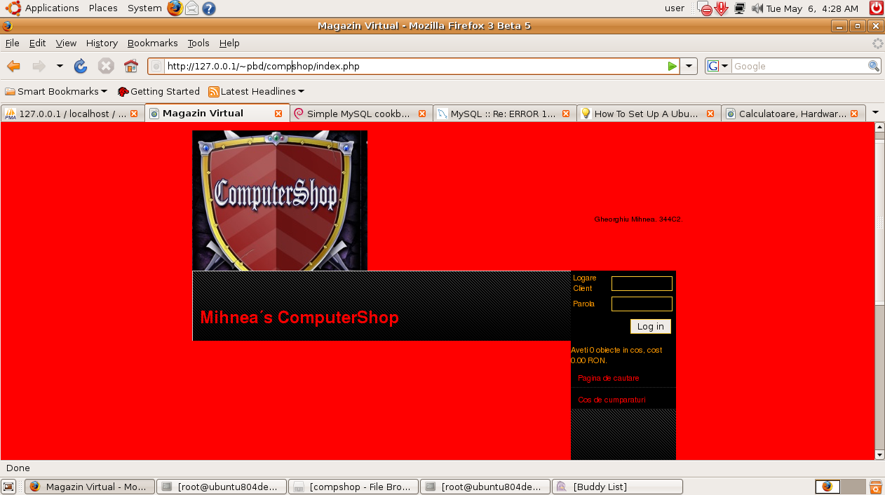

**The archive contains:**

**-**admin.php

-background image for a pleasant look

-shop logo

-buy.php

- .gif and. jpeg files for the page

-comp.php

-compshop.sql – the database that must be imported, contains the necessary tables and the test data

-- phpMyAdmin SQL Dump

-- version 2.11

-- http://www.phpmyadmin.net

--

-- Host: localhost

-- Generation Time: June 20, 2008 at 02:57 PM

-- Server version: 5.0.51

-- PHP Version: 5.2.5

SET SQL_MODE="NO_AUTO_VALUE_ON_ZERO";

--

-- Database: `computershop`

--

-- --------------------------------------------------------

CREATE DATABASE ComputerShop;

USE ComputerShop;

--

-- Table structure for table `produse`

--

CREATE TABLE IF NOT EXISTS `produse` (

`ID` int(11) NOT NULL auto_increment,

`Nume` varchar(100) NOT NULL,

`Producator` varchar(50) NOT NULL,

`Categorie` varchar(25) NOT NULL,

PRIMARY KEY (`ID`)

) ENGINE=MyISAM DEFAULT CHARSET=utf8 AUTO_INCREMENT=3 ;

--

-- Dumping data for table `produse`

--

INSERT INTO `produse` (`ID`, `Nume`, `Producator`, `Categorie`) VALUES

(1, 'Toshiba Satelite', 'Toshiba', 'Intel Duo Core'),

(2, 'HP Pavilion', '', 'Athlon 64 XP');

-- --------------------------------------------------------

--

-- Table structure for table `produsecom`

--

CREATE TABLE IF NOT EXISTS `produsecom` (

`IDProdus` int(11) NOT NULL,

`IDcomanda` int(11) NOT NULL,

`cantitate` int(11) NOT NULL,

PRIMARY KEY (`IDProdus`,`IDcomanda`)

) ENGINE=MyISAM DEFAULT CHARSET=utf8;

--

-- Dumping data for table `produsecom`

--

-- --------------------------------------------------------

--

-- Table structure for table `comenzi`

--

CREATE TABLE IF NOT EXISTS `comenzi` (

`ID` int(11) NOT NULL,

`User` int(11) NOT NULL,

`Data` datetime NOT NULL,

`Status` enum('comanda noua','in curs de livrare','livrat') NOT NULL,

PRIMARY KEY (`ID`)

) ENGINE=MyISAM DEFAULT CHARSET=utf8;

--

-- Dumping data for table `comenzi`

--

-- --------------------------------------------------------

--

-- Table structure for table `useri`

--

CREATE TABLE IF NOT EXISTS `useri` (

`ID` int(11) NOT NULL auto_increment,

`Nume` varchar(50) NOT NULL,

`Parola` varchar(16) NOT NULL,

`Adresa` varchar(100) NOT NULL,

PRIMARY KEY (`ID`)

) ENGINE=MyISAM DEFAULT CHARSET=utf8 AUTO_INCREMENT=3 ;

--

-- Dumping data for table `useri`

--

INSERT INTO `useri` (`ID`, `Nume`, `Parola`, `Adresa`) VALUES

(1, 'Eu', 'eu1234', 'aaaa');

-- --------------------------------------------------------

--

-- Table structure for table `caracteristici`

--

CREATE TABLE IF NOT EXISTS `caracteristici` (

`ID` int(11) NOT NULL,

`IDProdus` int(11) NOT NULL,

`Procesor` varchar(50) NOT NULL,

`An` year(4) NOT NULL,

`Pret` decimal(10,0) NOT NULL,

`Disp` int(11) NOT NULL,

PRIMARY KEY (`ID`,`IDProdus`)

) ENGINE=MyISAM DEFAULT CHARSET=utf8;

--

-- Dumping data for table `caracteristici`

--

INSERT INTO `caracteristici` (`ID`, `IDProdus`, `Procesor`, `An`, `Pret`, `Disp`) VALUES

(0, 1, 'Acer Aspire', 2007, 17999, 12);

-footer

-file for connecting to the database/adding function/deleting and computations:

<?php

function ConnectDB() {

if (!mysql_connect("127.0.0.1", "ComputerShop", "comp")) {

die("Nu se poate realiza conexiunea la baza de date!");

}

if (!mysql_select_db("compShop")) {

die("Nu se poate selecta din baza de date!");

}

}

function Addcomp($comp, $count) {

if (isset($_SESSION['comps'][$comp])) {

$_SESSION['comps'][$comp] += $count;

} else {

$_SESSION['comps'][$comp] = $count;

}

}

function Remcomp($comp, $count) {

if ((isset($_SESSION['comps'][$comp]) && ($_SESSION['comps'][$comp] >= $count))) {

$_SESSION['comps'][$comp] -= $count;

if ($_SESSION['comps'][$comp] == 0) {

unset($_SESSION['comps'][$comp]);

}

}

}

function CalcValue() {

$price = 0;

if (isset($_SESSION['comps'])) {

$query = mysql_query("SELECT * FROM catalog WHERE id_caracteristici IN (" . implode(",", array_keys($_SESSION['comps'])) . ")");

if ($query) {

while ($array = mysql_fetch_assoc($query)) {

$price += $_SESSION['comps'][$array['id_caracteristici']] * $array['Pret'];

}

}

}

return number_format($price, 2);

}

function CalcCount() {

if (isset($_SESSION['comps'])) {

return count($_SESSION['comps']);

}

return 0;

}

?>

-gorotron.css –css script for laying out in the page

-header.html and header.php

-index.php

**Table structure:**

-produse: Id, Nume, Producator, TipSistem(laptop, desktop, server)

-produsecom: Idprodus, Idcomnda, Cantitate

-comenzi: Id, Data, Status

-useri: Id, Nume, Parola, Adress

-caracteristici: ID, idprodus, Procesor, An, Pret, Stoc

**Bibliography:**

<http://www.debian-administration.org/articles/64>

-un cookbook mysql for Debian distributions

<http://forums.mysql.com>

-solving encountered errors

<http://www.howtoforge.com/ubuntu_debian_lamp_server>

<http://www.gorotron.com>

-script css and template

<http://www.dc-shop.ro>

-products

<http://www.imagechef.com>

-script for generating images

<http://www.kde-look.org>

-background

<http://www.bazededate.org>

<http://www.gimp.org>

-open source program for editing images

<http://www.php.net/manual/en/book.mysql.php>

-used functions