GUITAR
TUNER
06/06/2008 | SM Project
students : Alexandru Petrencu
Mihnea Gheorghiu
Victor Tone
groups : 344 C2

Table of contents

- Project ideea
- Implementation
- Hardware Design
- Software Design
- Functioning
- Conclusions
- Tools created
- References and Links

1. Project ideea
Why do we need a guitar tuner? Or why is it usefull? Seriously, when we need to tune a guitar , we can choose between: a computer + microphone + tunning application (such as Minituner - home.att.net/~jorgeguillen/minituner.html ), a tuning fork or musical ear (good hearing). Than why not build our own tuner. Except for the challenge of building a functional electronic assembly + the project grade, the tuner is useful when we don’t have the above elements: computer, tuning fork, fine hearing. Powered by batteri the assembly is usefull in case of a power surge, or on holiday(in the absence of a laptop).
2. Implementation
The project was thought to be used for tuning a guitar acoustic in Do major (C). The LCD will indicate if the string must be tightened, loosened or if it is tuned correctly.
The project uses as a starting point a board(presented in the .htm file) with the microcontroller chip ATMEL ATmega16. Except for that we use the following modules:
- input
  - a microphone with a condenser
  - an amplifier (using the tranzistor BC547as a base)
- output
  - LCD, 2 leds
To make the project easier, I have taken into account that the amplitude of the string fundamental signal is more pronounced.This way we only need to aplify the signal and determin the period between 2 leading edges (we no longer need the Fourier transform).

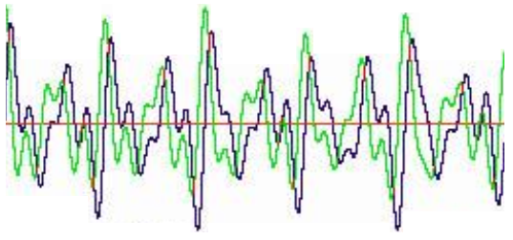
3. Hardware Design
The electric design, without the elements from the main board and without the LCD:
Obs. Elements are from the Proteus design.

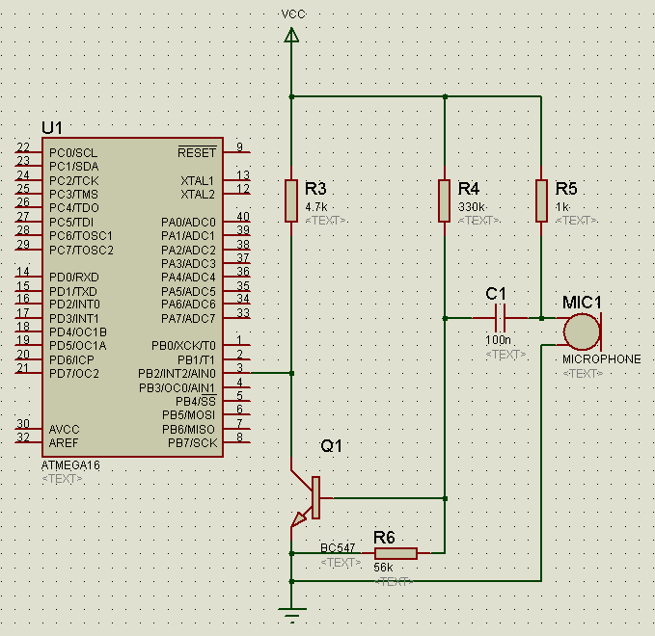

Microfonul si amplificatorul

The microphone and the cocndenser connected at an entry of the processor Atmega16

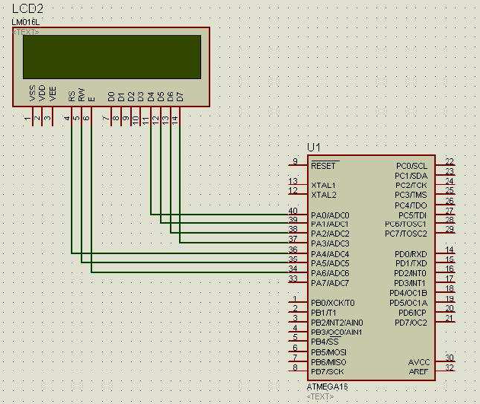
Connecting the LCD at an exit of the processorAtmega16

4. Software Design
Code is written in C (using AVR-gcc libraries).
Code structure is as follows:
initialize PORTB, PIN 2 on input
initialize PORTB on output
initialize PORTB on output(pins4,5,6,7) and inout(pins 0,1,2)
set prescaler
activate timer
infinite cycle
if a signal appers on PB2(leading edge)
repeat 16 times
reset timer
if a signal appears on PB2(another leading edge)
save value of the timer
calculate average value between periods
compare with named periods
command LEDs
if period is too big turn on “too low” LED
if period is too smal turn on “too high” LED
command LCD
if period is too great print “n”
if period is too small print “m”
if period is within the margine of error print “e”
5. Functioning
- Power up the board
- For tuning we hit the strings one at a time,so that each of them gets to vibrate independently for 1-2s
- The microphone takes over the signal, which is filtered by the condenser, and then aplified aprox. 60 times by the BC547 tranzistor
- Signal reaches portl PB2
- uC detects the leading edge and resets a timer
- for the case when the timer reaches the maximum value an overflow interrupt is triggered, and the result is saved in a variable
- at the next leading edge the result is stored from the timer in a variable
- sampling is repeated 16 times
- at the end the average value is calculated, and it is compared with predefined values to determine the string
- after we identify the string, we calculate the deviation and we decide which leds to turn on
- the leds indicate if the string is too tight, too loose or correctly tuned
- the LCD will display if the string is too tight, too loose ore correctly tuned

6. Conclusions

Disappointments:
- not very precise
- not enough time and will to implement the part with selecting what string to tune (the buttons)
Possibilities for expanding:
- Serial port available: we can extend with a memory and connect to the PC for data transfer
Problems faced:
- The main problem was not the coding part itself, but finding the frequencies that the microphone records (strings vibrate differently – especially when they are used – and the microphone reads sometimes a frequency, sometimes it’s double value). I played with the numbers of samplings and the accepted deviation and at the end it workd.
7. Tools
- The main board from the PM project (my temperature measuring project), to which I added a microphone, an amplification stage and an LCD
- 2 pictures with the board (disconnected and functioning)
- project AVR-gcc in AVR Tools 4 (in the folder “proiect16” – includes source proiect 16.c and file proiect16.hex which will be written on the ATmega16 with PonyProg )
- this README

8. Development environment
- AVR Tools 4, used to write and compile project
- WinAVR, used to compile C (it is integrated in AVR Tools)
- PonyProg, used to write the program in the memory of the ATmega16
- Microsoft Word, used for the README with nice links

9. References and Links
- http://www.myplace.nu/avr/gtuner/ - design and code for a guitar tuner done with Atmel2323
- http://www.uoguelph.ca/~antoon/tutorial/xtor/xtor8/xtor8.html - how to create an amplifier
- Resources from the lab activities 1 and 2 and PM course website
- lab3.pdf si lab3.c – for communicating with the LCD, took the API from there(lab3.c is available in my gists section)
- ATMEGA16_schema16.pdf –design with signals of the main board
- http://dan.physics.pub.ro/pm/Realizare_Placuta_Baza_Atmel/ - guide for the main board
- ATmega16.pdf – datasheet ATmega16

